Important supplements for vegetarians
- Vitamin B12
- Vitamin D
- EPA and DHA
- Iodine
- Calcium
- Zinc
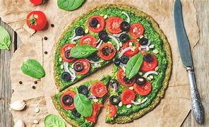
What is vegetarianism?
- a vegetarian is someone who doesn’t eat any meat, animal product, poultry and its products.
- Vegans instead eat only food obtained form plants.
The Vegetarian diet

An informational brochure by the Vegan society of America.
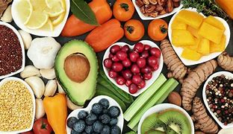
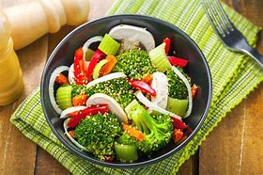

Pitfalls to avoid
- Assuming all vegan food Is healthy and safe for consumption
- Insufficient uptake of Vitamin B12
- Compensating for meat with cheese
- Reducing intake of calories
- Not taking sufficient water

Vegan snack?
Fresh fruit. vegetables. Roast nuts or chickpeas, Trail mix. Cereals with plant milk. Cashew nuts. Plant milk cappuccino or latte, chia, fruits dried seaweed snack.

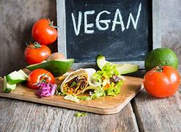
references
1. Dinu, M., Abbate, R., Gensini, G. F., Casini, A., & Sofi, F. (2017). Vegetarian, vegan diets and multiple health outcomes: a systematic review with meta-analysis of observational studies. Critical reviews in food science and nutrition, 57(17), 3640-3649.
2. Anderson, J. W. (2008). Beneficial effects of soy protein consumption for renal function. Asia Pacific journal of clinical nutrition, 17, 324-328.
Benefits of a vegan diet
Weight loss.
Healthy heart
Lower risk of cancer¹
Better kidney function²
Reduced risk of developing Alzheimer’s
More physical activity and exercise
Better overall health

What not to eat
Meat. Poultry. Fish. Seafood. Dairy and its products. Eggs. Bee products including honey and pollen
What to eat
Legumes. Tofu. Tempeh. seitan. Nuts. calcium fortified plant milks. Algae. Nutritional yeast. fruits, vegetables. Sprouted and fermented plant foods.

