13.
The integral
$$\int_{0}^{1}{2x-\frac{1}{x} dx}$$
is an improper integral because $0$ is not part of the domain of $\frac{1}{x}$.
It can be evaluated as:
$$\lim_{x→0}{\int_{x}^{1}{2x-\frac{1}{x} dx}}$$
$$\lim_{x→0}{{\left[x^{2}-\ln{x}\right]}_{x}^{1}}$$
$$\lim_{x→0}\left[\left(1^{2}-\ln{1}\right)-\left(x^{2}-\ln{x}\right)\right]$$
$$\lim_{x→0}{1-x^{2}+\ln{x}}$$
Since $\lim_{x→0}{\ln{x}}=-∞$, this integral diverges.

14.
(a)
$$y=f\left(x\right)=g\left(x\right)$$
$$-x+5=5x-x^{2}$$
$$x^{2}-6x+5=0$$
$$(x-1)(x-5)=0$$
$$x=1, 5$$

(b)
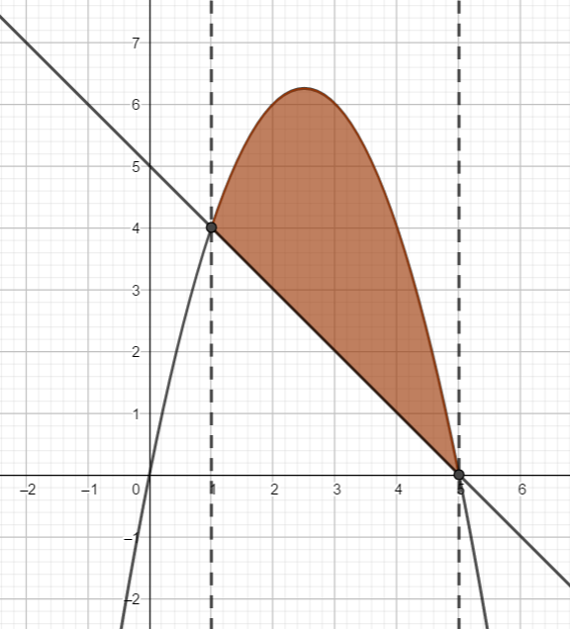
(c)
$$\int_{1}^{5}{\left(5x-x^{2}\right)-\left(5-x\right) dx}$$
$$=\int_{1}^{5}{-x^{2}+6x-5 dx}$$
$$={\left[-\frac{x^{3}}{3}+3x^{2}-5x\right]}_{1}^{5}$$
$$=\left(-\frac{{\left(5\right)}^{3}}{3}+3{\left(5\right)}^{2}-5(5)\right)-\left(-\frac{{\left(1\right)}^{3}}{3}+3{\left(1\right)}^{2}-5(1)\right)$$
$$=\frac{32}{3}≈10.67$$

15.
(a)
$$\int{x^{2019}⋅\ln{2x}dx}$$
$$u=\ln{2x}$$
$$u^{'}=\frac{1}{x}$$
$$v^{'}=x^{2019}$$
$$v=\frac{x^{2020}}{2020}$$
$$\int{uv^{'}}=uv-\int{u^{'}v dx}$$
$$\int{\left(\ln{2x}\right)\left(x^{2019}\right)}=\left(\ln{2x}\right)\left(\frac{x^{2020}}{2020}\right)-\int{\left(\frac{1}{x}\right)\left(\frac{x^{2020}}{2020}\right) dx}$$
$$\int{x^{2019}⋅\ln{2x}dx}=\frac{x^{2020}}{2020}\ln{2x}-\int{\frac{x^{2019}}{2020} dx}$$
$$=\frac{x^{2020}}{2020}\ln{2x}-\frac{x^{2020}}{2020⋅2020}+c$$
$$=\frac{x^{2020}}{2020}\left(\ln{2x}-\frac{1}{2020}\right)+c$$

(b)
$$\int_{e}^{e^{4}}{\frac{1}{x\sqrt{\ln{x}}}dx}$$
$$u=\ln{x}$$
$$\frac{du}{dx}=\frac{1}{x}$$
$$dx=x du$$
$$x=e→u=\ln{e}=1$$
$$x=e^{4}→u=\ln{e^{4}}=4$$
$$\int_{1}^{4}{\frac{1}{x\sqrt{u}} x du }$$
$$=\int_{1}^{4}{\frac{1}{\sqrt{u}} du }$$
$$=\int_{1}^{4}{u^{-\frac{1}{2}} du }$$
$$={\left[2u^{\frac{1}{2}}\right]}_{1}^{4}$$
$$=2\left(\sqrt{4}-\sqrt{1}\right)$$
$$=2$$

16.
(a)
$$f_{x}\left(x, y\right)=-2x+4y$$
$$f_{y}\left(x, y\right)=y^{2}+4x$$

(b)
$$f_{x}\left(x, y\right)=-2x+4y=0→x=2y$$
$$f_{y}\left(x, y\right)=y^{2}+4x=0$$
$$y^{2}+4\left(2y\right)=0$$
$$y^{2}+8y=0$$
$$y\left(y+8\right)=0$$
$$y=0, -8$$
$$y=0→x=0$$
$$y=-8→x=-16$$
The critical points are $\left(0, 0\right)$ and $\left(-16, -8\right)$.

(c)
$$f_{xx}\left(x,y\right)=-2$$
$$f_{yy}\left(x,y\right)=2y$$
$$f_{xy}\left(x, y\right)=f_{yx}\left(x,y\right)=4$$
$$H\left(f\right)=f_{xx}⋅f_{yy}-f_{xy}⋅f_{yx}$$
$$H\left(f\right)=\left(-2\right)\left(2y\right)-{\left(4\right)}^{2}=-4y-16$$
$$H\left(f\left(0,0\right)\right)=-4\left(0\right)-16=-16<0$$
There is a saddle point at $(0, 0)$.
$$H\left(f\left(-16, -8\right)\right)=-4\left(-8\right)-16=16>0$$
There is either a local minimum point or a local maximum point at $\left(-16, -8\right)$.
$$f_{xx}\left(-16,-8\right)=-2<0$$
There is a local maximum at $\left(-16, -8\right)$.

