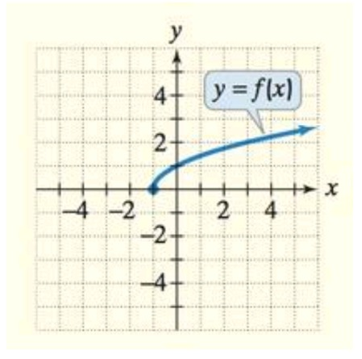

Range

Domain
Domain is a term used to describe set of possible inputs. A domain graph then comprises all input values under x-axis. On the other hand, the set of possible output values presented on y-axis have the name range.
From the graph and the equation y=f(x), we can observe that for every increase or decrease of x there’s a corresponding increase or decrease of y. Therefore, both the horizontal and vertical axis has no bound. As a result, the range and domain of the function are (-∞, ∞)
Domain (-∞, ∞)
Range (-∞, ∞)

