- Given the function f (x) = x⁴ – 6x³ + 1, determine any points of inflection
(0, 1) and (3, -80)
The first step is to find the first and second derivatives.
First derivative is 4x³ – 18x²
Second derivative is: 12x² – 36x
The second derivative is set equal to zero as follows:
12x² – 36x = 0
12x² = 36x
x² = 3x
x = 3 or 0
When x = 3, then f (x) = x⁴ – 6x³ + 1 is
f (x) = 3⁴ – 6(3)³ + 1
= -80
Therefore, one of the inflection points is (3, -80)
When x = 0, then f (x) = x⁴ – 6x³ + 1 is
f (x) = 0⁴ – 6(0)³ + 1
= 1
Therefore, another inflection point is (0, 1)
The inflection points for the function are (0, 1) and (3, -80)
- Determine the vertical asymptotes of the function f (x) = $\frac{x}{x^{2}+x-2}$
Determine all limits associated with those asymptotes. Then sketch a graph of the function.
To find the vertical asymptote(s) of a rational function, simply set the denominator equal to 0 and solve for x.
Let x² + x – 2 = 0
When solved using the quadratic formula, we get x = -2 or 1
Therefore, the vertical asymptotes are: -$2 and 1$
Lim _{x = -2 +} $\frac{x}{x^{2}+x-2}$ = ∞
Lim _{x = 1 +} $\frac{x}{x^{2}+x-2}$ = ∞
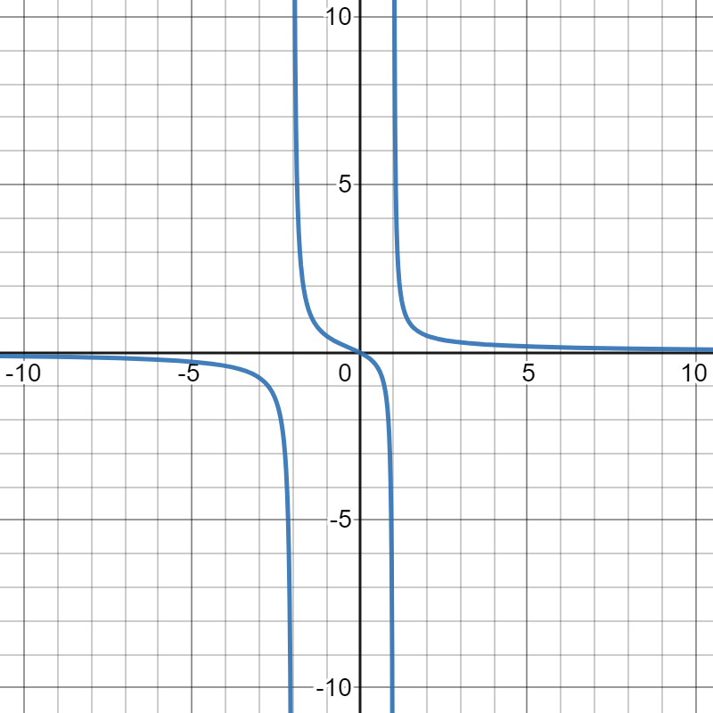
- The speed (s) in centimeters per second, of air escaping from a balloon can be modelled by s (r) = 1 + 0.9r² – r³, where r is the radius in cm, or the opening of the balloon. Determine the maximum speed of the airflow.
First we get the first derivative, which is $\frac{ds}{dr}=$1.8r – 3r²
$\frac{ds}{dr}=$ 0
1.8r – 3r² = 0
r (1.8 – 3r) = 0
r = 0 and r = $\frac{1.8}{3}$ = 0.6
The maximum speed will be at r = 0.6
s (0.6) = 1 + 0.9(0.6)² – (0.6)³
s = 1.108
Therefore, the maximum speed of airflow is 1.108 cm/s
- For the curve y = x³ -6x² + 9x, determine
- The x and y intercept
at x intercept, y = 0
x³ -6x² + 9x = 0
When done using the quadratic formula, x = 0, or 3
Therefore, the x intercept is (0, 0) and (3, 0)
At y intercept, x = 0
y = (0)³ – 6 (0)² + 9 (0)
y = 0
Therefore, the y intercept is (0, 0)
- Any maximum or minimum points
x³ -6x² + 9x
The first derivative is 3x² – 12x + 9
3x² – 12x + 9 = 0
Using the quadratic formula, x = 1, and 3
When x = 1, y = 1³ –6(1)² + 9(1) = 4
When x = 3, y = 3³ –6(3)² + 9(3) = 0
Therefore, the minimum point is 3, 0) and the maximum point is (1, 4)
The interval of increase is (-∞, 1) U (3, ∞)
The interval of decrease is (1, 3)
- Any points of inflection
The inflection point will be at the second derivative: 6x – 12
6x – 12 = 0
6x = 12
x = 2
- Sketch the curve
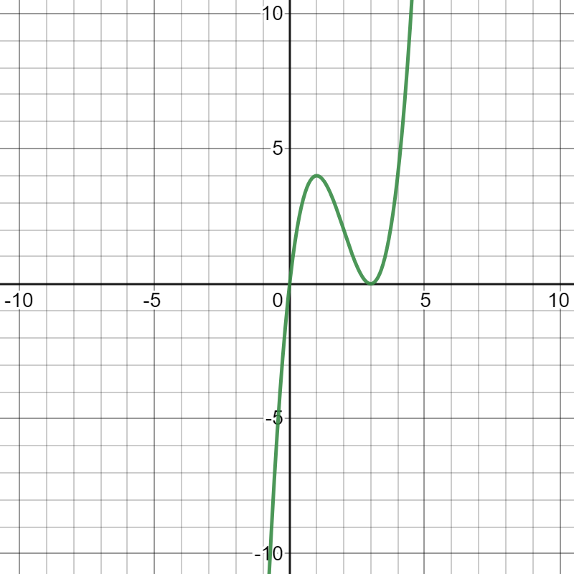

- Use the following information to sketch the graph of f (x)
- vertical asymptote is x = -2
$$\lim_{x → -2-}{f \left(x\right)= ∞}$$
$$\lim_{x → -2+}{f \left(x\right)= ∞}$$
Horizontal asymptote is y = 0
$$\lim_{x → ∞}{f \left(x\right)= 0^{+}}$$
$$\lim_{x → ∞}{f \left(x\right)= 0^{-}}$$
- Critical point: (2, -5)
Undefined at x = -2
Increase: x < -2, x >2
Decrease: -2 < x, x < 2
- inflection points (4, -2)
Undefined at x = -2
Concave up: x < -2, -2 < x < 4
Concave down: x > 4
- x-intercept: -1
y-intercept: -3
