Capacitors in Series and in Parallel

Students’ Name

Institution Affiliation

Date

- Part 1 Single capacitor

Gradient = 21.84495238
- The theoretical value of this capacitor, as read from its’ packaging, is 22 microCoulombs. Calculate the percent error.
Error
22- 21.845= 0.155
Percentage error
$$\frac{0.155}{22}×100=0.705\%$$

- For capacitor 1, create a graph with charge (in Coulombs) on the y-axis and voltage on the x-axis. Then use the slope of the graph to determine the value of the capacitor

The gradient of the graph is 24.51809524. and the slope of this graph represents the capacitance of the capacitor, therefore. The value of capacitor is approximately 25 microFarads
- For capacitor 2, create a graph with charge (in Coulombs) on the y-axis and voltage on the x-axis. Then use the slope of the graph to determine the value of the capacitor. Include a screenshot of your graph.

The gradient of the graph is 50.59047619. and the slope of this graph represents the capacitance of the capacitor, therefore. The value of capacitor is approximately 51 microFarads.

- create a data table for the equivalent circuit, with the total voltage and the total charge that correspond to those voltages
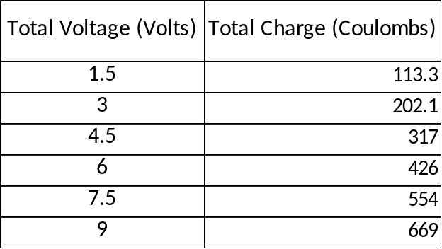
- Create a graph with charge (in Coulombs) on the y-axis and voltage on the x-axis. Then use the slope of the graph to determine the value of the capacitor. Include a screenshot of your graph.

The gradient of the graph is 75.10857143. and the slope of this graph represents the capacitance of the capacitor, therefore. The value of capacitor is approximately 75 microFarads.
- For a parallel circuit, how do we calculate the equivalent capacitance?
Equivalent capacitance in parallel arrangement is calculated by summing up the capacitance of each capacitor in the system.
Mathematically, equivalent capacitance is given as $c_{1}+c_{2}+c_{13}+…+c_{n}=c_{T}$ For n number of capacitors
- Using the values of capacitance that you found from the graphs of capacitor 1 and capacitor 2 above, what would the equivalent capacitance be?

$$c_{1}+c_{2}=c_{T}$$
$$24.51809524+50.59047619=75.10857143$$
Therefore, the equivalent capacitance is 75 microcoulombs

- When you have capacitors in parallel, is the parallel capacitance always greater, similar to, or less than the values on the individual capacitors?
The equivalent capacitance of capacitors in parallel is always greater then individual capacitance.
- Part 3: Series Capacitor CircuitFor capacitor 1, create a graph with charge (in Coulombs) on the y-axis and voltage on the x-axis. Then use the slope of the graph to determine the value of the capacitor

The gradient of the graph is 89.6403526. and the slope of this graph represents the capacitance of the capacitor, therefore. The value of capacitor is approximately 90 microFarads
- For capacitor 2, create a graph with charge (in Coulombs) on the y-axis and voltage on the x-axis. Then use the slope of the graph to determine the value of the capacitor

The gradient of the graph is 48.36713633. and the slope of this graph represents the capacitance of the capacitor. Therefore the value is 48 microFarads.
- Create a graph with charge (in Coulombs) on the y-axis and voltage on the x-axis. Then use the slope of the graph to determine the value of the capacitor.

The gradient of the graph is 31.46535067 and the slope of the graph represents the capacitance of the capacitors. Therefore, the capacitance is approximately 32 microFarads
- For a series circuit, how do we calculate the equivalent capacitance?
Equivalent capacitance of capacitors in series is obtained by adding the reciprocals of individual capacitance as indicates below.$\frac{1}{C_{1}}+\frac{1}{C_{2}}+\frac{1}{C_{3}}+…+\frac{1}{C_{N}}=\frac{1}{C_{T}}$ for n number of capacitors.
- Using the values of capacitance that you found from the graphs of capacitor 1 and capacitor 2 above, what would the equivalent capacitance be?

$\frac{1}{C_{1}}+\frac{1}{C_{2}}$=$\frac{1}{C_{T}}$
$$\frac{1}{89.6403526}+\frac{1}{48.36713633}=0.031830885$$

Implying equivalent capacitor is 31.41602 microFarads

- When you have capacitors in series, is the parallel capacitance always greater, similar to, or less than the values on the individual capacitors?
The equivalent capacitance of capacitors in series is usually less than values of individual capacitors.

Part 4; Mystery Capacitor
The multimeters that we have in the lab are only able to read capacitance values that are less than or equal to 100 microFarads. We have two capacitors that we tried to measure the capacitance.
- Should we wire these capacitors in series, or in parallel, in order to be able to do measurements to figure out the capacitance of each? Explain why.
The two large capacitors are supposed to be wired in series for effective capacitance will be less than either of them
Total voltage supplied by battery | 6.00 volts
Equivalent capacitance measured by meter | 73.3 microFarads
.For this, we will do just one measurement, and do a calculation based on the values rather than using slopes. Using the multimeter, we measured the voltages on both of the capacitors, and the equivalent capacitance for the two mystery capacitors, now wired in series.

- Based on these values, calculate the total charge on each capacitor. Show your work.
$$Q=CV where c=73.3 μF and v=6v$$
$$Q=73.3×6=439.8μC$$
The total charge is 439.8 microCoulomb

- What is the charge on each capacitor?
The charge on each capacitor is 439.8 microCoulomb since they are connected in series.

- Now, you measure the voltage on each of the two capacitors:
Voltage on capacitor 1 | 4.00 Volts
Voltage on capacitor 2 | 2.00 Volts

- Calculate the capacitance for capacitor 1.
$$c_{1}=\frac{Q_{1}}{V_{1}} where V_{1}=4v and Q_{1}= 439.8μC$$
$$c_{1}=\frac{439.8μC}{4v}=109.95μF$$

- Calculate the capacitance for capacitor 2
$$c_{2}=\frac{Q_{2}}{V_{2}} where V_{2}=2v and Q_{2}= 439.8μC$$
$$c_{2}=\frac{439.8μC}{2v}=219.9μF$$

References
Takahara, E., Sato, H., & Yamada, J. (2002, April). Series and parallel connections change over system for electric double layer capacitors (EDLCs) to electric vehicle energy saving. In Proceedings of the Power Conversion Conference-Osaka 2002 (Cat. No. 02TH8579) (Vol. 2, pp. 577-581). IEEE.
Zhang, L., Song, J. Y., Zou, J. Y., & Wang, N. (2008, June). High voltage super-capacitors for energy storage devices applications. In 2008 14th Symposium on Electromagnetic Launch Technology (pp. 1-4). IEEE.

