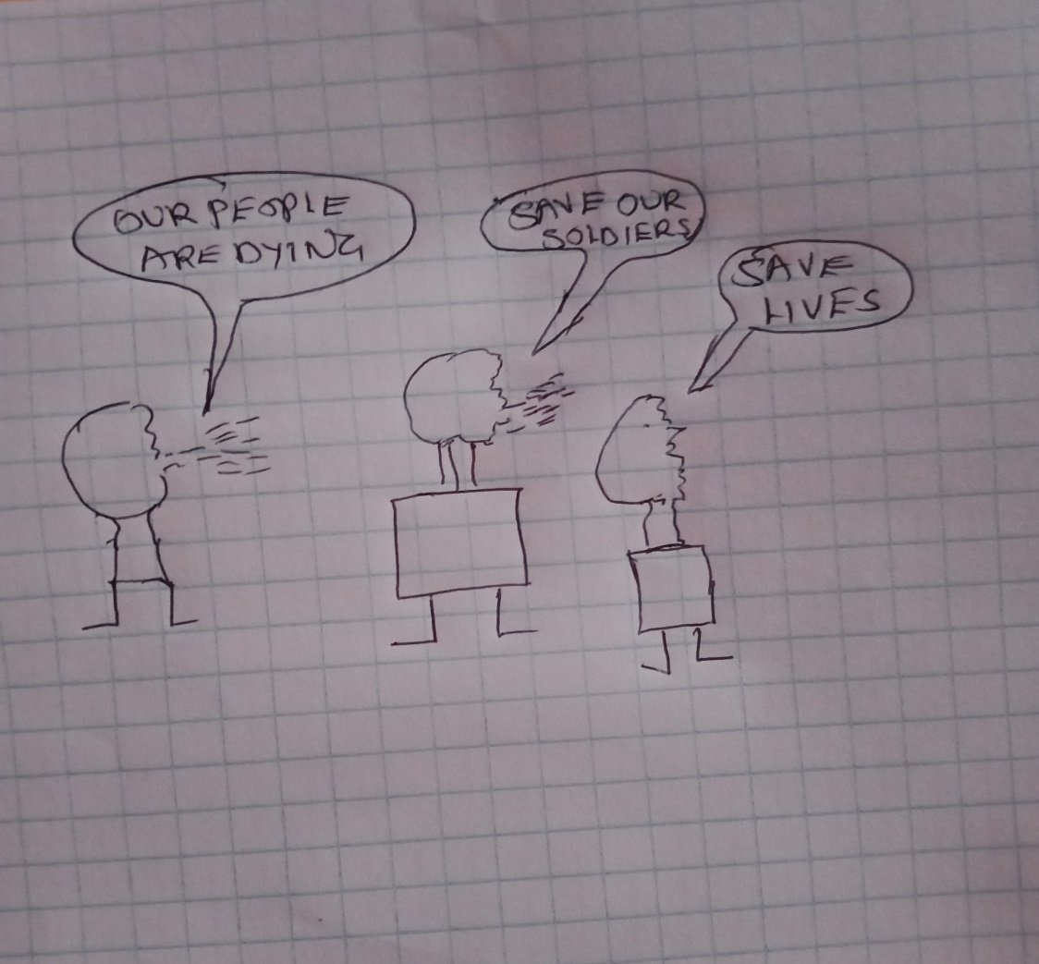

The political cartoon shows people protesting against the Vietnam War because of the many deaths it was causing. Many Americans were pressuring the government to withdraw the troops from Vietnam because many were dying there. Many people feared the consequences of the war. Bombing of the South Vietnamese countryside led to mass destruction of Vietnamese homes, wounding and killing loved ones. Many Vietnamese left their rural village and became refugees in the outskirts of towns and cities, hoping that they won’t encounter any more bombings. Many American troops lost their lives in the way. Many Americans feared the negative consequences of the war such as massive deaths and destruction of property. This was one of the arguments against the Vietnam War. Soldiers deserted and a strong resistance was mounted for the US government to withdraw its troops. It was becoming increasingly apparent that the US was losing the war. Many Americans saw the war as a waste of resources and lives and was not significant.

