MKT 445
lecture 1
lecture 2
case
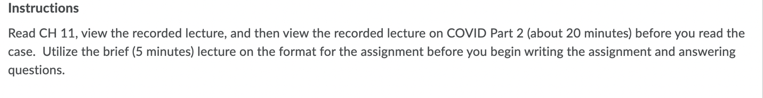
Ch 11 reading is uploaded (don’t feel obligated to read it if you don’t need to)
All lectures are attached above
The Case is uploaded as well

