Lab 3: The Celestial Sphere

Part 1: Earth’s Rotation (8 points)
Take the first page from the printout – the one that looks like this:
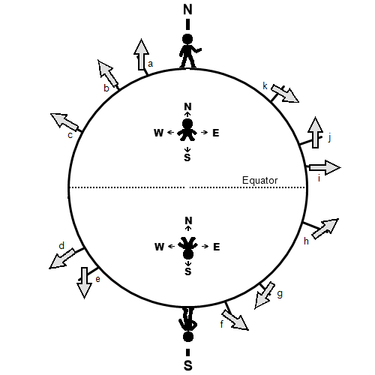
…and cut it out. You don’t have to be very precise – just get rid of the large chunks of empty page around it.
When you’re finished, get a long skinny object (like a pencil, or a cooking skewer, or a ruler) and tape it to the back of this two-dimensional globe. Make sure the long skinny object is aligned with the line between the North Pole and the South Pole, like this:
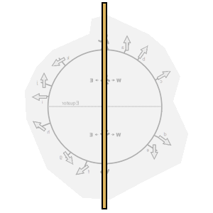
This long object represents Earth’s rotation axis: the imaginary line around which Earth spins like a top. Go ahead and hold the ends of the axis in your hands and twirl our 2-D globe around.
Over the course of a day, and over the course of a year, and over the course of many years, Earth’s rotation axis is always oriented the same way, with its two ends always pointing toward the same two directions in space.
Let’s see what that last thing means for our paper globe. Picture a very distant target, and hold your paper globe so that the rotation axis is pointing toward that target. If we were outside, a suitable target for this could be a particular mountain peak, or a distant building. Since you’re probably indoors, try picking something on the opposite side of the room, like a particular doorknob or a window (or better yet, something you see out the window). While keeping the rotation axis aligned in that direction, spin the Earth around some more. If your target object in the distance is far enough away, you can even walk around the room while holding your paper globe aligned the same way, and it’ll still be pointing toward that target.
Okay, let’s look at what’s actually on the cut-out. We have a bunch of arrow-shaped signs, labeled “a” through “k”. Let’s imagine people all over the world placed these signs, all at the exact same time, so that they were pointing to interesting stars in the sky. The person who placed arrow “k” saw an interesting star to their south, while the person who placed arrow “j” saw an interesting star to the north. The person who placed arrow “d” was in the southern hemisphere, and saw an interesting star almost straight up at zenith.
As you turn the Earth around the rotation axis, these arrows will suddenly start pointing in different directions in space. Maybe arrow “f” originally pointed toward a lamp in the room, and after you’ve turned the Earth a bit it’s now pointing toward the floor. If the keeper for that arrow-sign were to make a replacement pointing in the star’s new apparent location, it would point in a new direction. From this person’s perspective, the star has moved to a different location in the sky.
On closer examination, though, not every possible star direction has changed. If we imagine someone standing at the North Pole, and they’ve installed an arrow pointing straight up (from their perspective) – aligned in the same direction as the rotation axis – then that arrow will continue to point in that same direction as Earth rotates. If your rotation axis is pointing toward the middle of the ceiling fan, then that “North Pole arrow” would also be pointing toward the middle of the ceiling fan, and would continue to point toward that location as Earth rotates.
Let’s examine the arrow-signs sprinkled all over the world. Most of them will point in new directions as Earth rotates, but some of them will continue to point in the same direction as before.
Which arrow signs will continue to point toward the same targets as Earth spins? [2 points]
Arrows
B,c,d,i

While we’re at it, let’s make sure we’re spinning Earth in the right direction. If the South Pole is closer to you, you should see the Earth spin clockwise (as shown below). If you’re looking down upon the North Pole instead, you should see the Earth spin counter-clockwise.
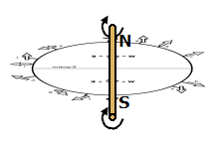
Let’s look at the two people near the middle of the cut-out: one somewhere in Earth’s northern hemisphere, and one somewhere in Earth’s southern hemisphere. If you imagine them standing on the globe, each one would be able to see any stars that are above them, but none of the stars that are beneath them (because there’s an Earth in the way).
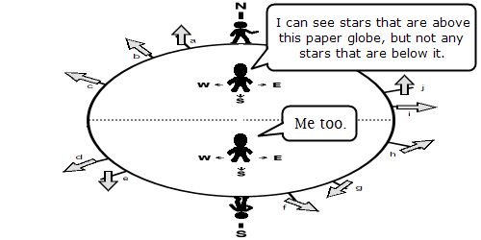
But as the Earth spins, their locations on Earth will be facing different directions in space, so the stars they’re able to see will change. A star will rise when its direction from Earth moves above the person’s ground, and it’ll set when its direction becomes below the ground again.
[4 points total]
For our person somewhere in the middle of the northern hemisphere, will they see stars rise in the west, or in the east?
In the east
For that same person, will they see stars set in the west, or in the east?
In the west
In which compass directions will the stars rise and set for our person somewhere in the southern hemisphere?
In the southern hemisphere the stars rise in the East, set in the West and revolve anti-clockwise around the South celestial pole.
Now let’s look at our person camped at the North Pole. Because she’s on the edge of our paper Earth, her horizon line is as shown below. If we cut “all possible directions in space” into two equal parts, she would be able to see any stars that are in the slightest bit toward the direction the North Pole is pointing at, and unable to see any stars that are even the slightest bit favoring the South Pole’s direction.
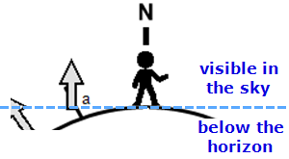
When we spun the Earth around for the last couple people, they saw stars rise and set over the course of a day. As we spin the Earth around some more, think about which stars our North Pole person can see, and which stars she can’t see. How do those lists change over the course of a day? [2 points]

Part 2: The Celestial Sphere (14 points)
When we describe locations in the sky using the celestial sphere, we’re treating the sky like the inside surface of a sphere surrounding us – except instead of physical locations upon that surface, we’re describing locations in terms of directions you can point. We describe how far apart different locations in the sky using angular distances, rather than using miles or kilometers.
Similar to how locations on Earth can be described with latitude and longitude, locations in the sky are described using right ascension and declination.
Declination (often abbreviated Dec.) is the sky’s equivalent of latitude. At the north celestial pole – the direction in space Earth’s own North Pole is pointing toward – the declination is +90°. As you move away from the north celestial pole the declination decreases: directions in space that are “straight up” from any point on Earth’s equator are at a declination of 0° (the celestial equator). Keep moving and the declinations become negative, all the way until you reach the south celestial pole: -90°, the direction in space Earth’s South Pole is pointing toward.
Right ascension (often abbreviated R. A.) is the sky’s equivalent of longitude. It is usually described in terms of hours, ranging from 0^{h} to 24^{h}.
Lines of constant declination are equally spaced. If you’re looking at a pair of stars with the same right ascension, the angular distance between them is equal to their difference in declination. For example, if two stars have the same R.A. but one’s declination is +20° and the other’s declination is +25°, the stars are 5° apart in the sky.
Just like lines of longitude on Earth, lines of constant right ascension are farthest apart at the celestial equator, and all meet up at the two celestial poles.
Let’s get a bit of practice.
Consider these stars:
- Star M is at R.A. = 15^{h}, Dec. = +40°.
- Star N is at R.A. = 15^{h}, Dec. = +51°.
- Star O is at R.A. = 15^{h}, Dec. = +35°.
Which is closer to Star M: Star N, or Star O? Explain your answer. [2 points]
Star o
Unlike longitude, right ascension is measured in just one direction — east. Because there are 24 hours in a day, each hour of right ascension measured along the equator equals 1/24th of a circle (360° divided by 24) or 15°. That's a little more than one-half the width of the W-shaped constellation Cassiopeia.
Star P has an R.A. of 17^{h} and a Dec. of +45°. Which pair of stars is closer together: Star M and Star O, or Star M and Star P? Explain your answer. [2 points]
Star M and O
We typically do not measure RA in degrees, but rather in hours. The reason we do this is to assist us in timing our observations. The sky "spins" through a complete circle of 360 degrees every 24 hours, or 15 degrees every hour. So a star 30 degrees east of the Vernal Equinox is at 2 hr RA. 0 hr RA and 24 hr RA are the same, so a star 30 degrees west of the Vernal Equinox is at 22 hr RA.

If you imagine the lines of R.A. and Dec. making a grid in the sky, then as Earth rotates the lines of declination stay put while the R.A. lines drift through the sky, making a complete loop around every 24 hours.
Let’s now imagine how various stars will be moving over the course of a night, using this diagram:
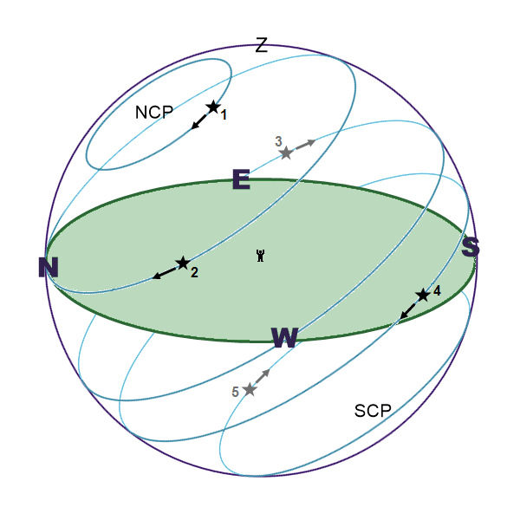
Earth is rotating from west to east, but with the celestial sphere it’s easier to imagine the Earth staying put, and the sky rotating around you in the opposite direction: from east to west. The above image shows the circular paths that five different stars take over the course of a day. These stars are numbered 1 through 5.
The locations of the north and south celestial poles are shown in this diagram as “NCP” and “SCP.”
Below are nine different descriptions. Which of the five stars in the diagram is being described by each? [1 point each, 9 points total]
This star is always well above the horizon for someone at this location on Earth. (Another term for this is circumpolar.)
STAR 1
This star will never get above the horizon for someone at this location on Earth.
STAR 5
This star spends exactly half of the time above the horizon (rising perfectly in the east), and exactly half of the time below the horizon (after it sets perfectly in the west).
STAR 3
This star spends all – or almost all – of its time above the horizon. At its lowest point it gets very close to the horizon, and it may or may not actually dip out of view. Even if it remains just barely above the horizon, though, it’ll be so low in the sky that all of the air in front of it (as well as any trees or mountains) will make it difficult to see.
This star sometimes appears above the horizon, but spends most of its time out of sight below the horizon.
STAR 4
This star rose in the east a short time ago.
STAR 3
This star is about to start setting in the southwest.
STAR 4
Out of these five stars, this one has the highest declination.
STAR 2
Out of these five stars, this one has the lowest declination.
STAR 4

Will any of these five stars reach zenith? If so, which one(s)? [1 point]
Yes STAR 2 will reach the zenith. The zenith is at altitude +90◦, straight above the observer's head.

Part 3 What Can You See? (11 points)

Let’s see if we can figure out which stars can be seen from which parts of the world.
It’s time for more arts and crafts. Get out your printed materials again and cut out the four small “person on Earth” diagrams from the second and third pages of the PDF. As before, you don’t need to be super-precise – just remove most of the excess paper from around them.
Find the last page of the “stuff to print” PDF – the one with all the outward arrows – and have it ready. You don’t need to do any cutting for this one, because it’ll be a background. (You can also choose to have this page just displayed on your computer screen.)
We’ll be taking a small “person on Earth” diagram and placing it in the middle of that page, like so:
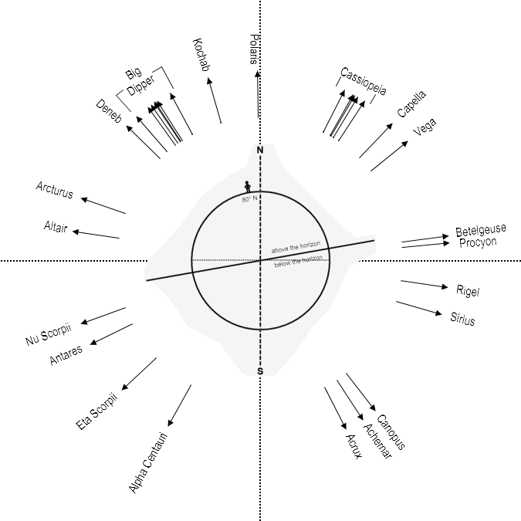
Make sure the equator (dotted line) and the North and South Poles line up properly with the dotted lines on the page.
The heavy solid line divides the sky into two equal halves: one half that the person currently experiences above the horizon, and one half that is currently below the horizon. (Since the distances to the stars are much much larger than the size of Earth, you can imagine shrinking this globe down to point-size.)

Let’s start with someone at the North Pole. Find this “person on Earth” diagram:
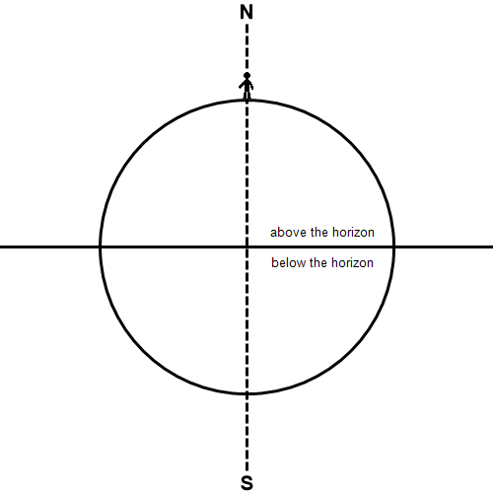
…and place it onto the page, making sure the poles and equator line up with the dotted lines. (In this case, the horizon line is in the same place as the Equator.)
If you’re at the North Pole, everything above a declination of 0° is above the horizon for you, and everything with a declination below 0° is below the horizon for you.
Compare this person’s “horizon line” with the directions to the various stars labeled in the background page.
Name two stars that are above the horizon for this person at the North Pole. [1 point]
Polaris
kochab
Name two stars that are below the horizon for this person at the North Pole. [1 point]
Rugel
sirius

Out of the stars labeled on the page, which one is closest to zenith for this person? [1 point]
polaris

We can crudely simulate Earth’s rotation by taking the “person on Earth” diagram and flipping it around the rotation axis – the line from the North Pole to the South Pole. We see that when we do this, it doesn’t change whether any given star is above or below the horizon, though they may appear in different places in the sky.
Let’s try somewhere a little more interesting: the diagram for the person located at 80° N (shown on the previous page). This person is a little further “down” from the North Pole, so his horizon in that direction is able to catch a few additional directions in space… while his horizon in the opposite direction loses some directions.
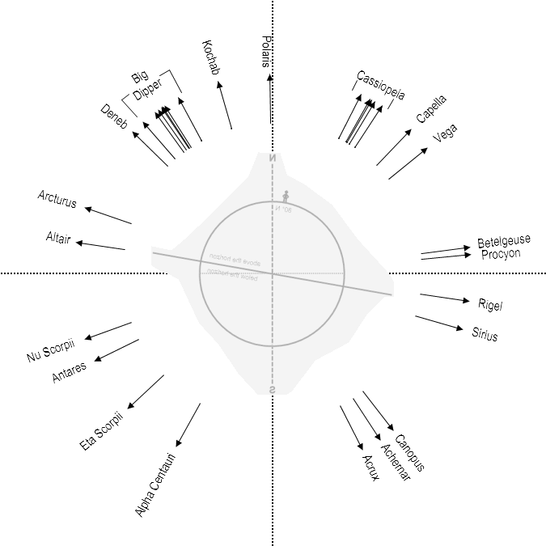
Flip back and forth between opposite times in Earth’s rotation, as shown above. (You might have to look carefully to see the lines from the back side of the page.) We see that a small swath of the available directions comes and goes depending on the time of day. For this person, some directions in the sky are above the horizon at some times of day, and below the horizon at other times of day.
Name two stars that are “sometimes up” (instead of “always up” or “never up”) for a person at 80° N. [1 point]
Altair
Arcturus
Name two stars that are always above the horizon for this person. [1 point]
Polaris
capella
Name two stars that are never above the horizon for this person. [1 point]
Nu scorpii
Antares

Let’s ditch the Arctic and head somewhere balmier. Let’s try this exercise using the diagram for a person at the Equator:
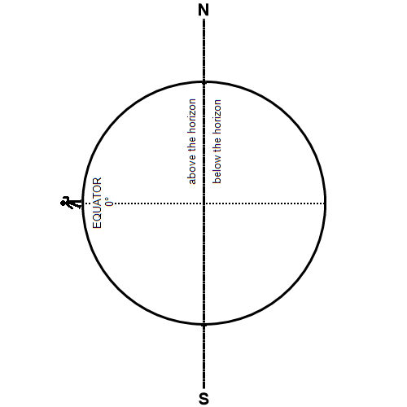
Place this “person on Earth” diagram on the “directions to various stars” page and look at what’s above and below the horizon, both in the original setup and with the Earth flipped around its rotation axis to another time of day.
Describe the situation for someone at the equator. What sorts of stars are always above this person’s horizon, what sorts of stars are always below her horizon, and what sorts of stars are sometimes above the horizon? [2 points] If you were at Earth’s equator, you see the celestial equator (which, after all, is just an “extension” of Earth’s equator) pass overhead through your zenith. The celestial poles, being 90° from the celestial equator, must then be at the north and south points on your horizon. As the sky turns, all stars rise and set; they move straight up from the east side of the horizon and set straight down on the west side. During a 24-hour period, all stars are above the horizon exactly half the time. (Of course, during some of those hours, the Sun is too bright for us to see them.)

For this person on the equator, where in her sky are the north celestial pole and south celestial pole? What happens to those locations as Earth spins through one day? [2 points]
If we are standing at the equator, we are at 0°. If we are standing at the North Pole, we are at 90° North; likewise for the South Pole, the latitude is 90° South. For us in Boulder, the latitude is 40°. The star Polaris is located very close to the North Celestial Pole.

This equatorial person is curious about a star she sees at zenith. If this star is at zenith for her, what must be true about its position in the celestial sphere (in terms of R.A. and Dec.)? [1 point]
Equator is directly overhead, and the poles are on opposite sides of the horizon. All stars are visible as they rise, culminate at the meridian, and set. As you move north, the Celestial Equator mirrors your movement, moving south the same number of degrees away from the zenith (the straight-overhead point) as you moved north of the equator. So, by the time you reach (30 degrees North of the Equator), the Celestial Equator has moved away from the zenith, 30 degrees to the south. Therefore, as seen from Austin, stars with declinations in the range +60 degrees to +90 degrees are circumpolar. Similarly, stars with declinations ranging from -90 degrees (SCP) to -60 degrees never rise above the horizon. The southernmost stars that can be seen from have declinations of about -60 degrees (although hills, buildings and haze make -40 degrees a more practical limit).

Part 4: The Sky in Las Vegas (24 points)
Now that we’ve gotten used to figuring out which stars are visible at a few different test locations on the globe, we’ll try it for Las Vegas.
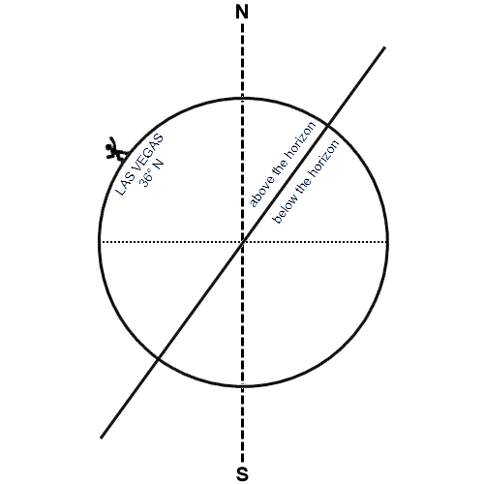
For each of the stars below, use the visual aids to figure out whether it’s always up, sometimes up, or never up for Las Vegas. [10 points]
Star | Declination | How often is it visible from Las Vegas?
Polaris | +89.3° | Always up
Capella | +46.0° | Never up
Deneb | +45.3° | Sometimes up
Vega | +38.8° | Never up
Altair | +8.9° | Sometimes up
Procyon | +5.2° | Never up
Sirius | -16.7° | Never up
Antares | -26.4° | Sometimes up
Alpha Centauri | -60.8° | Never up
Acrux | -63.1° | Never up

The star Canopus (“ka-NOH-pus”) is the second brightest star visible in Earth’s night sky (after Sirius). It’s not in the table above because it’s close to the border for whether it will cross the horizon for us – the paper diagrams are a little too clunky for this situation, and they might give you an incorrect result if you’re not super-precise about it.
Does Canopus just barely peek above an altitude of 0° above the horizon (perhaps hidden by mountains or too much air to be visible)? Or will it not get high enough even for that? Let’s try to find the exact cutoff.
For this, we should return to another place else in the world where it’s easier to figure out what’s going on. Let’s check back in on the fellow stationed at a latitude of 80° N. I’ve drawn some more on this diagram, and added some colors to make it clearer which lines we’re talking about.
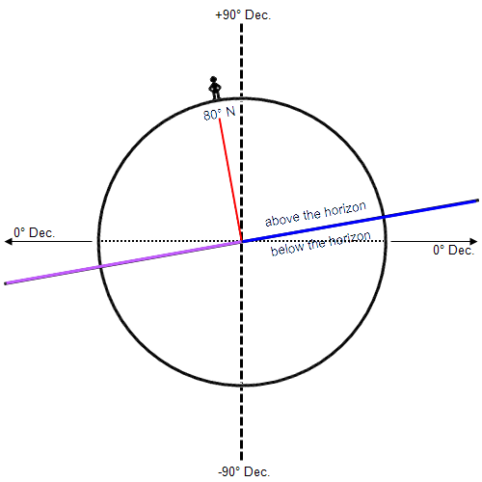
This person is located at a latitude of 80° N, which isn’t too far from the North Pole (90° N). With a bit of subtraction, you can figure out that (from the perspective of Earth’s center) he is located 10° away from the North Pole’s direction. That’s the angle between the red line and the heavy dashed line.
If the angle between the red line and the blue line is 90°, what is the angle between the heavy dashed line (pointing toward the north celestial pole) and the blue line? [1 point]
The heavy dashed line – which is the same as Earth’s rotation axis – points to a declination of +90°. The dotted line, which is at Earth’s equator, is pointing to a declination of +0°. If the angle between the dotted line and the heavy dashed line 90°, what is the angle between the dotted line and the blue line? [1 point]
80degrees
The blue line is pointing to which declination? [1 point]
90 degrees
Okay, that’s one piece of the puzzle: everything above that declination is “always up” for this person at 80° N.
Now let’s examine the purple line. What declination is it pointing toward? Explain how you reached that answer. [2 points]
-90degrees south
Now that we know which declinations the blue and purple lines are pointing to, we can divvy up the sky based on how visible it is for someone at 80° N.
If you’re at 80° N, stars at what range of declinations will be “always up”? [1 point]
stars with declinations in the range +60 degrees to +80 degrees are circumpolar always up
If you’re at 80° N, stars at what range of declinations will be “never up”? [1 point]
stars with declinations ranging from -80 degrees (SCP) to -60 degrees never rise above
If you’re at 80° N, stars at what range of declinations will be “sometimes up”? [1 point]
The southernmost stars that can be seen have declinations of about -60 degrees (although hills, buildings and haze make -40 degrees a more practical limit)

Think about how those numbers relate to the person’s latitude of 80°. It may help to remember that the North and South Poles (on Earth or on the celestial sphere) are at +/- 90°. Once you’ve got it figured out, we’ll try the same questions for Las Vegas (latitude 36° N).
(If you think you’ve got it but aren’t sure, you can play around with the visual aids, comparing your predictions with the declinations listed above to see if the results make sense.)
If you’re at 36° N, stars at what range of declinations will be “always up”? [1 point]
+06 degrees to +36 degrees

If you’re at 36° N, stars at what range of declinations will be “never up”? [1 point]
-06 degrees to -35 degrees

If you’re at 36° N, stars at what range of declinations will be “sometimes up”? [1 point]
The southernmost stars that can be seen have declinations of about -120 degrees

Canopus is at a declination of -52.7°. Does it ever get above the horizon for Las Vegas? [1 point]
No it does not
To see Canopus, you must either be in the Southern Hemisphere or in the southern latitudes of the Northern Hemisphere looking south during winter.

The seven main stars of the Big Dipper have declinations ranging from +49.3° to +61.8°. Are all of these stars “always above the horizon” for Las Vegas? [1 point]
Yes they are always visible
They are visible throughout the year from most of the northern hemisphere, and appears circumpolar above the mid-northern latitudes.
Cassiopeia is a prominent constellation near the north celestial pole whose five main stars make a W shape – or depending on their orientation, possibly an M, a 3, or a zig-zaggy E. These five stars have declinations ranging from +56.5° to +63.7°. Are they “always above the horizon” for Las Vegas? [1 point]
The constellation Cassiopeia, Queen of Ethiopia, can be seen in the northern hemisphere all year long. It is visible at latitudes between 90 degrees and -20 degrees. Since it is located close to the north celestial pole, it is completely below the horizon for anyone located south of -20 degrees.

Part 5: A Simulated Sky (6 points)
Finally, let’s take another look at how the stars are moving across the sky over the course of a night, due to Earth’s rotation.
There are four PDFs of simulated night-sky views created using the software package Stellarium. These views show the positions of the stars and planets in the sky as seen from Las Vegas, at various times on the night of September 14-15, 2021.
Each PDF imagines you’re relaxing on a hillside all night long, watching the stars slowly drift through the night sky. One PDF has you facing north the whole time, another has you facing east, and the last two south and west. Each PDF has four pages, showing you where the stars were at 8:00 PM, 10:00 PM, midnight, and 2:00 AM on that night.
For each direction, how do the stars move over the course of a night? (These are worth 2 points each, and I have done the first one as an example.)

How do the stars in the eastern sky move over the course of the night? The stars in the eastern sky are moving upward and rightward.
How do the stars in the southern sky move over the course of the night?
stars rise in the southeast and follow shorter, lower arcs across the south before setting in the southwest.
How do the stars in the western sky move over the course of the night?
The stars in the western sky are moving downward and lefttward.

How do the stars in the northern sky move over the course of the night?
Stars rise in the northeast and set in the northwest, moving in counter-clockwise circles around a point that's high above the northern horizon:
(Be careful with that last one!)

