14
ARCHITECTURE
THINK AHEAD
14.1 Considerthefunctionofarchitecturetorecordandreflectaculture’svalues.
14.2 Explaintheneedforarchitectstocombinefunction,form,andstructure.
14.3 Identifytraditionalmaterialsandmethodsusedinarchitecture.
14.4 Describetherelationshipoftechnologicalinnovationstochangesinarchitecturalformsandstructure. 14.5 Recognizetheimpactofcontemporaryenvironmentalconcernsonarchitecture.
Among the world’s oldest surviving structures is the dol- men in northwestern France pictured here (fig. 14.1). This dolmen was constructed from huge boulders, some set upright and another used as a roof to create a space. Its most likely function was to house the dead in an enclosed tomb. This bulky structure resembles
others in many parts of the world, including the British Isles, Jordan, India, and Korea. Though other dolmens have various functions, they all share a primitive con- struction technique and a massive appearance.
For at least five thousand years, people have built impressive structures, like this dolmen, that go beyond providing mere shelter. Architecture is thus the art and science of designing and constructing buildings not only for practical purposes but also for symbolic and aesthetic ones. It has great potential for enhancing many aspects of our daily lives; from the houses we live in to the places where we work, wor- ship, or spend our leisure time.
In this chapter we will examine the art and craft of architecture, from primitive structures to today’s high-tech creations. We will see that beyond the necessity for shelter, architecture can make important expressive statements that record and communicate a society’s values.
An Art and A Science
No matter what sort of structure they are building, architects address and integrate three key issues: func- tion (how a building is used); form (how it looks); and structure (how it stands up). As an art, architec- ture both creates interior spaces and wraps them in an expressive shape.
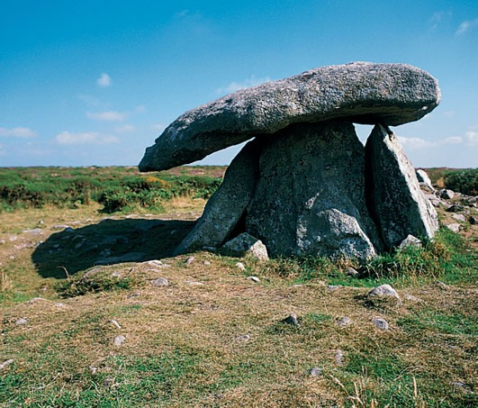
14.1 Dolmen. Crocuno, north of Carnac, France. James Lynch/The Ancient Art & Architecture Collection Ltd.
Listen to the chapter audio on myartslab.com
ARCHITECTURE CHAPTER 14 221
As a science, architecture is a physics problem: How does a structure hold up its own weight and the loads placed on it? Architecture must be designed to with- stand the forces of compression, or pushing () (); tension, or stretching (( )); and bending, or curving ([ ]); and any combination of these physical forces.
Like the human body, architecture has three essential components. These are a supporting skel- eton; an outer skin; and operating equipment, similar to the body’s vital organs and systems. The equipment includes: plumbing; electrical wiring; appliances; and systems for cooling, heating, and circulating air as needed. In earlier centuries, structures of wood, earth, brick, or stone had no such equipment, and the skel- eton and skin were often one.
Traditional Materials and Methods
The evolution of architectural techniques and styles has been determined by the materials available and by the changing needs and values of societies. In ancient times, when nomadic hunter-gatherers became farm- ers and village dwellers, housing evolved from caves, huts, and tents to more substantial structures.
Because early building designers (as well as those in nonindustrialized countries today) made struc- tures only out of the materials at hand, regional styles developed that blended with their sites and climates. Modern transportation and the spread of advanced technologies now make it possible
to build almost anything anywhere.
Wood, Stone, and Brick
Since the beginning of history, most structures have been made of wood, stone, earth, or brick. Each of these natural materials has its own strengths and weak- nesses. For example, wood, which is light, can be used for roof beams. Stone, which is heavy, can be used for load-bearing walls but is less effective as a beam. Much of the world’s major architecture has been constructed of stone because of its permanence, availability, and beauty. In the past, entire cities were slowly built by cutting and placing stone upon stone.
Dry Masonry
Probably the simplest building technique is to pile stones atop one another, as we saw with the dol- men above. The process has been used to make such rudimentary structures as markers, piles, and cairns throughout the world. When such massing is done with a consistent pattern, the result is called masonry. In dry masonry, where no mortar is used, the weight of the stones themselves holds the structure up. If the stones are cut or shaped before use, they are dressed.
Great Zimbabwe (“Great Stone House”) in East Africa (fig. 14.2) is an elliptical structure that gave its name to the country in which it is located. Probably built between 1350 and 1450 ce, it was used for about three hundred years. Great Zimbabwe is nearly round, with several conical structures inside whose original function
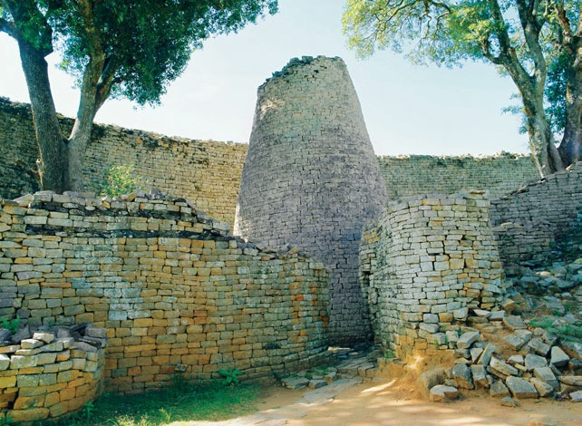
14.2 Great Zimbabwe. Zimbabwe. Before 1450. Height of wall 30 ́.
a. Plan. b. Interior.
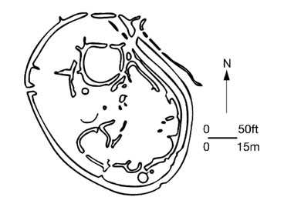
222 CHAPTER 14 ARCHITECTURE
Peter Groenendijk/Robert Harding.
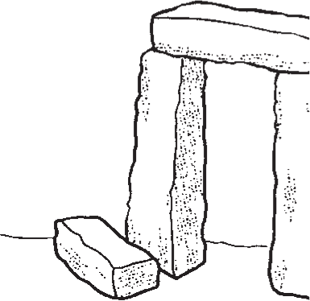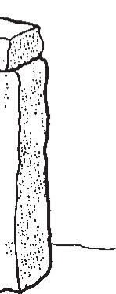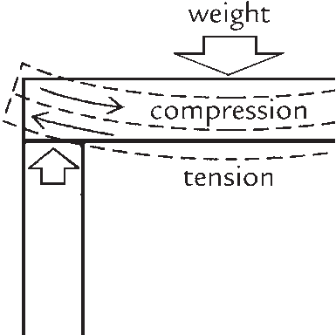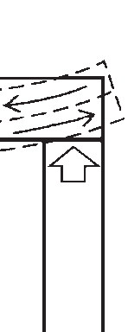
is still unknown. Its walls, made of dressed local stone, are approximately 30 feet high. For added stability, the walls were built up to 15 feet thick at the base, taper- ing slightly toward the top. Roofing was probably grass or thatch held together with sticks. The structure is the largest of a group of ancient stone dwellings that formed a trading city of perhaps twenty thousand people at its height. Though the outer walls of Great Zimbabwe have openings in selected locations for entry and exit, there are no windows; because these tend to weaken masonry walls, only structures that are considerably smaller can use them without external support.
Great Zimbabwe is the largest ancient stone struc- ture in Africa south of the great pyramids of Egypt, which are also built of dry masonry (see Chapter 15). Other notable examples of such buildings are Machu Picchu in Peru (see Chapter 20) and the ancient pueblos of the American Southwest, such as Mesa Verde.
Post and Beam
Prior to the twentieth century, two dominant struc- tural types were in common use: post-and-beam (also called post-and-lintel); and arch systems, including the vault. Most of the world’s architecture, including mod- ern steel structures, has been built with post-and-beam construction (fig. 14.3). Vertical posts or columns sup- port horizontal beams and carry the weight of the entire structure to the ground.
The form of post-and-beam buildings is deter- mined by the strengths and weaknesses of the mater- ials used. Stone beam lengths must be short, and posts relatively thick to compensate for stone’s brit- tleness. Wood beams may be longer, and posts thin- ner, because wood is lighter and more flexible. The strength-to-weight ratio of modern steel makes it pos- sible to build with far longer beams and thus to create much larger interior spaces.
Bundled reeds provided the model for the mon- umental post-and-beam Egyptian temples. A row of columns spanned, or connected, by beams is called a colonnade, as seen in the Colonnade and Court of Amenhotep III (fig. 14.4). Most ancient Egyptian temples were symmetrical, with aisles for processions that connected adjacent pavilions. Their arrangement was also generally hierarchical, with the more remote precincts accessible only to the higher-ranking priests.
14.3 Post-and-Beam Construction.
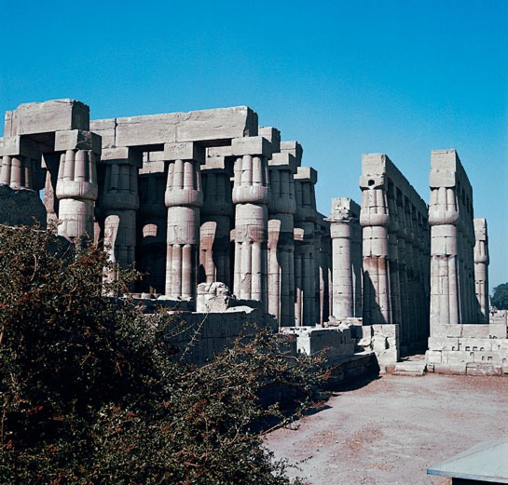
14.4 Colonnade and Court of Amenhotep III. Temple of Amun-Mut-Khonsu. 18th dynasty. Luxor, Thebes, Egypt. c.1390 bce.
Alistair Duncan © Dorling Kindersley.
Following the lead of the Egyptians, the Greeks further refined stone post-and-beam construction. For more than two thousand years, the magnificence of the Parthenon and other classical Greek architec- ture (see Chapter 16) has influenced the designers of a great many later buildings.
Round Arch, Vault, and Dome
Both Egyptian and Greek builders had to place their columns relatively close together because stone is weak under the load-bearing stresses inherent in a beam. The invention of the round arch (fig. 14.5) allowed builders to transcend this limitation and create new architectural forms. An arch may be supported by either a column or a pier, a more massive version of
ARCHITECTURE CHAPTER 14 223
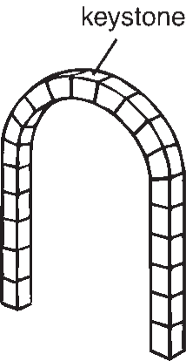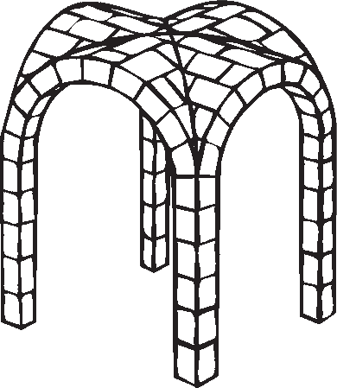
14.5 Round Arch.
Early civilizations of western Asia and the Mediterranean area built arches and vaults of brick, chiefly for underground drains and tomb chambers. But the Romans were the first to use the arch exten- sively in above-ground structures. They learned the technique of stone arch and vault construction from the Etruscans, who inhabited central Italy between 750 and 200 bce.
A round stone arch can span a longer distance and support a heavier load than a stone beam because the arch transfers the load more efficiently. The Roman arch is a semicircle made from wedge-shaped stones fitted together with joints at right angles to the curve. During construction, temporary wooden supports carry the weight of the stones. The final stone that is set in place at the top is called the keystone. When the keystone is placed, a continuous arch with load-bearing capacity is created and the wood support is removed. A series of such arches supported by columns forms an arcade (fig. 14.8).
Roman builders used the arch and arcade to create structures of many types throughout their vast empire in most of Europe, the Near East, and North Africa. The aqueduct bridge called the Pont du Gard, near Nîmes, France (fig. 14.9), is one of the finest remain- ing examples of the functional beauty of Roman engi- neering. The combined height of the three levels of arches is 161 feet. Dry masonry blocks, weighing up to 2 tons each, make up the large arches of the two
lower tiers. Water was once carried in a conduit at the top, with the first level serving as a bridge for traffic. The excel- lence of its design and construction has kept this aqueduct standing for two thousand years.
14.9 Pont du Gard. Nîmes, France. 15 ce. Limestone. Height 161 ́, length 902 ́. Photograph: Duane Preble.
Watch a video about the Pont du Gard on myartslab.com
Watch an architectural simulation of the round arch on myartslab.com
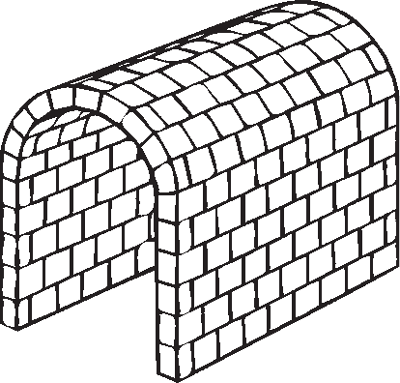
14.7 Groin Vault.
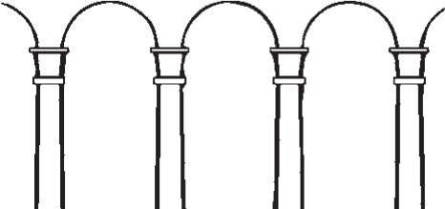
14.8 Arcade. Watch an architectural simulation of barrel
14.6 Barrel Vault.
and groin vaults on myartslab.com
a column. When extended in depth, the round arch creates a tunnel-like structure called a barrel vault (fig. 14.6). Roman builders perfected the round arch and developed the groin vault (fig. 14.7), formed by the intersection of two barrel vaults.
A vault is a curving ceiling or roof structure, tra- ditionally made of bricks or blocks of stone tightly fitted to form a unified shell. In recent times, vaults have been constructed of materials such as cast reinforced concrete.
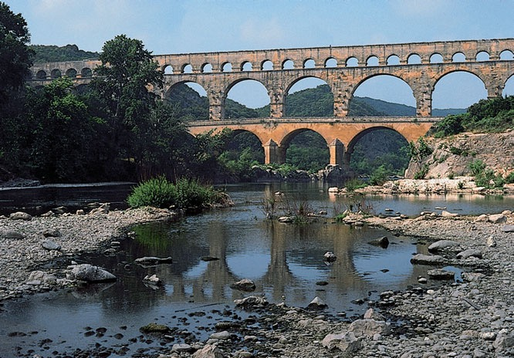
224 CHAPTER 14
ARCHITECTURE
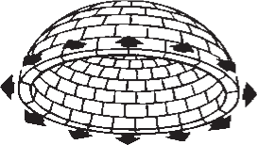
a. Dome (arch rotated 180°).
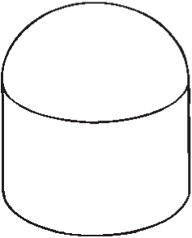
b. Dome on a cylinder.
c. Dome on pendentives. 14.10 Dome.
Roman architects borrowed Greek column design and combined it with the arch, enabling them to greatly increase the variety and size of their architec- tural spaces. The Romans also introduced liquid con- crete as a material for architecture. Concrete is a mix- ture of water, sand, gravel, and a binder such as lime or gypsum. Cheap, stonelike, versatile, and strong, con- crete allowed the Romans to cut costs, speed construc- tion, and build on a massive scale.
An arch rotated 180 degrees on its vertical axis cre- ates a dome (fig. 14.10). Domes may be hemispherical or pointed. In general usage the word dome refers to a hemispherical vault built up from a circular or polygo- nal base. The weight of a dome pushes downward and outward all around its circumference. Therefore, the simplest support is a cylinder with walls thick enough to resist the downward and outward thrust.
One of the most magnificent domes in the world was designed for the Byzantine cathedral of Hagia Sophia (“Holy Wisdom”) in Istanbul (fig. 14.11). It was built in the sixth century as the central sanctu- ary of the Eastern Orthodox Christian Church. After the Islamic conquest of 1453, minarets (towers) were added and it was used as a mosque. It is now a museum. The dome of Hagia Sophia rests on curving triangular sections called pendentives over a square base.
Hagia Sophia’s distinctive dome appears to float on a halo of light—an effect produced by the row of
14.11 Hagia Sophia. 532–535. Istanbul, Turkey. a. Exterior.
Photograph: Ayhan Altun.
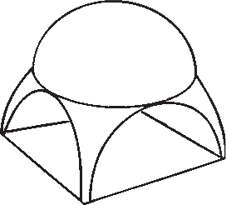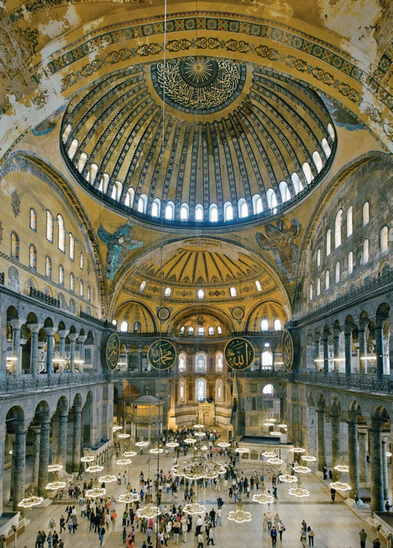
b. Interior.
Photograph: Ayhan Altun.
ARCHITECTURE
CHAPTER 14 225
windows encircling its base. Pendentives carry the enor- mous weight from the circular base of the upper dome downward to a square formed by supporting walls.
Pointed Arch and Vault
After the round arch, the pointed arch was the next great structural advance in the Western world. This new shape seems a small change, but it had a spectac- ular effect on the building of cathedrals. Vaults based on the pointed arch made it possible to build wider aisles and higher ceilings. We see the results of this new technology in the awesome height of the central aisle in the cathedral of Notre-Dame de Chartres, France (fig. 14.12).
A pointed arch (or Gothic arch, fig. 14.13) is steeper than a round arch, and therefore sends its weight more directly downward, but a substantial side- ways thrust must still be countered in tall buildings. Gothic builders accomplished this by constructing elaborate supports called buttresses at right angles to the outer walls. In the most developed Gothic cathe- drals, the outward force of the arched vault is carried to large buttresses by stone half-arches called flying buttresses (fig. 14.14).
By placing part of the structural skeleton on the outside, Gothic builders were able to make their cathe- drals higher and lighter in appearance. Because the added external support of the buttresses relieved the
14.12 Notre-Dame de Chartres. Chartres, France.
1145–1513.
Interior, nave.
Height 122 ́, width 53 ́, length 130 ́.
© Photo Scala, Florence.
- 14.13 Gothic Arch.
- 14.14 Flying Buttresses.
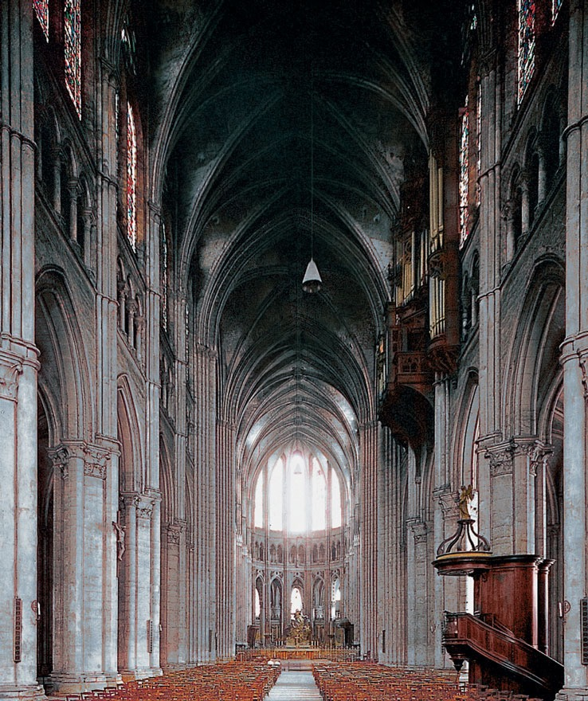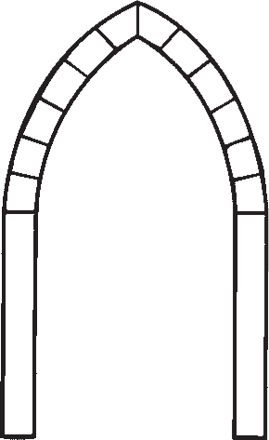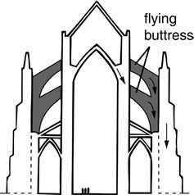
226 CHAPTER 14
ARCHITECTURE
cathedral walls of much of their structural function, large parts of the wall could be replaced by enormous stained-glass windows, allowing more light (a symbol of God’s presence) to enter the sanctuary. From the floor of the sanctuary to the highest part of the interior above the main altar, the windows increase in size. Stones carved and assembled to form thin ribs and pillars make up the elongated columns along the nave walls, which emphasize verticality and give the cathedral its apparent upward thrust. (We will consider the stylistic features of Gothic architecture in more detail in Chapter 16.)
After the Gothic pointed arch and vault, no basic structural technique was added to the Western architectural vocabulary until the nineteenth century. Instead, architects designed a variety of structures—at times highly innovative—by combining elements from different periods. Forms and ornamentation from the classical and Gothic periods were revived again and again and given new life in different contexts.
Truss and Balloon Frame
Wood has a long history as a building material. Besides the expected post and beam, timbers or logs have been used for centuries in trusses (fig. 14.15). A truss is a triangular framework used to span or to support. The perfection of mass-produced nails and mechani- cal saws in the nineteenth century led to advances in wood construction; the most important of these was the balloon frame (fig. 14.16). In balloon fram- ing, heavy timbers are replaced with thin studs held together only with nails, leading to vastly reduced con- struction time and wood consumption. (Old-timers who were unwilling to use the new method called it
14.15 Trusses.
14.16 Balloon Frame.
balloon framing because they thought it was as fragile as a balloon.) The method helped to make possible the rapid settlement of North America’s western frontier and is still used in suburban new construction today.
Modern Materials and Methods
Beginning in about 1850, modern materials have revolutionized architecture. The techniques (post and beam, arch, vault) have remained the same, but the arrival of cast iron, steel, and reinforced concrete have provided a wealth of new ways to create and organize spaces. More recently, some even newer materials, such as carbon fiber and cross-laminated timber, are shaping the buildings that we use.
Cast Iron
Iron has much greater strength than stone or wood and can span much larger distances. After the technol- ogy for uniform smelting was perfected in the nine- teenth century, cast and wrought iron became impor- tant building materials. Iron supports made possible lighter exterior walls and more flexible interior spaces because walls no longer had to bear structural weight. Architects first used this new material in factories, bridges, and railway stations.
The Crystal Palace (fig. 14.17), designed by Joseph Paxton, was a spectacular demonstration of what cast iron could do. It was built for the Great Exhibition of the Works of Industry of All Nations, the first inter- national exposition, held in London in 1851. Designed to show off the latest mechanical inventions, the Crystal Palace was built in six months and covered 19 acres of park land. This was the first time new industrial meth- ods and materials were used on such a scale.
Paxton used relatively lightweight, factory-made modules (standard-size structural units) of cast iron and glass. By freeing himself from past styles and masonry construction, he created a whole new architectural vocabulary. The light, decorative quality of the glass and cast-iron units was created not by applied ornamentation, but by the struc- ture itself. Paxton, inspired by leaf structures, said, “Nature gave me the idea.” The modular units pro- vided enough flexibility for the entire structure to be assembled on the site, right over existing trees, and later disassembled and moved across town.
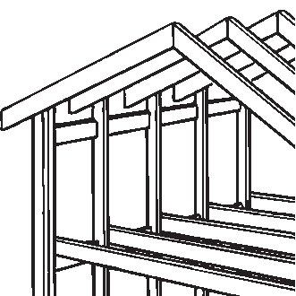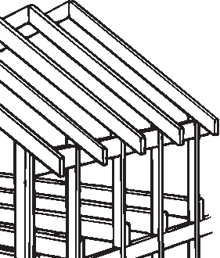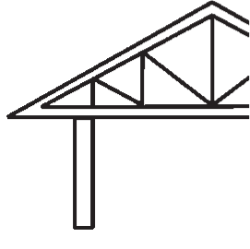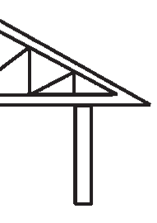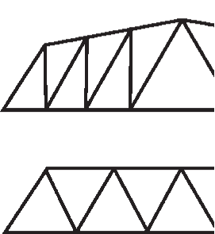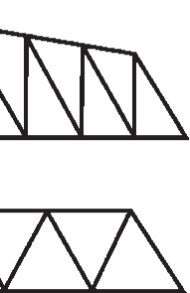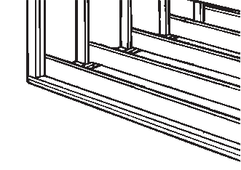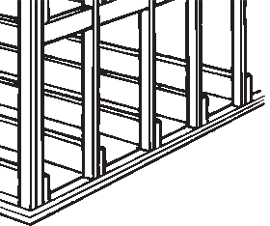
ARCHITECTURE CHAPTER 14 227
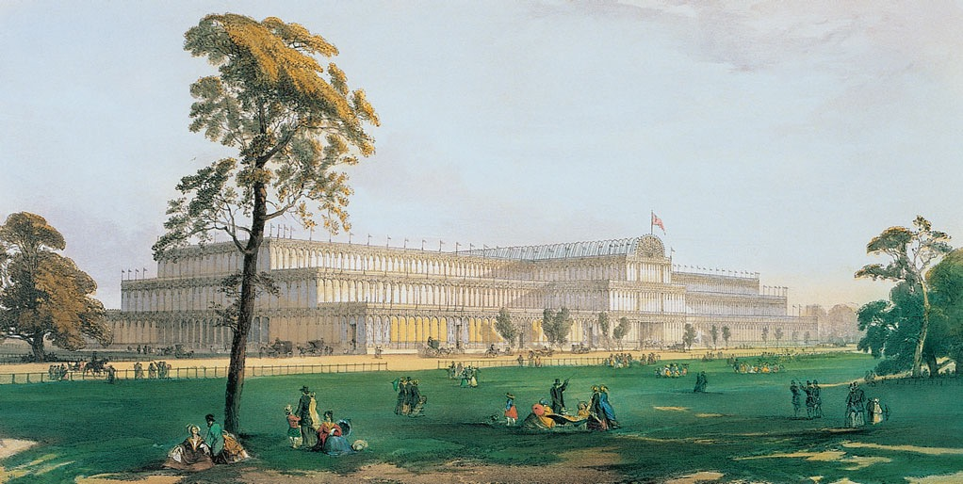
14.17 Joseph Paxton. Crystal Palace. London. 1850–1851. Cast iron and glass.
The Newberry Library. Photograph: Stock Montage, Inc.
Watch an architectural simulation about cast-iron construction on myartslab.com
Unfortunately, the building also showed the great defect of early cast-iron buildings: The unprotected metal struts tend to buckle on exposure to heat, mak- ing such buildings very susceptible to destruction by fire. The Crystal Palace indeed burned in 1936 after a fire broke out in its interior.
Steel and Reinforced Concrete
The next breakthrough in construction methods for large structures came between about 1890 and 1910 with the development of high-strength structural steel, used by itself and as the reinforcing material in reinforced concrete. The extensive use of cast-iron skeletons in the mid-nineteenth century had prepared the way for multistory steel-frame construction in the late 1880s.
Steel frames and elevators, together with rising urban land values, impelled a fresh approach to struc- ture and form. The movement began to take shape in commercial architecture, symbolized by early sky- scrapers, and found one of its first opportunities in Chicago, where the big fire of 1871 had cleared the way for a building boom.
Leading the Chicago school was Louis Sullivan, regarded as the first great modern architect. Sullivan rejected references to past buildings, and sought to meet the needs of his time by using new methods and materials. He had a major influence on the early devel- opment of what became America’s and the twentieth century’s most original contribution to architecture: the “skyscraper.”
Among the first of these skyscrapers was Sullivan’s Wainwright Building (fig. 14.18) in St. Louis, Missouri, which was made possible by the invention of the elevator and by the development of steel for the structural skeleton. The building boldly breaks with nineteenth-century tradition. Its exterior design reflects the internal steel frame and emphasizes the height of the structure by underplaying horizontal elements in favor of tall vertical shafts. Sullivan demonstrated his sensitivity and adherence to the harmony of traditional architecture by dividing the building’s façade into three distinct zones, reminiscent of the base, shaft, and capital of Greek columns (see fig. 16.6). These areas also reveal the various functions of the building, with shops at the base, offices in the central section, and utility rooms at the top. The heavily ornamented band at the top stops the vertical thrust of the piers located between the office windows.
Thus, the exterior form of the building shows its interior functions; this was a novel concept. Sullivan’s observation that “form ever follows function”1
228 CHAPTER 14 ARCHITECTURE
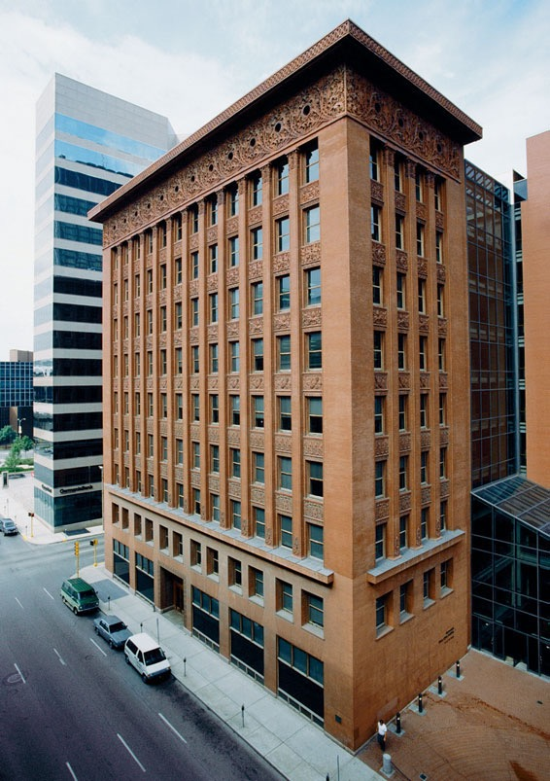
14.18 Louis Sullivan.Wainwright Building. St. Louis, Missouri. 1890–1891.
© Art on File/CORBIS. All Rights Reserved.
View the Closer Look for the Wainwright Building on myartslab.com
eventually helped architects to break with their reli- ance on past styles and to rethink architecture from the inside out.
In this spirit, modern architecture arose in Europe between 1910 and 1930. Younger architects rejected decorative ornamentation and references to the past, as well as traditional stone and wood construction, and they began to think of a building as a useful arrange- ment of spaces rather than as a mass. The resulting International Style expressed the function of each building, its underlying structure, and a logical (usu- ally asymmetrical) plan that used only modern materi- als such as concrete, glass, and steel.
The French architect and planner Le Corbusier showed the basic components of steel columns and reinforced-concrete slabs in a system that he called the Domino Construction System (fig. 14.19). The six steel supports are placed in concrete slabs at the same approximate locations as the spots on a domino game piece. Le Corbusier’s idea of supporting floors and roof on interior load-bearing columns instead of load- bearing walls made it possible to vary the placement of interior walls according to how the various rooms were used. He called one of his homes a “machine for living in,” but in fact its flexible spaces made it very com- fortable. And because walls no longer bore any weight, they could become windows and let in a great deal of natural light.
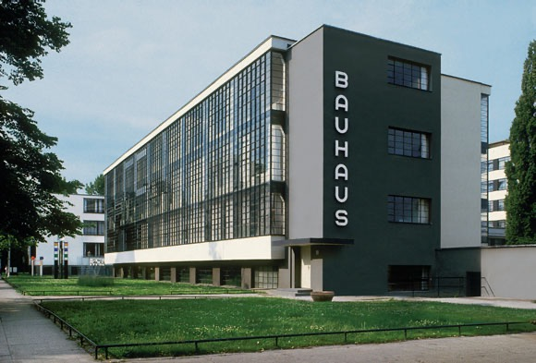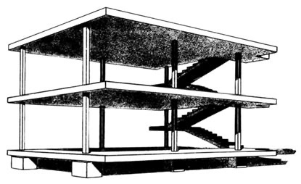
14.19 Le Corbusier.
Domino Construction System. Perspective drawing for Domino Housing Project. 1914.
© 2013 Artists Rights Society (ARS), New York/ADAGP, Paris/F.L.C.
14.20 Walter Gropius. Bauhaus Building. Exterior. 1926–1927. Vanni Archive/CORBIS. © 2013 Artists Rights Society (ARS),
New York/VG Bild-Kunst, Bonn.
ARCHITECTURE CHAPTER 14 229
Walter Gropius used the principles of the International Style in his new building for the Bauhaus when the design school moved to Dessau, Germany (fig. 14.20). The workshop wing, built between 1925 and 1926, follows the basic concept illustrated in Le Corbusier’s drawing. Because the reinforced-concrete floors and roof were supported by steel columns set back from the outer edge of the building, exterior walls did not have to carry any weight: they could be curtain walls made of glass. Even interior walls were
non-load-bearing and could be placed anywhere they were needed.
Generally the public was slow to accept the stripped-down look of the new International Style. In response, architects developed a more decorative and exuberant style in the 1920s and 1930s called Art Deco. This style used some of the structural tenets of the International Style, but retained decoration, often in an abstract style. The Kress Building (fig. 14.21) in Hollywood, California, for example, rises up to
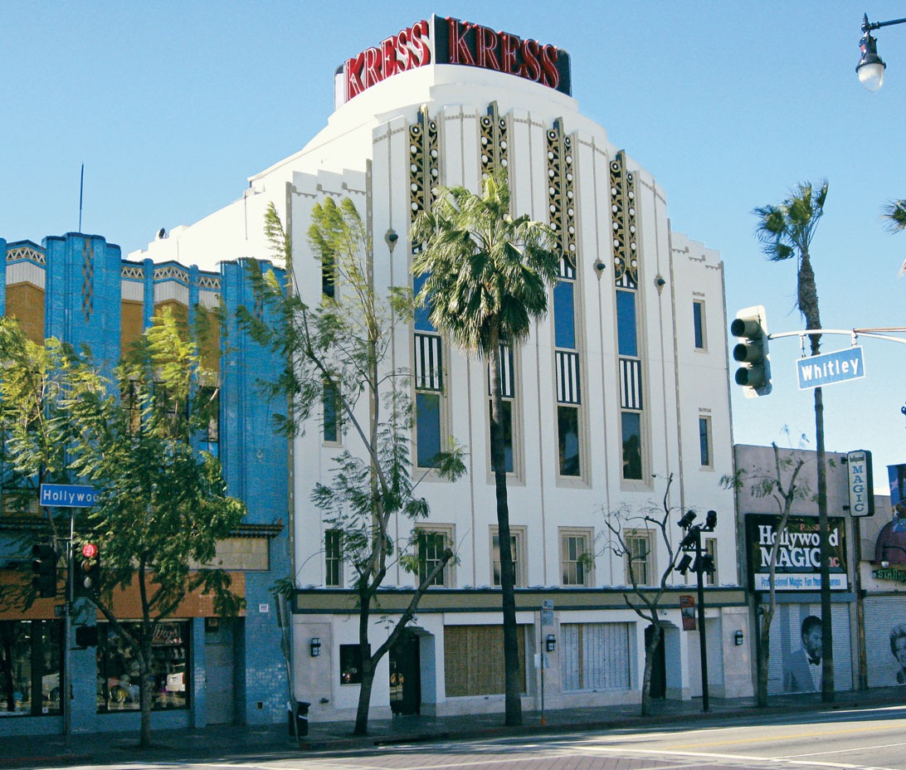
14.21 Edward F. Sibbert. Kress Building. Hollywood, California. 1935. Photograph: Patrick Frank.
230 CHAPTER 14 ARCHITECTURE
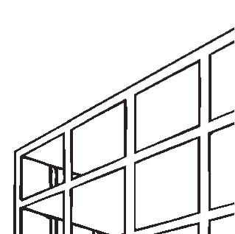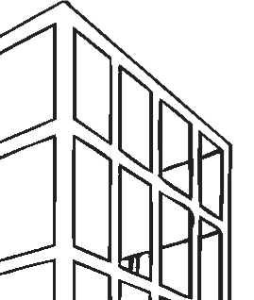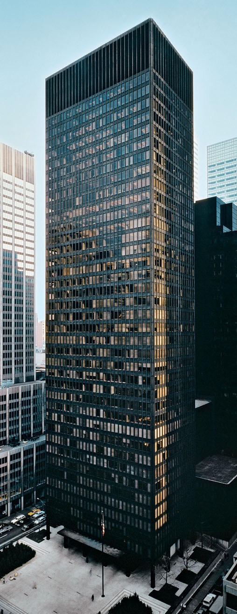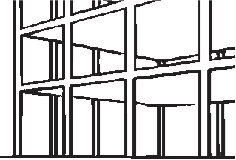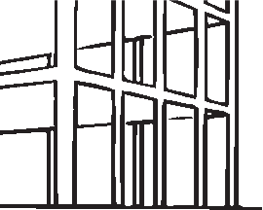
14.22 Steel-Frame Construction.
a vaulted ceiling at the top floor, adorned by shapes abstracted from growing fruit trees.
Le Corbusier’s idea for alleviating urban crowd- ing by using tall, narrow buildings surrounded by open space, and Sullivan’s concept for high-rise build- ings that express the grid of their supporting steel- frame construction (fig. 14.22), came together in the Seagram Building (fig. 14.23). Non-load-bearing glass walls had been a major feature of plans for sky- scrapers conceived as early as 1919, but only in the 1950s, with greater public acceptance of modern architecture, could such structures be built. In the Seagram Building, interior floor space gained by the height of the building allowed the architects to leave a large, open public area at the base. The vertical lines emphasize the height and provide a strong pattern that is capped by a top section designed to give a sense of completion. The austere design embodies architect Mies van der Rohe’s famous statement “Less is more.”
The International Style had an enormous, if sometimes negative, influence on world architecture. It often replaced unique, place-defining regional styles. By mid-century, modern architecture had become synonymous with the style. The uniformity of glass- covered rectilinear grid structures was considered the appropriate formal dressing for the anonymity of the modern corporation.
Recent Innovations
In the late twentieth century, improved construction techniques and materials, new theories regarding struc- tural physics, and computer analyses of the strengths and weaknesses in complex structures led to the further development of fresh architectural forms.
Suspension structures were known for decades through their use in tents and bridges, but the most
14.23 Ludwig Mies van der Rohe and Philip Johnson. Seagram Building. New York. 1956–1958. Photograph: Andrew Garn.
ARCHITECTURE CHAPTER 14 231
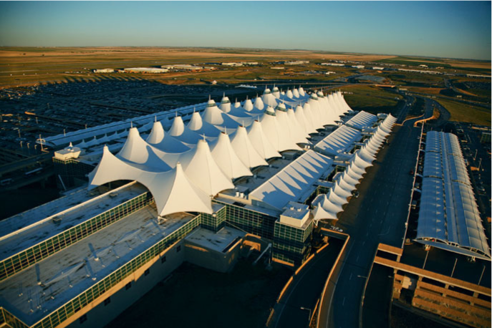
14.24 Fentress-Bradburn Architects. Jeppesen Terminal Building. Denver International Airport. 1994. Photograph provided courtesy of the Denver International Airport.
dramatic recent use of this technique in a major pub- lic building was in the Jeppesen Terminal Building at Denver International Airport (fig. 14.24). Its roof is a giant tent composed of 15 acres of woven fiberglass, making it one of the largest suspension buildings on Earth. This white roofing material
director Thomas Krens envisioned a museum that would celebrate the ever-evolving, often large-scale inventions of leading contemporary artists, while also featuring the art of architecture. Two other examples of museum architecture are the Museum of Contemporary Art, Denver (see fig. 14.30), and the Modern Wing of the Art Institute of Chicago (see fig. 25.31).
Architecture’s first techni- cal innovation of the twenty-first century is carbon fiber, and it may have an important impact
on how we build in the future. Scientists found that heating carbon atoms in an oxygen-free environ- ment fuses them together into some of the light- est and strongest materials yet discovered. Certain aircraft parts, racing car bodies, and bicycle frames already use carbon fiber. Shaping this fiber care- fully and coating it with polyester or nylon yields a new material that can literally be woven to create a building.
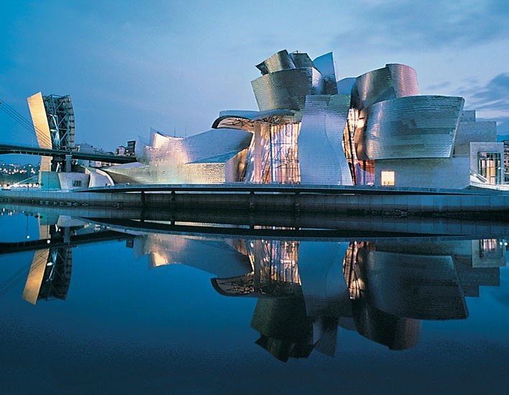
lets in large amounts of natural light without conducting heat, and it is coated with Teflon for water resis- tance and easy cleaning. Its exterior design was inspired by the snow- capped Rocky Mountains, which are visible from inside.
In recent years, art museums have become showplaces for cutting- edge architecture. Frank Gehry’s Guggenheim Museum, Bilbao (fig. 14.25), is more like a piece of functional sculpture. The develop- ment of computer graphics and modeling applications in the 1980s made possible this design, which the architect called a “metallic flower.” It is a dramatic limestone and titanium- clad cluster of soaring, nearly-dancing volumes that climax in a gigantic, glass-enclosed atrium. Museum
14.25 Frank O. Gehry. Guggenheim Museum Bilbao. Bilbao, Spain. 1997. Photograph by Erika Barahona Ede © FMGB Guggenheim Bilbao Museo.
232 CHAPTER 14 ARCHITECTURE
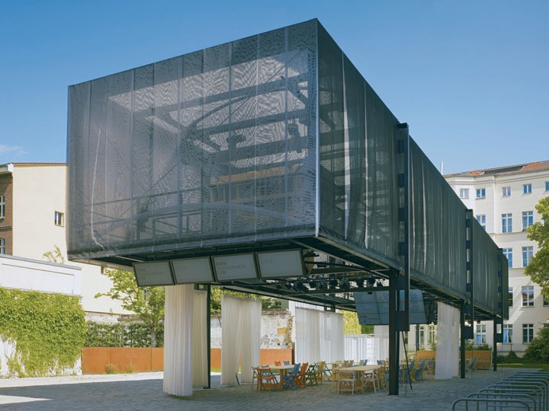
14.26 Atelier Bow-Wow. BMW Guggenheim Lab. 2011–
2012. Berlin, Germany.
Open-air, carbon fiber
structure.
Photo: Christian Richters © 2012 Solomon R. Guggenheim Foundation.
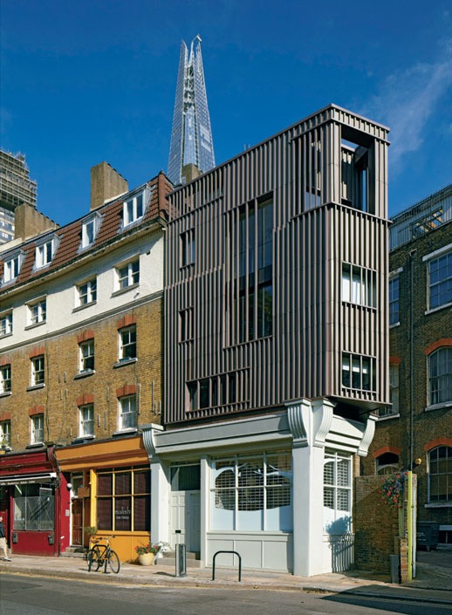
The Tokyo firm Atelier Bow-Wow recently created a public seminar space using carbon fiber (fig. 14.26). All of this building’s components are light enough to be handled by one person easily. The BMW Guggenheim Lab can shelter talks, exhibitions, discussions, screen- ings, and workshops; all of the implements for such functions are stored in the upper portion on pulleys, to be raised or lowered as needed. The building’s lightness was advantageous, because it eventually housed semi- nars on three continents.
Some old materials are also getting new treatments in the twenty-first century. Cross-laminated timber (CLT) uses wood in a new way, by laminating slabs of wood with their grains at an angle. This makes wood as strong as concrete, but much lighter. CLT slabs can range up to 11 inches thick and 60 feet long, and their flexibility makes them more earthquake resistant than concrete. Using trees harvested from sustainable forests also makes CLT a carbon-neutral building material.
The Alex Monroe jewelry store in London (fig. 14.27) is built of CLT, with the ground floor designed to harmonize with the surrounding shops. This floor is a showroom, while the upper floors house workshops and meeting rooms. Using prefab- ricated slabs brought to the site, builders erected the studio in only one week.
14.27 DSDHA. Alex Monroe jewelry store. 2011. Snowsfields, London.
Photo © Dennis Gilbert/VIEW.
ARCHITECTURE CHAPTER 14 233
FORMING ART
Xten Architecture: Shaping a Building
Some architectural offices are based more on collaboration between architects than on the insights and vision of a single creator. Xten Architecture is one
such firm, created in 2000 as a partnership with offices in California and Switzerland. Besides collaboration, their practice emphasizes using
sustainable technologies to create buildings that are “strong sculptural forms at the scale of the landscape,”2 according to their statement.
The State Archive in Lucerne outgrew its quarters in 2011, and decided to move to a new location in a new building that would enable better use
of digital technology. Xten Architecture proposed this design as an entry in an international competition.
The notes and plans from the project show how it took form.
The Archive site is located on an intersection of two major streets, and it slopes down- ward away from the corner (fig. 14.28a). As the process diagram shows (fig. 14.28b), the design evolved from a basic rectangle at one end
of the site. The main floor includes administrative spaces and a library, above two
levels of storage underground. This allows the landscape to dominate the exterior views, provides better security, and greatly reduces heating and cooling needs for the stored documents, some of which date from the Middle Ages. The main floor is shaped to provide both views to the outside and a pleasing profile from the exterior. These working spaces occupy the south and east sides of the building, to maximize natural daylight illumination. The diagram also envisions a Phase 2, with expanded underground storage on the north side.
The ground plan (fig. 14.28c) shows entry from the east (left), under a large covered porch
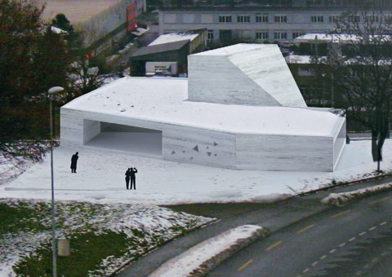
14.28a Xten Architecture. Proposal for State Archive. Lucerne, Switzerland. 2011.
Bird’s eye view.
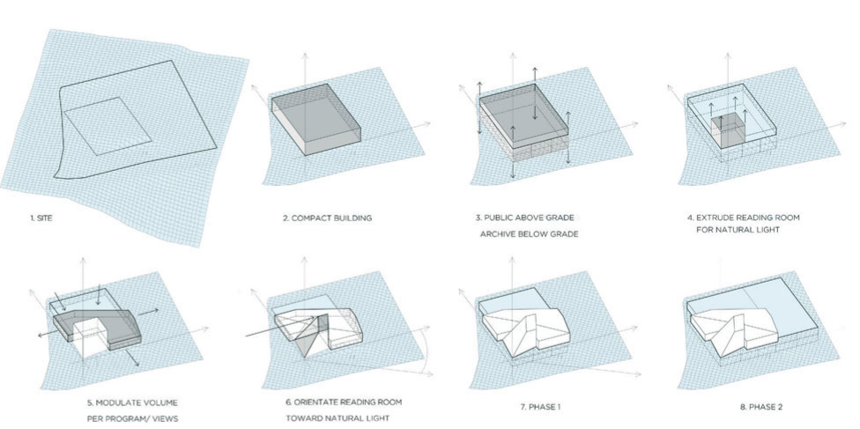
14.28b Process Diagram.
234 CHAPTER 14 ARCHITECTURE
Note that, in discussion with author and Pearson, the number of these figs has been changed so that they appear in sequential order both in layout and when mentioned in the main text.

to protect from the elements, which leads directly to a library with two glass walls. The reading room is on the same level, but it sits at the base of a hollow 33-foot tower that rises above. This tower is aligned facing northward, with a large high window to admit light. Northern natural light is more constant than southern, and it
is always indirect, an important consideration for document conservation. The back wall of this tower is angled to reflect the light downward. Because the site occupies a slight rise, many exterior windows have a view of the city.
The bird’s eye view (see
fig. 14.28a) shows the building’s striking façade, which is mostly determined by the usage of the spaces that it frames. The architects resisted the idea that a storage facility should resemble a fortress. This view shows the entry with its covered porch. We see the reading room tower with its sloping back wall above.
The design calls for a concrete exterior, poured on-site with controlled and layered irregularities in the mix. This allows the building to show sedimentation that reflects both the local soil and the gently sloping landscape nearby.
We will never know how
the building actually looks, because this design did not win the competition (the jury voted for a building with more above- ground storage). But the Xten project was widely commented on in the architecture press and won several awards.
14.28c Ground Plan.
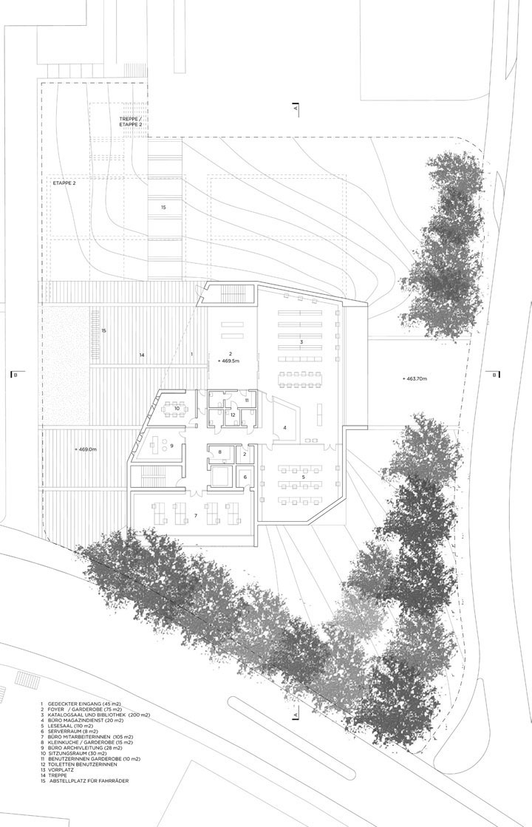
ARCHITECTURE
CHAPTER 14 235
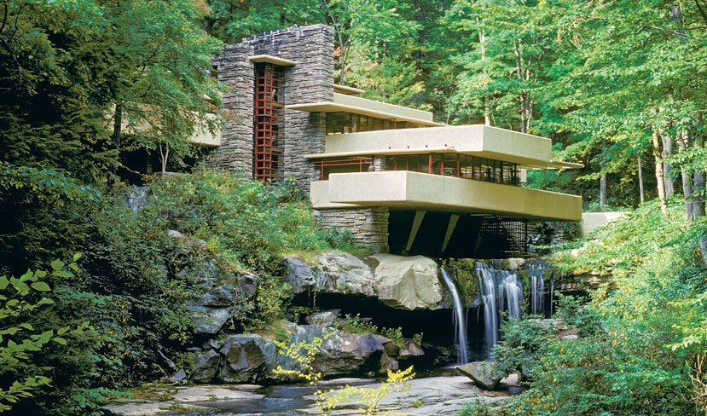
Designing with Nature
Most of the stylistic revolutions of the twentieth century did not consider a building in relation to its environment. An early exception to this trend was the work of American Frank Lloyd Wright, one of the most important (and iconoclastic) architects of the era. Wright was among the first to use open planning in houses, even before the International Style took hold (see his Robie House, fig. 22.26). Wright eliminated walls between rooms, enlarged windows, and discov- ered that one of the best ways to open a closed-in room was to place windows in corners. With these devices, he created flowing spaces that opened to the out- doors, welcomed natural light, and related houses to their sites and climates. Sliding glass doors were influ- enced by the sliding paper-covered doors in traditional Japanese architecture.
Wright also made extensive use of the cantilever to unite indoor and outdoor spaces. When a beam or slab is extended a substantial distance beyond a sup- porting column or wall, the overhanging portion is called a cantilever. Before the use of steel and rein- forced concrete, cantilevers were not used to a signifi- cant degree because the available materials could not extend far enough to make the concept viable.
One of the boldest and most elegant uses of the principle occurs in Wright’s Kaufmann Residence (also known as Fallingwater) at Bear Run, Pennsylvania
14.29 Frank Lloyd Wright. Fallingwater (Edgar Kaufmann Residence). Bear Run, Pennsylvania. 1936.
Mike Dobel/Alamy © 2013 Frank Lloyd Wright Foundation, Scottsdale, AZ/Artists Rights Society (ARS), NY.
Explore the architectural panorama of Fallingwater on myartslab.com
(fig. 14.29). Horizontal masses cantilevered from sup- porting piers echo the rock ledges on the site and seem almost to float above the waterfall. Vertical accents were influenced by surrounding tall, straight trees. The intrusion of a building on such a beautiful loca- tion seems justified by the harmony Wright achieved between the natural site and his equally inspiring architecture.
Building with an awareness of the surroundings is a generally accepted basic practice today. We see a contemporary example of such thinking in the recent project for the State Archives of Lucerne, Switzerland (see fig. 14.29). Xten Architecture took account of the slope, soil, and sunshine at the site, along with the special needs of a document storage facility. Located on a terrace overlooking the city center, the architects shaped the project in accordance with usage and envi- ronmental needs.
Contemporary Approaches
Increasing numbers of architects in recent years are thinking of ways to reduce the impact of building on the environment, and to make the interiors more
236 CHAPTER 14 ARCHITECTURE
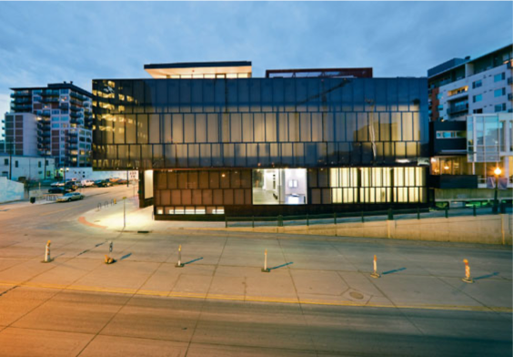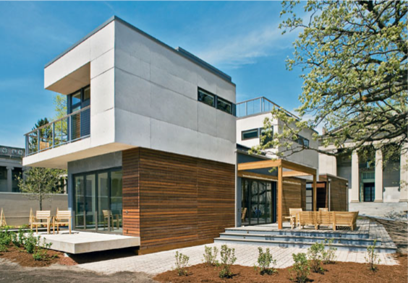
14.30 DavidAdjaye.MuseumofContemporaryArt,Denver. Denver, Colorado. 2007.
Photo by Dean Kaufman, courtesy Museum of Contemporary Art, Denver.
healthful. In the United States, the Green Building Council gives annual awards for leadership in environ- mentally sensitive design. Architects can submit their plans to the Council for rating, and the Council assigns points for such factors as harmony with prevailing wind or sunshine patterns, indoor energy efficiency, use of recycled water, and reduction of transportation costs for materials. The Council then makes annual awards for Leadership in Energy and Environmental Design (LEED), presenting Certified, Silver, Gold, and Platinum awards each year to projects that reach designated point levels.
Some museums have joined the quest to build green. The Museum of Contemporary Art, Denver (fig. 14.30), sits atop a cleaned-up hazardous waste site. Heating comes from a radiant floor; cooling is a low-energy evaporative cooler rather than an air condi- tioner. But the majority of its exterior wall is a double- skin façade, which reduces the need for both heat- ing and cooling. The roof is a green garden planted with local native species. Twenty percent of its build- ing materials come from recycled sources. Using 32 percent less energy than a comparable conventional structure, this museum is the greenest yet built, and it earned a Gold rating.
The mkSolaire Home by Michelle Kaufmann (fig. 14.31) represents the leading edge in green single- family home design. This prefabricated house can be placed on a wide variety of sites in an orientation to
14.31 Michelle Kaufmann. mkSolaire Home. 2008. Prefabricated house.
As exhibited at Museum of Science and Industry, Chicago. Photo by John Swain Photography, courtesy of Michelle Kaufmann.
maximize sunlight. It uses the most efficient insulation available, and window placements maximize cross- ventilation. On-demand water heaters, low-flow fix- tures, and a green roof also reduce energy demands. The architect certifies that this home, depending on where it is located, will earn either a Gold or a Platinum certification.
Most skyscrapers, with their heavy structural skeletons, sealed interior environments, and glassy exteriors, are very energy-inefficient. But the Aqua Tower in Chicago (fig. 14.32) incorporates several green characteristics that emboldened the owner to seek LEED Certification. The curving balconies that give the residential tower such a striking appear- ance also have a practical function: They reduce the building’s sway in windstorms, so that the structural supports on the upper floors can use less material. Heat-resistant glass reduces the need for air condi- tioning in summer. The three-story entrance pavilion at the base has an 80,000 square-foot garden on its roof, a literal “patch of green.” Inside the building, the apartments have sustainable bamboo floors and energy-efficient appliances. A 24-car electric vehicle- charging system awaits drivers in the basement.
In addition to their high efficiency, all these green buildings look good; but not all green buildings appear innovative from the outside. This is because some designers prefer to take the greenest route: to redesign existing buildings rather than build new ones.
ARCHITECTURE CHAPTER 14 237
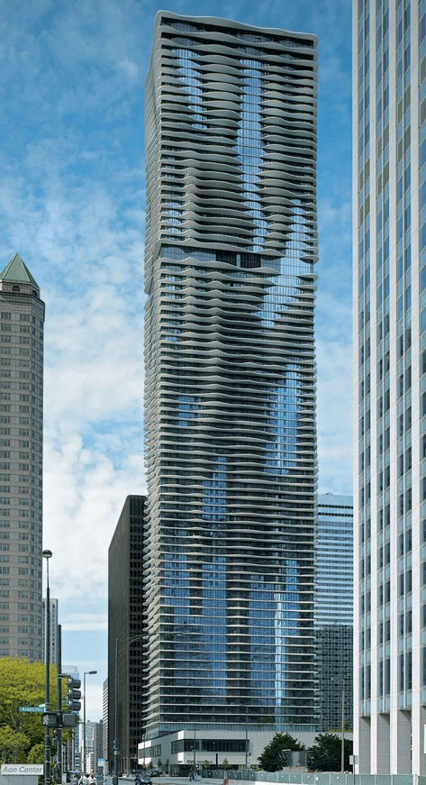
14.32 Jeanne Gang/Studio Gang Architects.
Aqua Tower. Chicago, Illinois. 2010.
Steve Hall © Hedrich Blessing. Courtesy of Studio Gang Architects.
Architecture is a frequently overlooked artform because it is generally considered a necessity rather than an expressive statement. As we have seen in the examples above, however, it is both. As the artform that surrounds us in our daily lives, architecture has long made human survival both possible and enjoyable.
Study and review on myartslab.com
THINK BACK
- What are the traditional methods of construction used in architecture?
- What impact has the development of high-strength structural steel had on architecture?
- How are environmental concerns affecting architecture today?
TRY THIS
We come to understand a building through a succession of experiences in time and space. To
do this we must explore buildings inside and out. Walk around your house or apartment. How do you respond to the entrance? The height of the ceilings? Wall and floor colors, textures, materials? Window sizes and placements?
K E Y T E R M S
cantilever – a beam or slab projecting a substantial distance beyond its supporting post or wall
colonnade – a row of columns usually spanned or connected by beams
International Style – an architectural style that emerged in several European countries between 1910 and 1920; characterized by the use of modern materials (concrete, glass, steel), avoidance of applied decoration, and focus on a building’s inner uses
masonry – building technique in which stones or bricks are laid atop one another in a pattern
post-and-beam system – structural system in which uprights or posts support a horizontal beam that spans the space between them
truss – a structural framework of wood or metal based on a triangular system, used to span, reinforce, or support walls, ceilings, piers, or beams
vault – a curving masonry roof or ceiling constructed on the principle of the arch
238 CHAPTER 14 ARCHITECTURE


