the purpose of this assignment is to explain core concepts related to cash distributions and capital structure.
Read the Chapter 14 Mini Case on page 604-606 in Financial Management: Theory and Practice. Using complete sentences and academic vocabulary
Create a 2 slide PowerPoint presentation in which you summarize your answers from the mini case. Be sure to include graphs, charts, and trends as appropriate.
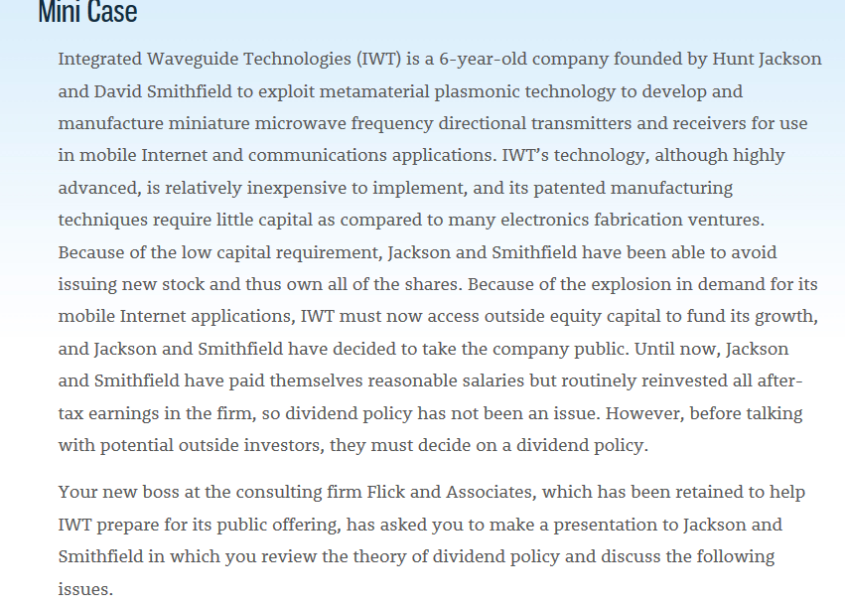

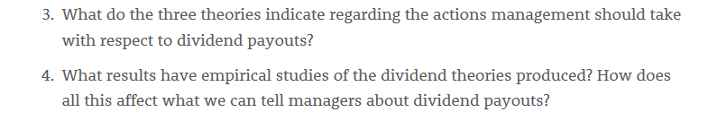

Read the Chapter 15 Mini Case on page 651-652 in Financial Management: Theory and Practice. Using complete sentences and academic vocabulary, please answer questions a and b.
Using the mini case information, write a 250-500 word recommendation of the financial decisions you propose for this company based on an analysis of its capital structure and capital budgeting techniques. Explain why you chose this recommendation.

