THINK AHEAD
- 8.1 Define printmaking terms such as print, matrix, edition, and artist’s proof.
- 8.2 Summarize the origins of printmaking in China and Western Europe.
- 8.3 Identify the artistic, social, and political functions of prints.
- 8.4 Distinguish methods of relief, intaglio, and lithographic printmaking processes.
- 8.5 Recognize the use of stencils, screenprinting, and digital technologies as contemporary forms of printmaking.
- 8.6 Compare the sculptural practice of working in editions to printmaking.
The first thing we might notice about the print Quiver (fig. 8.1) is its layering of images. A framed dragonfly hovers in a yellow-green square; a negative picture of a radio telescope seems to overlay a closer view of a similar device. Underneath all is a pattern of gray-green branches, silhouetted as if on a forest floor. Note that each layer has its color: gray, blue, brown, black, green. Overall, the work seems a med- itation on fragile structures, which might “quiver” in a strong wind.
This layering of images resembles in some ways the process of memory: Each of our memories inhabits a layer of our minds, and each probably has its “color” of feeling or association. Such are the goals of the cre- ator of Quiver, who said that she tries to make “visual poems.” It is no mistake that she chose a print to realize this vision because this type of layering is a technique uniquely suited to printmaking.
In the visual arts, printmaking describes a variety of techniques developed to create multiple copies of a single image. A print is thus one of a series of nearly iden- tical pieces, usually printed on paper. Prints are made from a matrix, which an artist may create of metal, wood, or stone. The artist supervises the printing of a group of images from the same matrix, usually
called an edition.
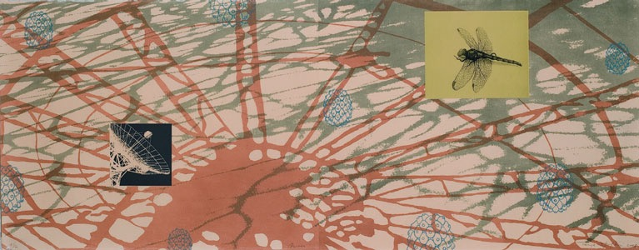
8.1 Tanja Softic. Quiver. 2008. Lithograph. 20 ̋ × 52 ̋. University of Richmond.
Listen to the chapter audio on myartslab.com
128 CHAPTER 8 PRINTMAKING
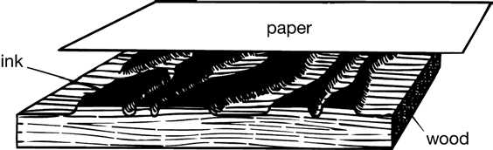
Nearly all original prints are numbered to indicate the total number of prints pulled, or printed, in the edition, and to give the number of each print in the sequence. The figure 6/50 on a print, for example, would indicate that it was the sixth print pulled from an edition of 50.
As part of the printmaking process, artists make prints called progressive proofs at various stages to see how the image on the matrix is developing. When a satisfactory stage is reached, the artist makes a few prints for his or her record and personal use. These are marked AP, meaning artist’s proof.
One of the best definitions of an original print comes from artist June Wayne: “It is a work of art, usually on paper, which has siblings . . . They all look alike, they were all made at the same time from the same matrix, the same creative impulse, and they are all originals. The fact that there are many of them is irrelevant.”1 Another artist described print editions this way: “Prints mimic what we are as humans: we are all the same and yet every one is different.”2
In this chapter we will look at some reasons for cre- ating prints, and discuss the various traditional meth- ods of printmaking: relief, intaglio, lithography, stencil. In our time, artists are using the old methods in new ways, sometimes combining them with digital tech- niques; we will conclude this chapter with a discussion of some of these new approaches.
Purposes of Printmaking
Although new technology is bringing different ways of communicating information, much in our society is still printed—newspapers, books, posters, magazines, greetings cards, billboards—so it is hard to imagine a time in which all illustrations were produced by hand, one at a time.
The technologies for both printing and paper- making came to Europe from China. By the ninth century, the Chinese were printing pictures; by the eleventh century, they had invented (but seldom used) movable type. Printmaking was developed in Europe during the fifteenth century—first to meet the demand for inexpensive religious icons and play- ing cards, then to illustrate books printed with the new European movable type.
8.2 Relief.
As recently as the late nineteenth century, print- makers were still needed to copy drawings, paintings, and even early photographs by making plates to be used, along with movable type, for illustrating newspa- pers and books. However, as photomechanical meth- ods of reproduction were developed in the later nine- teenth century, handwork played a decreasing role in the printing process.
Generally, artists make prints for one or more of the following reasons:
t They may wish to make multiple works that are less expensive than paintings or sculpture, so that their work will be available for purchase by a wider group of viewers.
t They may wish to influence social causes. Because prints are multiple works, they are easy to dis- tribute far more widely than a unique work of art.
t They may be fascinated by the process of print- making, which is an absorbing craft in itself.
Relief
We already know what a relief print is, if we think of how fingerprints, rubber stamps, and wet tires leave their marks. In a relief process, the printmaker cuts away all parts of the printing surface not meant to carry ink, leaving the design “in relief” at the level of the original surface (see the Relief diagram, fig. 8.2). The surface is then inked, and the ink is transferred to paper with pressure.
Woodcut
The oldest relief prints are woodcuts (or woodblocks). The woodcut process lends itself to designs with bold black-and-white contrast. The image-bearing block of (usually soft) wood is a plank cut along the grain. Because the woodcut medium does not easily yield
PRINTMAKING CHAPTER 8 129
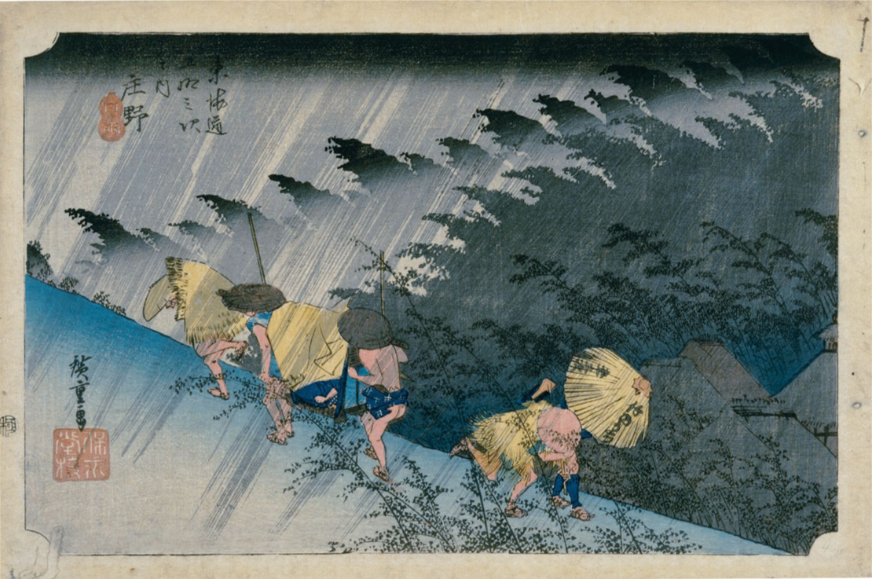
8.3 Utagawa Hiroshige. Shono hakuu (Light Rain at Shono), number 46. 1832–1833. Full-color woodcut. 87⁄8 ̋ × 13 3⁄4 ̋.
Collection UCLA Grunwald Center for the Graphic Arts, Hammer Museum. Purchased from the Frank Lloyd Wright Collection.
View the Closer Look for Japanese woodblock prints on myartslab.com
shades of color, artists who use it are generally drawn by the challenge of working in black and white only. Others use woodcut because they enjoy the feel of carving a fresh block of wood. Woodcut editions are limited to a couple of hundred because the relief edges begin to deteriorate with repeated pressure.
Woodblock printing flourished in Japan in the seventeenth through the nineteenth centuries. Japanese woodblock prints were made through a com- plex process that included multiple blocks to achieve subtle and highly integrated color effects. Because they were much cheaper than paintings, these prints were the preferred artform for middle-class people who lived in the capital city of Edo (now known as Tokyo). Their subject matter included famous theater actors, nightlife, landscapes, and even erotic pictures.
Japanese prints were among the first objects of Asian art to find favor among European artists, and many Impressionist and Post-Impressionist painters were strongly influenced by them (see Chapter 21).
Color woodcuts are usually printed with multiple woodblocks. As with most printmaking techniques, when more than one color is used, individually inked blocks—one for each color—are carefully registered (lined up) to ensure that colors will be exactly placed in the final print.
Hiroshige’s print Light Rain at Shono (fig. 8.3) is a good example of Japanese printmaking at a high level. The print required four blocks, one for each color. The atmospheric effects of the rain and the distant forest are delicate, and difficult to achieve, as the fine lines in this work require both careful carving and precision printing. The work is one of 53 that Hiroshige cre- ated that depict various stops on the road from Edo to Kyoto; it was his most popular series.
130 CHAPTER 8 PRINTMAKING
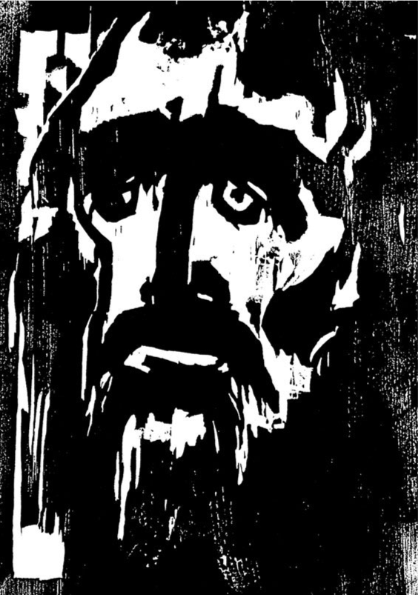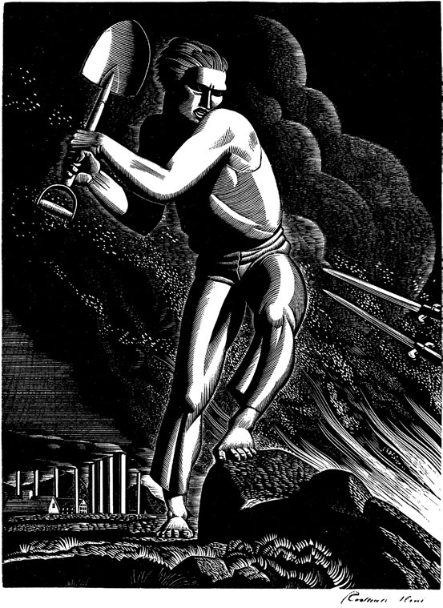
8.4 Emil Nolde. Prophet. 1912. Woodcut. (Cat. Rais. Schiefler-Mosel 110.) 121⁄2 ̋ × 813⁄16 ̋.
National Gallery of Art, Washington D.C. Rosenwald Collection. 1943.3.6698 © Nolde Stiftung Seebuell.
Watch a video about the printmaking process of woodcut on myartslab.com
The detail in Hiroshige’s print is quite different from the roughness of the woodcut Prophet (fig. 8.4) by German artist Emil Nolde. Each cut in this block is expressive of an old man’s face, and reveals the character of the wood and the woodcut process. The simplified light-and-dark pattern of the features gives emotional intensity to the image. Nolde’s direct approach is part of a long tradition of German printmaking.
Wood Engraving
A related method that was traditionally used for book illustration is wood engraving. In this method, the
8.5 Rockwell Kent. Workers of the World, Unite. 1937. Wood engraving. 8 ̋ × 51⁄8 ̋.
Fine Arts Museums of San Francisco, Achenbach Foundation for the Graphic Arts. Gift of the American College Society of Print Collectors. 54959. Courtesy of the Plattsburgh State Art Museum, State University of New York, Rockwell Kent Gallery and Collection, Bequest of Sally Kent Gorton.
artist uses very dense wood (often boxwood) set on end rather than sideways. The hardness of the wood requires the use of metal engraving tools, but it also makes large editions possible, facilitating the use of wood engraving in publishing.
One of the best wood engravers was the American artist Rockwell Kent, who made Workers of the World, Unite (fig. 8.5) in 1937. We see here the fine detail in the body and the background cloud that the dense wood, placed on end, allows. This work is also an example of socially conscious printmaking, as it shows a farmer defending his territory against encroaching military bayonets. Kent was an agitator throughout his life on behalf of workers of all sorts, and frequently made prints to forward his favorite causes.
PRINTMAKING CHAPTER 8 131
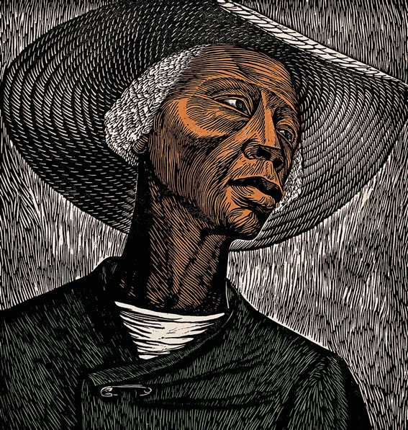
8.6 Elizabeth Catlett. Sharecropper. 1970.
Color linocut on cream Japanese paper. 217⁄16 ̋ × 203⁄16 ̋.
The Art Institute of Chicago Restricted gift of Mr. and Mrs Robert S. Hartman. 1992.182. Photography © The Art Institute of Chicago. © Catlett Mora Family Trust/Licensed by VAGA, New York , NY.
Linocut
The linoleum cut (or linocut) is a modern develop- ment in relief printing. The artist starts with the rub- bery, synthetic surface of linoleum, and just as in woodcut, gouges out the areas not intended to take ink. Linoleum is softer than wood, has no grain, and can be cut with equal ease in any direction. The softness of this matrix material makes fine detail impossible.
An example of a linoleum cut is Sharecropper (fig. 8.6) by Elizabeth Catlett, in which the even, white gouges betray the soft material. This work also typifies Catlett’s lifelong devotion to creating dignified images of African Americans.
A contemporary artist who uses relief techniques in an original way is Betsabeé Romero of Mexico City (fig. 8.7). She buys used tires whose tread is almost gone, and she carves relief patterns in them that are based on traditional Mexican popular culture motifs such as skeletons and flowers. The tires are easily inked for printing on long sheets, which she either sells by the yard or exhibits together with the tires.
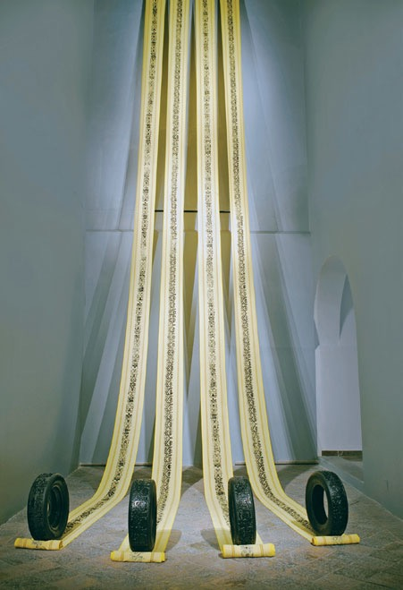
8.7 Betsabeé Romero, Ciudades que se van
(Cities on the Move). 2004. Tires and relief prints. Installation view. Each tire 235⁄8 ̋ diameter × 619⁄64 ̋ wide. Four prints on domestic fabric.
Each 59 ́ × 1911⁄16 ̋.
Inset: Del otro lado
de la velocidad
(On the Other Side
of Speed). Tire.
513⁄16 ̋ × 153⁄4 ̋.
Courtesy of the artist.
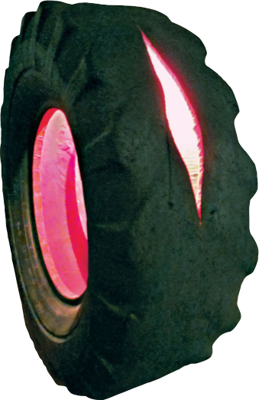
132 CHAPTER 8 PRINTMAKING
Intaglio
Intaglio printing is the opposite of relief printing: Areas below the surface hold the ink (see the Intaglio diagram, fig. 8.8). The word intaglio comes from the Italian intagliare, “to cut into.” The image to be printed is cut or scratched or etched into a metal surface. To make an intaglio print, the printmaker first daubs the plate with printer’s ink, then wipes the surface clean, leaving ink only in the etched or grooved portions. Damp paper is then placed on the inked plate, which then passes beneath the press roller. A print is made when the dampened paper picks up the ink in the grooves. The pressure of the roller creates a characteris- tic plate mark around the edges of the image. Intaglio printing was traditionally done from polished copper plates, but now zinc, steel, aluminum, and even plastic are often used. Engraving, drypoint, and etching are the principal intaglio processes.
8.8 Intaglio.
Watch a video about the process of
intaglio printmaking on myartslab.com
Engraving
We can also see the complex richness of engraved lines in Albrecht Dürer’s engraving The Knight, Death, and the Devil (fig. 8.10), reproduced close to its actual size. Thousands of fine lines define the shapes, masses, spaces, values, and textures in this complex print. The precision of Dürer’s lines seems appropriate to the sub- ject—an image of the noble Christian knight moving with resolute commitment, unswayed by the forces of chaos, evil, and death that surround him.
Drypoint
Drypoint is similar to line engraving. Using a pointed tool with a steel or diamond tip, the artist scratches lines into a soft copper or zinc plate. The displaced metal leaves a burr, or rough edge, similar to the row of earth left by a plow. The burr catches the ink and, when printed, leaves a slightly blurred line (see Drypoint diagram, fig. 8.9). Because the burr is fragile and deteriorates rapidly from the pressure of the printing press rollers, drypoint edi- tions are by necessity small and rarely done. Skillful draftsmanship is required, for drypoint lines are dif- ficult to execute and almost impossible to correct. More often, artists use drypoint to fill in details in already-etched plates.
8.9 Drypoint Plate.
Etching
The process of making an etching begins with the preparation of a metal plate. The artist paints the surface of the copper or zinc plate with a coating of either wax or varnish that will resist acid. The artist then draws easily through this ground with a pointed tool, exposing the metal with each stroke. An etch- ing tool may be as thick as a pen, but is more often closer to a needle. Finally, the plate is immersed in nitric acid. Acid bites into the plate where the draw- ing has exposed the metal, making a groove that varies in depth according to the strength of the acid and the length of time the plate is in the acid bath.
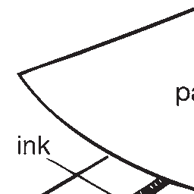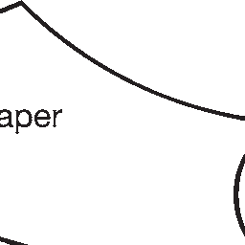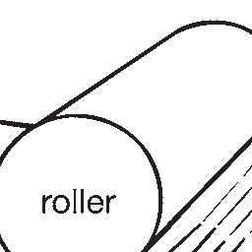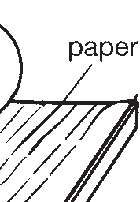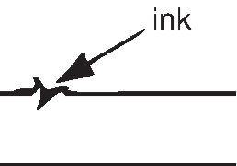
To make an engraving, the artist cuts lines into the polished surface of a metal plate with a burin, or engraving tool. This exacting process takes strength and control. Lines are made by pushing the burin into the metal to carve a groove, removing a narrow strip of metal in the process. A clean line is preferable; thus any rough edges of the groove must be smoothed down with a scraper. Engraved lines cannot be freely drawn because of the pressure needed to cut the grooves. Darker areas are shaded with various types of cross- hatching. A successful engraving therefore requires precise, smooth curves and parallel lines. To see a good example of engraving, look at the United States cur- rency; all of our bills are engravings, made by experts.
PRINTMAKING CHAPTER 8 133
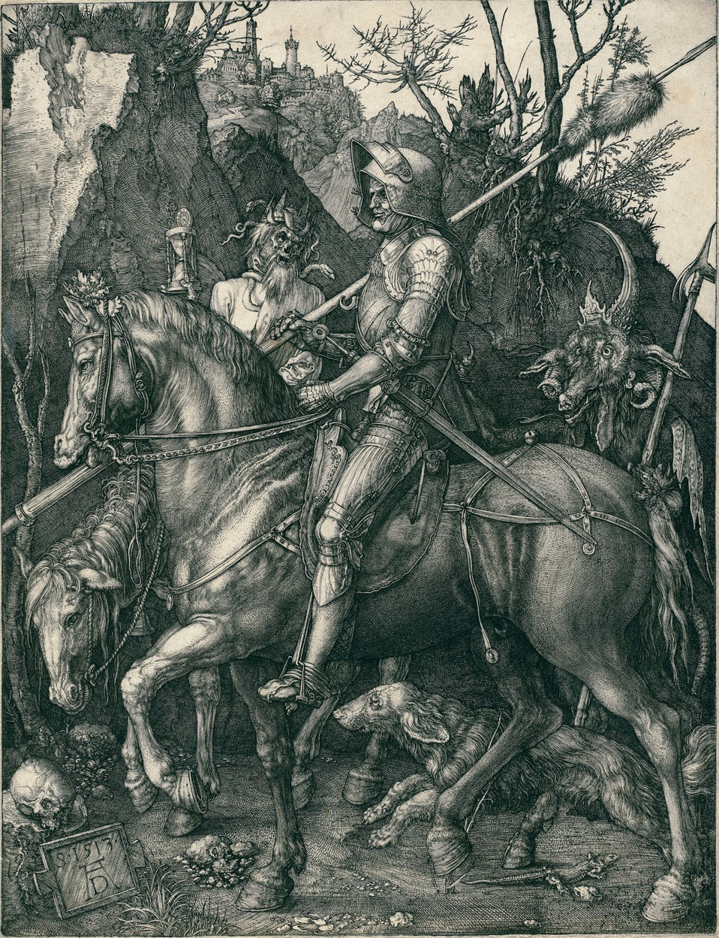
8.10 Albrecht Dürer. The Knight, Death, and the Devil. 1513. Engraving. Plate 95⁄8 ̋ × 71⁄2 ̋.
National Gallery of Art, Washington D.C. Rosenwald Collection 1943.3.3519.
134 CHAPTER 8 PRINTMAKING
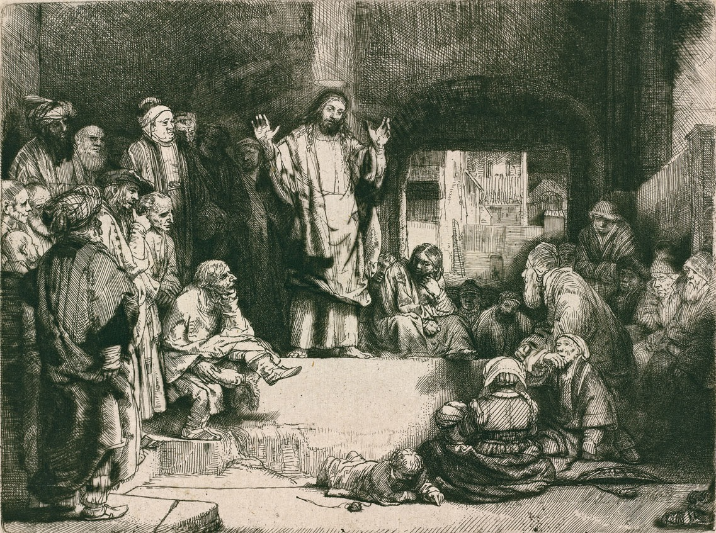
8.11 Rembrandt van Rijn. Christ Preaching. c.1652. Etching, engraving, and drypoint. Plate 61⁄16 ̋ × 81⁄8 ̋. National Gallery of Art, Washington D.C. Gift of W.G. Russell Allen 1955.6.5.
Because they are more easily produced, etched lines are generally more relaxed or irregular than engraved lines. We can see the difference in line qual- ity between an etching and an engraving—the free- dom versus the precision—by comparing the lines in Rembrandt’s etching Christ Preaching (fig. 8.11) with the lines in Dürer’s engraving (see fig. 8.10).
In Christ Preaching, Rembrandt’s personal under- standing of Christ’s compassion harmonizes with the decisive yet relaxed quality of the artist’s etched lines. This etching shows Rembrandt’s typical use of a wide range of values, mostly created through hatching.
Skillful use of light and shadow draws attention to the figure of Christ and gives clarity and interest to the whole image. In a composition in which each figure is similar in size, Rembrandt identified Jesus as the key figure by setting him off with a light area below, a light vertical band above, and implied lines of attention leading to him from the faces of his listeners.
Etching yields only lines, but there is a way to cre- ate shaded areas in intaglio. Aquatint is an etching process used to obtain gray areas in black-and-white or color prints. The artist sprinkles acid-resistant powder on the plate over parts that need a gray tone. When
PRINTMAKING CHAPTER 8 135
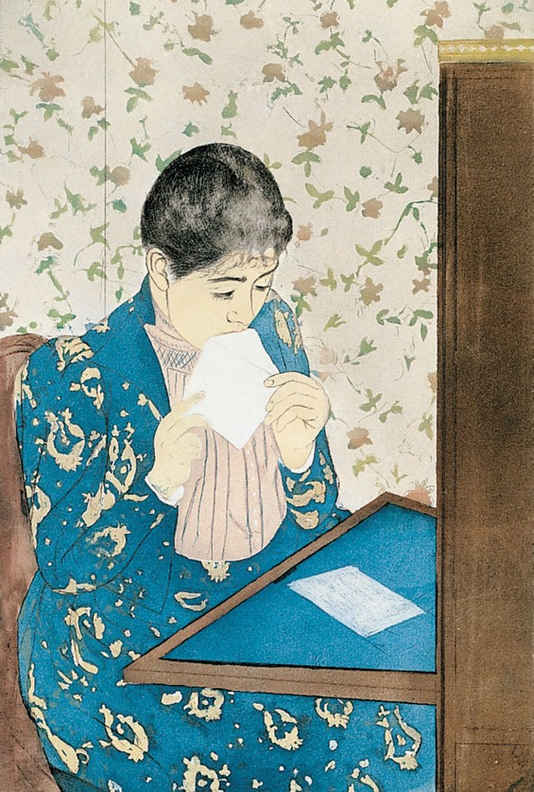
8.12 Mary Cassatt. The Letter. 1891.
Drypoint and aquatint, printed in color from
three plates; fourth state of four. 135⁄8 ̋ × 815⁄16 ̋.
The Metropolitan Museum of Art Gift of Paul J. Sachs, 1916. © 2013 Image
copyright The Metropolitan Museum of Art/Art Resource/Scala, Florence.
the plate is bathed in acid, the exposed areas between the paint particles are eaten away to produce a rough surface capable of holding ink. Values thus produced can vary from light to dark, depending on how long the plate is in the acid and how thick the dusting of powder. Because aquatint is not suited to making thin lines, it is usually combined with a linear print process such as engraving or etching.
American artist Mary Cassatt combined a few inta- glio techniques in her work The Letter (fig. 8.12). She made the colored areas with aquatint; she scratched the lines in the surface of the plates with drypoint. She used three plates, one for each color.
Because the acids used in intaglio printing are highly toxic and give off potent fumes, many con- temporary intaglio artists are drawn to new nontoxic methods. Some of these involve using different chemi- cals, such as dry citric acid or ferric chloride powders, in place of the nitric acid bath. Another method is electroetching, in which a low-wattage electric current is passed through a solution of sulfate salts in water. This process yields a nonacidic bath that will etch a plate without endangering the health of the artist.
Lithography
Etching and engraving date from the fifteenth and sixteenth centuries, respectively; lithography was per- fected in the early nineteenth century.
Lithography is a surface or planographic printing process based on the mutual antipathy of oil and water (fig. 8.13). Lithography lends itself well to a direct manner of working because the artist draws an image on the surface of the stone or plate, without any cut- ting. Its directness makes lithography faster and some- what more flexible than other methods. A lithograph is often difficult to distinguish from a crayon drawing.
Using litho crayons, litho pencils, or a greasy liquid called tusche, the artist draws the image on flat, fine-grained Bavarian limestone (or on a metal surface that duplicates its character). After the image is complete, it is chemically treated with gum arabic and a small amount of acid to “fix” the drawing on the upper layer of the stone. The surface is then damp- ened with water and inked. Water repels the oil-based ink in the blank areas, but ink adheres to the greasy
8.13 Lithography.
Watch a video about the technique of lithography on myartslab.com
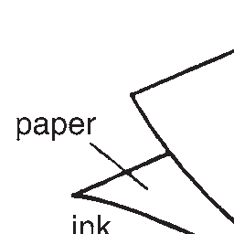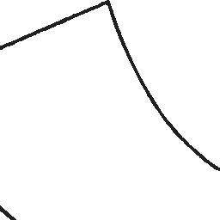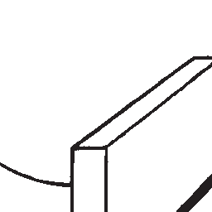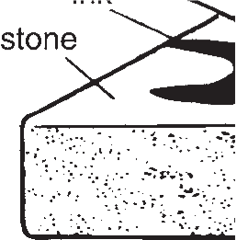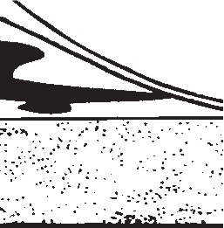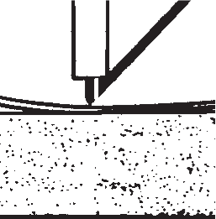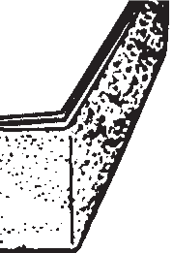
136 CHAPTER 8 PRINTMAKING
area of the image. As in other print processes, when the surface is covered with paper and run through a press, the image is transferred to the paper. Because the surface remains intact, lithographic stones or plates can be reused after cleaning.
Although lithography was a new medium in the early 1800s, it had a major impact on society because prints could be produced quickly and easily. Before the development of modern printing presses, it provided the illustrations for newspapers, posters, and hand- bills. Honoré Daumier, one of the first great litho- graphic artists, made his living drawing satirical and documentary lithographs for French newspapers. His personal style was well suited to the direct quality of the lithographic process.
In Rue Transnonain (fig. 8.14), Daumier care- fully reconstructed a horrible event that occurred
during a period of civil unrest in Paris in 1834. The militia claimed that a shot was fired from a building on Transnonain Street. Soldiers responded by entering the apartment and killing all the occupants, including many innocent people. Daumier’s lithograph of the event was published the following day. The lithograph reflects the artist’s feelings, but it also conveys informa- tion in the way news photographs and Web sites do today. Rembrandt’s influence is evident in the compo- sition of strong light and dark areas that increase the dramatic impact of Daumier’s image.
The leading European printmaker of the late nine- teenth century, Henri de Toulouse-Lautrec, created many of his most innovative works using lithography. In the space of about ten years, he created hundreds of posters that advertised everything from nightclub acts to bicycles. His use of bright colors and flattened,
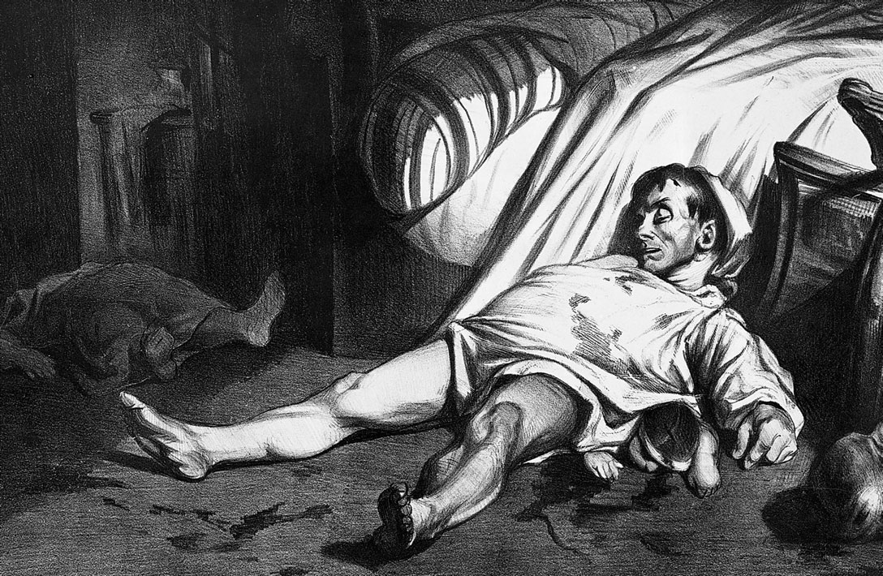
8.14 Honoré Daumier. Rue Transnonain, April 15, 1834. 1834. Lithograph. 111⁄4 ̋ × 173⁄8 ̋. © The Cleveland Museum of Art, 2001. Gift of Ralph King. 1924.809.
PRINTMAKING CHAPTER 8 137
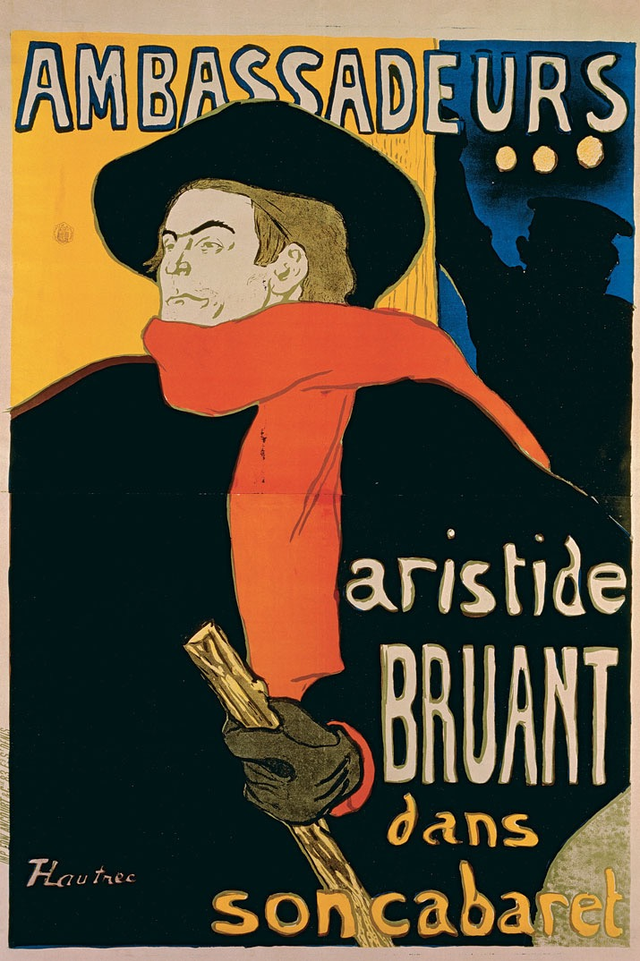
8.15 Henri de Toulouse-Lautrec. Ambassadeurs: Aristide Bruant. 1892.
Color tusche and spatter lithograph. 5215⁄16 ̋ × 361⁄4 ̋.
The Baltimore Museum of Art: Nelson and Juanita Greif Gutman Collection, BMA 1951.69.4. Photography by Mitro Hood.
modern compositions influenced graphic designers for several decades. Among his most vivid works is Ambassadeurs: Aristide Bruant (fig. 8.15), the poster that he created for Aristide Bruant’s engagement at an upscale nightclub (see facing page).
Most books that have pictures are printed today with a version of lithography called offset.
Each page image is burned onto a metal litho- graphic plate and then inked, but the ink is first transferred, or offset, onto a rubber cylinder before printing on paper. This method, which is suited to rotary presses, gives uniform ink depth across an entire printing. It is used to print this book and many others.
138 CHAPTER 8 PRINTMAKING
FORMING ART
Henri de Toulouse-Lautrec (1864–1901): Printing from Life
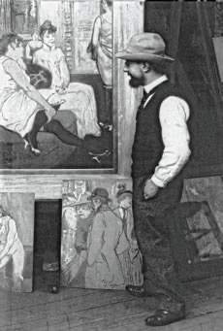
8.16 Henri de Toulouse- Lautrec in his studio.
Photograph courtesy of Patrick Frank.
The cabaret singer Aristide Bruant provides an important key to the work of Henri de Toulouse-Lautrec, because the two were friends who inhabited the nocturnal world of the bar and the nightclub. The artist’s relationship with Bruant helped to shape some of his lithographic creations.
Bruant as a teenager had lived in the poor neighborhoods of Paris, where he befriended people on both sides of
the law. He even obtained passes to enter the prison of
La Roquette, where executions were carried out. Bruant used these experiences in his songs, which were laden with sad social commentary about the poor and the desperate. He was among the most popular singers of the day.
When Bruant opened his own cabaret in 1885, Toulouse- Lautrec became one of its most
devoted patrons; the following year, the singer put the artist’s work on permanent display
at the club. Toulouse-Lautrec
in turn created a lithographic portrait of Bruant (fig. 8.17). In this work, we see the singer’s unconventional attire, with broad-brimmed hat and bright neck wrap.
We also see the artist’s
fluid and creative use of the lithographic medium. He used crayons of various widths for the lines, and tusche for the solid dark areas. He created the white patches at the right by dropping melted wax on the stone, keeping ink away from that part. The speckles were created by spattering, as he flicked the bristles of an ink- laden brush.
For ten years, Bruant’s cabaret flourished; his act, which included taunting the audience, drew crowds of people who made the trek out to the somewhat shady neighborhood of Montmartre. There they saw the aloof and somber singer perform his tragic songs.
When the upper-crust nightclub Les Ambassadeurs lured Bruant for an engagement in its fashionable area of Champs Elysées, the singer commissioned Toulouse- Lautrec to design a poster (see fig. 8.15). He responded with a rich creation in five colors, composed of a few, mostly flat, shapes in a large format unusual for that time. Each color required a separate lithographic stone. The deep blue area at the upper right
is a doorway where a sailor stands. Bruant’s body fills most of the frame, bringing him close to the picture surface, overlapping the name of
the club at the top. The two zones of the flaming red
scarf converge near Bruant’s head, leading us to the singer’s distant and somewhat haughty demeanor in his face. Toulouse-Lautrec specialized
in capturing such reserved emotional states. The poster also reflects Toulouse-Lautrec’s careful study of Japanese printmakers, who often used
flat shapes in bright colors to depict nightlife scenes.
This poster was not an immediate success; the Ambassadeurs manager disliked the bold design, which was novel for its day. But Bruant loved it: “Am I that grand?” he reportedly remarked.3 He insisted
that hundreds be printed and plastered across Paris. They survive to this day, the originals mostly in museums, and many knock-off copies everywhere else.
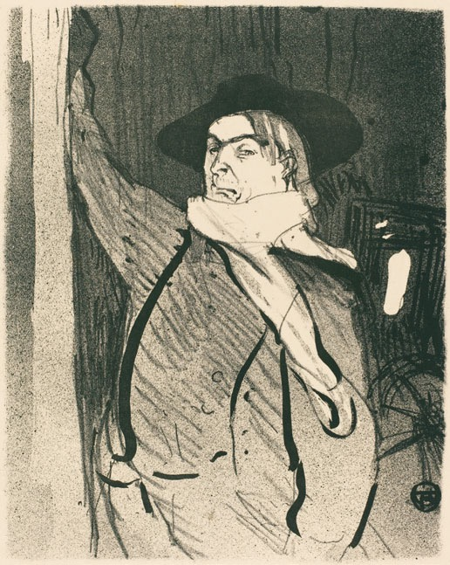
8.17 Henri de Toulouse-Lautrec.
Aristide Bruant. 1893. Lithograph. 101⁄2 ̋ × 81⁄4 ̋. National Gallery of Art, Washington D.C. Rosenwald Collection 1947.7.169.
PRINTMAKING CHAPTER 8 139
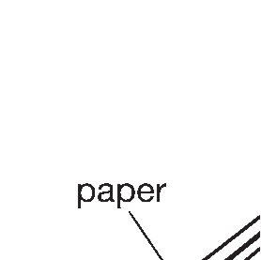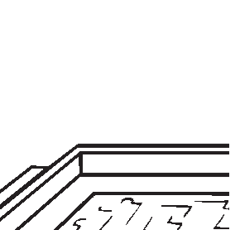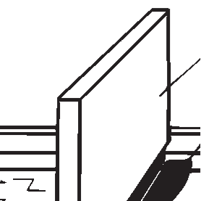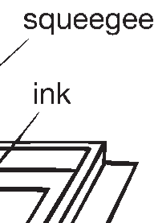
Stencil and Screenprinting
In simplest terms, a stencil is a sheet with a design cut out of it; painting or spraying over the sheet transfers the design to the picture plane. Stencils are a quick way of making lettering or repeated designs on walls, but here we will consider them as a method for mak- ing multiple works of art.
Stencils are a favored method of street artists who communicate political messages, because they permit fast fabrication without the need for redrawing each time. (One such work, by the well-known street art- ist Banksy, is pictured in fig. 25.25.) A few stencil art- ists make objects of more subtle design, however. One of these is Kim McCarthy, a Seattle-based artist who
8.19 Screenprinting.
Watch a video about the process of
silkscreen printing on myartslab.com
also uses the alias Urban Soule. Her Urban Buddha (fig. 8.18) shows many repeated patterns in the back- ground that she achieved with stencils using blue and green paint. The black skulls and the dominant Buddha image were also sprayed through stencils. The draw- back to using stencils is that only positive and negative spaces are produced; shading is not possible. McCarthy overcame this difficulty by adding many colors, brush- strokes, and paint drips. The trails of black and white paint suggest the quick execution of street art.
Screenprinting is a refinement of the technique of stencil printing. Early in the twentieth century, stencil technique was improved by adhering the stencil to a screen made of silk fabric stretched across a frame (synthetic fabric is used today). With a rubber-edged tool (called a squeegee), ink is then pushed through the fabric in the open areas of the stencil to make an image of the stencil on the material being printed (see Screenprinting diagram, fig. 8.19). Because silk was the traditional material used for the screen, the process is also known as silkscreen or serigraphy (from the Latin for silk, sericum).
Screenprinting is well suited to the production of images with areas of uniform color. Each separate color requires a different screen, but registering and printing are relatively simple. There is no reversal of the image in screenprinting—in contrast to relief, intaglio, and lithographic processes in which the image on the plate is “flopped” in the printing process. The medium also allows the production of large, nearly mass-produced editions without loss of quality.
Silkscreen printing thus lends itself to poster pro- duction, and many social movements have allied them- selves with silkscreen artists to help spread the word about their causes. For example, Ester Hernández
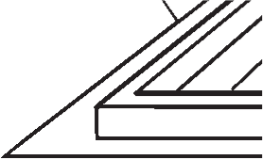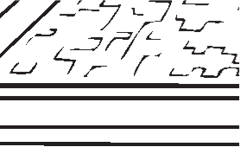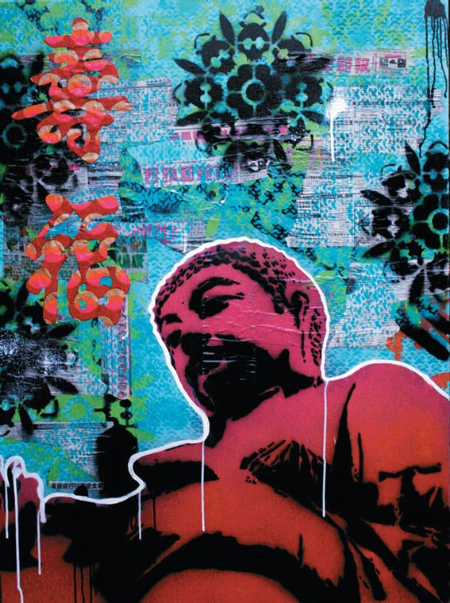
8.18 Kim McCarthy. Urban Buddha. 2009.
Stencils and mixed media on canvas. 36 ̋ × 48 ̋. Kim McCarthy.
140 CHAPTER 8 PRINTMAKING
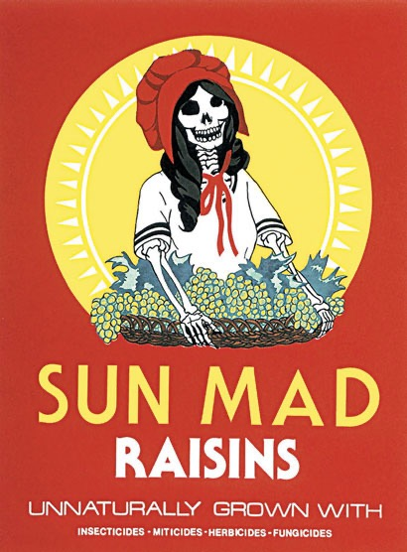
- 8.20 Ester Hernández. Sun Mad. 1982 Silkscreen. 22 ̋ × 17 ̋.
Courtesy of the artist.
- 8.21 Elizabeth Murray. Exile from Thirty-Eight. 1993.
Twenty-three color lithograph/screenprint
construction with unique pastel application by the
artist. 30 ̋ × 23 ̋ × 21⁄2 ̋. Thirty-eight unique works.
© 2013 The Murray-Holman Family Trust/Artists Rights Society (ARS), New York.
View the Closer Look for Elizabeth Murray’s Exile on myartslab.com
made hundreds of posters that asserted Chicano identity and denounced the working conditions of Mexican-American laborers. Her screenprint Sun Mad (fig. 8.20) is both an excellent example of silkscreen art and a memorable protest against the use of pesticides.
The latest development in screenprinting is the photographic stencil, or photo screen, achieved by attaching light-sensitive gelatin to the screen fabric.
Elizabeth Murray’s Exile (fig. 8.21) takes screen- printing and stenciling to the limit. The base of this work is a piece of irregularly shaped yellow board embossed with a pattern and screenprinted with a design based on newspaper pages. Above this she laid a jagged and perforated blue sheet, which was also silkscreened and lithographed with colors. Finally, she cut a large piece of red paper, screenprinted and lithographed on it, and then set it above the other two layers. All the layers show hand-drawn crayon and pencil marks along with the printed colors. The artist describes Exile as a “23-color lithograph and screen- print construction with collage and pastel.”4
Contemporary Approaches
Experimental printmaking in recent years has taken on new types of printing materials, and digital technol- ogy. More artists are also taking the idea of multiple artworks into the third dimension. Each of these has altered the boundaries of the medium.
African-American artist Ellen Gallagher leafed through stacks of 50-year-old magazines directed at a black audience, and borrowed advertisements that encouraged people to erase their blackness in various ways. She digitally scanned these ads and then altered them by affixing mold-made plasticine shapes to their surfaces (fig. 8.22). “Mr. Terrific” is one of 60 panels that make up the larger work Deluxe. In this panel we see a man holding a can of hair straightener called Johnson’s Ultra-Wave, which the ad says “will make you really proud of your hair.” Gallagher satirized this 1950s attempt at self-fashioning by attaching a huge yellow blob that covers both hair and eyes. She said of this work: “I’m creating fiction on top of an existing readability.”5 All 60 panels of Deluxe were made in an edition of 20.
Digital technology has altered printmaking at a basic level by eliminating the tangible plate. A digital
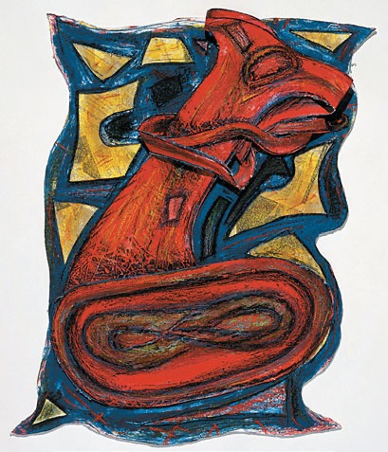
PRINTMAKING CHAPTER 8 141
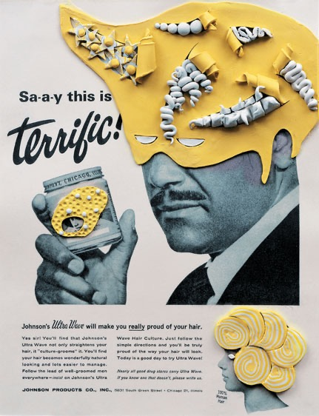
8.22 Ellen Gallagher. “Mr. Terrific” from Deluxe. 2004–2005. Aquatint, photogravure, and plasticine. 13 ̋ × 10 ̋.
© Ellen Gallagher. Courtesy Gagosian Gallery.
matrix is made not by hand but with a keyboard and mouse. Some artists make digital prints using paint- ing and photo-editing programs, and then erase the matrix files when the “edition” is complete. This technology allows for the creation of prints that are not original in the traditional sense because they are infinitely reproducible. In 2007, the English duo Gilbert and George (who do not use their last names) made a print available for free downloading on the Internet for 36 hours. The edition was limited not by the number of downloads, but by the clock.
Many printmakers today combine printmaking techniques with other kinds of media. One of these is Nicola López, who uses woodcut and lithography to create installations that are specific to each exhibition. In her 2006 work Blighted (fig. 8.23), she printed on Mylar, a transparent film. Her images of shattering buildings and tumbling structures are based on her memories of the attacks of September 11, 2001.
Related to the print is the editioned work, in which artists create molds that can generate a limited number of three-dimensional works. Artists make editioned
works for many of the same reasons that they made prints in the past. Like a traditional print, an editioned work is made in multiple copies, but it may or may not use the traditional techniques. In a recent editioned work, Walter Martin and Paloma Muñoz borrowed the format of the snow globe to create haunting works with scenes of danger. Their series Travelers shows tourists and hikers in pre- carious positions. In Traveler CLXXXVI (fig. 8.24), a snow- bound hiker has stumbled on a rabbit hole which is occupied by two very large specimens of menacing size. The mysteri- ous atmosphere of this work collides in a darkly humorous
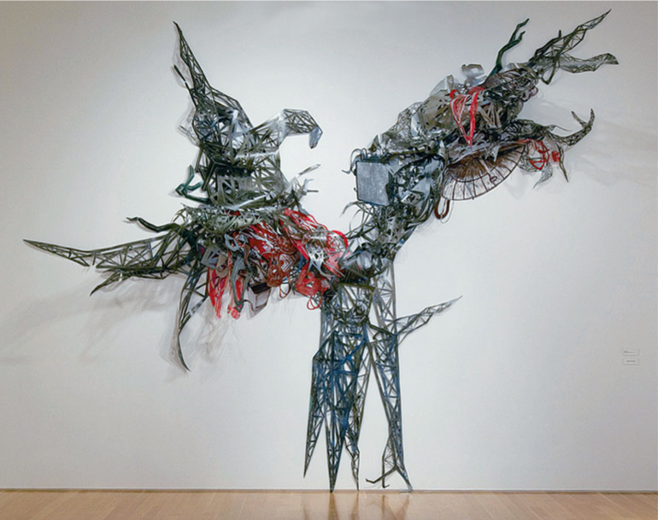
8.23 Nicola López. Blighted. 2006. Woodblock and lithography on mylar. 20 ́ × 22 ́. Caren Golden Fine Art/Nicola Lopez.
142 CHAPTER 8 PRINTMAKING
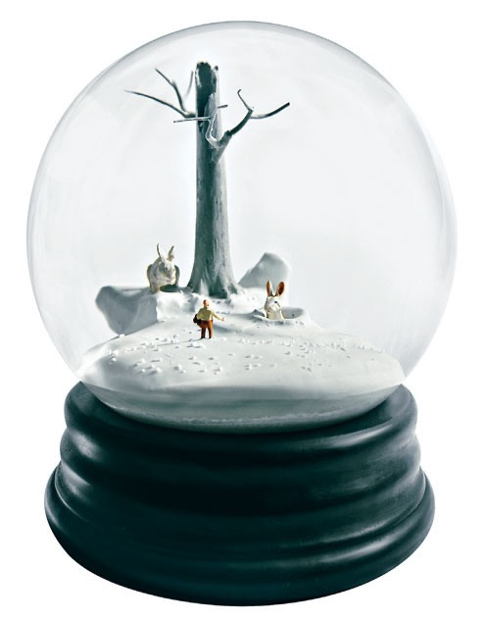
8.24 Walter Martin and Paloma Muñoz. Traveler CLXXXVI. 2006. Mixed media.
9 ̋ × 6 ̋ × 6 ̋.
2006 © Walter Martin & Paloma Muñoz.
way with the cheap and sentimental prototype of the snow globe. The artists created this work in an edition of 250, filling the globe with plastic snowflakes like the souvenir-shop versions that they parody. Shaking the globe only adds to the scene’s humorous aspect.
As we have seen in the examples in this chapter, prints have been used throughout the centuries to pro- duce multiple copies of an image. Because printmaking is less expensive than other media, and can be more eas- ily distributed, works can reach a wider audience.
Study and review on myartslab.com
THINK BACK
- Why do artists make prints?
- What are the principal techniques
of printmaking?
- How are today’s artists varying the traditional techniques?
TRY THIS
In 2009, the Associated Press filed a copyright lawsuit against the artist Shepard Fairey for his use
of a news photo of President Barack Obama in a lithographic poster titled “Hope.” Fairey claimed that he had transformed the photo enough that the poster amounted to a new creation. The case was settled in 2011 under terms that neither party was allowed to disclose. Research the case with online materials, and form an opinion: How original was Fairey’s print?
K E Y T E R M S
intaglio – any printmaking technique in which lines and areas to be inked are recessed below the surface of the printing plate
matrix – the block of metal, wood, stone, or other material that an artist works to create a print
offset lithography – lithographic printing by indirect image transfer from photomechanical plates
registration – in color printmaking or machine printing, the process of aligning the impressions of blocks or plates on the same sheet of paper
relief printmaking – a technique in which the parts of the printing surface that carry ink are left raised, while remaining areas are cut away
screenprinting – a technique in which stencils are applied to fabric stretched across a frame and paint or ink is forced through the unblocked portions of the screen onto paper or another surface beneath
PRINTMAKING CHAPTER 8 143

