1.GRAM POSITIVE COCCI - Dichotomous Key (she want atleast 6 listed from video)
Videos FOR question
https://youtu.be/Cv-R1TT3txQ
https://youtu.be/ChEByq75Me0

After making a List and Chart of the organisms reviewed in the videos a dichotomous key using the various characteristics and test results that can used. .
ALL ORGANISMS MUST BE KEYED OUT AND SUCCESSFULLY STAND ALONE TO COMPLETE THE KEY SUCCESSFULLY. PLEASE MAKE A CHART LIKE THIS WITH THE LIST HIGHLIGHTED ABOVE.
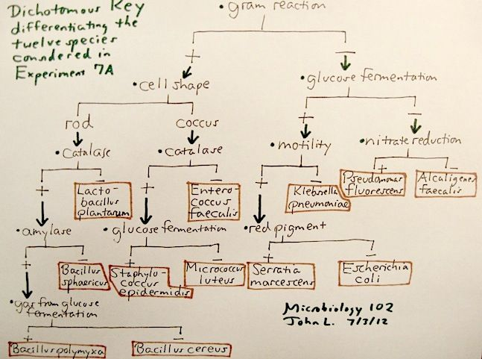

2. Gram Positive Bacilli (Rods). You will be responsible for creating a chart indicating the different characteristics of the organisms covered in the videos. Please note: the videos must be watched to gain the information. WATCH THE VIDEO: https://youtu.be/hapLalUP8As
After making a list of the organisms reviewed in the videos, create a chart using at least 10 different characteristics.
Example of the Chart this is what it should look like
