Name:
Instructor:
Course:
Date
Question 1
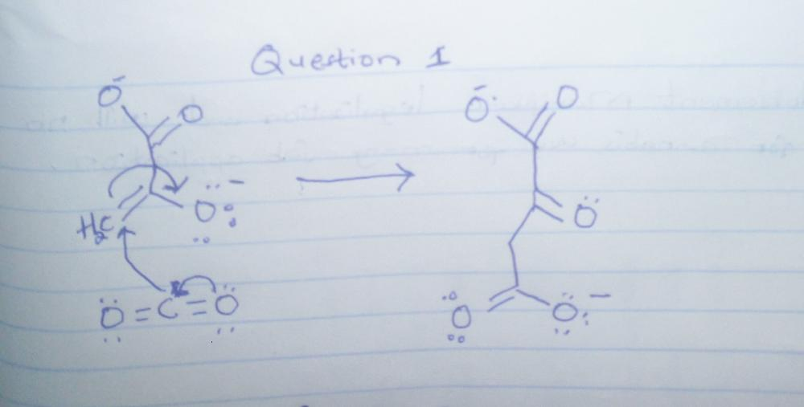
Question 2
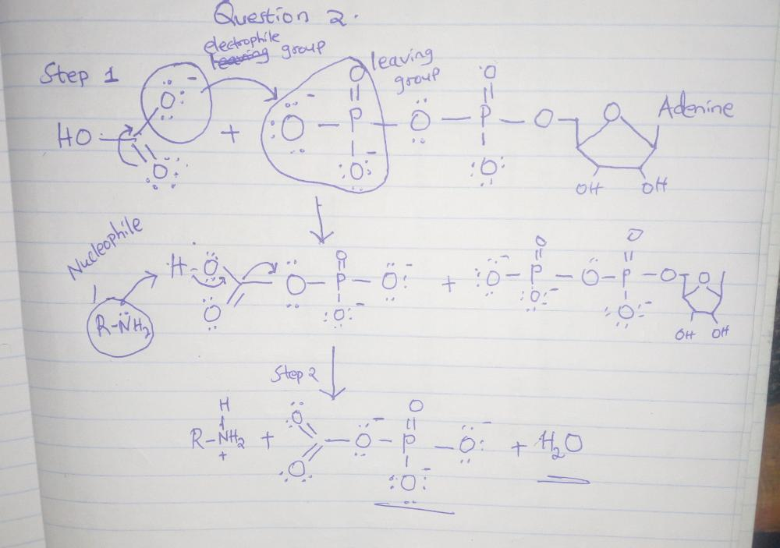
Question 3
Why ethyl acetate wouldn’t undergo hydrolysis at neutral pH
This is because hydrolysis of ethyl acetate without presence of acid cannot give acetic acid and ethyl alcohol thus wouldn’t occur.
Question 4
Why reaction of hydroxide and bromomethane would not give hydrogen hydride and bromomethanol?
Water cannot be used as a nucleophile under normal circumstances therefore no nucleophilic substitution can occur.

