Atomic structure, chemical bonding, Lewis structure, and 3D molecular shape
Institutional Affiliation
Student Name
Professor Name
Course
Date

Group 1
I have selected CH₄ and PCl₃ for my experiment.
Methane CH₄ is a non-polar covalent bond compound. They slightly differ in their electronegativity. Therefore carbon and hydrogen share the electrons equally.
PCl₃ is formed by a polar covalent. Chlorine has a higher electronegative charge than phosphorous. This leads to the presence of lone pair electrons at the top of the molecule.
Data table
CH₄
Chemical formula: CH₄ | Central atom: Carbon
Dot Diagram of each element:  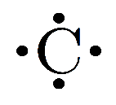 H• | Total # of electrons:  Carbon 4  Hydrogen 1(4)  Total = 8
Lewis Structure (Dot structure) of the molecule:
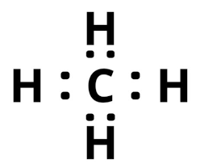

Chemical formula: PCl₃ | Central atom:  phosphorous
Dot Diagram of each element:  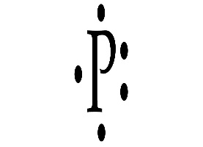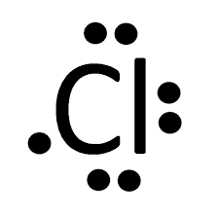 | Total # of electrons:  Phosphorous: 5  Chlorine:7(3)  Total 26
Lewis Structure (Dot structure) of the molecule:
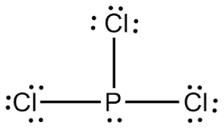

Group 2
I have selected CO₂ and NH₃ for my experiment.
CO₂ has a non-polar covalent bond when in a molecule. This is caused by the presence of two oxygen atoms of equal electronegativity pulling electrons density from the carbon at 180 degrees from each other. That results in no net differential charge in any direction in this molecule.
NH₃ is formed by polar covalent this happens due to the lone electrons at the top of the molecule.
Data table 1 (group2)
Carbon IV oxide (CO₂)
Chemical formula: CO₂ | Central atom: Carbon
Dot diagram of the elements:  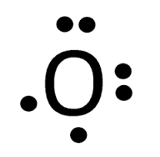 | The # of electrons:  Carbon 4  Oxygen 6(2)  Total 16
Lewis structure(dot structure)
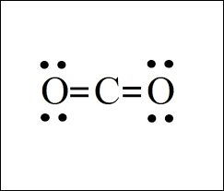

Ammonia NH₃

Chemical formula: NH₃ | Central atom: Nitrogen
Dot diagram of the elements:  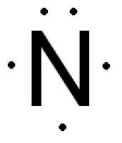 H• | The # of electrons:  Nitrogen 5  Hydrogen 1(3)  Total 8
Lewis structure(dot structure)
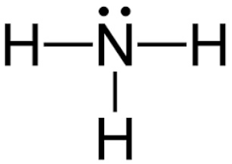

Group 3
For this experiment, I will work on these compounds: BH₃ and BeCl₂
BH₃ has a non –polar covalent bond. This is because both borane (2.04) and hydrogen (2.20) has an electronegativity that’s almost the same. Hence the bond becomes nonpolar.
BeCl₂ forms a non-polar. Beryllium’s two outer electrons bond covalently with two chlorine atoms resulting in no lone pairs. BeCl₂ structure is linear with the symmetric charge distribution around beryllium.
Data table 1 (group 3)
BH₃
Chemical formula:  BH₃ | Central atom: borane
Dot diagram of the element:  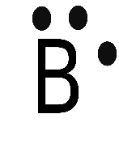 H• | The # of the atoms:  Boron 3  Hydrogen 1(3)  Total 6
Lewis structure (dot structure)
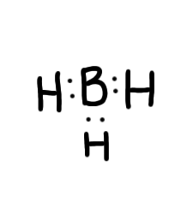

Chemical formula:BeCl₂ | Central atom: beryllium
Dot diagram of the element:  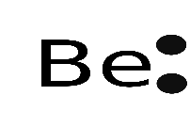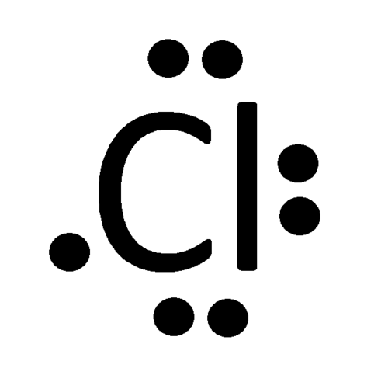 | The # of the atoms  Beryllium 2  Chlorine 7(2)
Lewis structure (dot structure)
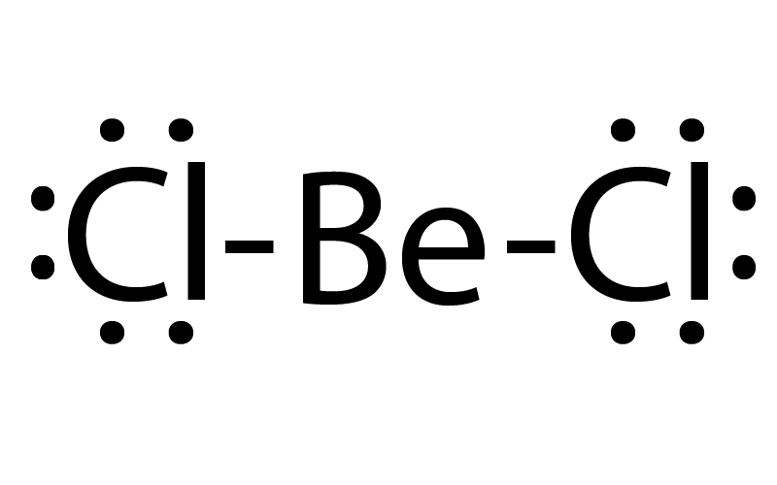

Molecular Geometry
The valence-shell electron-pair repulsion theory is an assumption that atoms in a molecule achieve a geometry that minimizes repulsion between electrons in the valence shell of the atom. the compounds in the table below show how VSEPRT is used.
Data table 2

Chemical formula | # of Electron Domains around Central Atom | Number of lone pairs on the Central Atom | Molecular geometry and Bond Angles  Example: tetrahedral, 109.5 deg
CH₄ | 8 | 0 | 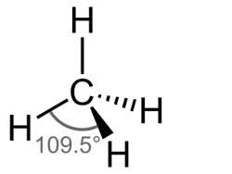
PCl₃ | 26 | 2 | 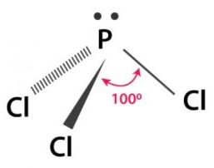
CO₂ | 16 | 0 | 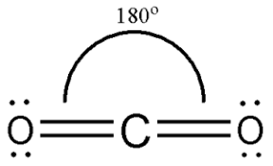
NH₃ | 8 | 2 | 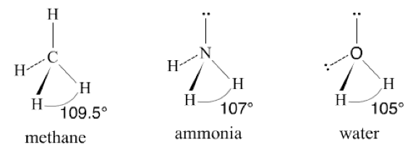
BH₃ | 6 | 0 | 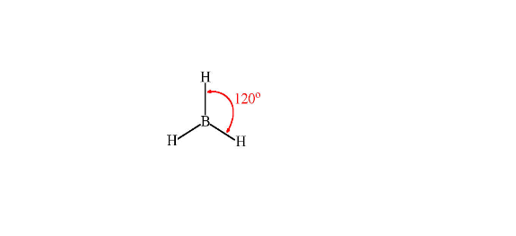
BeCl₂ | 16 | 0 | 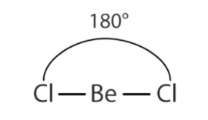

Bonding and Polarity
When atoms combine to form a compound. It is called bonding. Some molecules are formed by covalent bonds by sharing electrons equally while others are formed by ionic bonds by transferring their valence electrons. Bonds are identified by the characteristics they portray. For example, an ionic bond is formed when metals react with non-metals and thus exhibit ionic characteristics. When nonmetals react they form a covalent bond.
They are two types of polarity nonpolar
covalent bond and polarity covalent bond. In non-polarity, electrons are equally shared. Polar covalent are formed when an atom with greater electronegativity attracts the electrons more strongly leading to the formation of lone electrons.
Data table 3
Chemical formula | Unique bonds between atoms | Electronegativity difference for each unique bond | Bond classification | Is it polar or non-polar
CH₄ | C-H | 0.4 for C-H | C-H is a nonpolar bond | CH₄ is nonpolar
PCl₃ | P-Cl | 0.97 for P-Cl | P-Cl is polar | PCl₃ is polar
CO₂ | C-O | 0.89 for C-O | C-O is polar | CO₂ is polar
NH₃ | N-H | 0.84 for N-H | N-H is polar | NH₃ is polar
BH₃ | B-H | 0.16 for B-H | B-H is non-polar | BH₃ is nonpolar
BeCl₂ | Be-Cl | 1.59 for Be-Cl | Be-Cl is polar | BeCl₂ is polar

Reference

Mark B Fischer, B.S. Chemistry, U of California; Ph.D. Inorganic Chemistry, U of Wisconsin-Madison

SEPR Model of Molecular Geometry by Ronald J Gillespie, Istvan Hargittai
John Emsley, The Elements, 3rd edition. Oxford: Clarendon Press, 1998.
Pauling, Linus (1960). The Nature of the Chemical Bond.

