Determination of structure from spectroscopy

1. Determine the molecular formula
The carbon and hydrogen make up most of the structure but some oxygen is present. The oxygen amount is:
$$\%O=100-73.1-7.4=19.5\%$$
If we assume that 100g of the compound is used then:
$$grams C=73.1 g grams H=7.4 g grams O=19.5 g$$
This allows us to calculate the mols of each:
$$mols C=\frac{73.1 g}{12.01 g/mol}=6.09 mols$$
$$mols H=\frac{7.4 g}{1.008 g/mol}=7.34 mols$$
$$mols O=\frac{19.5 g}{15.999 g/mol}=1.22 mols$$
This means we can determine the empirical formula:
$C:H:O$ $6.09:7.34:1.22=\frac{6.09}{1.22}:\frac{7.34}{1.22}:\frac{1.22}{1.22}=4.99:6.01:1≈5:6:1$
Thus the empirical formula is $C_{5}H_{6}O$
The empirical mass is:
$$M\left(C_{5}H_{6}O\right)=5\left(12.01\right)+6\left(1.008\right)+1\left(15.999\right)=82.097 g/mol$$
We can now determine the molecular formula:
$$Molecular formula=empirical formula ×\frac{molecular mass}{empirical mass}$$
$$Molecular formula= C_{5}H_{6}O×\frac{164}{82.097}=C_{5}H_{6}O×2= C_{10}H_{12}O_{2}$$

2. Structural aspects from FTIR
To help determine the structure we need to know the number of rings, double or triple bonds in the molecule. This is the unsaturation number determined as shown below:
$$Unsaturation number (Ω)= \frac{2(C+1)+N-X-H}{2}$$
Where C is carbon, N is nitrogen, X is a halogen (Cl, Br, I etc.) and H is hydrogen. Oxygen does not affect the unsaturation number.
For this molecule:
$$Unsaturation number \left(Ω\right)= \frac{2\left(10+1\right)+0-0-12}{2}=\frac{10}{2}=5$$
This means that there are 5 degrees of freedom.
We will now use the FTIR spectrum, proton NMR and carbon NMR to determine what these degrees of freedom are.
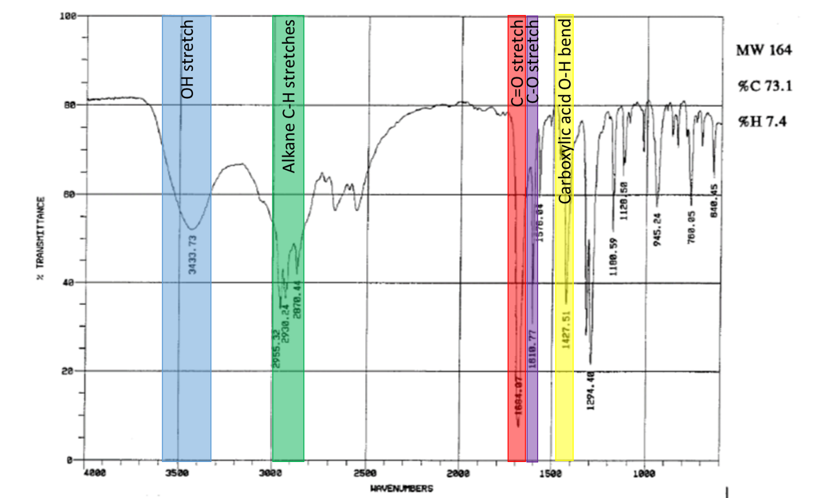

Proton NMR:
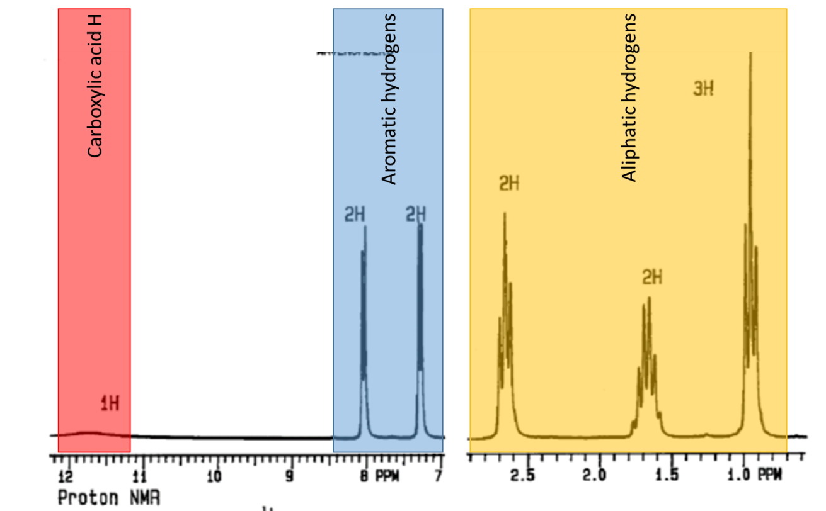
The peak at around 2.5 ppm represents 2 hydrogens and is a triplet. This means there are 2 neighbouring hydrogens (³J coupling). The peak at around 1.6 ppm represents 2 hydrogens but is a sextet meaning it has 5 neighbouring hydrogens. This is likely next to a CH₃ group and a CH₂ group. The peak at around 1.0 ppm represents 3 hydrogens (likely a CH₃ group) and is a triplet. This means it is next to 2 hydrogens, likely a CH₂ group.
Therefore, we can say there is a 3 carbon aliphatic chain attached to an aromatic ring.
The aromatic region shows that there are 2 sets of 2 equivalent hydrogens. This is only possible if the aliphatic chain and the carboxylic acid group are para to each other on the ring.
The unsaturation number of 5 accounts for the aromatic ring (ring and 3 double bonds = 4) and the carbonyl of the carboxylic acid.

Carbon NMR:
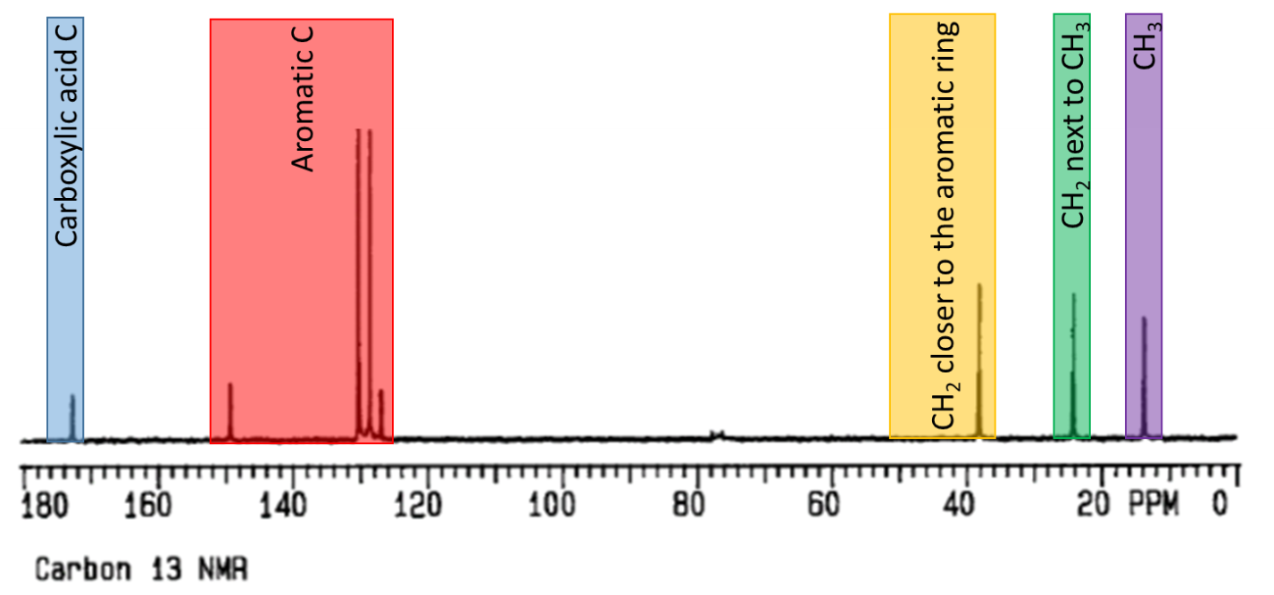
This was primarily used to confirm that the C=O stretch in the FTIR spectrum was a carboxylic acid. It also confirms the aliphatic and aromatic regions seen and described in the proton NMR.

The structure
The ultimate structure is:
