

Executive Summary:

Overview of the Program: Child maltreatment is any form of abuse or neglect on a child under eighteen years by a parent, caregiver, or another person that results in harm to a child. It is a significant public health issue with harmful consequences on the most vulnerable members of the society. Due to increased incidence of Child Maltreatment in Saudi Arabia, preventive and protective programs are needed.
Goal: To reduce incidence of child maltreatment among Saudi children in Riyadh. Objective: To reduce child maltreatment incidence among Saudi population in Riyadh by 10%, by 2022.
Methods: A PRECEDE-PROCEED planning model has been used as guide to build and provide structure and organization of the program. Moreover, stakeholder analysis is used in order to involve all desired stakeholders to planning the intervention as well as implementing it.
Evaluation: Quasi-Experimental Pre-test-post- test design used to answer research question which is “Did the incidence of child maltreatment decrease in Riyadh city after implementing “prevention of Child Maltreatment Program?”. This design commonly found in evaluations of health promotion programs using a comparison group but it has some limitations such as none random assignment and time and money consuming.
Conclusion/ Recommendation: Our new intervention strategies are expected to achieve the goal of the program which reduce the incidence of child maltreatment among Saudi children in Riyadh. Further programs with distinct strategies should be implemented and executed on larger sample size for better outcomes.

Topic/ target group:
Target population of the program entitled “Prevention of Child Maltreatment among Saudi Population” is Saudi parents who have one child or more aged 18 years old or less in Riyadh.

Needs assessment:
Child maltreatment is worldwide issue with vigorous impact on the child's’ life and has a severe consequence affecting not only the child himself but the whole society. WHO define child maltreatment as: “All forms of physical and/or emotional ill-treatment, sexual abuse, neglect or negligent treatment or commercial or other exploitation, resulting in actual or potential harm to the child’s health, survival, development or dignity in the context of a relationship of responsibility, trust or power.’’ (1).
The prevalence of child maltreatment differs globally from one type to another depending on the community, society and the family/caregivers condition. 1 out of 4 adults were physically abused when there were children, worldwide. On the other hand, psychological abuse estimated by WHO to be the most prevalent kind of abuse in the world by 36% while physical abuse comes subsequently by 23% (2).
In Saudi Arabia year of 2000, child maltreatment has been first recognized as a public issue through the national media that focused on lacking policies and regulations. Since then, multiple governmental agencies and NGOs established for the goal of child protection and worked to release the Child Protection Act in 2013. (3)
In 2005 Royal Decree instructed to form the National Family Safety Program (NFSP) that aimed to prevent child maltreatment and domestic violence. In 2007 they established Child Protection Centres CPCs in big hospitals around the kingdom and creates Child Protection Team that evaluate any suspected child abuse case reported from the hospitals. Intervention made based on the cases reported with help of the social services and any confirmed physical or sexual abuse referred for further investigation to the police office. Also, they established a National Family Safety Registry and obligate healthcare professionals and school professionals to reporting any suspected case to the registry. Another big step in 2010 was made by the NFSP is creating a 24 hours helpline (116-111) operate the whole week for counselling services. (3) Cases of child maltreatment in Saudi Arabia have been increasingly recognized and reported especially after the release of child protection regulation in 2013. Fig.1 (2)(4). Recent report

from the NFSR in 2016 stated that physical abuse and neglect were greater than any other types of maltreatment (3) Fig.2.
Several studies suggested that child maltreatment has many risk factors. Its varies between communities and individuals according to the perception and awareness of the issue. Poverty strongly associated with child abuse or neglect and considered as a major risk factor. This correlation doesn't mean that poverty will lead to abuse or neglect. Instead, its environmental trigger that will increase the prevalence of abuse in presence of poverty (5).
This preview shows how complex is the issue. Such factors difficult to control nor change like poverty. Others, with good management and proper care can be altered through an extensive prevention program with authority's support. However, most of the efforts in Saudi Arabia had been focused toward protection rather than prevention, therefore, we emphasize the need in having preventive program to reduce child maltreatment in the community through addressing all associated health determinants that lead to it (2).
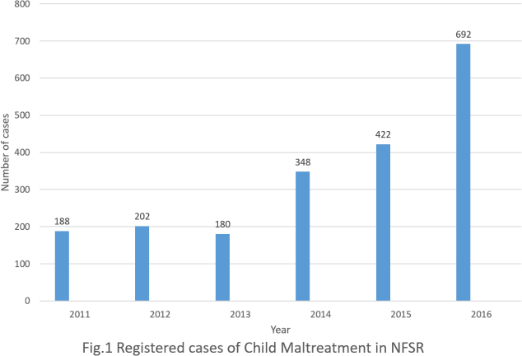
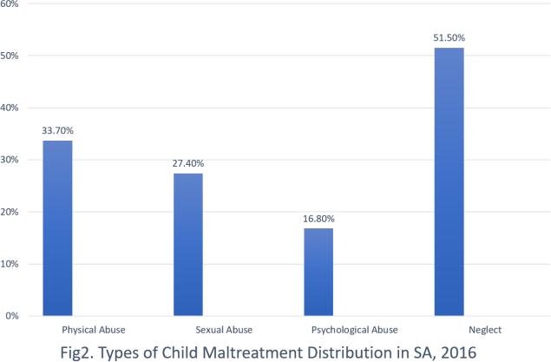

Limitation:
NFSP stopped to report each form of child maltreatment separately after 2016. Majority of reported maltreated cases were neglect and physical abuse in Saudi Arabia due to cultural norms that might refuse to report other forms of maltreatment. Unfortunately, there are no programs existing particularly for child maltreatment protection and prevention as well as lack of precise statistics to represent child maltreatment rate that belonged to each Saudi city.

Theoretical/ Conceptual Framework:

Based on PRECEDE-PROCEED planning model, we address the current situation of child maltreatment among Saudi population in Riyadh and assess multilevel determinants and

needs as well as develop a plan to achieve the desirable future. Furthermore, this framework will guide us also to develop vision, mission, goal, objective, and subobjectives of our program.

PRECEDE- PROCEED framework:

Planning Phase
What can be achieved? What needs to be changed to achieve?
PRECED

Phase 4  Educational/ ecological Assessment | Phase 3  Behavioural &Environmental Assessment | Phase 2  Epidemiological Assessment | Phase 1  Social Assessment

Predisposing:
Behavioural:
-Undesirable children behaviour.
-Child inability to tell or defend in case of being maltreated
- Lack of parental skills.
-Children left at home with caregivers.
-Addicted/ drunken parent.
-Misdiagnosis of maltreated cases.
-Under-reporting of cases from healthcare workers

We completed this step and selected child maltreatment as prevalent health issue calling for program planning and intervention.
- Parents unaware about the needs of their children.
- Lack of knowledge about laws of children maltreatment.

Reinforcing:

- Lack of commitment to available guidance and policies of child maltreatment.
- Cultural norms

Enabling:

- Lack of training courses for health professionals (medical, psychiatric, and social).
- Poor accessibility to hotline services.

Environmental:
-Limited child protection centres and multi-specialized team.
-Lack of educational programs about prevention of child Maltreatment.
-Unsafe homes.

Based on statistics were conducted in KSA by the National Family Safety Program NSFP on 2016, they stated the prevalence of each form of child maltreatment as shown below:
- Physical 33.7%
- Sexual 27.4%
- Psychological 16.8%
- Neglect 51.5%

LOW
Phase 5 Administration &  policy diagnosis | Phase 6 Implementation | Phase 7  Process evaluation | Phase 8  Impact evaluation | Phase 9  Outcome evaluation
PROCEE

The aim of selecting this conceptual framework:
    - It helps us to achieve the desired outcomes through a clear plan of the study objectives.
    - It illustrates the health determinants or risk factors of child maltreatment
    - It gives the stakeholders to be engaged effectively in the whole process.

Limitations of this model:
Financial and human resources are a dilemma with huge lack of qualified experienced social workers who are essential for program success.

1.4 Stakeholder analysis
HIGH

Protect | Good Relations
- Children: Educational awareness campaigns to teach children about child maltreatment and how to defend themselves.  - Friends, neighbors, and Relatives: Involve them in decreasing child maltreatment in our community. | MOH, MOE, Ministry of labor and social services, Parents, Ministry of Interior.  -Engaging MOH as major decision-making body, in providing health resources, training health workers, diagnosis of cases and in developing educational material.  Ministry of labor and social services:  -Responsible for developing policy and regulation.  -Developing awareness programs for the whole community to support children and their families, protect children from maltreatment and educate them how to report cases.  Parents: are primary responsible for children basic needs and wellbeing.  Ministry of Interior: Collaborate with hospitals and social services.  Ministry of Education: Source of information and facilitate educational programs.
Low priority | Monitoring
 | - Engaging Media to support the program through disseminating awareness among public population and highlighting program successes.

INFULENCE
HIGH

Part 2: Program Planning

Vision

Society free from child maltreatment.

Mission

Prevention of child maltreatment among children in Riyadh through developing and implementing preventive program in cooperation with government and institutes.

Goal

‘’To reduce incidence of child maltreatment among children in Riyadh.’’

Main Objective of Child Maltreatment

“To reduce child maltreatment incidence among children by 10% in Riyadh, by 2022.”

Subobjectives Targeting behavioural factors:
- By 2021, increase number of reported cases about child maltreatment among Saudi population in Riyadh by 30%.
- By 2020, decrease number of children left at home with caregivers in Riyadh by 30%.

Targeting environmental factors:

- By 2020, increase number of centres providing care for child maltreatment in Riyadh by 10%.
- By 2021, increase number of educational programs about prevention of child maltreatment in Riyadh by 40%.

Program action plan

Total timeframe of the program From January 2019 to December 2022.

Behavioural sub-objective: By 2020, decrease number of children left at home with caregivers in Riyadh by 30%.
Strategy | Activity | Timeframe | Person responsible | Resources required | Measures of success
1- Facilitate access to day care centres.  [Environmental change strategy, enabling- oriented] | - Conduct meetings with heads of labor to emphasize the importance of having day care centers at their organizations for employees. | From January 2019 to  June 2020  (18  months) | - Shaden | - Budget  - Suitable safe buildings.  - Available places at work to create day care centers. | Access to day care centres facilitated.
 | - Meet with private organizations to make day care centers affordable and accessible.
2- Raise parents’ awareness [Education strategy, predisposing- oriented] | - Conduct educational sessions for parents. | From June 2019 to October 2019  (four months) | - Sahar | - Suitable  Auditorium.  - Literature- based knowledge  - Budget for education material. | Parents` awareness increased.
 | - Create videos about how caregivers may abuse children.

Environmental sub-objective: By 2020, increase number of centres providing care for child maltreatment in
Riyadh by 10%.
Strategy | Activity | Timeframe | Person responsible | Resources required | Measures of success
Propose a research addressing the gap  [Educational strategy, predisposing oriented] | - Collect statistical data about center / population ratio. | From January 2019 to  June 2019 (six months) | - Fatimah  - Dareen | - Budget  - Researchers  - Time  - Venue  - Office  stationary | Research proposed.
 | - Conduct educational sessions to increase reporting of child maltreatment cases.
Facilitate licences for care centres  [Policy strategy, reinforcing oriented] | - Conduct meeting with policy makers to explain the importance of  increasing day care centers. | From June 2019 to December 2019  (six months) | - Jumana | - Time.  - Policy  makers.  - Venue. | Licences for care centres facilitated.
 | - Collaborate with Licensing Authority offices which will facilitate the application process for licenses at affordable prices.

Part 3: Program Evaluation

Evaluation question:

Did the incidence of child maltreatment decrease in Riyadh city after implementing “prevention of Child Maltreatment Program”?

The evaluation design:

Quasi-experimental design results in interpretable and supportive evidence of program effectiveness, but usually cannot control for all factors that affect the validity of the results. There is no random assignment to the groups, and comparisons are made on experimental and comparison groups. Each consist of 70 parents who have at least one or more child aged 18 years old or less in Riyadh with measurement of both groups one month before implementation to set a baseline measurement and one month after program implementation.
Evaluation design: Quasi-Experimental design- Pre-test-post- test design

- Experimental group O1 X O2

- Comparison group O1 O2

where: O1 = pre-test scores- 1 month before implementation

X = prevention of Child Maltreatment Program implementation O2 = post-test scores- 1 month after implementation
the objective | the indicator | type | measurement  method | type of  method | timeframe
By 2020, decrease number of children left at home with caregivers in Riyadh by 40%. | 1- Rate of attendance educational sessions for parents. | Process indicator | Attendance log record. | Quantitative | 6 months
 | 2- Rate of awareness of children maltreatment | Outcome indicator. | Questionnaire pre and post educational sessions | Quantitative | 6 months

By 2020, increase number of centres providing care for child maltreatment in Riyadh by 20%. | 1- NO. of meeting with policy makers. | Process indicator. | Meeting log record. | Quantitative | 6 months
 | 2- NO. of centres providing care for child maltreatment. | Outcome indicator | Document Review. | Quantitative | 24 months

Limitations of the evaluation design:

Quasi-experimental pre-test-post-test design is a design that commonly found in evaluations of health promotion programs using a comparison group. This design is often used when a control group cannot be formed by random assignment. This is similar to our case due to religious and cultural constrains. In such a case, a comparison group (a non-equivalent control group) is identified, and both groups are measured before and after the program. Use of a pre-test would help ensure that the groups are similar and provide baseline measurement.
Limitations of the quasi-experimental design includes that our sample may not be representative of community. The intervention may be delayed for those in the comparison group after completion of the program. Moreover, without random assignment, it would be impossible to control other variables which might affect the intervention results. Participants can be influenced by the environment around them. For example, they might give answers not based on how they truly feel and believe but on what they think the researcher wants to hear.
Results could be subjective due to the possibility of human error. This process is lengthy and require a large amount of financial and personnel resources (costly and time-consuming process).

References:
  - Report of the Consultation on Child Abuse Prevention. World Health Organization. 1999.
  - Child maltreatment. World Health Organization. 2014.
  - Mogaddam M, Kamal I. Prevalence of Child Abuse in Saudi Arabia from 2000 to 2015: A Review of thet Literature. Journal of Oral Hygiene & Health. 2015;3(s1).
  - Al Eissa M, Almuneef M. Child Abuse and Neglect in Saudi Arabia: Journey of recognition to implementation of national prevention strategies. Child Abuse & Neglect. 2010;34(1):28-33.
  - Council of Health Services. Saudi Arabia. Hospital-Based Child Maltreatment Registry: The Annual Report. 2012.
  - Child Maltreatment Prevention. Iowa: Department of Public Safety, University of Wisconsin Population Health Institute; 2017.
  - Gilbert R, SpatzWidom C, Browne K, et al. Burden and consequences of child maltreatment in high income countries. Lancet. 2009;373:68-81.
  - Jouriles EN, McDonald R, Slep AM, et al. Child abuse in the context of domestic violence: prevalence, explanations, and practice implications. Violence Vict. 2008;23:221-235.
  - Nelson HB, Martin CA. Increased child abuse in twins. Child Abuse Negl. 1985;9:501- 505.
  - Lee C, Barr RG, Catherine N, et al. Age-related incidence of publicly reported shaken baby syndrome cases: is crying a trigger for shaking? J DevBehavPediatr. 2007 Aug;28(4):288-93.
  - Al eissa M and Almuneef M (2010): Child abuse & neglect in Saudi 183 Arabia: journey of recognition to implementation of national 184 prevention strategies. Child Abuse Negl; 34:28-33.
  - The Saudi National Safety Prgram Annual Report 2011.Available http://www.nfsp.org.sa/ar/awarness/DocLib/annual_ report 2011.pdf

