Required materials for this Week 4 Lab Worksheet:
- Calculator
- Appendix 2 from the table found in the E-book in your Connect Account
For the enthalpies of formation, (kJ/mol):
Appendix 2 is found at the end of the e-book found in your Connect account. Please see the image below on where to find Appendix 2:
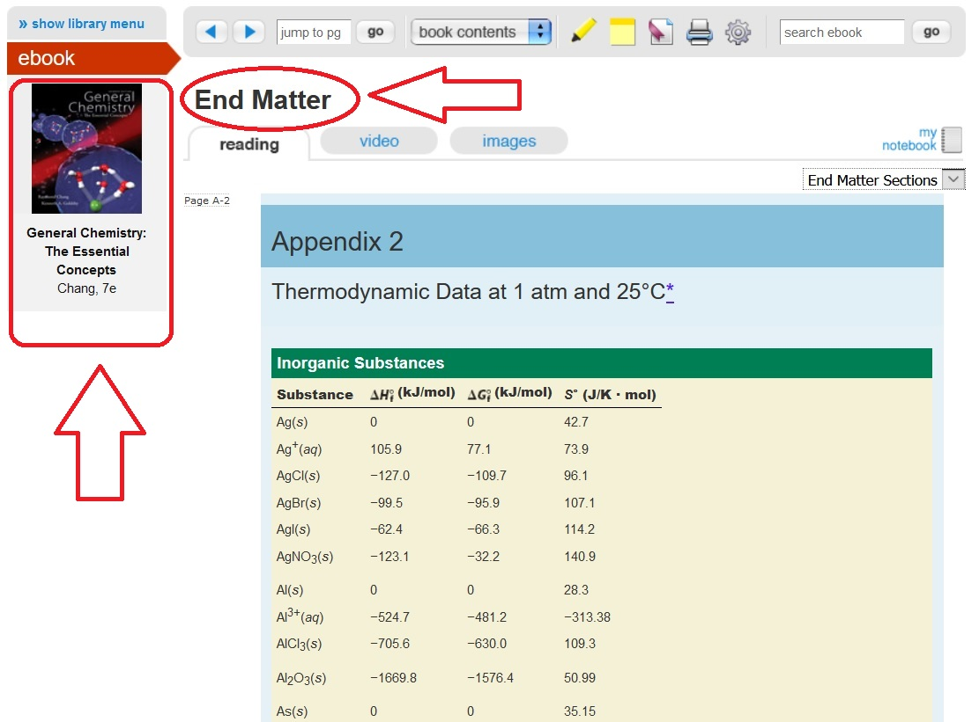
- Equations from your E-book.
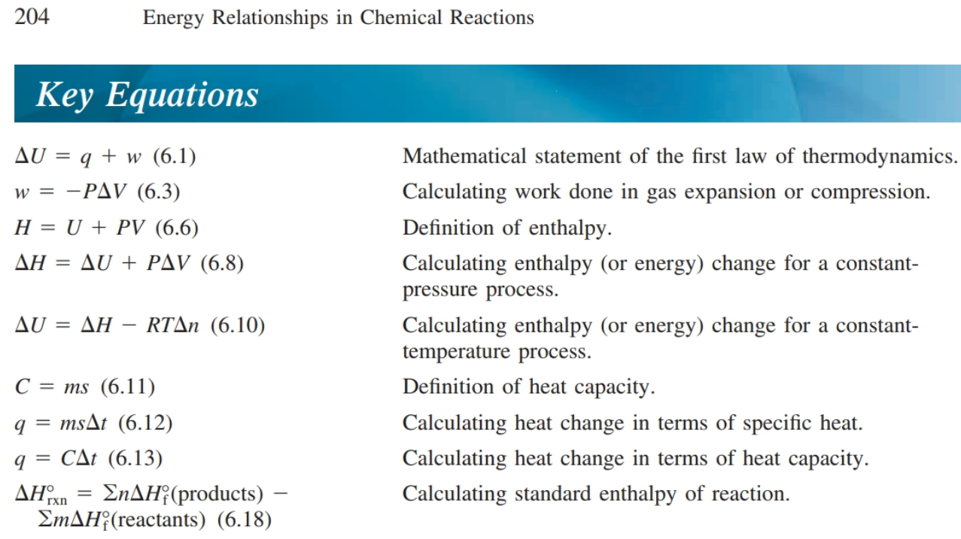

- When you multipy an equation by “X” to solve for the number of moles asked, you also multiply the dH values by “X”.
- When you divide an equation by “X” to solve for the number of moles asked, you also divide the dH values by “X”.
- When you write the reverse reaction, you change the sign of dH (from – to + or + to -)
- To find dHº of any equation from the tables, write the balanced equation first and then find the values of dH from the first column in Appendix 2. Put the values down under each reactant and product. Don’t forget to multiply by the number of moles. Add the values from the product side and do the same for the reactant side. To calculate dH of the reaction subtract the sum of the values of the reactant side from the product side See last equation under key equations.
Examples:
- N₂ (g) + 3H₂ (g) 2NH₃ (g)
dH values from the Appendix are:
- 0 + 3(0) 2(-46.3) Don’t forget to multiply the dH values with the moles in a balanced equation
dHº = (Sum of values on product side – sum of values on reactant side)
- dHº = -92.6 – (0)
- dHo = -92.6 kJ (this value is for 2 moles and therefore the units are kJ instead of kJ/mole. If you divide this value by number of moles given for the product, the units will then be kJ/mole)

Oxidation | Reduction
Loss of Hydrogen atoms from the reactants  CH4 C | Gain of Hydrogen atoms  N2 NH3
Gain of the Oxygen atoms by the reactants  C CO2 | Loss of Oxygen atoms  CO2 C
Loss of an electron by metals or metal ions  Cu Cu⁺¹  Cu⁺² Cu | Gain of an electron  Cu⁺¹ Cu  Cu Cu⁺²

- Any reactant that gets oxidized, is a reducing agent. Pb Pb+2 (Pb lost 2 electrons and therefore Pb got oxidized. Since it gave up to 2 electrons (or oxidized), it is a reducing agent.
- Any reactant that gets reduced, is an oxidizing agent. Cu+2 Cu (Cu gained 2 electrons and therefore Cu got reduced. Since it gained 2 electrons (or reduced), it is an oxidizing agent.

Week 4 Lab Questions (START HERE):
- Calculate the dHº for the combustion of Methane (CH4). (2 points)
CH₄(g) + O₂(g) CO₂(g) + H₂O(g) (don’t forget to balance the equation before you start the calculations). Show your work.

- Did CH4 get oxidized or reduced? Circle the correct answer. (1 point)
- Did O2 get oxidized or reduced? Circle the correct answer. (1 point)
- Is CH4 an oxidizing or reducing agent? Circle the correct answer. (1 point)
- Is O2 an oxidizing or reducing agent? Circle the correct answer. (1 point)

- Calculate the dHo of the decomposition reaction of HI using the values from the table in Appendix 2 (2 points)
HI(g) H₂ (g) + I₂ (g) dHo = ____________
(don’t forget to balance the equation before you start the calculations). Show your work.

- Calculate the dHo for 1 mole of decomposition of HI (without using the tables). Show your work. (1 point)
- Calculate the dHo for 6 moles of decomposition of HI (without using the tables). Show your work (1 point)

- Consider this reaction:

H₂(g) + O₂ (g) H₂O (g) dHo = __________

- Balance the equation and put the correct number of moles in the equation above. (1 point)

- Classify the forward reaction as (1) Combustion, (2) Decomposition, (3) Single replacement, (4) Double replacement, (5) Neutralization, (6) Synthesis. Circle the correct answer. (1 point)

- In this reaction did Hydrogen get oxidized or reduced? Circle the correct answer. (1 point)

- Based on your answer above is Hydrogen an oxidizing or reducing reactant? Circle the correct answer. (1 point)

- In this reaction did Oxygen get oxidized or reduced? Circle the correct answer. (1 point)

- Based on the answer above, is Oxygen an oxidizing or reducing agent? Circle the correct (1 point)
- Calculate the dHo of the Synthesis reaction using the values from the table in Appendix 2. Show your work. (2 points)

- If 4 moles of H2 is used in a balanced equation for the synthesis reaction, how many moles of water will be produced (without using the tables). Show your work. (1 point)

- If 4 moles of H2 is used for the Synthesis reaction, calculate the enthalpy of the reaction without using the tables. Show your work. (1 point)

- If 4 moles of H₂O is required to be produced, how many moles of H₂ and how many moles of O₂ will be required (without using tables). Show your work. (1 point).

- If 1 mole of water is required to be produced, how many moles of H₂ and O₂ will be required (without using tables)? Show your work. (1 point)

- If 6 moles of water is decomposed, how many moles of H₂ and O₂ will be formed? (1 point)

- If 6 moles of water is decomposed, calculate the enthalpy of the reaction without using the values from the table available in Appendix 2 of your textbook. (2 points)

Solve the following problems from your textbook. (10 points each).
- Practice Exercise on Page 186 (First solve Example 6.1 and then attempt the practice exercise).

- Practice Exercise on Page 187 (First solve Example 6.2 and then attempt the practice exercise).
- Practice Exercise on Page 191 (First solve Example 6.3 and then attempt the practice exercise).

- Practice Exercise on Page 194 (First solve Example 6.5 and then attempt the practice exercise).

- Practice Exercise on Page 196 (First solve Example 6.6 and then attempt the practice exercise).
- Practice Exercise on Page 203 First solve Example 6.10 and then attempt the practice exercise).

Solve example 6.9 and then attempt the Hess’ law questions below.
- Show how the equations listed below with dHo values can be manipulated to calculate the dHo of the following equation (5 points)
2KCl(s) + H₂SO₄ (l) 2HCl (g) + K₂SO₄ (s) dHo = ?

- HCl (g) + KOH (s) KCl (s) + H₂O (l) dHo = - 200.0 kJ
- H₂SO₄ (l) + 2KOH (s) K₂SO₄ (s) + 2 H₂O (l) dHo = -340.0 kJ

- Use the following two equations
- ½ N₂ (g) + O₂ (g) NO₂ (g) dHo = +35 kJ
- ½ N2 (g) + ½ O₂ (g) NO (g) dHo = +90.4 kJ

to calculate the dHo of
NO (g) + ½ O₂ (g) NO₂ (g) dHo =

- Use the following equations: (5 points)
- Fe₂O₃ (s) + 3CO (g) 2Fe (s) + 3 CO₂ (g) dHo = -27 kJ
- CO (g) + ½ O₂ (g) CO₂ (g) dHo = -283 kJ

To calculate the dHo of
2Fe (s) + 3/2 O₂ (g) Fe₂O₃ (s)

