CHM 1040: GENERAL CHEMISTRY II LAB
Week 5: Chapter 14. Chemical Kinetics Worksheet
Name: __________________________

Solve the following problems from your textbook (10 points each)
- Practice Exercise on page 471 (First solve Example 14.1 and then attempt the practice Exercise).
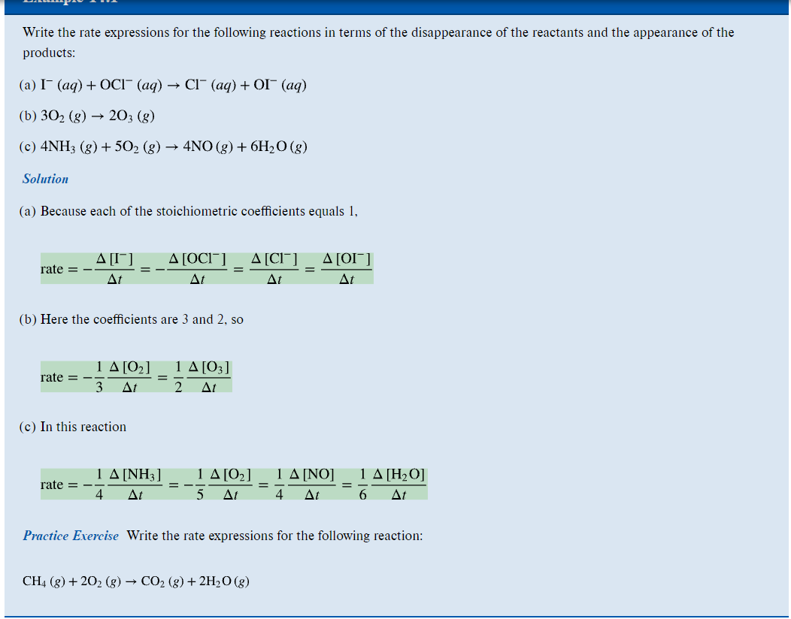

- Practice Exercise on page 472 (First solve Example 14.2 and then attempt the practice Exercise).
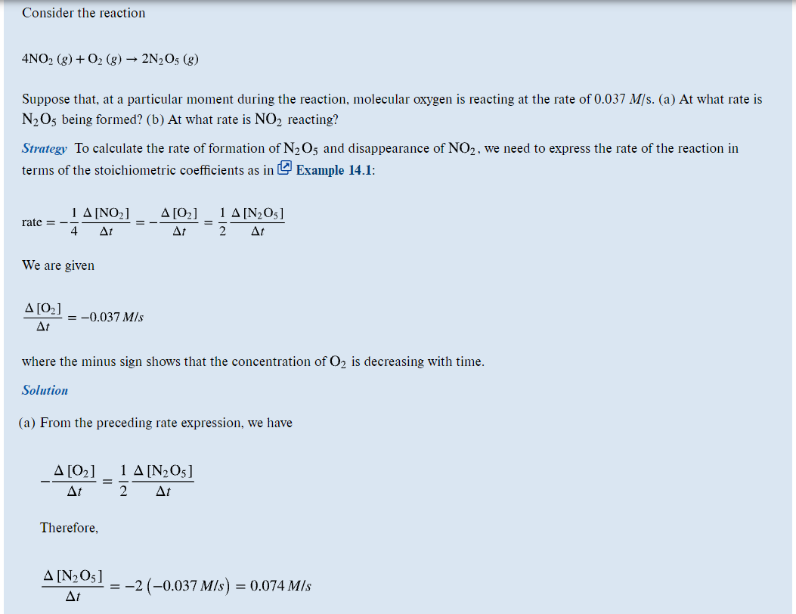
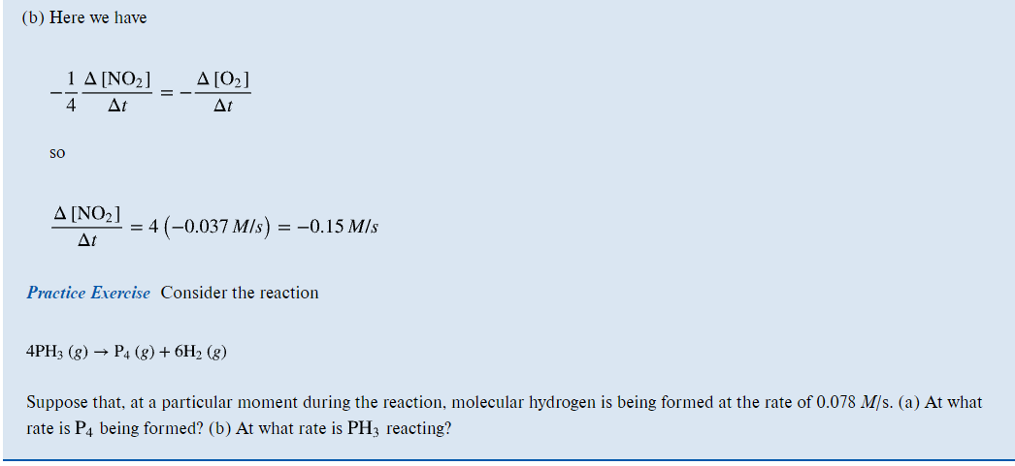
- Practice Exercise on page 477 (First solve Example 14.3 and then attempt the practice Exercise).
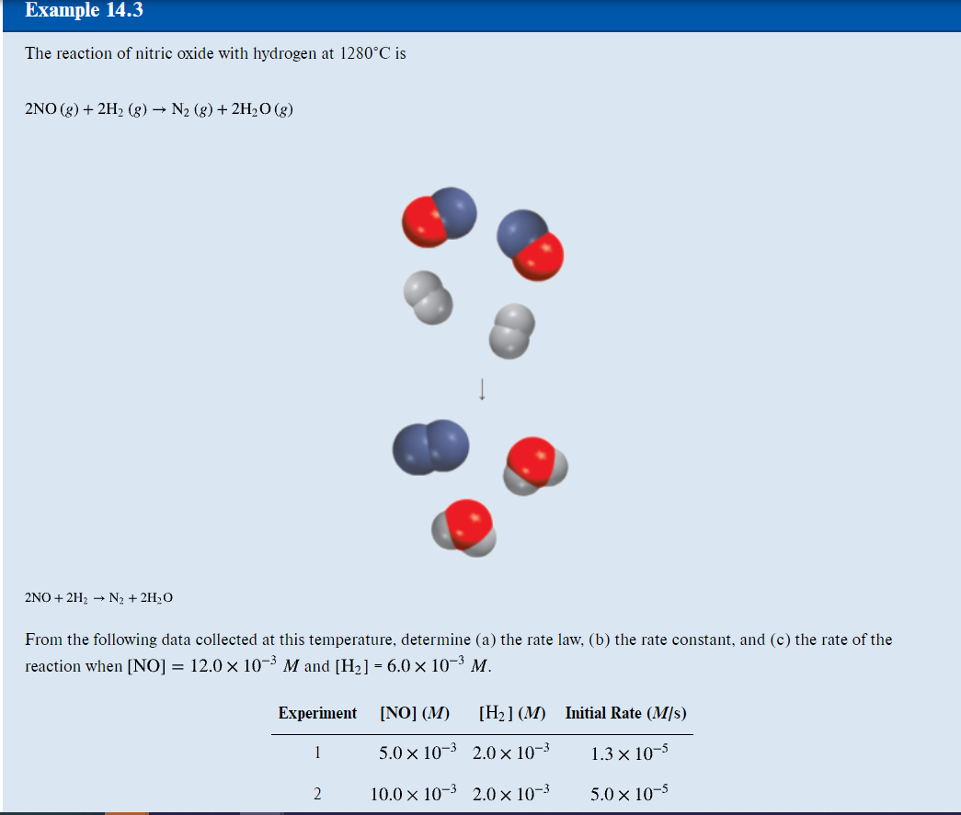
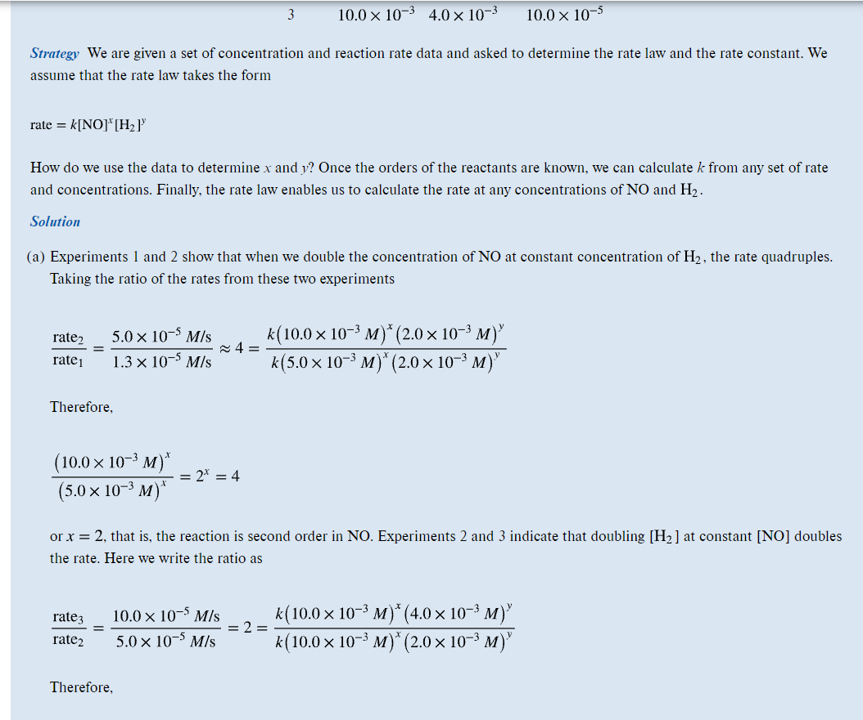
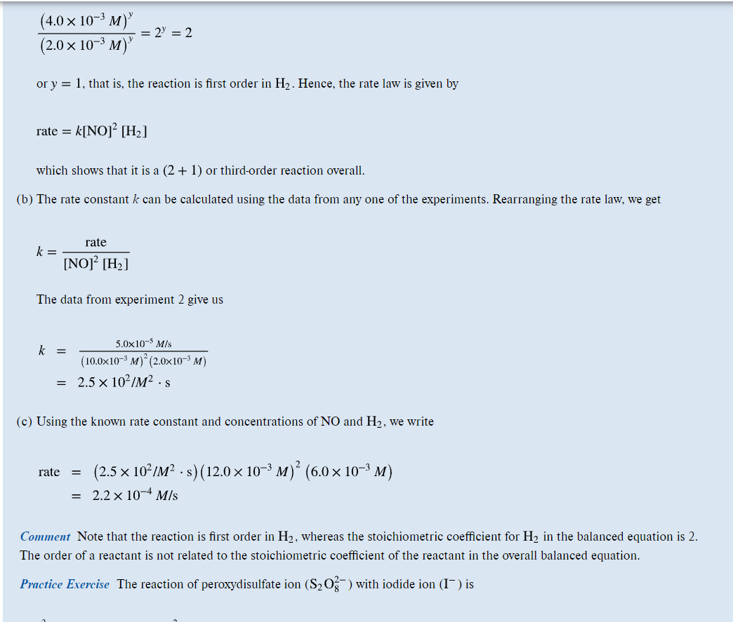
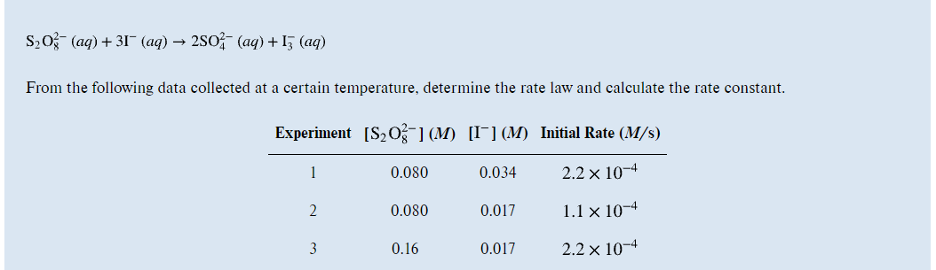
- Practice Exercise on page 481 (First solve Example 14.4 and then attempt the practice Exercise).
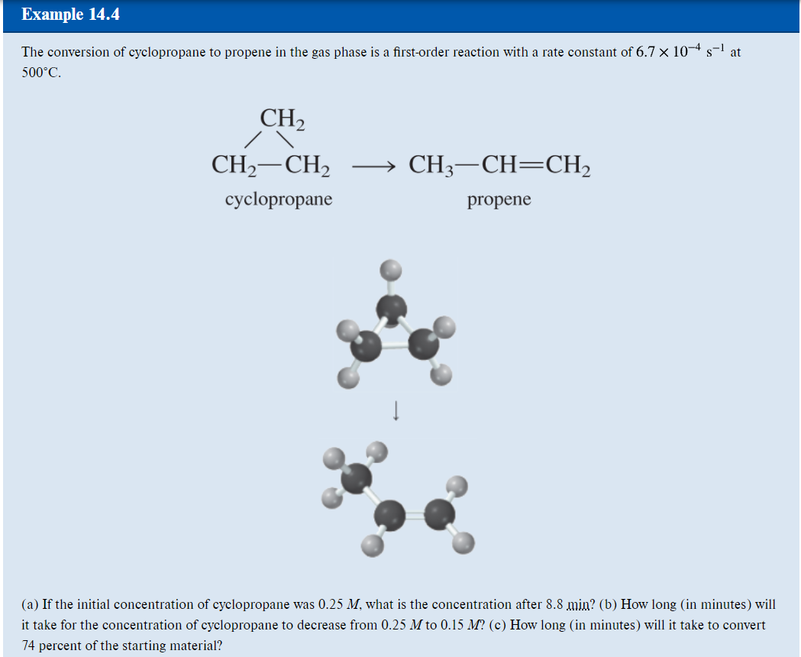
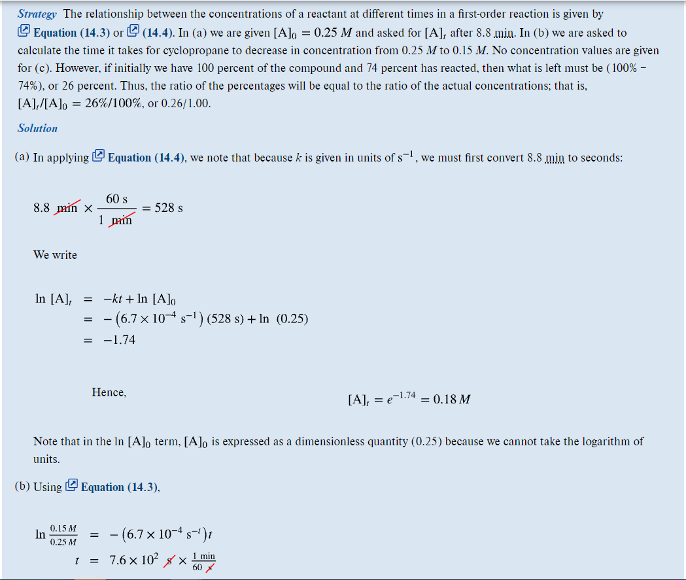
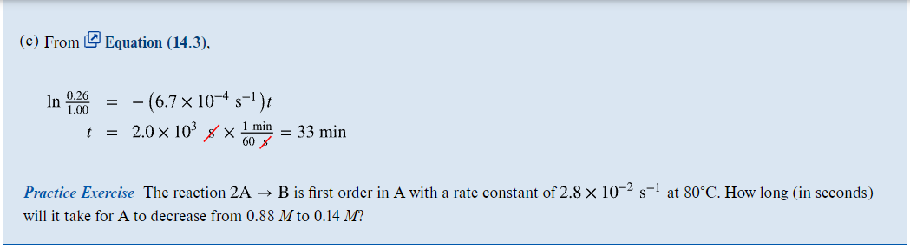
- Practice Exercise on page 483 (First solve Example 14.5 and then attempt the practice Exercise).
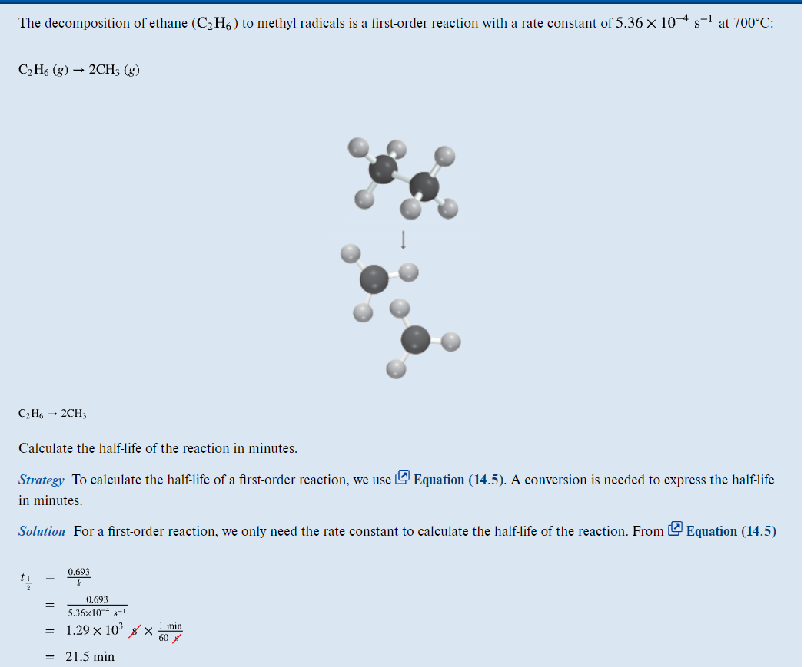
- Practice Exercise on page 485 (First solve Example 14.6 and then attempt the practice Exercise).
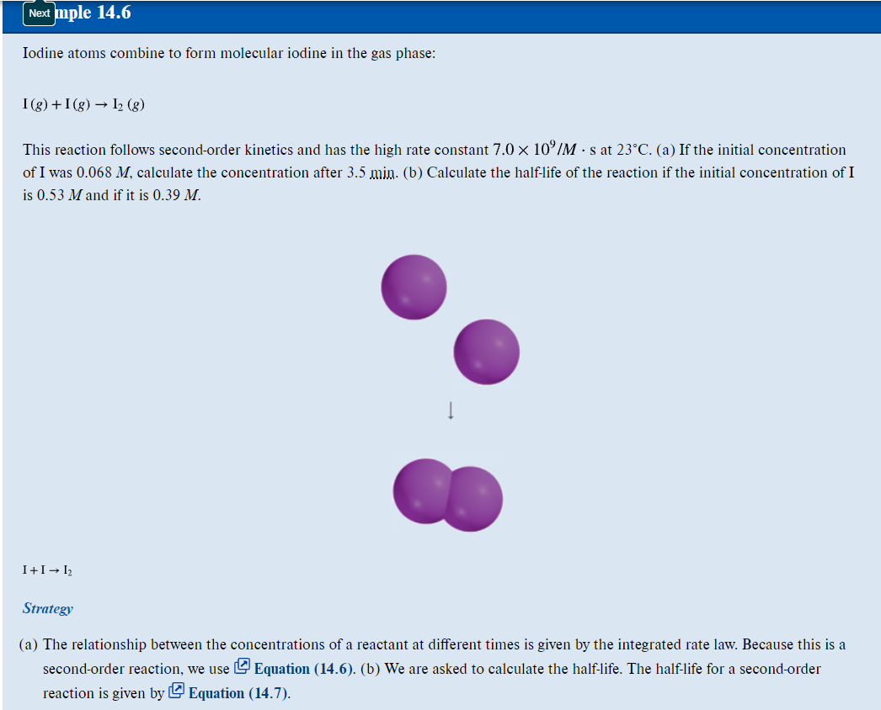
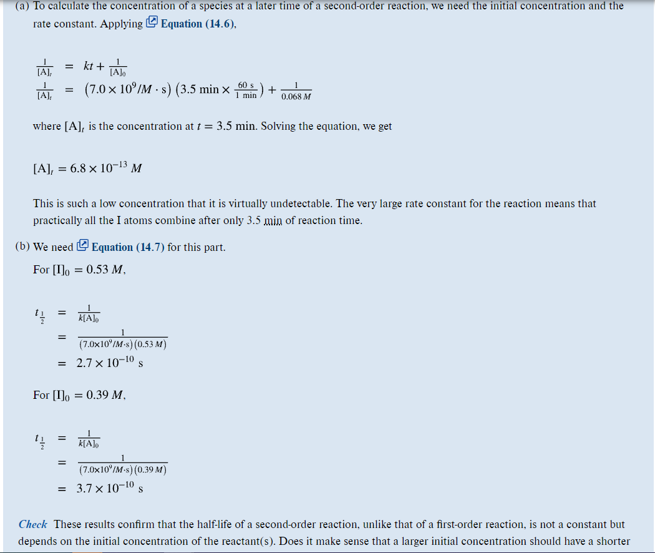
- Practice Exercise on page 490 (First solve Example 14.7 and then attempt the practice Exercise).
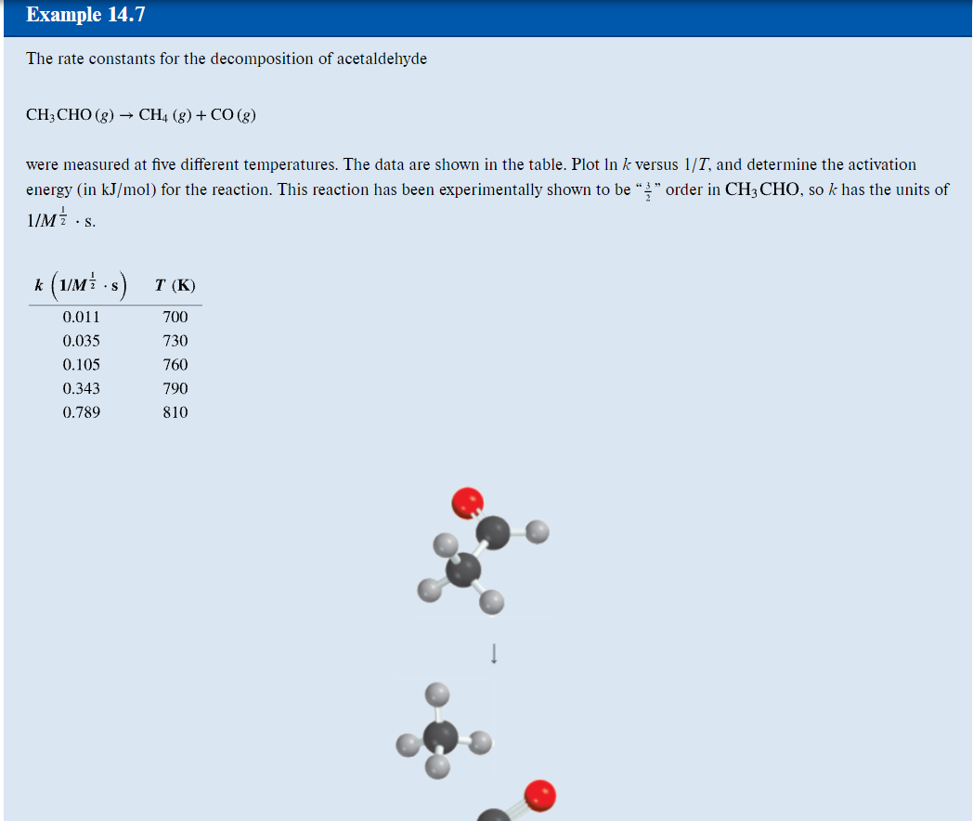
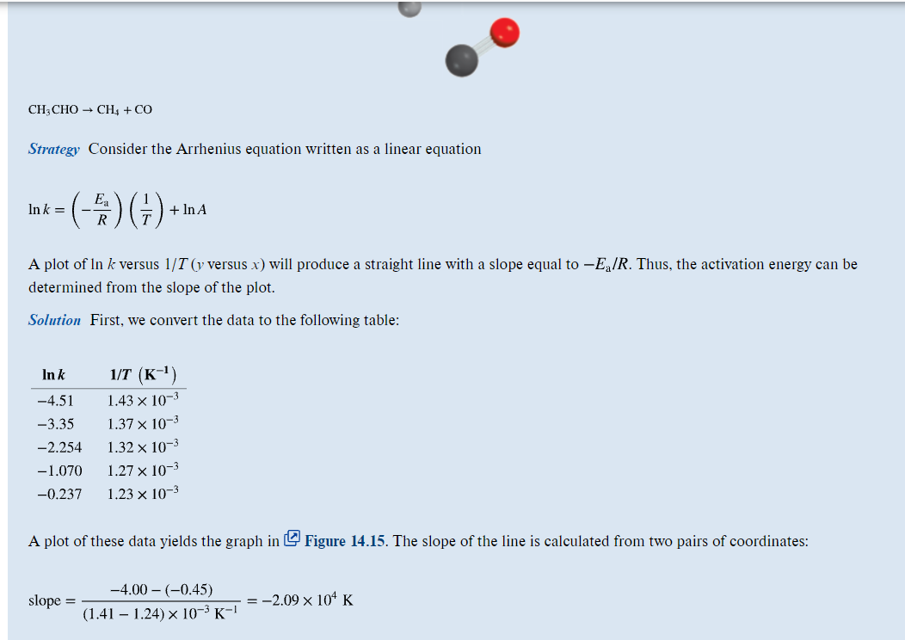
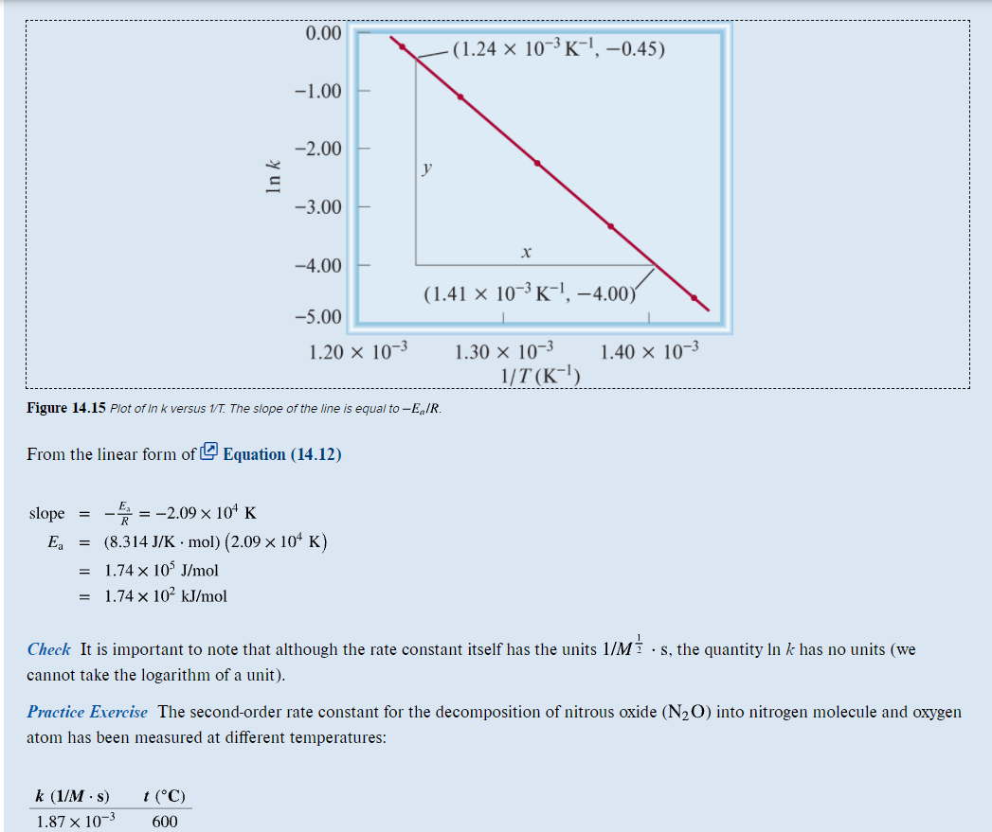
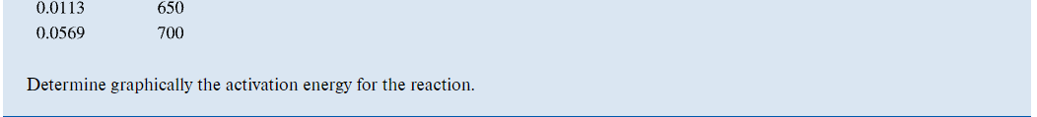
- Practice Exercise on page 491 (First solve Example 14.8 and then attempt the practice Exercise).
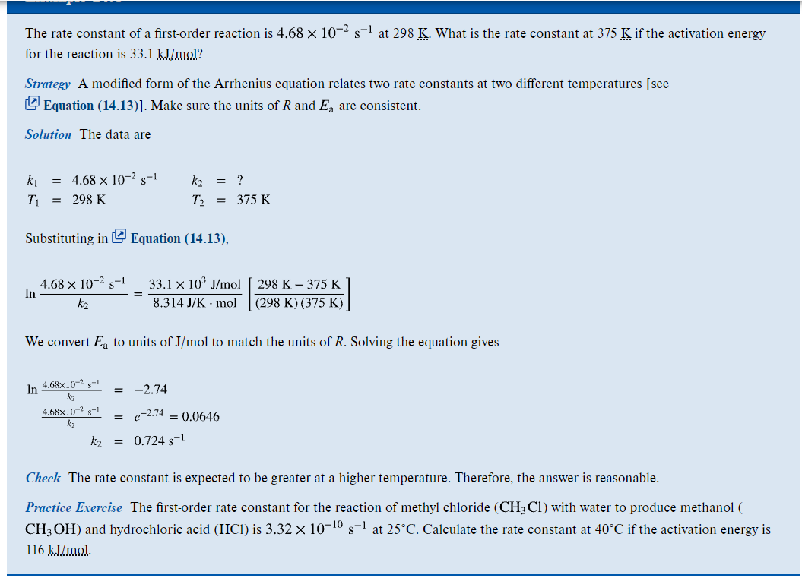
- Problem 14.22(a) (Similar to Example 14.5) – on page 504
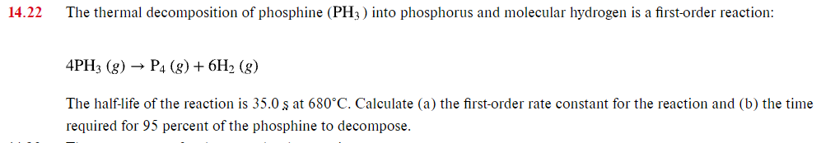
- Problem 14.22 (b) (Similar to Example 14.4) – also on page 504
Part b is the time required for 95 percent of the phosphine to decompose

