CHM 1040. GENERAL CHEMISTRY II LAB
WEEK 6. CHAPTER 15. CHEMICAL EQUILIBRIUM
NAME: ______________________

Solve the following problems from your textbook. (10 points each)
- Practice Exercise on Page 520 (First solve Example 15.1 and then attempt the practice exercise).
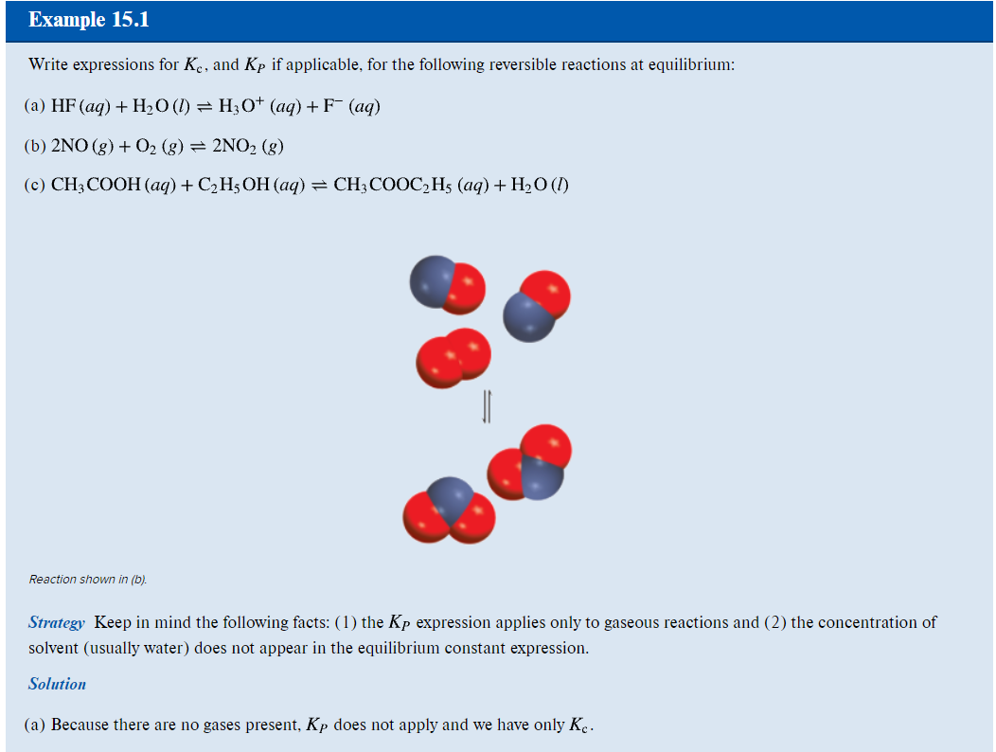
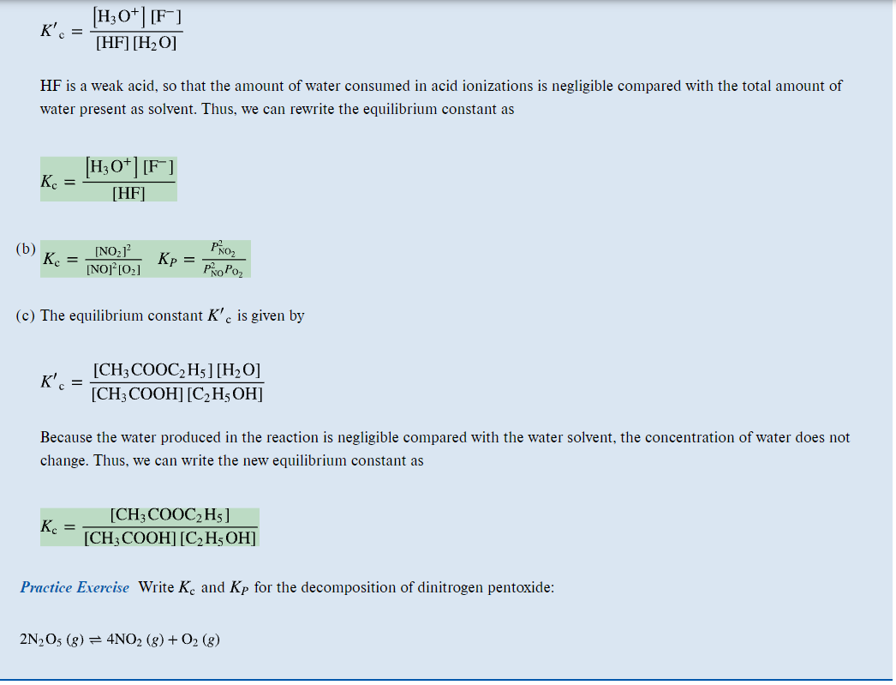
- Practice Exercise on Page 520 (First solve Example 15.2 and then attempt the practice exercise).
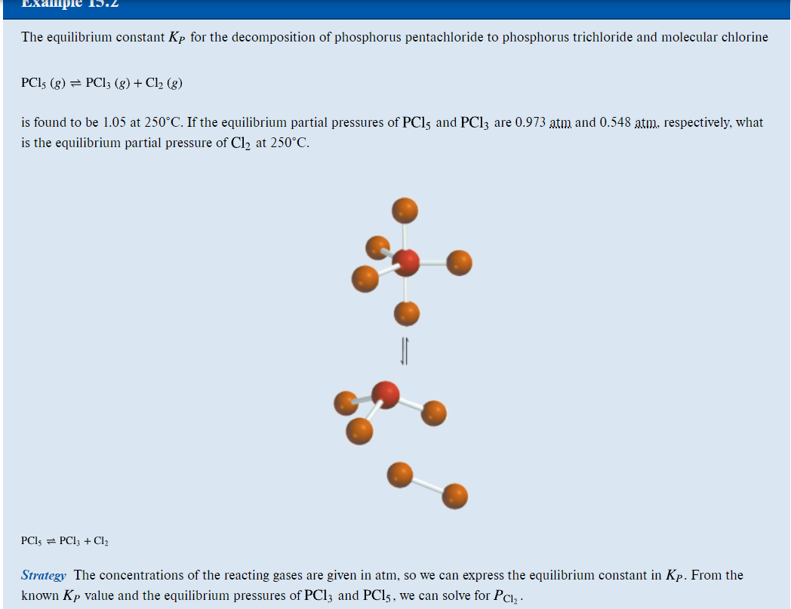
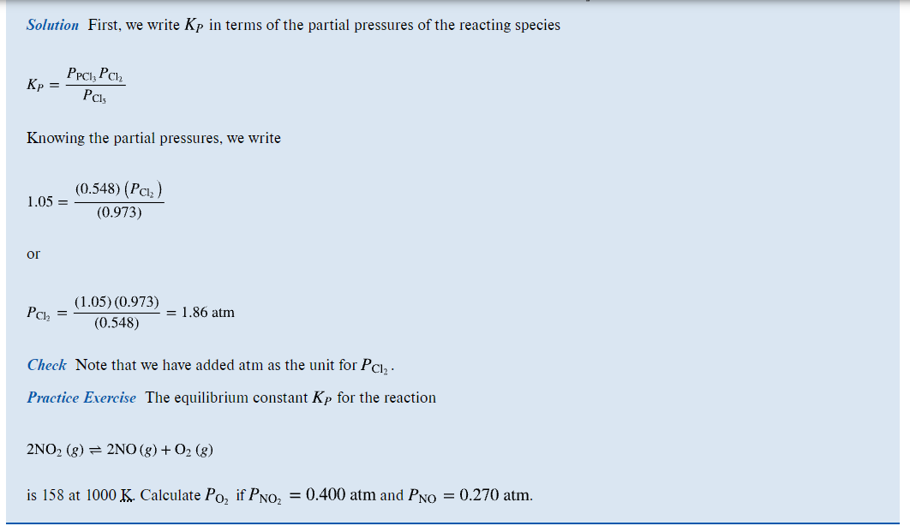
- Practice Exercise on Page 521 (First solve Example 15.3 and then attempt the practice exercise).
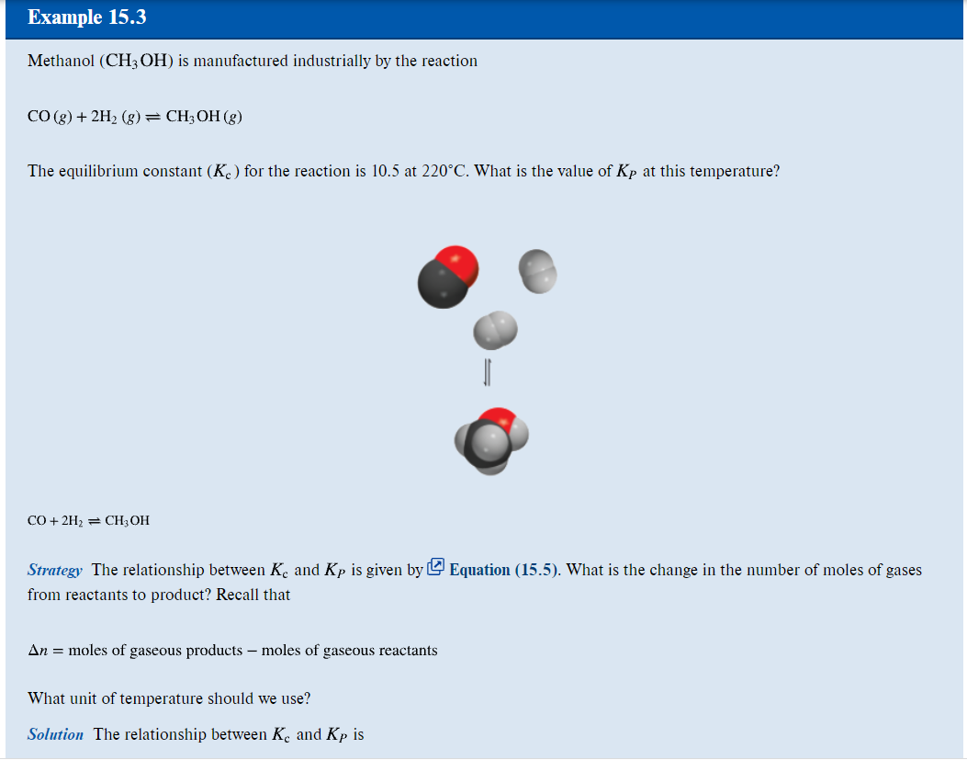
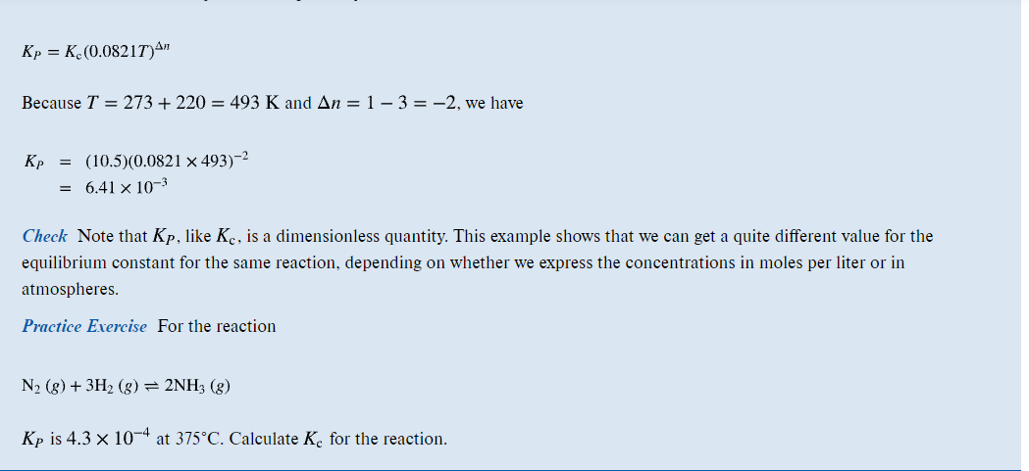

- Practice Exercise on Page 523 (First solve Example 15.4 and then attempt the practice exercise).
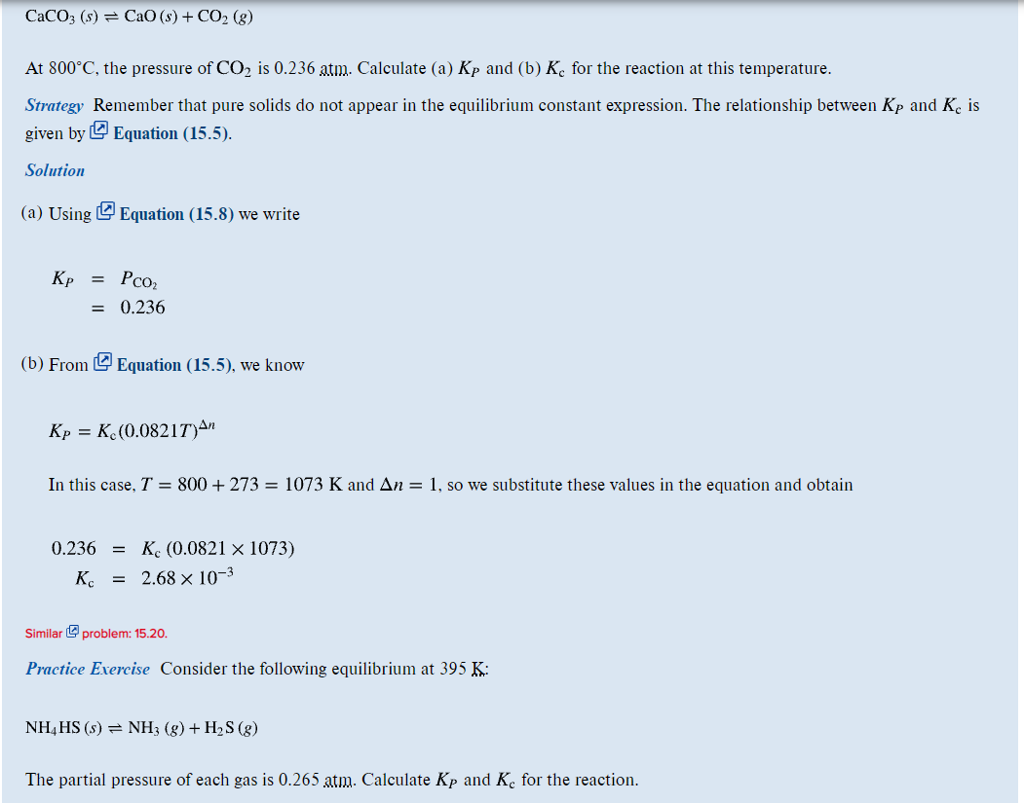
- Practice Exercise on Page 531 (First solve Example 15.8 and then attempt the practice exercise).
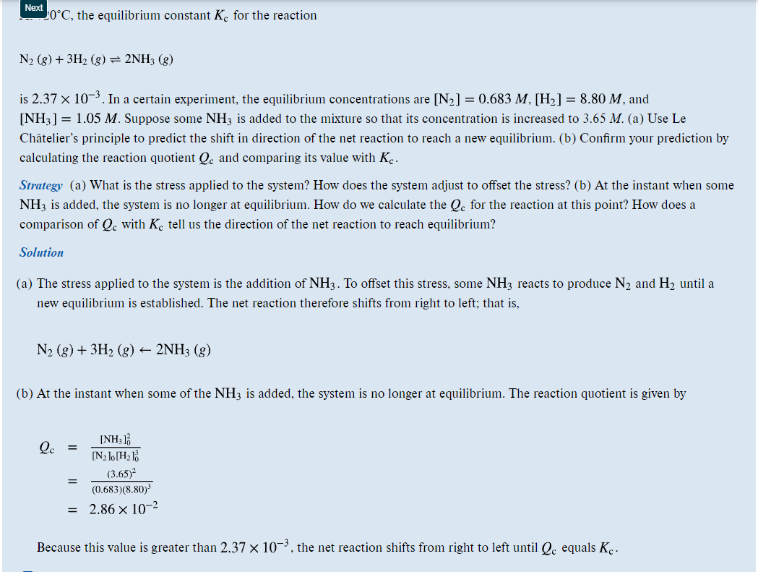
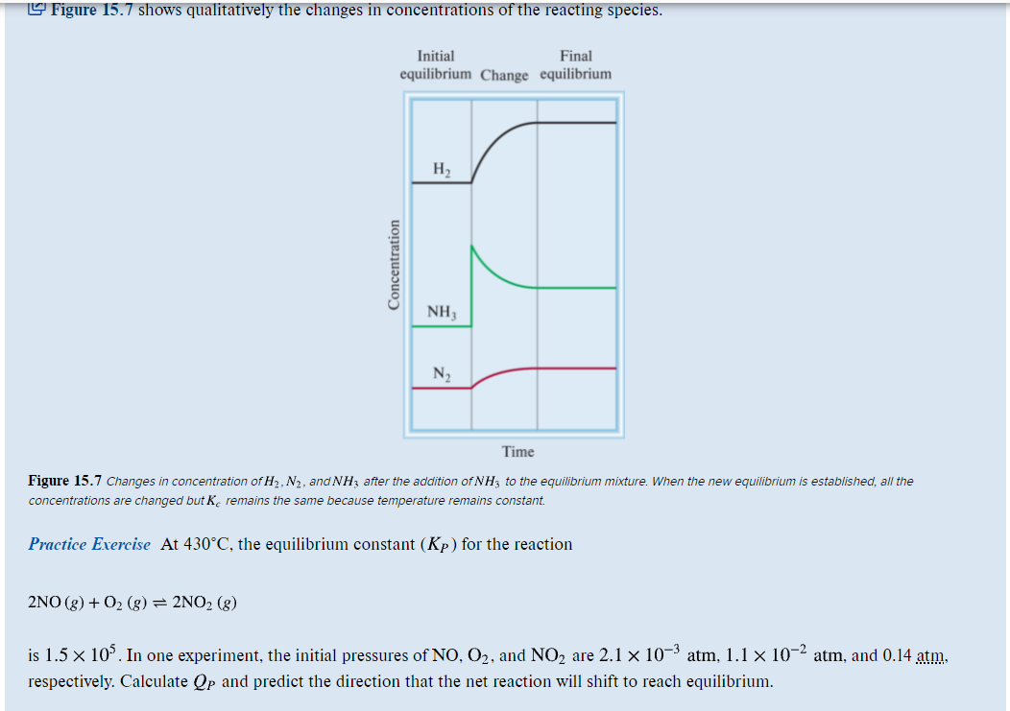
- Practice Exercise on Page 533 (First solve Example 15.9 and then attempt the practice exercise).
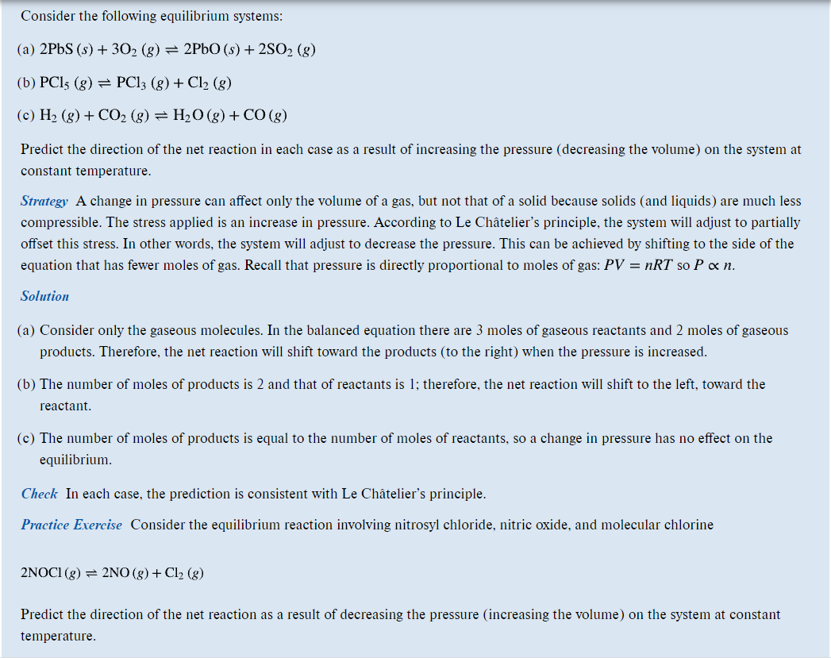
- Problem 15.7 (Similar to Example 15.1).
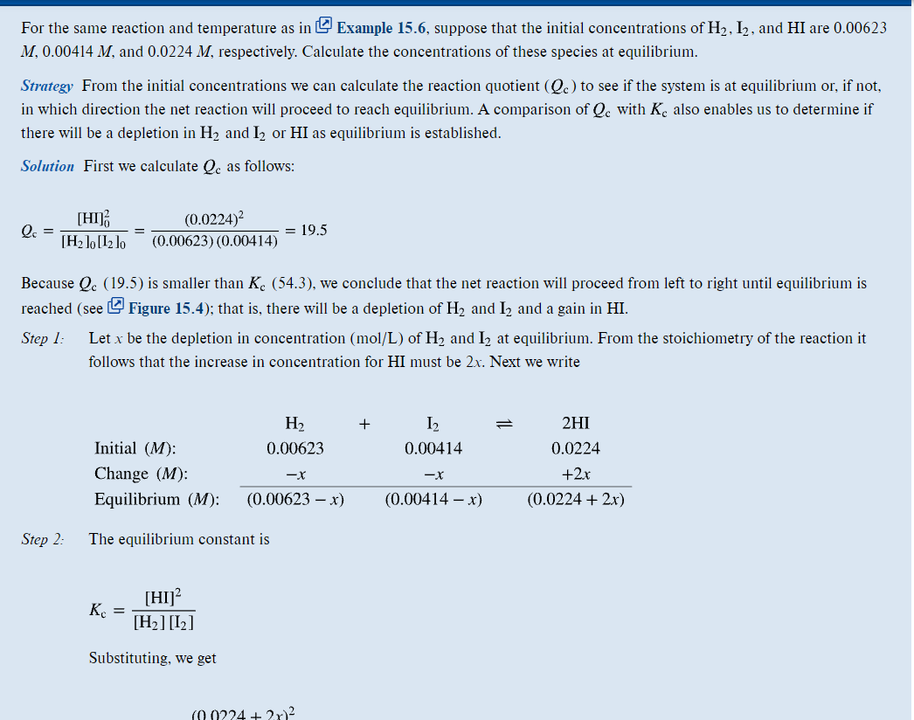
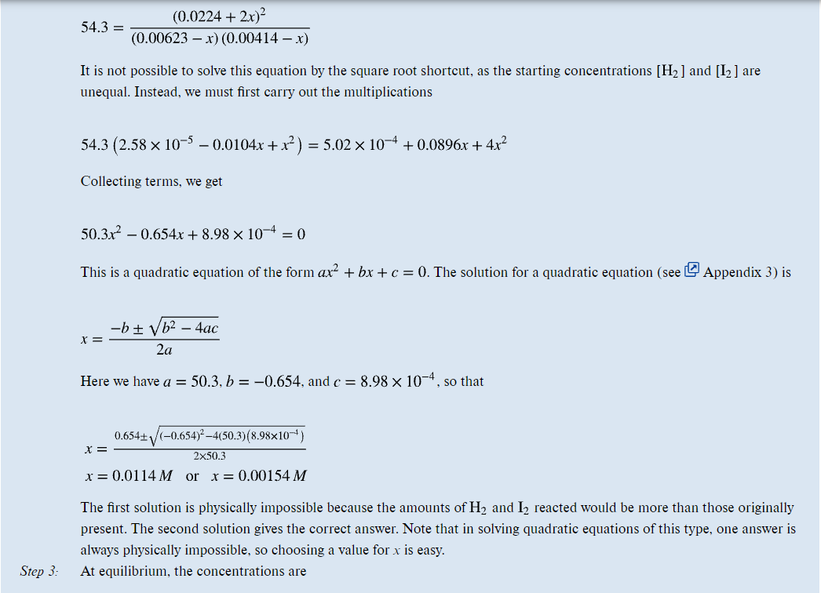
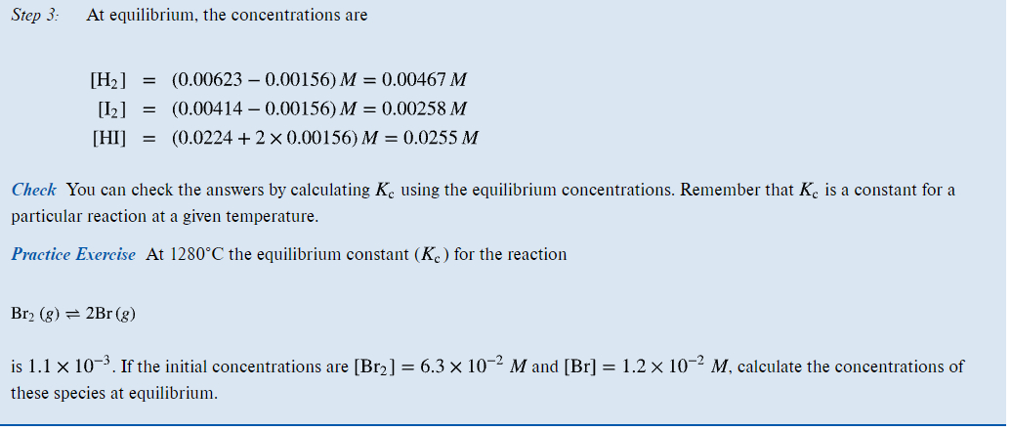
- Problem 15.8 (Similar to Example 15.1).
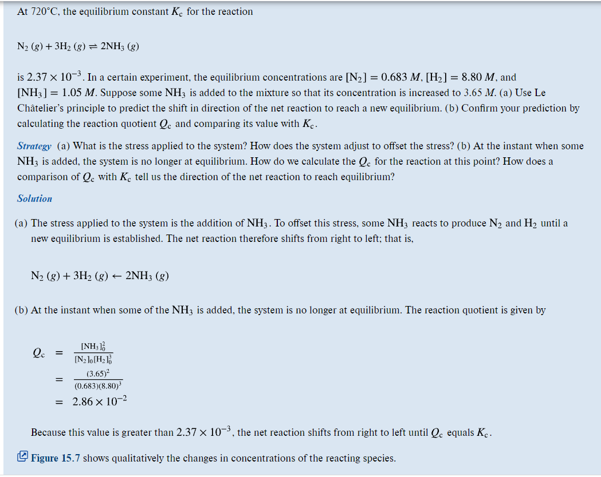
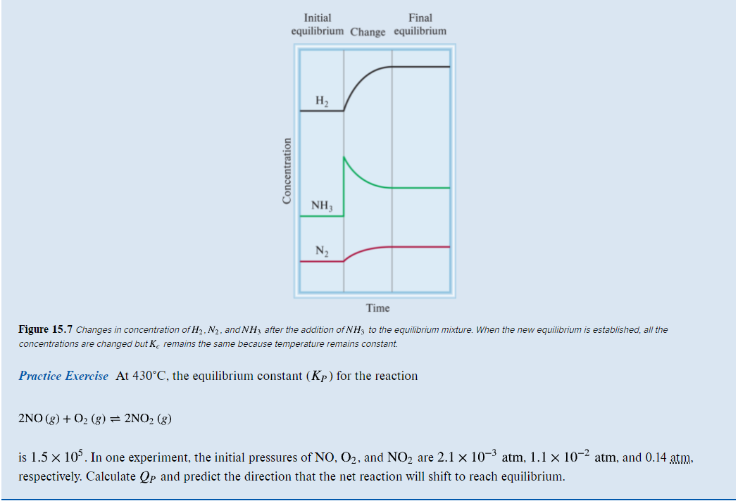
- Problem 15. 15 (Similar to Example 15.3)

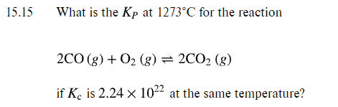
- Problem 15. 16 (Similar to Example 15.3)
