Lab 1 – Coulomb’s Law
Investigating the force between charged objects
Purpose: to investigate the quantitative aspects of the electric force between two objects, including the dependences on both distance and charge. Also, to place the electric force into context with our force problem-solving process from first-semester physics.

Introduction

Coulomb’s Law: “The magnitude of the electric force that a particle exerts on another is directly proportional to the product of their charges and inversely proportional to the square of the distance between them.” Mathematically, the magnitude of this electrostatic force F_{E} acting on two charged particles (q₁, q₂) is expressed as:
F_{E} = k$\frac{q_{1}q_{2}}{r^{2}}$

Where r is the separation distance between the charged objects and k is a constant of proportionality, called the Coulomb constant, k = 8.99 × 10⁹ Nm²/C².

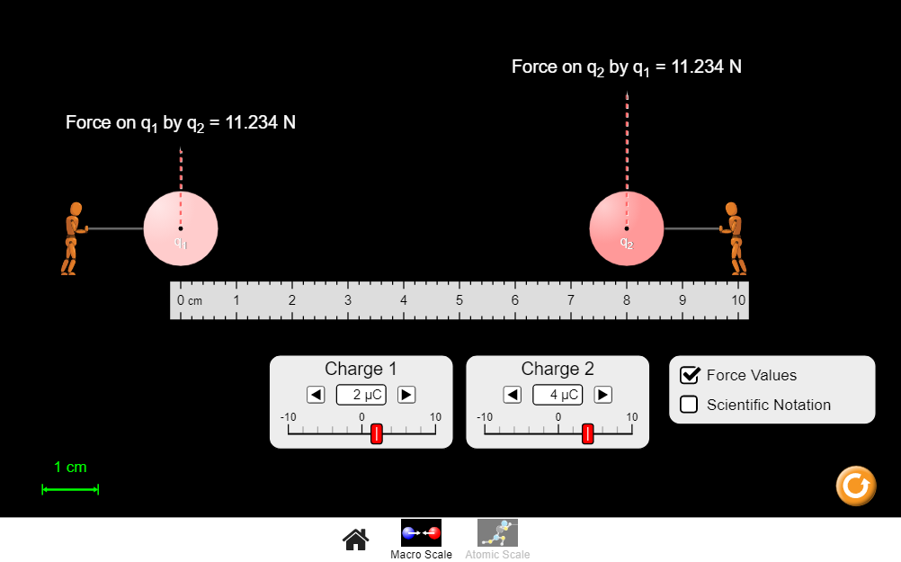

Part 1 – Determining the value of Coulomb’s constant k

Experiment 1-A: How the force depends on distance

- Click on the following link and select the “Macro Scale” version of simulation. Set your own values for Charge 1 (q₁) and Charge 2 (q₂), and write their values in the first row of Table 1 below. These values will remain the same for all trials in Table 1.

https://phet.colorado.edu/sims/html/coulombs-law/latest/coulombs-law_en.html

- Change the distance between the two charges to match each of the values given in Table 1. The ruler is marked in centimeters, and each charge can be placed to the nearest centimeter.

- For each distance value, record the force value given by the simulation.

- Fill in the rest of Table 1 by calculating the values of r² and 1/r² in the specified units.

Table 1
q₁ (𝜇C) | q₂ (𝜇C) | r (cm) | r² (m²) | 1/r² (1/m²) | F_{E} (N)
-4 | 8 | 10 | 0.01 | 100 | 28.760
Use the same  charge values above  in all trials  that follow. |  | 9 | 0.0081 | 123.457 | 35.506
 |  | 8 | 0.0064 | 156.25 | 44.938
 |  | 7 | 0.0049 | 204.08 | 58.694
 |  | 6 | 0.0036 | 277.778 | 79.889
 |  | 5 | 0.0025 | 400 | 115.041
 |  | 4 | 0.0016 | 625 | 179.751
 |  | 3 | 0.0009 | 1111.111 | 319.557

Analysis for Experiment 1-A:

- Use Excel software and the data from Table 1 to make a graph of F_{E} versus r.
(With r on the horizontal axis.) What do you notice about the shape of the graph?

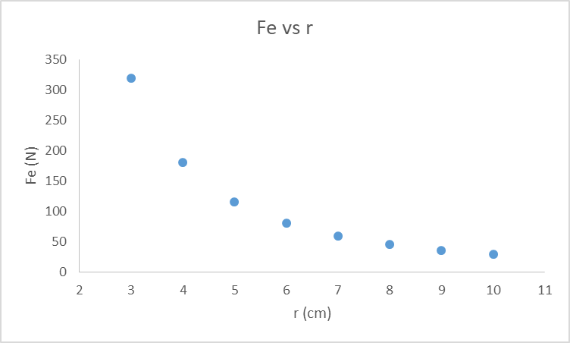

The shape of the graph shows that as the distance (r) increases, the Force (F_{E}) between the
two charges decreases.

- Use Excel to make a graph of F_{E} (in Newtons) versus 1/r² (in 1/m²). Add a trendline to the graph and use its slope to find Coulomb’s constant k.

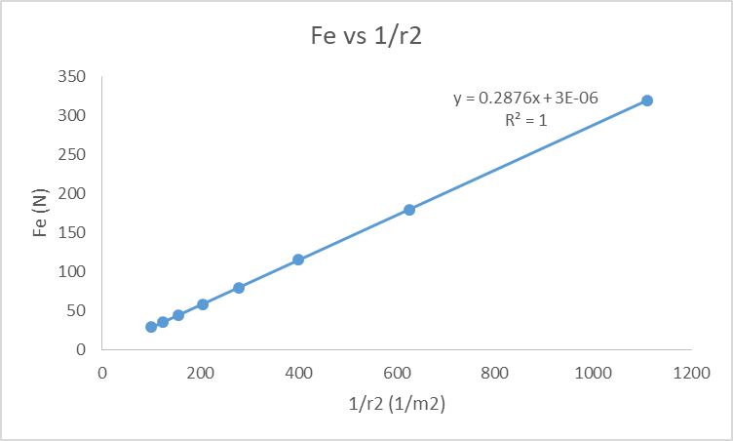

F_{E} ∝ 1/$r^{2}$

m (slope) = $r^{2}$x F_{E}

m (From graph) = 0.2876

F_{E} = $\frac{kq_{1}q_{2}}{r^{2}}$
Rearrange above equation

k = $\frac{m}{q_{1}q_{2}}$

k = $\frac{0.2876}{(4 x {10}^{-6})(8 x {10}^{-6} )}$

k = $8.9875 x {10}^{9}$ Nm²/C²

- Calculate the percent error in k (where k_{known} = 8.99 × 10⁹ Nm²/C²). Also, is the percent error value what you would expect in this case? Why or why not?

k_{exp} = $8.9875 x {10}^{9}$ Nm²/C²

% error = $\frac{8.9875 x {10}^{9}-8.99 x {10}^{9}}{8.99 x {10}^{9}}$

Percent error = 0.0278 %

Yes we expected the percent error to be low because there was a perfect linear relationship in
the graph between F_{E} and 1/$r^{2}$

Note: Include screenshots of all created graphs with your lab report.
Experiment 1-B: How the force depends on charge

- Reset the “Macro Scale” simulation, and set the value of charge q₂ and the distance r, as shown in Table 2. These values will remain the same for all trials in Table 2.

https://phet.colorado.edu/sims/html/coulombs-law/latest/coulombs-law_en.html

- Change the charge of object 1 to match each of the values given in Table 2. In each instance, record the value of the electric force given by the simulation.

Table 2
q₁ (μC) | q₂ (μC) | r (cm) | F_{E} (N)
10 | 5 | 6 | 124.827
9 | Use the same  values above  for q₂ and r  in all trials  that follow. |  | 112.344
8 |  |  | 99.862
7 |  |  | 87.379
6 |  |  | 74.896
5 |  |  | 62.414
4 |  |  | 49.931
3 |  |  | 37.448

Analysis for Experiment 1-B:

- Use Excel software and the data from Table 2 to make a graph of F_{E} (in Newtons) versus q₁ (in Coulombs). What do you notice about the shape of the graph?

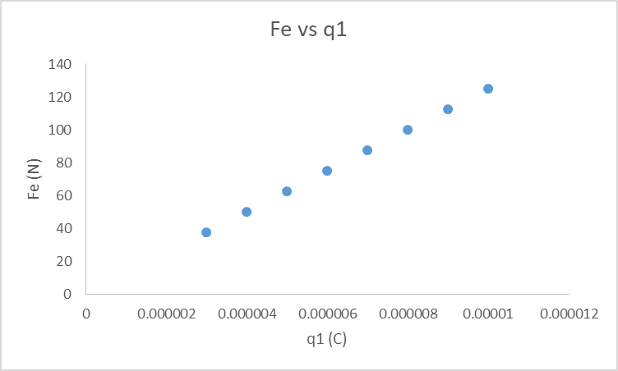

It is a straight line graph whereby an increase of q1 leads to an increase of Fe

- Add a trendline to the graph and use its slope to find Coulomb’s constant k. (See the footnote below for a hint about graphing accurately in Excel.)

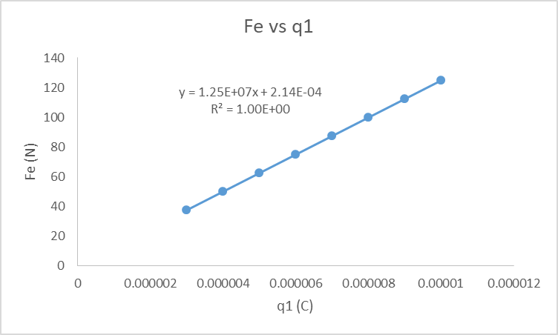

F_{E} ∝ q1

m (slope) = $\frac{F_{E}}{q1}$

m (From graph) = $1.25 x {10}^{7}$

F_{E} = $\frac{kq_{1}q_{2}}{r^{2}}$

Rearrange above equation

k = $\frac{mr^{2}}{q_{2}}$

k = $\frac{(1.25 x {10}^{7}){(0.06)}^{2}}{(5 x {10}^{-6} )}$

k = $9.0 x {10}^{9}$ Nm²/C²

- Calculate the percent error in k (where k_{known} = 8.99 × 10⁹ Nm²/C²). Also, is the percent error value what you would expect in this case? Why or why not?

k_{exp} = $9.0 x {10}^{9}$ Nm²/C²

% error = $\frac{9.0 x {10}^{9}-8.99 x {10}^{9}}{8.99 x {10}^{9}}$

Percent error = 0.111 %

Yes we expected the percent error to be very low because there was a perfect linear
relationship in the graph between F_{E} and q1

Note: Include screenshots of all created graphs with your lab report.
Wrapping-up Part 1:

- Are the two values you calculated for k similar to each other? Should they be?

Both values are similar to each other. Yes they should be similar because k is constant which only depends on the medium. As the medium is air, therefore there is no change in the value of k.

- If one of the charge values is increased, what kind of change would we expect to see in the value of the force? Possible answers are directly proportional, inversely proportional, proportional to the square, etc.

The value of force will increase because force and charge are directly proportional to each other.

- If the separation between charges is increased, what kind of change would we expect to see in the value of the force? Possible answers are directly proportional, inversely proportional, proportional to the square, etc.

The value of force will decrease because force and separation are inversely proportional to each other.

Part 2 – Determining the charge Q on a repelling balloon

Consider the following experiment, which has already been performed. You do not need to set up the experiment yourself. Measurements for you to analyze will be given below.
- Blow up 2 balloons, tie them closed, and charge them by rubbing with fur. Try to get an even charge by rubbing all over each balloon, not just one part. The rubber of the balloon is an insulator so charge tends to stay in one place.
- Now tie the balloons to a pair of strings hanging down from the ceiling. They will most likely discharge during this process so once they’re hung, charge them again. The balloons should separate from each other and make a 10- or 20-degree angle between the strings.
- Measure the vertical height h, and/or the diagonal distance L along the string, from the ceiling to the center of one of the balloons.
- We need to determine the angle between the strings, but use of a protractor at the ceiling is usually too difficult. Instead, measure the distance r between the centers of the balloons, to the nearest centimeter or two. Trigonometry can then be used to find the half-angle 𝜃 (shown in the diagram below) based on the values of r and h (or r and L).
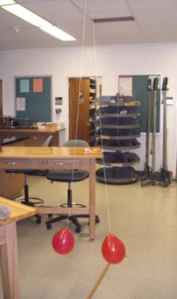
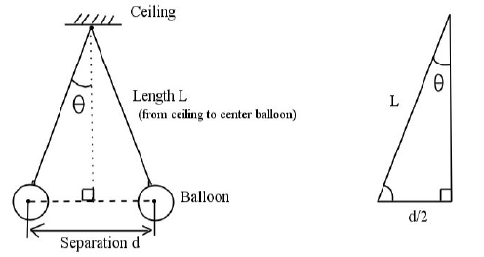
L
h
r

Table 3
Experimental Measurements
Separation r between balloon centers | 68 cm
Height h from ceiling to balloon center | 190 cm
Length L along string to balloon center | 193 cm
Mass m of each balloon | 3.65 g
Angle 𝜃 as defined in diagram | 10.15 $°$
Charge q of each balloon | 0.574 µC

Now let’s figure out the charge q on each of these balloons, based on the above measurements. We will assume that both balloons have the same mass m, and the same charge q. Think back to first-semester physics. How would you go about creating an equation that relates the forces and geometries of this situation, in order to solve for the variable q? The following steps will guide you through the process.

- Draw a free-body diagram of the forces acting on just one of the balloons. Identify all forces acting on that one balloon, and label them with the appropriate force.

Tension, T

Electric Force, $F_{E}$

Weight, W

- Use your free-body diagram to develop two Newton’s 2nd Law equations, based on the condition of static equilibrium in the horizontal and vertical directions, respectively.

Horizontal Direction

Tsinθ - $F_{E}$ = 0

Vertical Direction

Tcosθ - W = 0

- Two of the force variables in your equations should be related to quantities listed in Table 3. Rewrite your equations in terms of those quantities, if you have not already done so. Your equations should still involve variables, not numerical values.

$F_{E}$ = $\frac{kq^{2}}{r^{2}}$ , W = mg
Substitute the above expressions in the equations derived earlier

Horizontal Direction

Tsinθ - $\frac{kq^{2}}{r^{2}}$ = 0 Tsinθ = $\frac{kq^{2}}{r^{2}}$

T = $\frac{kq^{2}}{r^{2}sinθ}$ (Equation 1)

Vertical Direction

Tcosθ - mg = 0 Tcosθ = mg

T = $\frac{mg}{cosθ}$ (Equation 2)

- You should have two equations at this point, but each one only contains one remaining force variable, the value of which is unknown. Combine the two equations into one by eliminating this unknown force variable.

T = $\frac{kq^{2}}{r^{2}sinθ}$ (Equation 1)

T = $\frac{mg}{cosθ}$ (Equation 2)

Subtract Equation 2 from Equation 1

T - T = $\frac{kq^{2}}{r^{2}sinθ}$ - $\frac{mg}{cosθ}$

$\frac{kq^{2}}{r^{2}sinθ}$ - $\frac{mg}{cosθ}$ = 0

- Solve the remaining equation for the unknown charge q in terms of all the other variables. Variables that should appear in your equation are: the separation r, the mass m, the angle 𝜃, and the physical constants g and k.

$\frac{kq^{2}}{r^{2}sinθ}$ = $\frac{mg}{cosθ}$

$q^{2}$ = $\frac{{mgr}^{2}sinθ}{kcosθ}$

q = $\sqrt{\frac{{mgr}^{2}sinθ}{kcosθ}}$

- Consult the diagram of the balloon experiment on the previous page. Use a right-triangle to calculate the numerical value of the angle 𝜃, based on the other values in Table 3. Also, enter your result in Table 3 with the appropriate units.

$\frac{r}{2}$ = $\frac{68}{2}$ = 34 cm

$tanθ$ = $\frac{34}{190}$

$θ$ = 10.15$°$

- Calculate the numerical value of the charge q on the balloon, and express it with the appropriate SI prefix and units. Also, enter your result in Table 3.

q = $\sqrt{\frac{{(3.65 x {10}^{-3} kg)(9.8 \frac{N}{kg})(0.68)}^{2}sin10.15}{\left(9.0 {x 10}^{9} N.\frac{m^{2}}{C^{2}}\right)cos10.15}}$

q = 0.574 µC

- How many excess electrons were transferred onto the balloon during the charging process?

Excess electrons = $0.574 x {10}^{-6} C$ x $\frac{1 electron}{1.6 x {10}^{-19} C}$

Excess electrons = $3.588 x {10}^{12}$electrons

By default, the slope of this graph will probably be displayed in scientific notation but with far too few digits. To correct this, right-click on the displayed equation, select “Format Trendline Label…”, change the Category to Scientific, and increase the number of digits to at least 3.

