The Effect of the Pandemic on Domestic Airline Supply and Demand
Cory Armstrong
Embry-Riddle Aeronautical University
30 May 2021

Text should be Align Left Almost all areas of the economy, including the domestic airline, have suffered from the Covid 19 pandemic. Domestic airlines are believed to operate in the same state and are therefore cheaper and shorter than international airlines. The latest global dangers in all markets influenced the sector by the COVID-19 pandemic. One of the first companies affected is the domestic aviation industry since the disease spreads rapidly to humans. To date, the epidemic has not been effectively managed or handled, and the population of the world has an enormous concern. Since then, the stock makret of the airline companies has fallen. This incidence leads us to evaluate the influence of COVID-19 on the efficiency of the domestic airline business. As government and industry restraints in aviation are relieved, the protocols established out by relevant industries and the authorities are crucial to monitoring and managing hazards like the COVID-19 pandemic in a consistent way. Each component from airport departure and arrival, aircraft, and other supply chain operators requires dependable, practical passenger travel hazards. With the travel restrictions imposed on Americans, as an attempt to curb the spread of the virus, the supply and demand for airlines reduces significantly, impacting their income growth and reduction in operations.
Travel Restrictions and its Impact on Supply and Demand
Abolishing travel restrictions internationally, the once prosperous business travel industry can also be permanently modified when businesses get used to a less expensive, more efficient, and safe video conferencing option. Moreover, rising levels of unemployment will hinder expenditure on the market, lousy passenger morality, and the ongoing lousy publicity. This paper aims to monitor how Covid 19 has dramatically impacted the demand and supply of domestic flights in ways such as the reduced demand from the customers and the decreased supply to the available customers, mainly due to the set traveling restrictions and regulations. On both the supply as well as demand sides, there has been an impact. Calculating the implications on demand-side passenger counts demonstrates this. Despite the estimates, passenger demand is expected to drop by 48 percent to 85 percent by 2020. By January 2021, there were about 30.8 million passengers on U.S. Airlines, which is a significant drop of 0.3 million from 49 million during the same month in 2020 (Bureau of Transportation Statistics, 2021). On the supply side, passenger seat capacity might drop by 71 percent globally and 51 percent locally. Europe, Africa, and the Middle East are expected to reduce domestic aircraft capacity significantly. In terms of revenue, it is estimated that there will be a 60% drop in sales. The aviation industry is responsible for more than 65 million jobs around the world. Airline firms tend to face additional expenditures due to the installation of sanitization services and infrared thermometers due to COVID-19 (Research and Markets, 2020). The corporations have suffered considerable losses as a result of this. Because of this, some airports/airport terminals have practically closed their business sales as a measure to contain the spread of coronavirus. Also, the shutdown of businesses as part of the containment measure further resulted in low number of travelers by air, which also forced some of the airlines to reduce their operational capacity to fit the demand and supply (Hotle & Mumbower, 2021). According to Hotle and Mumbower (2021), large airports and airports in multi-airport cities in the U.S. experienced the greater service reduction. The majority of governments responded by establishing regulations restricting domestic and international travel, and as of April 6, 2020, 96 percent of all domestic airline locations had limitations not due to the government restrictions but due to the market supply and demand. On the other hand, many airports remain open for cargo handling to maintain the air cargo industry's stability, which is critical for many households, towns, and businesses. Furthermore, many clients travelling through the airlines are concerned about their health and choose to stay at home rather than travel. Passenger airlines have been crippled, resulting in significant losses in terms of revenue. Hotle and Mumbower (2021) further point that the airline industry reported a loss of $5.2 billion in the first quarter of 2020. This loss involves both large and smaller passenger carriers in the United States. This loss informed the government’s response to help the airline industry recover from the economic effects.
Covid 19 has decreased demand for domestic flights; this is due to the travel restrictions introduced because of the rapid spread of the disease, especially during the mid-2020 when the pandemic was at its peak. People feared travelling and added with the travel restrictions that limited the number of people travelling, the airline industry took the greatest hit. The COVID-19 pandemic had a fundamental impact on the domestic aircraft sector due to tour regulations and a drop in traveler calls. Significant decreases in passenger diversity resulted in the elimination of flights or empty airplanes between airports and decreased the number of airlines, and caused many airways to defer their workforce. To reduce losses, others have tried to prevent refunds for canceled flights. Airlines and airport operators to have laid-off staff. The massive decline in demand for passenger air travel due to the COVID-19 epidemic and containment measures is jeopardizing the survival of several companies in the airline transport industry and the rest of the domestic aviation industry, expose many jobs at risk. Although the aviation industry has long been a focus of government policy, the COVID-19 issue has led to a fresh round of loans, loan guarantees, wage subsidies, and equity infusions, raising questions about competition and also better usage of public funds. Worldwide, airlines suffered a huge loss, but the U.S. government took the initiative to help airlines that could have become bankrupt. The enactment of Coronavirus Aid, Relief, and Economic Security (CARES) Act on March 27, 2020 resulted in the government investing $50 billion in passenger carriers and further $8 billion in cargo carriers in form of loans, loan guarantees, and payroll support (Hotle & Mumbower, 2020). These travel restrictions have led to a reduction in the number of passengers and, thus, many domestic flights with only a few people are canceled or flown. Reduced passenger numbers have resulted in lower revenues, forcing people to be laid off and increasing losses. However, part of the requirements to access the government bailout was that employers retain their employees
However, covid 19 has significantly reduced prices for domestic flights. The average round trip fare reduced from $372.15 in 2019 to $306.07 in 2020 (Airlines for America, 2020). As more countries remove their Covid-19 restrictions, emphasis is moving back to the domestic aviation industry, which has been virtually shut down for months. Some passenger airlines have maintained skeleton fleets flying for repatriation flights (Suau-Sanchez, 2020). In contrast, others have switched passenger jets to cargo flights, but all would prefer to return to their primary role of safely transporting people around the country. According to The Economist (2020), with the reduced number of passengers, domestic flights have opted to increase their charges on flights to help in increasing their income. Domestic airlines are highly dependent on the economy, which means that with the fall of many passengers, the economy will obtain very little from the domestic sector; therefore, to cater to this loss, the airline sector has to hike the prices of domestic flights.
Moreover, covid 19 has resulted in a decrease in the number of available domestic flights. Hotle and Mumbower (2021) estimated that the number of U.S. airline market declined by 32.1% compared to the previous year. To prevent the spread of the Covid 19 disease, many people are discouraged from making regular flights. Also, due to the lower number of passengers, the number of operational airlines has significantly reduced during the peak of coronavirus. Following the various measures imposed by the different governments to curb the spread of the pandemic, the government has ensured minimal flights, and this has therefore discouraged many people from making regular visits (Rooley, 2020).The government's regulations and also the rules on individual travel have resulted in a reduction in the number of flights operational. This will therefore have a negative impact on the economy of the country. However, through the imposed measures, the government may only allow very few people to travel to obtain social distance. The COVID 19 epidemic is affecting several organizations in the domestic airline business throughout the world. Different airlines and countries responded to the outbreak in different ways, and they all utilize different strategies. Both domestic and international aviation passengers have decreased in general (Gallego, 2020). About half of all passenger traffic is expected to be lost, resulting in a 57 percent drop in airport revenue. All domestic and foreign airlines were predicted to experience a 48 percent drop in revenue passenger kilometers. To address the social distancing and decrease the spread of covid 19, the government expects planes to carry fewer passengers. Therefore, this negatively impacts the economy of the state compared to the regular days. This section rambles, often repeating information. No data on traffic and fares is presented.
However, Covid 19 has led to challenges when it comes to forecasting the demand for domestic flights. This is because there are laid down measures that limit freedom when it comes to making regular domestic flights. If this is a reference to the US, it’s not correct Moreover, the actual revenue management forecast has been used for years and has been reported to become less relevant due to the changes in Covid 19 (Rooley, 2020). The curves and logistics used in the past have become irrelevant due to the irrelevance and lack of validity of the previously trained data. This means that estimating the income generated from the local flights is somehow tricky. Consequently, the traditional ways of forecasting are being affected by the current environment of the high volatility of schedules and the restrictions on travel that have been put in place. This is true, but your topic is not airline revenue management.
Nevertheless, Covid has increased the demand for cargo flights that operate domestically. Because people with the country are willing to transport cargo goods to different parts of the country, cargo flights have increased due to the need for people to transport their goods within and mainly outside the country. The increase in the number of cargo flights has been a replacement for passenger flights. After abolishing travel restrictions, the once prosperous business travel industry can also be permanently modified when businesses get used to a less expensive, more efficient, and safe video conferencing option. Moreover, rising levels of unemployment will hinder expenditure on the market, lousy passenger morality, and the ongoing lousy publicity. This paper aims to monitor how Covid 19 has dramatically impacted the demand and supply of domestic flights in ways such as the reduced demand from the customers and the decreased supply to the available customers, mainly due to the set traveling restrictions and regulations. On both the supply as well as demand sides, there has been an impact. Calculating the implications on demand-side passenger counts demonstrates this. The airports can acquire profits due to the cargo flights and, therefore, cater to some of their expenses.
Consumer Demand Theory
Demand theory is one of the microeconomic theories and one of the economic principles that explains the relationship between consumer demand for products and services and their prices in the market. This theory forms the basis of the demand curve, which relates the consumer demand to the amount of products and services available in the market. Hildenbrand (2014) explains that the demand theory examines the role of that the demand plays in pricing of products and services. Therefore, to understand this theory better, it is important to understand the quantity of products and services that the consumers are willing to pay for a given product at a given time. It is the concept in the market that people demand for products and services in order to continue satisfying their needs and desires. Therefore, the demand for products at a certain price reflects the satisfaction. As Hildenbrand (2014) explains, the demand theory is characterized by two features; utility to satisfy the desires and wants, and the consumer’s ability to pay for the services and products. Consumer spending collapsed during the COVID-19 as consumers were forced to change their spending behavior.
Amid the pandemic, most airlines experienced significant reduction in the number of travellers, but projections show that there is some hope that things will get better sooner than expected. The figure below shows that the demand for air travel is beginning to pick-up and soon the airline industry may be back to normal operations and capacity.
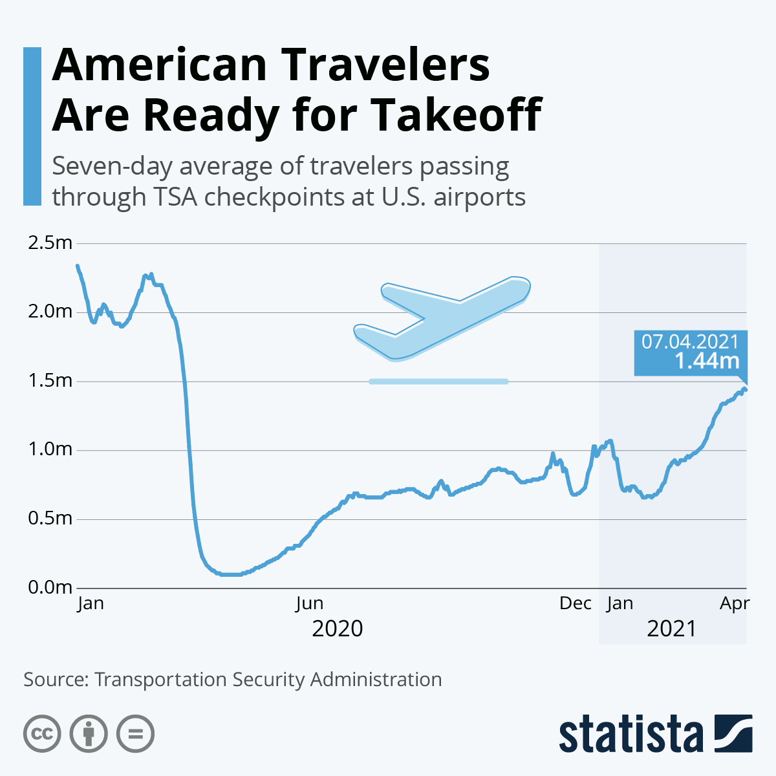
Average Traveler Data (Source: Statista.com)
After 2020, the year that was describes as the worst period in the aviation business, data from Transportation Security Administration shows that the demand for airlines is increasing. This is associated with the reduced travel restriction measures within the United States and across the world as many other countries began to open up their economies. By March 2020, the airline passenger traffic dropped by 90% within weeks (Ritcher, 2021). However, the weeks of the month of April saw the industry experience higher number of people getting tickets to travel across the United States and outside. As the above figure shows, by April 7, 2021 the number of air passengers had increased to 1.44 million in a week compared to the weeks of January 2021 when the number was below 1 million. This increase in the number of passengers is informed by the increase in the demand for air travel.
Conclusion
Finally, COVID-19 is a major pandemic that requires immediate action. Governments have devised policies to protect their citizens, some of which include a complete lockdown and the donning of protective masks. Moreover, covid 19 has resulted in a decrease in the number of available domestic flights. To curb the spread of the Covid 19 disease, many people are discouraged from making regular flights. People chose not to fly on for several reasons: 1) a fear of becoming infected at the airport and on flights, 2) The CDC recommended against non-essential travel, 3) firms canceled most business travel, and 4) many leisure destinations such as Disney were closed. These are factors that affect the demand curve. Changes in domestic airline behavior in response to the COVID 19 crises travel restrictions and the ensuing economic crisis resulted in a significant drop in demand for airline services. Airline behavior (I don’t know what this is) affects the supply curve, not demand. Some countries, such as India, have ceased stamping passports due to health and safety concerns. Domestic flights have been impacted by Covid 19, which has influenced demand and the supply for domestic flights.To wide up,Covid 19 has had a significant impact on the demand and also the supply of domestic flights, resulting in lower demand from customers and lower supply to available customers, owing to the imposed limits and rules. The establishment of social distance barriers is one of the innovative and creative ideas implemented to combat the epidemic. These are designed to keep passengers safe from one another on planes, lowering the risk of disease transmission. To mitigate the effects of COVID-19 on the passengers' airline, the domestic airline organization will take additional innovative steps, such as increasing the influx of plane cargo.

References
Data & Statistics: Domestic round-trip fares and fees. (2020, April 9) Airlines for America. https://www.airlines.org/dataset/annual-round-trip-fares-and-fees-domestic/
Gallego, I., & Font, X. (2020). Changes in air passenger demand as a result of the COVID-19 crisis: using Big Data to inform tourism policy. Journal of Sustainable Tourism, 1-20.
Hotle, S., & Mumbower, S. (2021). The impact of COVID-19 on domestic US air travel operations and commercial airport service. Transportation Research Interdisciplinary Perspectives, 9, 100277.Research and Markets. (2020, October 1). “Global infrared thermometers market report 2020: The most demanded medical product during the COVID-19 pandemic-Market projected to rise to $1.4 billion by 2027.” Global News Wire. https://www.globenewswire.com/news-release/2020/10/01/2102071/28124/en/Global-Infrared-Thermometers-Market-Report-2020-The-Most-Demanded-Medical-Product-During-the-COVID-19-Pandemic-Market-Projected-to-Rise-to-1-4-Billion-by-2027.html
Impact of COVID-19 on the Aviation Industry, 2020: Historical Market Growth Estimations, and Deviations in the Growth Rate Post-COVID-19 Pandemic. (2020) Business Wire. https://www.businesswire.com/news/home/20200422005684/en/Impact-of-COVID-19-on-the-Aviation-Industry-2020-Historical-Market-Growth-Estimations-and-Deviations-in-the-Growth-Rate-Post-COVID-19-Pandemic---ResearchAndMarkets.com
Ritcher, F. (2021, April 9). “American travelers are ready for takeoff.” Statista. https://www.statista.com/chart/24599/passenger-screenings-at-us-airports/
Rooley, J. (2020). How COVID-19 has affected the aviation industry and its approach to risk. Willistower. https://www.willistowerswatson.com/en-GB/Insights/2020/06/how-covid-19-has-affected-the-aviation-industry
Suau-Sanchez, P., Voltes-Dorta, A., &Cugueró-Escofet, N. (2020). An early assessment of the impact of COVID-19 on air transport: Just another crisis or the end of aviation as we know it?. Journal of Transport Geography.
Gebrekidan, s., Bennhold, K., Apuzzo, M. & Kirkpatrick, D. (2020). Ski, Party, Seed a Pandemic: The Travel Rules That Let Covid-19 Take Flight. Publication. https://www.nytimes.com/2020/09/30/world/europe/ski-party-pandemic-travel-coronavirus.html?searchResultPosition=1
Coronavirus is grounding the world’s airlines. (2020,) The Economist. https://www.economist.com/business/2020/03/15/coronavirus-is-grounding-the-worlds-airlines
The Economist. (2020). The new coronavirus could have a lasting impact on global supply chains. https://www.economist.com/international/2020/02/15/the-new-coronavirus-could-have-a-lasting-impact-on-global-supply-chains

