Global ABC

Student’s Name
Department, University
Course Number and Name
Instructor’s Name
Date

Contents
Question#1 2
Table-1/Company analysis 2
Vertical Analysis of Profit and loss statement 2
Table-2/Company analysis 2
Horizontal Analysis of Profit and loss statement 2
Table-3/Company analysis 3
Vertical Analysis of Balance Sheet 3
Table-4/Company analysis 3
Horizontal Analysis 3
Question#2 4
Table-5/Company analysis 4
Analyze the Company’s cash flows in 2019 4
Changes in operating assets and liabilities 4
Conclusion 4
Question#3 5
Table-6/Company analysis 5
liquidity ratios 5
Quick Ratio 5
Current Ratio 5
Solvency Ratio 5
Debt-to-Equity (D/E) Ratio 5
Solvency Ratio 5
Profitability Ratio 5
Gross Profit Margin 5
Operating Profit Margin 5
Net Profit Margin 5
Return on Assets 6
Question#4 6
Question#5 7
Question#6 7

Global ABC

Question#1

Table-1/Company analysis

Vertical Analysis of Profit and loss statement
In 2019 the gross profit is increased by approximately 7% as the revenue increased. And development charges are also decreased in 2019 by 1.2 % there is also a decline in selling and admin expenses of 2.1% which increase the profitability of the company in 2019. As we analyze the operating expenses they are decreased by 4.1% from 2018. Financial charges increase in value but less the percentage of revenue from the previous year. As we observe a loss in other investments but there is net profit in 2019 as compared to the big loss in 2018.
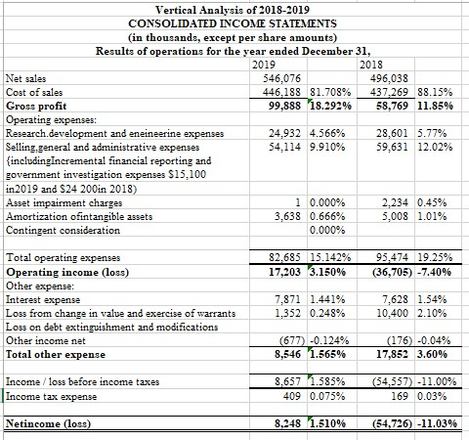

Table-2/Company analysis

Horizontal Analysis of Profit and loss statement
The revenue was increased by 10.09% in 2019 from 2018 revenue that was big growth. Cost of goods sold also increased but that was very less increase as compared to the revenue which was only 2.04% that’s why Gross profit increased by 70% approximately. Research and development charges were decreased by 12.83% which is a very big percentage for this type of expenses selling and marketing were also decreased by 9.25% which shows that the company is going toward a cost-cutting strategy. Asset impairment charges were also decreased which was almost zero which means the company is not producing a new type of assets for the year which is also proof from cutting off funds in research projects. Operating expenses reduced by 13.40% in 2019 from 2018 and operating profit was converted into profit as it was a loss in 2018. Financial charges increased but not so much. Therefore, the overall company generated profit as compared to the previous year in which it was in loss.
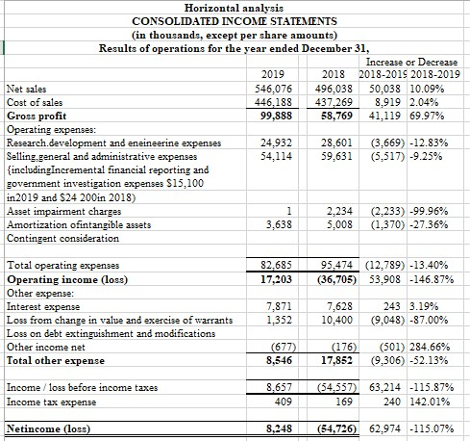
Table-3/Company analysis

Vertical Analysis of Balance Sheet
Total assets are increased by 8.21% which shows the net worth or value of the company increased. Receivable is increased by 20% which is bad but the sale is increased so the value of assets also increased. Inventories are increased by 3.05% which is not much affected because sales increase so need more to produce. Prepaid expensed are reduced by 64% as we have seen the research and development charges and admin expensed are cut down. There is not much change in long fixed assets as the company was not invested in property or any other fixed assets. But other noncurrent assets increased by a huge percentage which was 800% approximately. As a company not paid for prepaid assets expenses it paid its current liabilities more rapidly than in the previous year so all current liabilities decreased by 17.73%. Long-term loans did not change much because that was a big amount which they borrowed and paid slowly it will pay in 5 years as mentioned in the payment schedule. Total Long term liabilities increased due to other noncurrent liabilities increased. Equity was increased by injecting more capital and also increased by decreased in deficit due to profit this year.
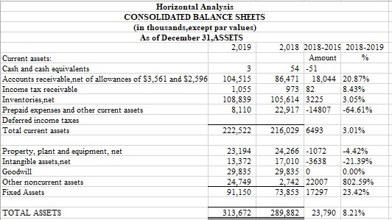
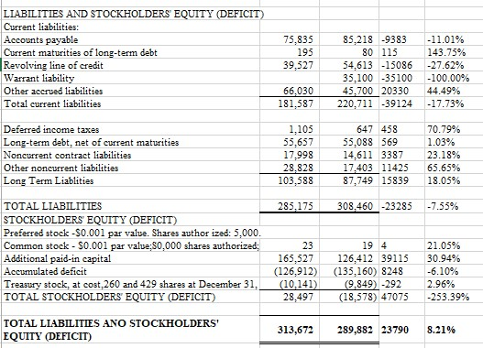

Table-4/Company analysis

Horizontal Analysis
Accounts receivable are 33.32% of total assets which are not good and it also increased from the previous year. Inventories are 34.69% of total assets which means the company is not many assets based as we see above 67% consist of inventories and accounts receivable. Properties are very few against total assets which are 7.39% only large partition of fixed assets is intangible assets and goodwill which means there is not much to claim for lenders. Liabilities side. The big partition of the lability sides is current which is about 58% this means the company has good solvency but not having good liquidity. The equity partition is only 9.08% which means the shareholders are not so much affected by its bad performance but the lenders are very much concerned about performance.
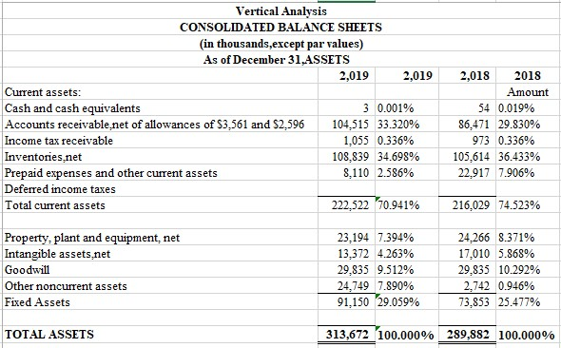
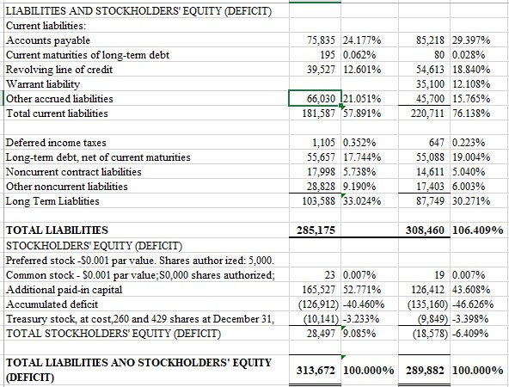

Question#2

Table-5/Company analysis

Analyze the Company’s cash flows in 2019
Cash raised by net profit as in this year company earns profit as compared to the previous year in which company goes in loss. Cash from Amortization of Intangible assets is decreased by 27% from the previous year which adds less cash in net cash as compared to the previous year. Depreciation approximately added the same amount in this year as in previous. Change in value and exercise of warrants is decreased it effected as it added 87% less from the previous year in cash flow as asset increase cash is added less. Stock-based compensation expense also decreased it will add 1415 less from the previous year. Amortization of financing fees is 53% less than previous so it reduced less cash in net cash. Asset impairment charges are reduced so it means again in cash. Other non-cash adjustments net cash adjustments are 87% less so it reduced less cash than the previous year.
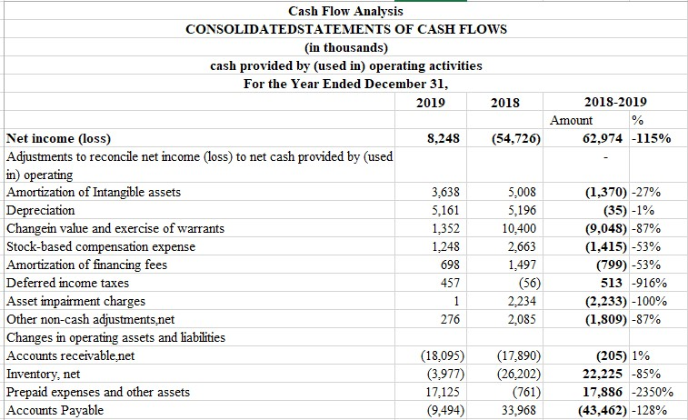
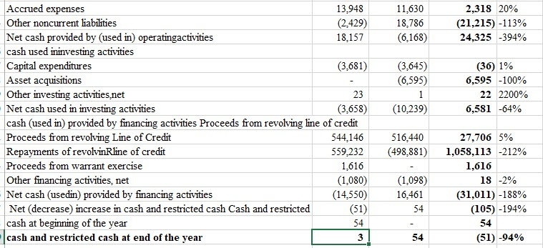

Changes in Operating Assets and Liabilities
Accounts receivable net less more cash as asset increase cash decreased. Inventory net less cash 85% less than from the previous year. Prepaid expenses and other assets are reduced so it added cash more from the previous year. Accounts Payable decreased so it reduced to cash by 29.397% less than from the previous year. Accrued expenses added more cash from the previous year by 20%. Other noncurrent liabilities are reduced so it will add cash in this year as compared to last year in which has a negative impact. Cash used in investing activities has the same impact as in last year as Capital expenditures not done Asset acquisitions not take pales and Other investing activities net has little bit grater impact on cash flow positively.

Summary: Net (decrease) in cash and restricted cash has occurred as we observed in the balance sheet the current liabilities are decreased and current assets are decreased
Question#3
Table-6/Company analysis

liquidity ratios: Quick Ratio
Formula: Quick ratio = (marketable securities + available cash and/or equivalent of cash + accounts receivable) / current liabilities. Quick ratio = (current assets – inventory) / current liabilities.
The answer in sheet Table-6 for the quick ratio is 62.61% which is good enough but not very healthy for the manufacturing business.

Current Ratio
The formula is Current Liabilities/Current Assets for a current ratio. The value from balance sheet 2019 is 81.60% which is not good enough for this type of business it should be more than 2.0

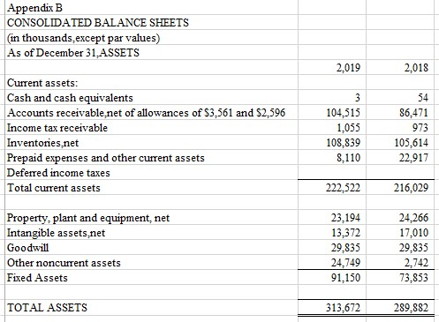
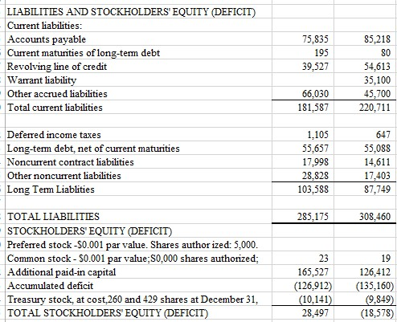
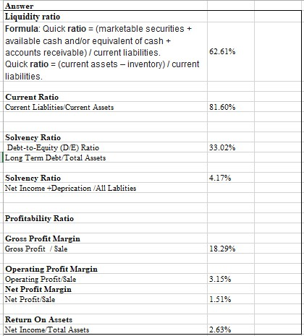

Solvency Ratio

Debt-to-Equity (D/E) Ratio
The formula is Long Term Debt/Total Assets. Equity debt is 33.02% which is Very good for the manufacturing business but in this case realization of profit is speared in more than one year so it is not considered good enough.

Solvency Ratio
The value derived from Net Income + Depreciation /All Liabilities. Is 4.17 it's mean it produced only 4.17 % of its liabilities which me it is not producing good enough for liabilities.

Profitability Ratio

Gross Profit Margin
Drive from in table-6 of workbook company analysis Gross Profit / Sale. 18.29 % gross profit is very good.

Operating Profit Margin
Operating Profit/Sale
3.15% which is a very low company having a large amount of Admin Expenses to meat 18.29% of gross profit.

Net Profit Margin
Net Profit/Sale
1.51% is a very low-profit Percentage for a manufacturing company.

Return on Assets
Is derived from this given formula in Table-6 Net Income/Total Assets is 2.63%. The very low percentage of return on assets as it has a very low amount of Assets or having a large number of liabilities against its assets.

Question#4
Due to Covid-19 Sale of the company Decrease so the profit of the company also decrease and fixed expense is on continuous bases so the profit is a decrease. Inventory also increased from the previous year due to which total assets also increased. Cash flow is not Effect because Received in advance and realization of profit is after that the date of the 2019 Annual Report, due to unprecedented decreases in demand, an oil price war, and economic uncertainty resulting from the COVID-19 pandemic, crude oil prices have declined precipitously. A significant portion of the Company’s sales and profitability is derived from the sale of products impacted by oil prices. While the Company has yet to experience significant supply chain interruptions or material cancellations of orders, the potential impact of future disruptions, continued economic uncertainty and continued depressed crude oil prices, and declining rig count levels may have a significant adverse impact that may result in the recognition of material impairments or other related charges.

Question#5
The company can mitigate the problem by increased manufacturing and taking the and also has to invest in research and development project which was reduced in 2019 by which the company will be isolated due to the lack of technology so it has to produced new items as they did in 2019 the sale was increased.
And has to pay its debt as given below
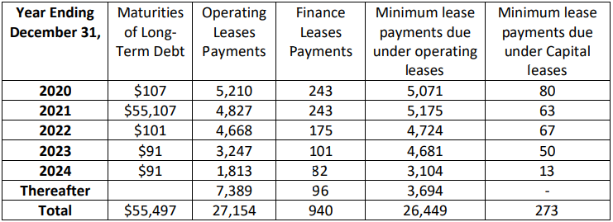
Therefore it has to continue its manufacturing, by all means, it will get paid in the future.

Question#6
The Company offers a great deal of the motors to clients who produce enormous generators that are utilized to make power. These generators are frequently utilized in far off territories of the conventional energy network (regularly oil and gas fields) just as to give reinforcement capacity to structures. The Company's business is enhanced across end markets and applications and incorporates broad secondary selling and administration parts programs. The Company has not delivered any money profits on its Common Stock to date. The installment of profits has been limited by the Credit Agreement and the arrangement overseeing the Unsecured Notes. The Company expects to hold its future profit to help activities and to back development. Finally, since mid-2016, the Company caused considerable costs identified with its rehashing of earlier fiscal summaries and endeavors toward remediation of its material shortcomings.
The Company effectively decreased these expenses with the culmination of the rehashing of its earlier budget reports in May 2019. The Company is presently current with their fiscal summary filings and as it keeps on chipping away at remediation of its material shortcomings. There is a more grounded interest for expanded deals inside the energy end market were inferable from more grounded interest for power age items, including those utilized inside the oil and gas market, and expanded interest for request reaction items, more appeal for items utilized in the medium-obligation truck market in ongoing two years. Due to this company was in loss and not be able to give Dividend and carry a big amount of loss till next so many years. And also sharing control with Leander because they get surrounded by lenders by showing wrong statements and overly borrowed against its assets. Profit also will be retained for more years or more for her sustainability. Lander is part of management so they have to pay to its landers to get full control and make good decisions for its growth.

