Paper Title

line 1: 1st Given Name Surname
line 2: dept. name of organization (of Affiliation)
line 3: name of organization (of Affiliation)
line 4: City, Country
line 1: 2nd Given Name Surname
line 2: dept. name of organization (of Affiliation)
line 3: name of organization (of Affiliation)
line 4: City, Country
line 1: 3rd Given Name Surname
line 2: dept. name of organization (of Affiliation)
line 3: name of organization (of Affiliation)
line 4: City, Country

Abstract— An abstract is a brief summary of a research article and is often used to help the reader quickly ascertain the paper's purpose. The typical maximum length of an abstract is 250 words.
Keywords—comma separated keywords related to your research topic.

Introduction
The main purpose of the introduction is to give a description of the problem that will be addressed. In this section the researcher might discuss the nature of the research, the purpose of the research, the significance of the research problem, and the research question(s) to be addressed. The introduction can span a maximum of 2 columns in the research article.

literature survey
The Literature Survey section in the research article briefly discusses the list of works/papers you used as a source to conduct your research and write your article. A good website to search for research articles is Google Scholar (scholar.google.com). The research articles cited and discussed in the literature survey section should be listed in the References section at the end of the paper (see below). 7 cited papers are required. The literature survey can span a column in the paper (no exact rule that governs the length of the literature survey).

algorithmic design
The Algorithmic Design section describes the core of your work. The discussion in this section depends on the project topic you selected. You are required to have a minimum of a 1-page description of your selected topic.

system Implementation
Some aspects of the algorithm(s) you discussed in Section III should be implemented in code using a high-level language programming language of your choice such as C/C++, Java, Python, etc. A description of your implementation should be presented in this section. You are required to have a minimum of a 1-page description of your implementation.

conclusion
The conclusion is the last section in your paper that provides some concluding remarks on your work. The conclusion is typically a small paragraph. Any future extensions to your work usually go into this section.

References
The References section lists the papers you referenced (cited) in your work. An easy way to format the references as below is to find the respective paper on Google Scholar:


Click on the ” link and copy the Chicago format for referencing the paper.
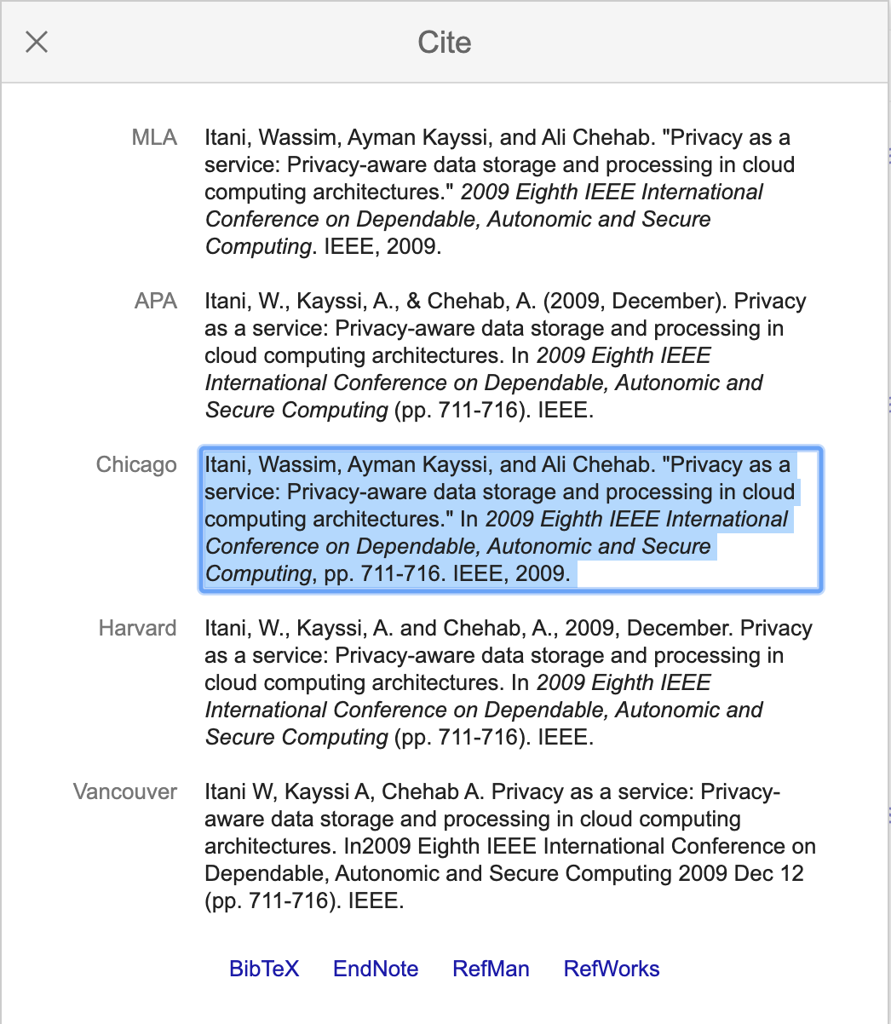
- G. Eason, B. Noble, and I. N. Sneddon, “On certain integrals of Lipschitz-Hankel type involving products of Bessel functions,” Phil. Trans. Roy. Soc. London, vol. A247, pp. 529–551, April 1955. (references)
- J. Clerk Maxwell, A Treatise on Electricity and Magnetism, 3rd ed., vol. 2. Oxford: Clarendon, 1892, pp.68–73.
- I. S. Jacobs and C. P. Bean, “Fine particles, thin films and exchange anisotropy,” in Magnetism, vol. III, G. T. Rado and H. Suhl, Eds. New York: Academic, 1963, pp. 271–350.
- K. Elissa, “Title of paper if known,” unpublished.
- R. Nicole, “Title of paper with only first word capitalized,” J. Name Stand. Abbrev., in press.
- Y. Yorozu, M. Hirano, K. Oka, and Y. Tagawa, “Electron spectroscopy studies on magneto-optical media and plastic substrate interface,” IEEE Transl. J. Magn. Japan, vol. 2, pp. 740–741, August 1987 [Digests 9th Annual Conf. Magnetics Japan, p. 301, 1982].
- M. Young, The Technical Writer’s Handbook. Mill Valley, CA: University Science, 1989.

