The Pandemic Pain is More Serious in Emerging Markets and Developing Countries: Causes and Remedies.
Institution affiliation
Student’s Name
Date of Submission

Executive Summary

The Pandemic Pain is More Serious in Emerging Markets and Developing Countries: Causes and Remedies.
Introduction
The Coronavirus has been a global pandemic that has negatively affected the economy of countries across the world. Most of the effects have been felt by the emerging markets and developing economies in the sub-Saharan countries. However, some Eastern European emerging markets like Moldova, Poland, Romania, and Serbia have also been deeply hit by the pandemic. The impact has affected developing economies and some of the developed countries like the United Kingdom that experienced a sharp decline in its Gross Domestic Product (GDP). As a result, most of the countries have experienced increased unemployment, reduction in working hours, temporary layoffs, high death rates, especially to the men and the old, increased poverty, low savings, low investments, reduced revenues to the government, low population and discouragements in the job search that has led to the staggering economy. There are possibilities that these economies can be restructured, but still, both the indirect and direct financial costs are enormous. During this particular time, savings is one of the instruments used by people worldwide as part of financial security. State governments, central banks as well as commercial banks use the same formula to shape their spending.
At the onset of the pandemic, most predictions looked at developing economies as areas that record-high death rates. The assumption was that most of these developing economies have inadequate resources in the health sector like fewer hospital beds, inadequate medical equipment, and health workers to fight the diseases. Surprisingly, the death rates have been very high in developed economies like the United States and Europe than in Emerging Markets and Developing Economies (EMDEs). Some of the reasons why Latin America has been hit hard by the coronavirus include the inequality gap, existence of many informal sectors, large population in the cities, increasing rate of internal migration, and inadequate public health system. Additionally, Latin America has less experience in the inversion of deadly viruses when compared to Africa and East Asia, where people have experienced Ebola and severe acute respiratory syndrome (SARS). It is perceived that people from those regions have been cautious about the consequences of deadly viruses, and they have been taking respective measures like maintaining social distance to save their lives.
(the) Coronavirus has affected the financial markets and the world economy by interfering with businesses and organizational activities. It has negatively affected income as a result of low productivity, remote working, and premature deaths. Although it’s an impact that shakes the global economy, emerging markets and Developing Economies are greatly affected. Due to staggering economic activities, most of the EMDEs took loans to be used to fight the pandemic. Even before the pandemic onset, most EMDEs countries had debts, and others had few chances to undertake discretionary fiscal policies. This is an economic situation that can easily send EMDEs countries into a default state. The projection shows that in 2021, the EMDEs' budgetary deficits are likely to double to almost 10.5% of their GDP averagely than in 2019. Also, government debt is predicted to cover up to 63% of the total GDP, increasing by over 10% from 2019.
In terms of external debts, EMDEs have over $11 trillion in external debt and approximately $3.9 trillion in debt service. The pandemic has created a global health emergency plan, and, likely, the unconditional increase in debt can also create an international development emergency plan. This situation invites a high risk of insolvency that cannot be controlled by raising the alarm on corporate default risks. To reduce the dilemma of both international and internal debts of EMDEs countries, there must be a technique to write off their interest payments in the coming years. Alternatively, since these countries need extra support, International Monetary Fund (IMF) should also come in hand and expand these countries' credit lines. For example, Colombia asked for an increase. (increase in what?)
The increase in public debt and pressure created by the coronavirus pandemic in emerging markets and developing countries have created a long-run crisis, especially in the health sector. After all, there are high chances that more focus is placed on coronavirus, therefore, underfunding other crucial health welfare programs. EMDEs countries have inadequate health resources, and there are also many other diseases that are not related to the pandemic, but they are killing more people. As a result, government attention is on the pandemic and channels almost all of its funds for the health system in treating covid 19, neglecting other diseases such as tuberculosis, malaria, and HIV/AIDS. In 2020, almost 40 million children were not vaccinated in Pakistan. In the long run, this is crucial because if cutting funds continues, even other welfare like free maternity will be highly affected.
In figure 1, we can see that government debts in EMDEs have dramatically increased due to fiscal stimulus packages. Even if the fiscal stimulus is eliminated, EMDEs country's fiscal condition is worse due to a steady decline in revenue from a staggering economy. The research done by consultancy Oxford Economics shows that if the situation continues the way it is, Mexico's government debt is likely to rise by over 11% of the GDP by 2021. On the other side, India is also expected to increase by 8.7 % (fig 1). Country's such as Thailand, Poland, Chile, and Brazil declared larger stimulus debt packages, and this means that they receive large debt gains in return. However, a higher rate of government borrowing means an impetus that stimulates private sector development that seeks extra financial support to cover internal costs during the pandemic. Higher borrowing costs will also come at the expense of business investment, which will weigh on productivity and longer-term economic growth.
Exchange rate market in EMDEs
Advanced economies provided policy support to EMDEs economy policymakers on ways of sustaining the economic blow. Most of the emerging markets' economies tightened their policies to prevent capital outflow to avoid inflation due to depreciation in the exchange rate. Still, as a result of the pandemic, they have adapted policy equivalent to developed economies. Most of the emerging market economies use reserve barriers, allowing adjustment to exchange rate (fig 2). In many cases, most countries inject liquidity to facilitate their market activities; for example, countries like Poland and Indonesia further eased some policies to support credit. However, EMDEs should be in a position of engaging in massive exportation to the rest of the world for it to restore their economic growth. They will, in turn, earn a reasonable foreign exchange that can be used to repay their international debts.
The Impact of Imposed measures by the Government
Government measures such as imposing lockdowns as a means of combatting the spread of the virus have caused total disturbances in the supply chain due to the closure of factories. For instance, China is one of the EMDEs, and the restrictions imposed, such as lockdowns, greatly influenced the production and manufacturing sector. (how?) Another sector affected is the service industry like hospitality, transportation, and tourism, as they have experienced losses due to travel bans. Other policies such as self-isolation and quarantine led to a massive reduction in consumption level, thus reducing the demand for goods and services. This is because consumers were forced to change their spending habits due to low income and household. Also, most people fear the nature of this pandemic because it's unpredictable; therefore, they save more than spending.
The Role of External Demand Shocks under no Lockdown condition.
In this scenario, we look at the Turkish demand factor (Fig 3). A reduction in demand for foreign goods creates a total decline in the output of the domestic sector. The graph below shows three scenarios, and the first scenario expresses the demand shock in the global condition. For instance, if a reflection from the Turkish data presents a decline in automobiles by a certain percentage, then it means there is a global decline for demand in automobiles across the world and, more so, EMDEs. Also, (fig 3) shows the change in total output, exports, and imports during the pandemic for both scenarios. The total result is reduced by 19.8% in the first scenario. The exports declined by 23.4%; this was 5.5 more than the decline experienced in the imports, which was 17.9%. This situation is more consistent with EMDEs countries because most of them depend on importing intermediate goods. Therefore, demand plays a critical role in the total economic costs; if foreign demand reduces, then aggregate output also reduces.
Investment and capital formation in EMDEs
Investment and formation of capital in developing countries and emerging markets were declining even before the Coronavirus hit, and this was being caused by the unstable or fluctuating prices of raw materials, poor infrastructure, especially the research and development institutions were lacking and lack of modern equipment and machines, very high costs of production and seasonal employment. For instance, in Pakistan, 14% of its Gross Domestic Product is expenditures on investment. Out of this percentage, 10% is for the private sector while the remaining 4% is for public investment. It is said that the two proportions have to be regular for the past half a decade. However, the Pakistan industrial sector, which is essential to investment, had been declining before the coronavirus pandemic because, from research, it is evident comparing the years 2017-2018 and 2019 it had grew by 4.9% in 2017-2018 while in 2019, it only grew by 1.4%. When the Coronavirus pandemic hit, this economy was highly affected in terms of investments. Very few industrial investments and other investments were made due to the increased uncertainties of the labor force and high costs of production with reduced sales. The private sector still was not getting adequate financing from banks before March 2020, meaning it was producing less, and this reduced production has led to a decline in the growth of Gross Domestic Product. So, with the coronavirus, the case worsened.
Pakistan's main investment and capital formation in the past five years is seen to come from China-Pakistan Economic Corridor (CPEC). It is estimated to be a $60 billion infrastructure-oriented bilateral stimulus program coordinated jointly by Pakistan and China as a fraction of the bigger One Belt One Road Infrastructure. Now with the foreign country lockdown, such coordination was disabled, leading to worsening of Emerging Markets and developing economies in terms of investments and capital formation.
Remedies
Loan exposures should be reduced. This would help in at least assisting the ability of the business to survive in this challenging pandemic, and the cost of living will not be too high so, the public debt is taken before it can be paid. This is because when we continue borrowing, we are additional liabilities of the economy, and this has an effect of burdening the citizens of the country, especially in the developing countries, in terms of high taxes, high cost of living, and reduced savings and investments as almost all the income is consumed. Increasing public debts not only affects the citizens but also the emerging markets because decreased consumption due to high prices of commodities will lead to declining of these markets or even their collapse.
Changing of business model operation. The developing countries can remedy the much pandemic pain to emerging markets and their developing economies by changing the way they operate their businesses, for instance, by reducing expenditures or looking for cheaper commodities, improving on the quality and quantity of products being dealt with, looking for new markets, advertising the products and taking consideration of the customer's taste and preference. This will lessen the burden the pandemic has brought to emerging markets and developing economies.
Adjustment of expenses. For instance, before the coronavirus pandemic, businesses would run even day and night. But now, there is a reduction of working hours and lockdowns, meaning somehow the number of customers being served is minimal compared to the former normal situation. The businesses need to adjust expenses by reducing the number of workers, postage, staff tea, rent, electricity bill, and transportation costs and also reduce spending on luxuries activities that are not very necessary. This will have a long-run positive impact on the businesses and the developing economies as they try to survive in the challenging pandemic period.
Adjusting the expectations they had before the pandemic. Before the pandemic hit, there were projections and expectations that the businesses that are the emerging markets had, so with the onset of the pandemic, there is a need to adjust those projections and expectations as things are not working the same as they would have worked. The developing economies and the emerging markets should plan again and make informed decisions considering the current changes because of the pandemic.
Seeking alternatives. The emerging markets and the developing countries should seek alternatives to remedy the pain caused by the pandemic. They can achieve this by reviewing all the chain of their services or looking for alternatives in their operation areas, may it be chain channels of suppliers, raw materials, or transportation. To avoid hurting and inconveniencing the clients, disclosing the challenges and sharing the plan of action is necessary. The customers may also help or advise where necessary, and some will be retained for the new alternative.
Consolidating the existing customers. Apart from obtaining new customers by using limited resources, deploying the available resources more to maintain the current clients happily and satisfied is another way to ensure guarantee of the ones business to continue doing well. The emerging markets should have in mind that the clients are going through the same challenges with them, and they may be looking for alternatives to one of your products or service. It is good to show appreciation to customers when they buy a product from them and offer an incentive for supporting them continuously and avoid using vulgar language to clients (?? What does this mean). The EMDEs will be relieved the current pain that was caused by the pandemic.
Applying for help. The business people and developing economies should not shy off from exploring. Asking for help, whether financially, in management, services, and advice, may help greatly. Some of the assistance listed above are available for free, while some are offered at a manageable cost. It is important to keep in mind that resources are always scarce, and all support in managing risks and reducing the business exposure is worth not ignoring. The emerging markets and the developing economies may reduce the pain they are going through in the coronavirus pandemic.
Ensuring that the public health system is of high quality. One of the reasons why the most developed countries are not hit heavily by this pandemic is because they have a stable, modern, and high-quality health system. Meaning, they have not spent much compared to less developed countries or else the developing economy because they had the machines and the equipment needed for the pandemic. Secondly, their need for an extra fund is not as huge as that for developing countries. Ergo, they don't require a public debt to fund the pandemic, and if they need some funding, it's not equivalent to the one needed by the developing economies. Having a high-quality and stable health system will reduce the heavy burden as the funds used to buy equipment to help fight the pandemic would be saved hence having no much burden on the economy.
Social protection. The much pain to the emerging markets and developing economies will be protected in future if the country exercises social security where it the country stays ready in case of a crisis and also reduce inequality and expanding its social housing. In the developed countries, there is social protection, and that is why when the pandemic hit, these economies were not affected greatly. Again, the developed countries are always ready in case of any crises; they know how to deal with them.
Ensuring that the quality of the Education system is maintained and is worthwhile. In many developed countries like China and the United States of America, the education system is of high quality in that the learned have greatly helped in decreasing the spread of the disease. In contrast, in less-developed countries, the skills acquired in schools are not worthwhile, and the scientists in such countries aren't helping much in such a crisis. The time, financial and other resources used to purchase the pandemic vaccine would be used to at least help the poor or even increase public spending.
Proper use of the public fund. There is a need to ensure proper management of the general fund in the emerging markets and developing countries as these economies are characterized by a high rate of corruption and embezzlement of public funds. Having leaders who are honest and who ensure the public fund is used in the way and for the right purpose is key. In developed countries, there are very minimal cases of corruption and embezzlement of public funds, and that is why their economies were not affected much by the pandemic as in the developing countries.
Taxation. There should be a progressive tax in that equality in paying taxes is achieved. People receiving high incomes should be taxed according to their incomes, while those earning low should give low as taxes. Taxes being the main source of government revenue would help in case of such a pandemic. The developing countries should make sure there are no tax evaders, and this tax is used in the right way. This would have helped lessen the burden of the pandemic on these countries and their emerging markets. The business people also would be relieved of the tax burden they are facing now.
Regulation of privatization. The developing economies should come up with measures that are strong enough to stop a secret agreement for an illegal purpose and behaviors that are not competitive. The developed countries have regulated their privatization in that their economies are protected against foreign collusion. This has an impact of ensuring that the marketing of the economy is stable, which helps greatly in case of a pandemic like a coronavirus.
Conclusion
The Emerging Markets Developing Economies have felt the coronavirus pain more greatly than the developed countries, as explained above. There are still opportunities to improve the crisis by reimagining privatization regulation, social protection, ensuring National reconciliation, equity, and making the environment sustainable. Alternatively, there is a great need to tighten the health system of the EMDEs and implement the remedies to support sustainable growth and development once the pandemic abates.

Work Cited
Akpan, I. J., Udoh, E. A. P., & Adebisi, B. (2020). Small business awareness and adoption of state-of-the-art technologies in emerging and developing markets, and lessons from the COVID-19 pandemic. Journal of Small Business & Entrepreneurship, 1-18.
Barua, S. (2020). Understanding Coronanomics: The economic implications of the coronavirus (COVID-19) pandemic.
Çakmaklı, Cem, et al. COVID-19 and emerging markets: an epidemiological model with international production networks and capital flows. National Bureau of Economic Research, 2020.
Contini, C., Di Nuzzo, M., Barp, N., Bonazza, A., De Giorgio, R., Tognon, M., & Rubino, S. (2020). The novel zoonotic COVID-19 pandemic: An expected global health concern. The Journal of Infection in Developing Countries, 14(03), 254-264.
Frankel, J. "The Pandemic Pain of Emerging Markets." Project Syndicate (2020).
Loayza, N. V., & Pennings, S. (2020). Macroeconomic policy in the time of COVID-19: A primer for developing countries.
Manley C. (2020). The consequences of COVID-19 on developing and emerging economies. Journal of International economics. Retrieved from: https://blog.realinstitutoelcano.org/en/the-consequences-of-covid-19-on-developing-and-emerging-economies/
Maria Nicola, Zaid Alsafi, Catrin Sohrabi, Ahmed Kerwan, Ahmed Al-Jabir, Christos Iosifidis, Maliha Agha, and Riaz Aghaf. “The socio-economic implications of the coronavirus pandemic (COVID-19): A review.” International journal of surgery (London, England) vol. 78 (2020): 185-193. doi:10.1016/j.ijsu.2020.04.018.
Martin Mühleisen et al. COVID-19 Response in Emerging Market Economies: Conventional Policies and Beyond. IMF. 2020. Retrieved from: https://blogs.imf.org/2020/08/06/covid-19-response-in-emerging-market-economies-conventional-policies-and-beyond/
Mofijur, M., Fattah, I. R., Alam, M. A., Islam, A. S., Ong, H. C., Rahman, S. A., ... & Mahlia, T. M. I. (2020). Impact of COVID-19 on the social, economic, environmental and energy domains: Lessons learnt from a global pandemic. Sustainable production and consumption.
Reinhart, C., & Reinhart, V. (2020). The pandemic depression: The global economy will never be the same. Foreign Aff., 99, 84.

Appendices
Figure 1
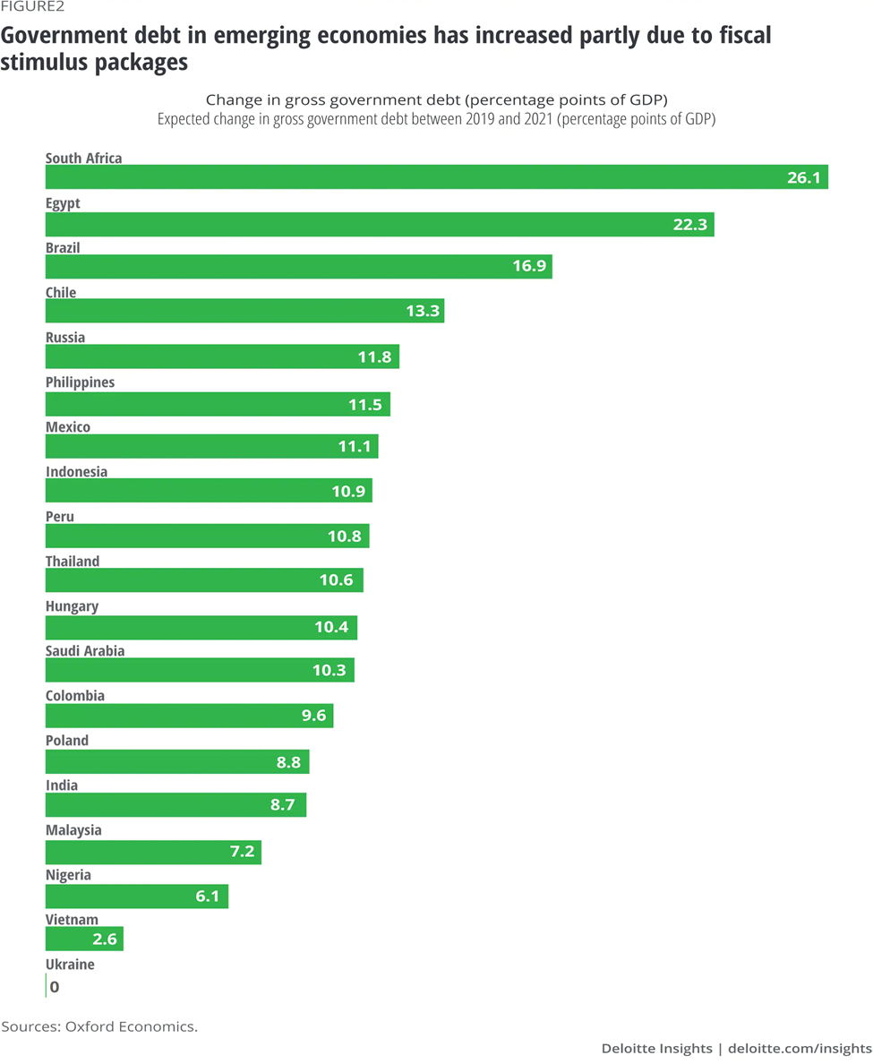
Figure 2
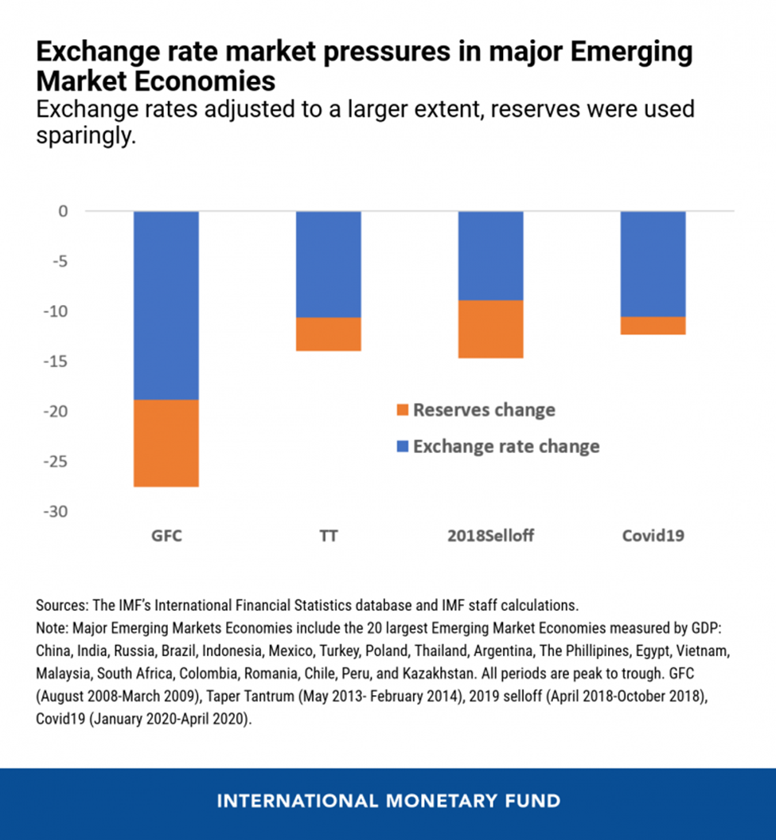

Figure 3
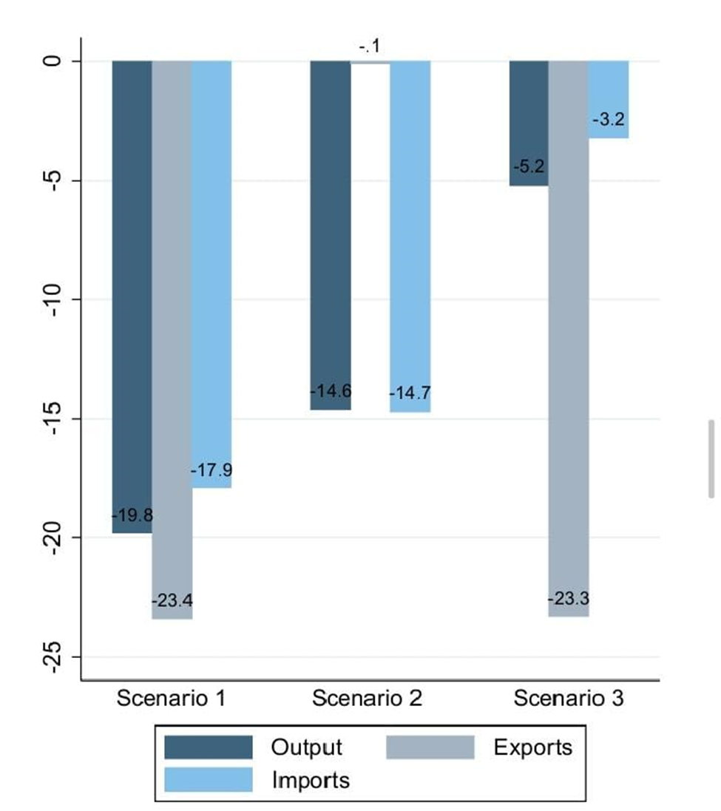

Frankel, J. "The Pandemic Pain of Emerging Markets." Project Syndicate (2020).
Maria Nicola, Zaid Alsafi, Catrin Sohrabi, Ahmed Kerwan, Ahmed Al-Jabir, Christos Iosifidis, Maliha Agha, and Riaz Aghaf. “The socio-economic implications of the coronavirus pandemic (COVID-19): A review.” International journal of surgery (London, England) vol. 78 (2020): 185-193.
Contini, C., Di Nuzzo, M., Barp, N., Bonazza, A., De Giorgio, R., Tognon, M., & Rubino, S. (2020). The novel zoonotic COVID-19 pandemic: An expected global health concern. The Journal of Infection in Developing Countries, 14(03), 254-264.
Martin Mühleisen et al. COVID-19 Response in Emerging Market Economies: Conventional Policies and Beyond. IMF. 2020.
Maria Nicola, Zaid Alsafi, Catrin Sohrabi, Ahmed Kerwan, Ahmed Al-Jabir, Christos Iosifidis, Maliha Agha, and Riaz Aghaf. “The socio-economic implications of the coronavirus pandemic (COVID-19): A review.” International journal of surgery (London, England) vol. 78 (2020): 185-193.
Barua, S. (2020). Understanding Coronanomics: The economic implications of the coronavirus (COVID-19) pandemic.
Frankel, J. "The Pandemic Pain of Emerging Markets." Project Syndicate (2020).
Çakmaklı, Cem, et al. COVID-19 and emerging markets: an epidemiological model with international production networks and capital flows. National Bureau of Economic Research, 2020.
Loayza, N. V., & Pennings, S. (2020). Macroeconomic policy in the time of COVID-19: A primer for developing countries.
Reinhart, C., & Reinhart, V. (2020). The pandemic depression: The global economy will never be the same. Foreign Aff., 99, 84.
Loayza, N. V., & Pennings, S. (2020). Macroeconomic policy in the time of COVID-19: A primer for developing countries.
Akpan, I. J., Udoh, E. A. P., & Adebisi, B. (2020). Small business awareness and adoption of state-of-the-art technologies in emerging and developing markets, and lessons from the COVID-19 pandemic. Journal of Small Business & Entrepreneurship, 1-18.
Akpan, I. J., Udoh, E. A. P., & Adebisi, B. (2020). Small business awareness and adoption of state-of-the-art technologies in emerging and developing markets, and lessons from the COVID-19 pandemic. Journal of Small Business & Entrepreneurship, 1-18.
Çakmaklı, Cem, et al. COVID-19 and emerging markets: an epidemiological model with international production networks and capital flows. National Bureau of Economic Research, 2020.

