Whooping Cranes Journal

21st July 2021: start time 1000hrs to 1036hrs
Hey, whooping cranes!
- Breeding Habitat;
During this moment of time my observation was that whooping cranes have a tendency of breeding in wetlands which are shallow and covered with grass. Their migration patterns seem to be revolving around wet lands and covered with grass. The interesting thing here is that wetlands are good feeding grounds thus feeding easily owing to their long-stretched beaks and conducive environment for setting up their shelter since proximity to food is guaranteed. According to habitational nature of whooping cranes we can classify them into two that is wetland and upland habitat
Troubles Encountered.
In order to view or observe the hidden cranes zooming out aided a great deal. The most ambiguous part that challenged me is that as you continue to stretch the image so that to get a clear view of the crane images becomes blurred thus obscuring from identify the cranes.
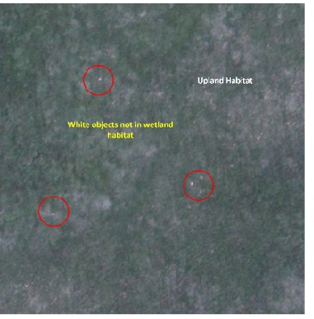

Screenshot showing the whooping cranes habitation

22nd July 2021: start time 0921hrs to 0933hrs
- Behavior;
During this period of time, I have observed that it is a normalcy of whooping cranes to occur in groups. Their way of living is communal thus they are so united evidenced by their nests which are so closed. This is the most surprising part of whooping cranes. They are live a united lifestyle.
The problem encountered as perv this visit is that observing their walking pace is like a rocket science since the it is not a video image thus you cannot actually tell.

23rd July 2021: start time 1341hrs to 1407hrs
- size and shape:
whooping cranes can be large characterized by long legs and necks. They can be having webbed feet to help them avoid sinking in water catchment areas. This is so interesting since it is one of their adaptive features that enables them to walk on water as they search for food.
Problem encountered here is that since the image is an aerial view it is difficult to observe their webbed feet.
Some white dots are big while others are small that shows they vary in both size and shape
Screenshot showing large body size of cranes
24th July 2021: start time 1012hrs to 1059hrs
- Color Features
matured whooping cranes tends to be bright white and have red color accents on their heads. Immature whooping cranes have whitish color. This can mean their color pattern depends on age. This is so surprising. The problem encountered is that it is so difficult to see that observation on an aerial view photograph.
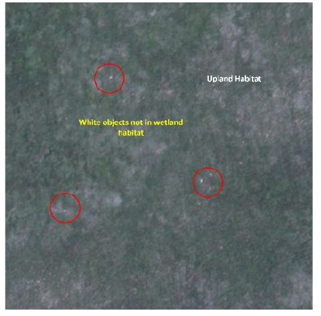
Screenshot showing the color patterns of whooping cranes.

