DATA ANALYSIS
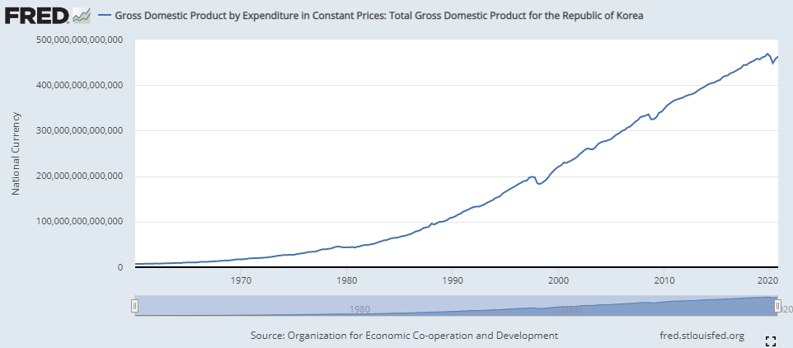

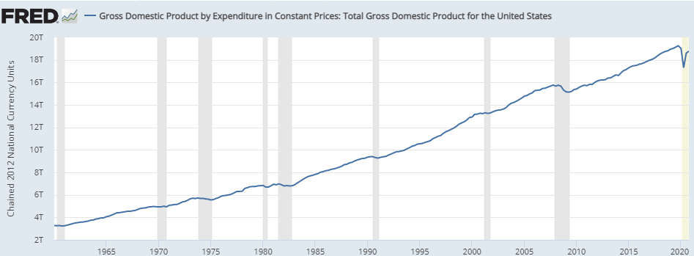
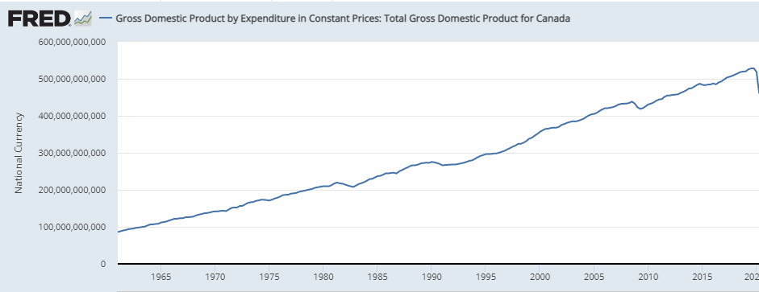
ln(Y_{i,t)} = αi + βit + Є_{i},t,
detrending,
Korean regression will be:
Ln(Y_{i,t}) = 1.954+

