HEALTH ATTITUDES AND BEHAVIORS

DEMOGRAPHIC VARIABLES: Each variable can be subdivided into smaller groups and used for comparison purposes (e.g., men vs. women)
Gender (Male [1], Female [2]) _______ [GEN] YELLOW = VARIABLE NAME
Age in years _________ [AGE] BLUE = QUANTITATIVE RESPONSE CODE
My zip code is __________ [ZIP]
Height _______ feet, [FT] _______ inches [IN]
Weight _______ pounds [LBS]
Ethnicity (African American [1], American Indian [2], Asian/Pacific Islander [3], White/Non Hispanic [4], Hispanic/Latino [5], Other [6]) [ETHN]
Religion (Atheist [1], Agnostic [2], Buddhist [3], Catholic/Christian [4], Hindu [5], Mormon [6], Muslim [7], Protestant/Christian [8], Other [9]) [REG] Number of years in school ____________________ [SCH]
Relationship Status (Married [1], Divorced [2], Living together [3], Single/Never Married [4], Separated [5]) [REL]

RESPONSE TO THREATENING MESSAGE SCALE BELOW
SE1-3 Measure participants’ self-efficacy (confidence that one can remain healthy)
SEV1-2 Measures how severe the participant thinks the disease is
FR1-4 Measures how afraid participants are
DA1-4 Measures how much the participant wants to distance herself from the threatening message
INT1-4 Measures what the participant intends to do
BEH1-3 Measures behaviors that the participant will engage in after reading the message
ATT1-2 Measures the participant’s attitude
REA1-2 Measures the participant’s reasoning
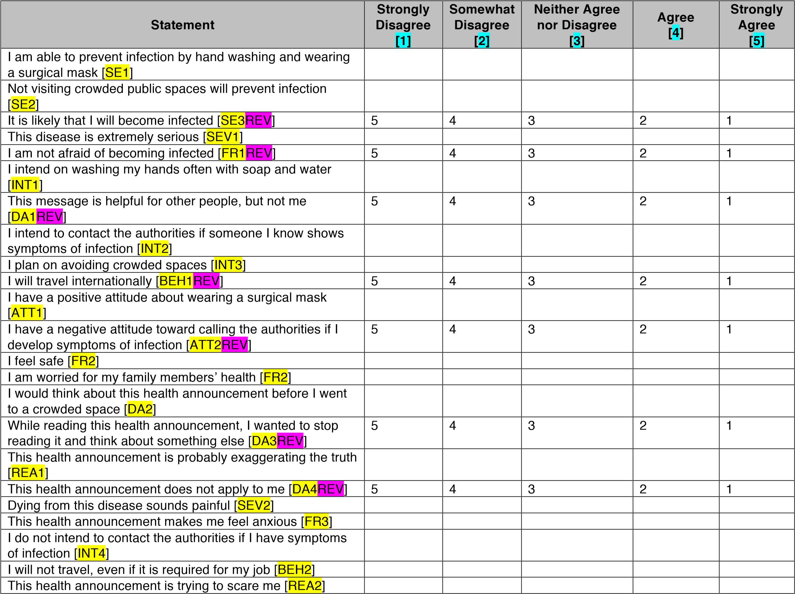
I feel calm [ |  |  | FR4 | REV | ] | 5 | 4 | 3 | 2 | 1
I will be quarantined as long as recommended, if necessary
[ | BEH3 | ]

Place a ✔ in the scale below to rate how OFTEN you did the following things:
AT-RISK HEALTH BEHAVIOR SCALE
RSK1-10 Measure various risky health behaviors that participants might have engaged in
Activity |  |  |  |  |  |  |  |  |  |  |  |  |  | Never  [1] | Rarely  [2] | Occasionally  [3] | Often  [4] | Always  [5]
Had unprotected sex | [RSK1 |  | ]
Butchered an animal [ | RSK2 |  | ]
Ate raw meat or fish [ | RSK3]
Spent time in the woods [ |  | RSK4 |  |  | ]
Visited a developing country [ |  |  |  | RSK5 |  |  |  | ]
Camped near an area with bats [ |  |  |  |  |  | RSK6 |  |  | ]
Drank untreated water from a stream, pond, or river [ |  |  |  |  |  |  |  |  |  |  |  | RSK7 | ]
Consumed animal products that were not that were not
purchased in a grocery store [ |  |  |  | RSK8 |  |  |  | ]
Spent time around exotic animals [ |  |  |  |  |  |  | RSK9 |  |  | ]
Spent time around unvaccinated domestic animals [ |  |  |  |  |  |  |  |  |  |  | RSK10 |  | ]

Place a ✔ in the scale below to rate how much you FEEL THIS EMOTION RIGHT NOW.
EMOTIONAL WELLBEING SCALE
PAF1-10 Measures positive emotions
NAF1-10 Measures negative emotions
Statement |  |  |  |  |  |  |  |  |  |  |  |  |  |  |  |  | At All [1 | Not  ] | A Little [2] | Moderately | Quite A Bit |  |  | Extremely
  [3]
  [5]
 |  |  |  |  |  |  |  |  |  |  |  |  |  |  |  |  |  |  |  |  |  | [4]
Interested [ |  |  |  |  |  |  | PAF1 |  |  |  |  |  | ]
Distressed [ |  |  |  |  |  |  |  | NAF1 |  |  |  |  |  | ]
Excited [ |  |  |  | PAF2 |  |  |  |  |  | ]
Upset [ |  |  | NAF2 |  |  |  |  |  | ]
Strong [ |  |  | PAF3 |  |  |  |  |  | ]
Guilty [ |  |  | NAF3 |  |  |  |  |  | ]
Scared [ |  |  |  | NAF4 |  |  |  |  |  | ]
Hostile |  |  | [NAF5]
Enthusiastic [ |  |  |  |  |  |  |  |  | PAF4 |  |  |  |  |  |  | ]
Proud [ |  |  | PAF5 |  |  |  |  |  | ]
Irritable [ |  |  |  | NAF6 |  |  |  |  |  | ]
Alert [ | PAF6 |  |  |  |  |  | ]
Ashamed [ |  |  |  |  |  |  | NAF7 |  |  |  |  |  | ]
Inspired [ |  |  |  |  | PAF7 |  |  |  |  |  | ]
Nervous [ |  |  |  |  | NAF8 |  |  |  |  |  | ]
Determined [ |  |  |  |  |  |  |  |  | PAF8 |  |  |  |  |  | ]
Attentive [ |  |  |  |  |  | PAF9 |  |  |  |  |  | ]
Jittery [ |  | NAF9 |  |  |  |  |  |  | ]
Active [ |  | PAF10 |  |  |  |  |  |  |  | ]
Afraid [ |  | NAF10 |  |  |  |  |  |  |  | ]

Place a ✔ in the scale below to rate how much you AGREE with the following statement.
HEALTH BEHAVIOR SCALE
H1-10 Measures various health behaviors that participants engage in
Statement |  |  |  |  |  |  |  |  |  |  |  |  |  |  |  |  |  |  |  |  |  |  |  |  |  |  | Stron  Disag |  | gly  ree | Disagree | Neither Agree nor Disagree |  |  |  | Agree | Strongly Agree
  [2]
  [4]
 |  |  |  |  |  |  |  |  |  |  |  |  |  |  |  |  |  |  |  |  |  |  |  |  |  |  |  | [1] | gly  ree |  |  | [3 | ] |  |  |  | [5]
I limit the amount of fat I eat [ |  |  |  |  |  |  | H1]
I limit the amount of salt I eat [ |  |  |  |  |  |  |  | H2 |  |  | ]
I avoid eating large amounts of sugar [ |  |  |  |  |  |  |  |  |  |  |  |  |  |  | H3 | ]
I avoid chips and fried foods [ |  |  |  |  |  |  | H4 |  |  | ]
I limit the amount of red meat I eat [ |  |  |  |  |  |  |  |  |  |  |  |  | H5 |  | ]
I get angry and annoyed when I am caught in traffic [ |  |  |  |  |  |  |  |  |  |  |  |  |  |  |  |  |  |  |  |  | H6 |  | REV |  |  | ] | 5 |  |  | 4 | 3 |  |  | 2 |  | 1
I get irritated and mad when waiting in lines [ |  |  |  |  |  |  |  |  |  |  |  |  |  |  |  |  | H7 |  | REV] |  |  |  |  |  |  |  | 5 |  |  | 4 | 3 |  |  | 2 |  | 1
Things build up and I lose my temper [ |  |  |  |  |  |  |  |  |  |  |  |  |  |  | H8 | REV |  | ] |  |  |  |  |  |  |  |  | 5 |  |  | 4 | 3 |  |  | 2 |  | 1
I conduct either a breast or testicular exam every month [ |  |  |  |  |  |  |  |  |  |  |  |  |  |  |  |  |  |  |  |  |  |  |  | H8 |  | ]
I check my skin for unusual spots or coloring every few
months [ | H9 | ]
I have physical exams every year [ |  |  |  |  |  |  |  |  |  |  |  | H10 |  |  | ]
I have dental exams every year [ |  |  |  |  |  |  |  |  |  | H11 |  |  |  | ]
I get my blood pressure checked every year [ |  |  |  |  |  |  |  |  |  |  |  |  |  |  |  |  | H12 |  |  | ]
I go to all of my scheduled healthcare appointments |  |  |  |  |  |  |  |  |  |  |  |  |  |  |  |  |  |  |  |  | [H13 |  |  | ]
I consult a healthcare provider right away when I have
unfamiliar physical symptoms [ |  |  |  |  |  |  |  |  | H14 |  |  | ]
I take prescription medication only as directed by a
healthcare provider [ |  |  | H15 |  | ]
I fill my prescriptions immediately [ |  |  |  |  |  |  |  |  |  |  |  | H16 |  |  | ]
I use tobacco products [ |  |  |  | H17 |  | REV |  |  |  | ] |  |  |  |  |  |  |  |  |  |  |  |  |  |  |  |  | 5 |  |  | 4 | 3 |  |  | 2 |  | 1
I use recreational drugs [ |  |  |  |  | H18 |  | REV |  |  |  | ] |  |  |  |  |  |  |  |  |  |  |  |  |  |  |  | 5 |  |  | 4 | 3 |  |  | 2 |  | 1
I drink more than two alcoholic beverages a day [ |  |  |  |  |  |  |  |  |  |  |  |  |  |  |  |  |  |  |  | H19 |  | REV |  |  | ] |  | 5 |  |  | 4 | 3 |  |  | 2 |  | 1

Place a ✔ in the scale below to rate how much you AGREE with the following statement.
HEALTH SELF-EFFICACY SCALE
HSE1-5 Measures how much confidence/self-efficacy participants have with regards to different health behaviors
Statement |  |  |  |  |  |  |  |  |  |  | Strongly  Disagree  [1] | Disagree  [2] | Neither Agree nor Disagree  [3] | Agree  [4] | Strongly  Agree  [5]
I am confident that I can have a positive influence on my
health [ |  |  | HSE1 | ]
I have set some definite goals to improve my health [ |  |  |  |  |  |  |  |  | HSE2 | ]
I am actively working to improve my health [ |  |  |  |  |  |  | HSE3 | ]
I am able to meet my health goals [ |  |  |  |  | HSE4 | ]
I feel in control of how and what I learn about my health
[ | HSE5 | ]

PRIMARY CARE SCALE Measures various routine health treatment behaviors
Do you have a primary care physician? (Yes [1] or No [2]) ______
I see a healthcare provider (#) _____ times each year. [HPYR]
Date of your most recent physical (Month, Year) ___________[PMO], _______ [PYR]
Reason for your last doctor’s visit ______________________________ [REA]
Do you get a flu shot each year? (Yes [1] or No [2]) ________ [FLU]

