Dehaven Johnson
Professor Sutton
Portfolio - ENG 102_B1Y - Spring 2019-FULL Semester
7th May 2019
Reflective introduction
Portfolio assessment is intended to bring light of the themes present in the literature regarding its assessment. I learned as students we understand the process theory of composition and also guide student learning through documenting our writing processes as well as giving a voice in interpreting student’s development.
Diagnostic draft
The Diagnostic draft of the article published in the New York Times illustrates how the writer crafted his article and referring to “Negro” rather than “Malcolm X.” I learned that the writer’s intention was to cover the emotional pain from the reader of the article. Moreover, writer does not disclose deeper details on the exact occurring. Another writer in the New York Post article did not hide any material facts right from communication with the Malcom X hence attracts the reader’s attention emotionally before his assassination. The diagnostic draft is not fine-tuned to bring the readers intended message. Hence, it may have some grammatical errors and sentence issues that need to be addressed.
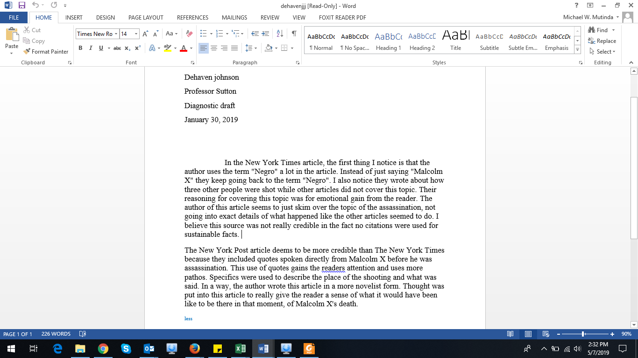
Reflective finish
The diagnostic finish illustrates how the writer is in position to make adjustments to finer details. This illustrates the readers intended message in a clear manner and ensures that the grammatical, sentence structure to make the work clearer and understandable.
The revision plan would include; sharing the draft with colleagues and tutor who would assist in identifying the errors. Thereafter, I would go through the work again and correct the errors as I seek clarification where possible.
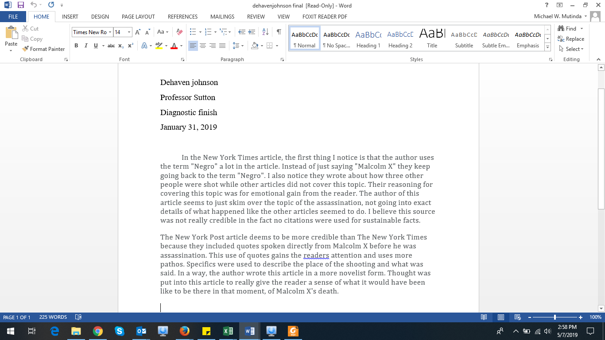
Popular Culture Analysis Assignment Sheet
The topic included is the, “Home Alone: Life as an only child.” The main thesis is the, “thirst for freedom of the child freedom his parent’s orders and getting what he really wants.” The main points included is the role of the parents in growth of children and conflicts between children and parents during the child’s growth. The child desires to break from their parent’s orders and attention while on their other side they want companionship.
The annotated bibliography
The topic considered in this assignment is the, “Popular Culture Topic Proposal.” The topic selected in the proposal is the celebrity worship and clearly illustrates how people have shifted from worship God to praising and seems to worship the celebrities. Several items that influence people’s viewing, listening, clothing and signing, conversations and everything that celebrities are associated with. People want to look famous and hence act as though they worship celebrities. All the literature material both primary and secondary would be considered for this task to be accomplished.
