deology, Political Belief, Government Decline:
Conservative Successes:
- Self-described "conservatives", Republican leaders claim that they uphold traditional American values - "family values" and the unregulated "free market" as the core of capitalism.
- both traditional and neo-conservatives hold "small government" as a core value and are adamantly anti-tax, anti-regulation, and anti-organized labor.
Republicans frame the role of government in very negative terms, succeeding in winning public support through the manipulation and control of large segments of news and entertainment media.
The single most persistent and effective falsehood used by conservatives is that all of mainstream media - "The Media" - is liberal.
Example: Linking "liberalism" to government taxation and overspending, budgetary irresponsibility, moral laxity, even sexual permissiveness, and immorality.
Example: Linking the "liberal" label to anti-business, anti-free market politics.
Republicans have successfully used periods of economic decline - usually caused by laws and policies that they actually generated - to cut government programs and projects that support the working class, middle class, and the poor in times of temporary or extended economic or geophysical crisis - massive floods, hurricanes, oil spills, earthquakes, fires. see Naomi Klein, Shock Doctrine: http://www.nytimes.com/2007/09/30/books/review/Stiglitz-t.html?_r=0

Example:
The failure of federal emergency services in the wake of Katrina, the extremely destructive hurricane of 2005 that decimated New Orleans and much of the US coast on the Gulf of Mexico.

Example:
The Republican success at underfunding regulatory federal inspections of seabed/undersea oil drilling, resulting in the massive "BP" (British Petroleum) oil "spill" calamity of 2010.

self-labeled "conservatives" routinely skew their political positions and statements to align with sentiments, attitudes, and beliefs widely held in the US public - however inaccurate, afactual, or mythical these might be. Denials of the relationship between the use of fossil fuels and climate change, for example.
Example:
Describing professors and authors of books and articles as effete, naive intellectuals with no genuine personal connection with "the American People". see Senator Brown anti-intellectual attacks against Prof. Elizabeth Warren: http://nbcpolitics.nbcnews.com/_news/2012/11/06/14979130-in-costliest-ever-senate-race-warren-beats-brown-for-massachusetts-seat?lite

Example:
Using traditional racial stereotypes that trigger fear or reinforce negative perceptions about people of color is a typical and very frequently used tool.

Example:
LInking community-based service organizations to large-scale voter fraud.
Republicans routinely combine American nationalism with American scientific ignorance to defend large-scale corporate interests.
Example:
Denial that climate change is happening, and now (since obviously it is happening), denying that human activity - particularly fossil fuel use - contributes in any way to climate change.

_________________________________________________________________
re "white privilege":
http://scholarworks.gsu.edu/cgi/viewcontent.cgi?article=1051&context=history_theses
The following sites researched by Sean Daryanto, thank you!

3500 For-Profit Universities as of 2015:
https://nces.ed.gov/pubs2016/2016112.pdf
Attributes as to why for-profit universities fell:
- NY Times report on for-profit universities:
https://www.nytimes.com/2012/07/30/education/harkin-report-condemns-for-profit-colleges.html?pagewanted=all&_r=0
- Occupy Activists paying off student debt with respect to Corinthian College
https://www.theguardian.com/money/2014/sep/17/occupy-activists-student-debt-corinthian-colleges
- Almost 50% decline in for-profit enrollment
https://www.theatlantic.com/education/archive/2014/04/how-higher-ed-contributes-to-inequality/360407/
_________________________________________________________________________

Decline of the Middle Classes:

Class dynamics and the influences and causes of benefits or detriments to the middle-class that has been hailed as the proof of the social and economic viability of capitalism.

As other course materials have described, liberals, progressives, and moderates who believe that the purpose of a democratic government is to represent and protect the interests of as much of the population as possible, including power minorities.

The Left tends to press for laws, social programs and projects to address societal inequities, funding these with taxes paid by the the general population and businesses.

______________________________________________________________

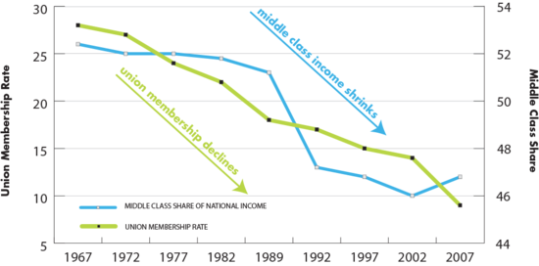

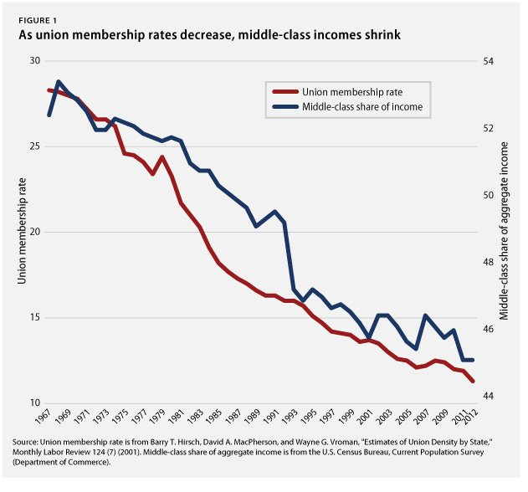
While the Warren Court was rendering pro-social justice decisions, it was also favoring corporate interests with anti-union decisions.
- OPEC (Organization of Oil Exporting Countries) staged the first of two oil embargos. When the OPEC countries lowered the supply of oil to industrial and developing nations,
- fuel shortages had the immediate effect of slowing or halting transportation and shipping, thereby, making all commodities in short supply - including food.
- The large unions used walk-out and slow-down measures to push their employers to raise wages as a defense against the loss of purchasing power due to inflation of the US dollar. Rising prices and wages both contributed to further inflation of the dollar as US manufactured products continued to lose sales on the global markets - especially high-priced items like automobiles and home appliances.

Union actions that negatively affected the daily lives of the great majority of Americans turned the general public against them. Further, some of the largest unions suffered from the corruption of their leadership elite by corporate lobbyists, conservative politicians, and organized crime syndicates.
In the short term, reducing government employment, particularly during recessions, adds workers directly to the unemployment rolls. In addition, fewer workers translates into fewer paychecks, which dampens consumption and further spreads through the economy, magnifying the effects of the recession.

Since the election of President Obama, Republicans have persistently stated that "government does not create jobs". Note that all of the massive infrastructure projects including the Golden Gate and Bay Bridges, the massive dam and electrification project throughout the US, and over 650,000 miles of national highways were completed under the federal Works Projects Administration of President Franklin Delano Roosevelt's "New Deal" program. By the end of the WPA project in 1943, it had provided work for 8.5 million people.
http://www.publiceye.org/christian_right/cr_intro.html

As Prof. Ancheta has shown, for two centuries, the American Right has effectively used apparently "race blind" and "color blind" criteria to achieve racially discriminatory goals in municipal, state and federal laws covering educational, employment, business, and recreational activity as well as international immigration.

Two devices often used to camouflage or disguise racial intent and objectives are class/economic criteria, such as income level, and cultural criteria, such as non-"American"/"non-standard" accents.

Conservatives traditionally believe in small government, low taxes, individual responsibility and resist the creation and maintenance of government service programs and government regulations that affect the "free market".

Challenges to the economic and social status quo in the 1960s and '70s brought strong reactions from the Right. With very effective electoral campaigns, the Republican Party placed Richard Nixon, Ronald Reagan - both running on a restoring "law and order" campaigns, and George H.W. Bush - "no new taxes" - into office, covering all but 4 years of the period between 1968 and 1992.

View and analyze the following charts: These reflect the actual effect of the government policies and practices that were put in place during those years of Republican leadership and congressional power.

Check on the reliability of the data and the conservative explanations for the condition of the middle- and working classes and the poor.

_________________________________________________________

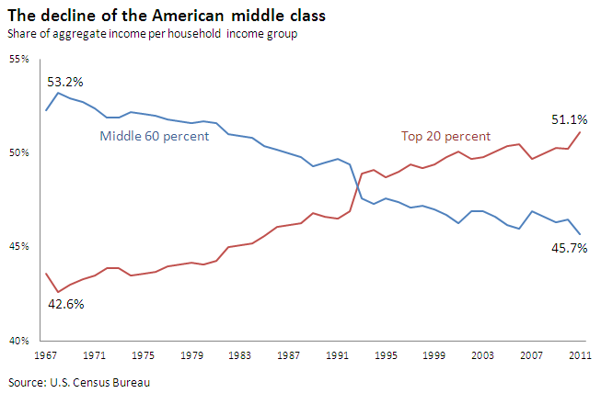

_______________________________________________

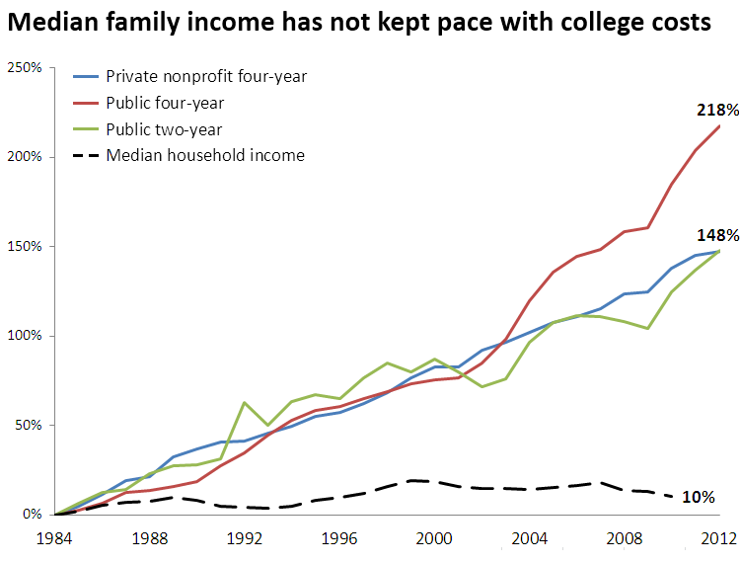

[Note Well: increases for tuition an fees at "four-year" (BA, BA, MA, PhD granting) public colleges and universities has risen at a higher and faster rate than private colleges and universities. DPG]

President Ronald Reagan lead the large-scale destruction of American unions with the firing of all 11,000+ members of the airport tower controllers union in 1981, the very first year of his tenure in office. The members of PATCO, the Professional Air Traffic Controllers Organization, had complained of harsh work conditions that endangered the general public. When Congress refused to act, PATCO held an illegal walk-out strike that essentially gave the option to Pres. Reagan to use emergency power to fire the strikers. PATCO was replaced by less experienced military air traffic controllers. Pres. Reagan imposed a lifetime ban against all participants in the strike: Strikers would never work in the. http://www.politico.com/story/2008/08/reagan-fires-11-000-striking-air-traffic-controllers-aug-5-1981-012292

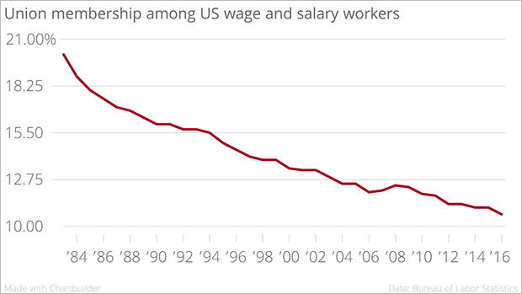

In US 1973, the US dollar was already losing value on the world market when:

The US Right (self-described "conservatives") used its growing influence on the managers of public education and the supposedly "liberal" media to easily convince a large segment of the voting public that all and any unions were socialist and/or corrupt; that the failing 1970s economy was the fault of the unions, not domestic or foreign policy.

Federal budget cuts of the 1980s and '90s coincided with the state and local cuts that had begun in California with the passage of the Proposition 13 initiative. The cutting of government programs put hundreds of thousands of people out of work over less than ten years.

The view from the center-right Brookings Institute:

"Note well the Reagan years of the prior precipitous drop, the rise of government employment during the Clinton recovery period, and the most recent sharp drop that continued into the first 18 months of the Obama Administration."

The National Deficit as Political Weapon

The Right has also effectively generated fear in the general public of the adverse effects of the growing "out-of-control" national debt.

Presidents Nixon and Reagan also blamed the growing national debt on social programs, including the costs of Social Security and MediCare "entitlements". Congress succeeded in cutting the budgets of government-funded programs to the point where they had very limited effect in addressing the issues that they were established and directed to do. The decreasing effectiveness of the programs lead to their termination and that, in turn, lead to the termination of social service programs at the state and municipal levels beginning in 1971 and ranging into and through the Clinton (Democrat) administration.

The private sector continues to be an engine for growth as the United States recovers from the Great Recession. However, tight budgets force a number of difficult decisions on policymakers (especially state and local ones), who are forced to lay off workers in order to meet their bottom lines. The result is that public-sector employment was in sharp decline until year two of the Obama Administration economic recovery, though Pres. Trump takes full credit for continuing low unemployment data and positive stock market activity. Even as the nation’s unemployment rate improves, salaries and wages have increased only incrementally and very slowly.

Cuts in government funding – especially in the case of public school teachers – have also compromised the future in ways that fail the strictest cost-benefit test. As state and local governments continue to face budget challenges, there is imminent risk that they will be forced to make decisions that are both penny and pound foolish.

Promising Recent Developments:

Successful Teacher Strikes, negotiations in several cities and a few states

https://www.edweek.org/ew/articles/2018/09/12/teacher-strikes-are-heating-up-in-more.html

Walk-outs, negotiations by nurses and related health-medical professionals

https://www.healthcaredive.com/news/10k-nurses-in-new-york-plan-strike-over-staff-shortages/550876/

https://www.nytimes.com/2019/04/10/nyregion/nurses-strike-nyc.html

https://fox5sandiego.com/2019/06/03/mental-health-physicians-plan-strike-against-kaiser-permanente/

