Deposits

Question 1:  2  3 | What are the main types of deposits. Explain. See https://www.gobankingrates.com/banking/banks/types-bank-deposits/.  Define "deposit beta". How do banks initially respond to the rise in the Federal Reserve's policy rate in 2017? How did these first changes affect their profitability? How did it affect depositors and borrowers?
 | Are all deposits created equal? What types of deposits are the best?

When Rate Increases Get Less Sweet for Banks

Lenders haven’t felt pressure to raise deposit rates in response to Fed rate increases, but that will eventually change

Bank of America is among the big U.S. lenders that say they expect deposit betas to be around 50%, starting very low and rising over time. PHOTO: DOMINICK REUTER/AGENCE FRANCE-PRESSE/GETTY IMAGES
By
AARON BACK
March 26, 2017 11:57 a.m. ET
2 COMMENTS
For now, Federal Reserve rate increases are all gravy for banks. They instantly start charging more for loans but raise deposit rates by little or nothing.
But at some point, depositors are going to start demanding more. Just when this inflection point will come, and how much it will cost banks, is highly uncertain.
Banks are looking at the last rate-increase cycle, which began in 2004, for guidance. Then, as now, rates had been exceptionally low for a long period when the Fed began ratcheting them up, though they were starting at 1%, not zero.
Following the first few rate increases that year, banks raised deposit rates only slightly. The amount that deposit interest costs went up in response to changes in the federal-funds rate, called the “deposit beta” by analysts, was just 6.6% in the third quarter of 2004, according to calculations by Keefe, Bruyette and Woods analyst Frederick Cannon. This means that an increase of roughly half a percentage point in the effective federal-funds rate during that period raised banks’ deposit costs by just 0.03 percentage point.
\
But this response gradually increased as rates crept higher until the third quarter of 2006 when the change in deposit costs was greater than the change in rates. Over the course of the tightening cycle, this total deposit beta came to around 45% of the change in rates.
This time around, banks are expecting something similar. Some of the biggest lenders in the country, including J.P. Morgan Chase andBank of America , have said they expect deposit betas to be around 50%, starting very low and rising over time.
Some analysts believe the response could be even less than in the last cycle, which would be positive for banks. The banking system is more concentrated, more flush with deposits and sees less lending opportunities than in the mid-2000s, so there could be less competition for deposits.
But top bankers are staying cautious. As J.P. Morgan Chief Financial Officer Marianne Lake said at the company’s investor day last month, “we’ve never really seen this movie before, coming off a zero bound rate.” She added that new technology and new regulations requiring banks to have more stable funding sources could increase the competition for deposits.

Get financial insights and commentary on global investing from The Wall Street Journal’s Heard on the Street team. Subscribe to the podcast.
In this mobile age, it is easier than in 2004 to move money around quickly. Some online players have been offering relatively high rates for years. In late February,Goldman Sachs raised the rate on its two-year online certificate of deposit from 1.25% to 1.3%, according to Greg McBride, an analyst at Bankrate. Similar rates are available from Ally Financial , Capital One and others.
So far this online competition hasn’t made much of a difference to traditional banks. With rates near zero since late 2008, savers have been conditioned not to think of deposits as a source of income. But, as rates keep rising, this mind-set will eventually change. When it does, the reaction could be strong.
Just when this may happen is anyone’s guess. Last time around, deposit betas only started approaching 50% in mid-2005, when the federal-funds rate had been raised by 2 percentage points, to 3%.
So banks likely have ample runway for now. But when it eventually runs out, investors in bank stocks may get a nasty jolt.
Write to Aaron Back at aaron.back@wsj.com

Why Falling Rates Haven’t Sunk the Banks

Investors are bidding up bank shares hoping that a small decline in deposit costs is a taste of things to come
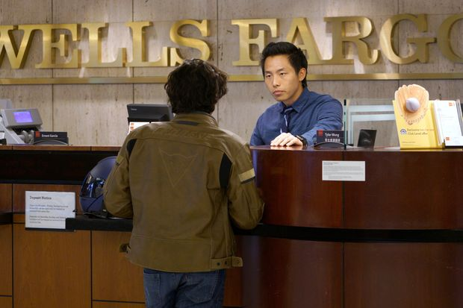

Overall year-over-year deposit growth was 5.8% across the largest U.S. banks in the third quarter.
PHOTO: RICK WILKING/REUTERS
By
Telis Demos
Updated Nov. 13, 2019 4:09 pm ET
  - SAVE
  - PRINT
  - TEXT
When it comes to bank stocks, there is a lot riding on deposits.
The KBW Nasdaq Bank index is up 9% over the past month, more than double the gain of the S&P 500. Behind that rally is not so much confidence that rates or the economy will suddenly zoom higher, but a belief that banks can manage through the Federal Reserve’s easing, thanks to some help on funding costs. Analyst estimates for 2020 net interest margins at Bank of America BAC 0.46% and Wells Fargo, WFC -0.03% for example, have ticked higher since the end of October.
Banks now get a historic proportion of their funding from deposits, the cheapest form of liability, versus bonds or short-term borrowing. Overall year-over-year deposit growth was 5.8% across the largest U.S. banks in the third quarter—the fastest pace since the start of 2017, according to Federal Reserve figures. The upshot is that some 89% of large U.S. banks’ total liabilities are now deposits, the highest proportion since 1985, according to Federal Reserve figures.
Take It to the BankYear-over-year deposit growth for the biggest U.S. banks has accelerated sharply.Source: Federal Reserve
%2015’16’17’18’190123456
Importantly, banks’ so-called golden deposits, the noninterest-bearing ones, ticked higher. These are typically day-to-day checking accounts for people and corporations on which they expect no interest—making them nearly free funding for banks. Depositors had been shifting this money into more productive places for a while, drawn by higher rates on offer elsewhere. But these deposits actually grew by a median 0.1% from the second quarter to the third across the biggest banks, the first sequential jump in at least five quarters, according to JPMorgan Chase analysts.
Another reason for optimism is that deposit costs didn’t fall as much as they could have in the third quarter, suggesting there could be pent-up declines to come.
Interest-bearing deposit costs at the biggest banks ticked down only 0.01 percentage point sequentially in the third quarter, according to Autonomous Research figures. That is despite a drop of half a percentage point in the effective fed-funds rate. There is usually a lag after Fed actions, as banks take some time to push through pricing changes. So the pace of decline has plenty of room to accelerate, if historical patterns hold.
Autonomous’s Brian Foran says big banks seem to be pointing to a roughly 0.15-percentage-point decline in deposit costs from the third quarter to the fourth.
There are still some good reasons to be cautious going into next year. For one, banks are competing as intensely as ever for customers, and the biggest banks are thinking longer-term than just 2020 net interest margin. JPMorgan Chase JPM 0.39% Chief Financial Officer Jennifer Piepszak, for example, said the bank wouldn’t risk a relationship with a corporate customer over “a few ticks” of interest by demanding they accept a lower or zero rate. Banks might also give corporate clients breaks on fees to retain deposits, sacrificing noninterest revenue.
“Clients are…going to continue to be disciplined” about seeking the best deals from their banks, State Street STT 0.23% CFO Eric Aboaf said in October when asked by analysts if he expected noninterest-bearing deposit growth to rebound.
Plus, if customers were to start keeping money in checking accounts at no interest, that might not be a great sign. Mr. Aboaf also warned that clients are more likely to leave cash in noninterest accounts “in a quick recessionary environment.”
Finally, the usefulness of cheap deposits is lessened if banks have nothing to do with the money. Sequential loan growth dropped from 1.1% in the second quarter to 0.7% in the third quarter for the biggest U.S. banks, Fed figures show.
Bank investors have seemed happy with “not as bad as feared” lately. But they would be smart not to get too giddy here, either.

Latest

tes
The interest rate news has been grim for U.S. banks. The vast majority are asset sensitive, and the swoon in long-term rates followed by a 50 basis point Federal Reserve cut could crunch net interest income in the coming periods. The selloff in bank stocks that began in late February has been far deeper than the one in August 2019 when the Fed started reducing its benchmark rate, thanks to fears that the spread of the coronavirus will trigger a recession and drive up credit losses.
But banks' ability to cut deposit rates so far during the easing cycle offers a silver lining. Overall deposit costs have been nearly as sensitive to declining market rates as they have in the past, despite fears that banks' success in controlling deposit costs when rates were rising would sap their ability to lower them when rates fell.
The industrywide cumulative deposit beta — the change in banks' deposit costs against the change in the effective Fed funds rate during the period — was 15.7% in the fourth quarter of 2019, the first full quarter after the most recent easing cycle began, according to data from S&P Global Market Intelligence. That is below the levels set one quarter into the previous three easing cycles, but not by much. The analysis uses the quarter before an easing or tightening cycle begins as the starting point to measure cumulative betas.
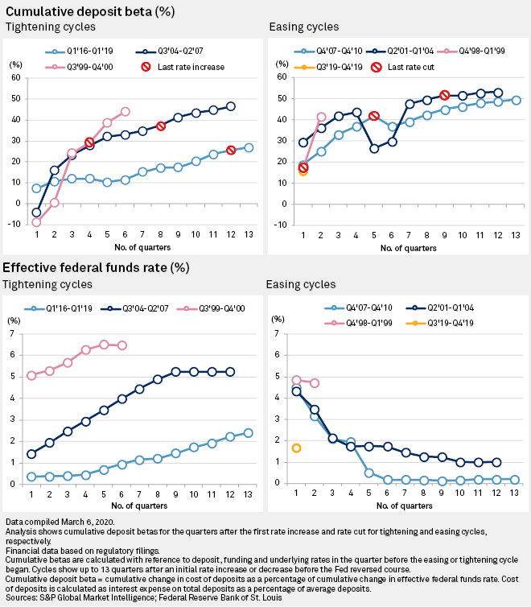
The fourth-quarter 2019 performance, like its predecessors, is also well ahead of initial betas in the previous three tightening cycles, which ranged from negative 8.9% to 7.3%. Once again, it appears that banks have been able to cut deposit prices more quickly than they were forced to raise them when market rates were increasing.
"There's enormous pressure to cut rates on deposits to match the declines that are happening with asset yields," Andrew Frisbie, an executive vice president at the analytics and advisory firm Novantas, said in an interview.
Among commercial customers that received big rate increases during the up cycle, banks have been able to lower prices at betas of around 100%, Frisbie and colleagues wrote in a March 3 report. The big Fed cut now gives banks "air cover to lower rates" for commercial customers that received moderate increases.
Markets and analysts widely expect more cuts from the Fed, including at its next scheduled meeting on March 17-18, as Treasury yields have plummeted to new lows. "There is still a fair amount of room for [deposit] rates to be cut if interest rates were to head toward zero," Frisbie said in the interview.
Among consumers, there is a shift in psychology and less inclination to shop around when rates fall below a certain threshold, Frisbie said. Data collected by Novantas shows that consumers "get somewhat less price sensitive if all of a sudden you can't get a rate that starts with a one."
Commercial clients' tendency to build up precautionary cash cushions amid economic conditions associated with low rates, and less competition from money market alternatives, also give banks more latitude to lower pricing, Frisbie said.
The industrywide cost of deposits was 79 basis points in the fourth quarter of 2019, compared with 24 basis points in the third quarter of 2015, just before the most recent tightening cycle began, according to data from S&P Global Market Intelligence.
Still, banks face competition from online competitors that have aggressive growth targets and "won't take their feet off the gas," keeping upward pressure on promotional rates and forcing banks to be "nimble," Novantas cautioned in the report.
Banks "need to be very surgical in understanding who are the customers where you might be able to cut with a near 100% beta and what customers ... you might need to cut with less ferocity," Frisbie said.

S&P Market Global Sept 2020

Even before fears about the potential impact of the coronavirus drove interest rates down, banks had described plans to further trim deposit prices, with maturing high-yield certificates of deposits providing a particularly rich opportunity.
Some banks that sat out the rate competition on the way up have less room to maneuver now, and have advised as much. By contrast, banks with exceptionally high betas during the most recent tightening cycle have generally done considerably better than the industry on the way down.
Banks with at least $3 billion of assets that had the 25 highest cumulative deposit betas from the third quarter of 2015 through the first quarter of 2019 posted a median beta of 50.7% for the period. That compares with a median for the entire industry of 15.1% over the same period. The group posted a median cumulative beta of 27% from the second quarter through the fourth quarter of 2019, well ahead of the industry median of negative 1.5% over the same time.
Companies like Goldman Sachs Group Inc., which markets online, high-yield savings accounts to consumers through its Marcus brand, fit the pattern. It had a cumulative beta of 73.9% during the most recent tightening cycle, and a cumulative beta of 35.7% so far in the easing cycle.
Other banks with high betas when rates were rising and that have not yet exhibited high betas on the way down may well play catch-up.
New York Community Bancorp Inc., where CDs make up about a third of interest-bearing liabilities, had a 46.5% cumulative beta during the most recent tightening cycle, but a cumulative beta of just 12.6% so far during the easing cycle. Almost 94% of its CDs are due to reprice in 2020, however, and the bank estimated that a 100-basis-point decline in interest rates would increase its net interest income by 2.52% for the year. Its stock was down by 7.9% from Feb. 19 to March 11, compared with a 33.4% decline for the SNL U.S. Bank and Thrift index.
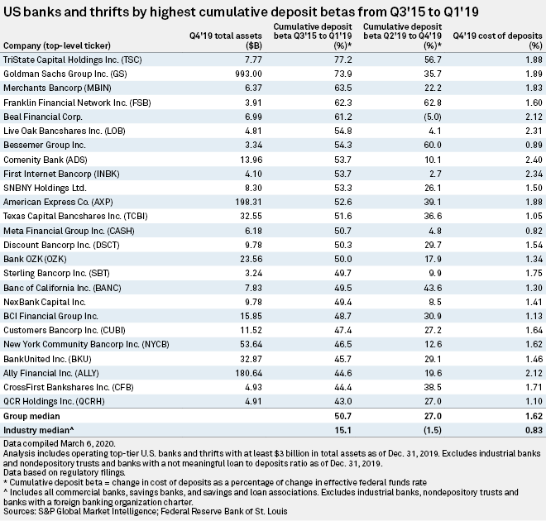

- Author
- Harry TerrisZain Tariq
- Theme
- Banking

