Diabetes Day  Student Name:  Institution name:    In this pamphlet diabetes is considered as one of the major health issues in the community. In this effect a day was set to educate students on the different ways diabetes affects us, the approach to diabetes patients and trends in the disease which is common in the community today  August 1st, 2018, 6 to 8 p.m.  Meeting at the Gymnasium  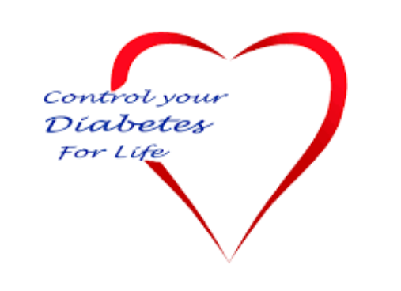  Resources available locally for diabetes concerns  1. American Diabetes Association  2. Diabetes Youth Foundation | Today, diabetes has become a common disease in the community and it came to my mind that we all need to come together and discuss the disease.  In our discussion, we will educate one another on way s to stay healthy and avoid the disease at all costs. Another issue why I chose the topic is to discuss a number of ways we can ensure patient safety from people with diabetes (Weinger, et. al., 2015). 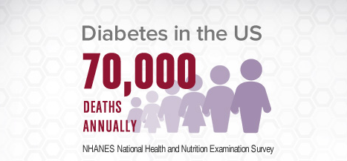  It is important to understand that there are different types of diabetes namely;  1. diabetes 1  2. Diabetes 2 |   Information that should be shared to caregivers of diabetic patients  - It is important for caregivers of diabetic patients to encourage constant checking of the patient’s well-being  - Caregivers ought to ensure that the patient observes the medication requirements all the time  - Caregivers should supervise the diet of the patient and body fitness. (Cristian, 2012).  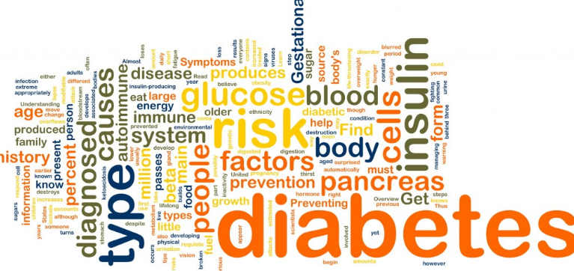

Tips to prevent diabetes  Cut Sugar and Refined Carbs From Your Diet  Eating sugary foods and refined carbs can put at-risk individuals on the fast track to developing diabetes.    Work Out Regularly  Performing physical activity on a regular basis may help prevent diabetes.  Drink Water as Your Primary Beverage  Water is by far the most natural beverage you can drink.  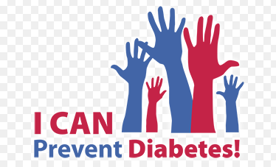 |   Lose Weight If You're Overweight or Obese  Although not everyone who develops type 2 diabetes is overweight or obese, the majority are  Quit Smoking  Smoking has been shown to cause or contribute to many serious health conditions, including heart disease, emphysema and cancers of the lung, breast, prostate and digestive tract  Watch Portion Sizes  Whether or not you decide to follow a low-carb diet, it's important to avoid large portions of food to reduce the risk of diabetes, especially if you are overweight.   | Major causes of the disease include;  * Pancreatitis  * Glucagonoma..  * Cushing’s syndrome.  * Family history of diabetes  * Overweight (Todd, et. al., 2017)    References  Byers, J. F., & White, S. V. (2014). Patient safety: Principles and practice. New York, NY: Springer.  Cristian, A. (2012). Patient Safety in Rehabilitation Medicine, An Issue of Physical Medicine and Rehabilitation Clinics - E-Book.  In Todd, D. W., & In Bennett, J. D. (2017). Patient safety.  Weinger, K., & Carver, C. A. (2015). Educating Your Patient with Diabetes.


