- Passive transport is movement of the ions and as well as other atomic molecules across the cell membrane without use of energy.
- Simple diffusion, osmosis and facilitated diffusion.

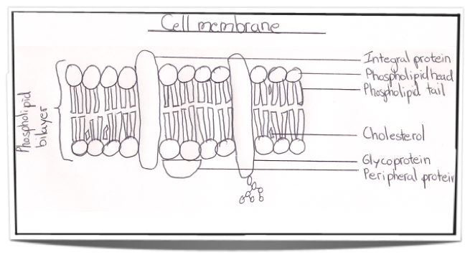
- Simple diffusion is movement of the solutes from high concentrated gradient to low concentrated gradient across a semipermeable membrane.
- Sizes of the particles, concentration gradient, temperatures and diffusion distance.
- Equal concentration.
- Channels and carrier proteins
- I. Sodium ions from inside cell bond gets in place to pump.
ii. ATP is broken into ADP in protein which provides energy to change the pump shape.
iii. Sodium ions are released outside the cell
iv. 2 potassium ions bond to the activated pump.
v. Pump changes shape to original and releases potassium inside.
9. Osmosis is process by which solvent molecules move from a less concentrated solution to more concentrated solution through a semipermeable membrane.
10. Hypotonic solution is a solution which has greater concentration of solvent inside than outside, while hypertonic solution is one that has greater concentration of the solvent outside than inside. The osmosis moves towards hypotonic solution. Osmosis stops when the concentration in both sides levels.
11. Because water molecules are neutral and so small.
12. Is the movement of the ions across a cell membrane into a region of higher concentrated by use of enzyme and energy.
Types of active transport include sodium-potassium pump, Exocytosis and Endocytosis.
Active transport is important in cell survival because it helps the cell to move substances against the concentration gradient.
13. Ion pump is a Trans membrane protein that moves ions across a biological membrane against their concentration gradient via active transport. Ion pump is physical to the plasma membrane between the interior and exterior parts of the cell.
14. contransport is the secondary active transport in which the energy is used to transport molecules across the membrane without no direct coupling of ATP.
15. Endocytosis is process in which substances are brought into the cell.
Types including phagocytosis, pinocytosis and receptor-mediated endocytosis.
16. Events of phagocytosis include activation of the phagocyte, chemotaxis of phagocytes, attachment of the phagocyte to the microbe or cell, ingestion of the microbe or cell by the phagocyte and destruction of the cell.
17. Is a mode of endocytosis in which small particles suspended in extracellular fluid are brought into the cell through an invagination of the cell membrane, resulting in a suspension of the particles within a small vesicle inside the cell. Similarity between phagocytosis and pinocytosis is that they both engulfing a material.
18. Receptor-mediated endocytosis is a form of endocytosis in which receptor proteins on the cell surface are utilized to capture a particular target molecule. The receptors, which are trans-membrane proteins, cluster in regions of the plasma membrane known as coated pits. After the receptors bind, endocytosis is triggered and then the attached molecules are taken to the cell in a vesicle.

