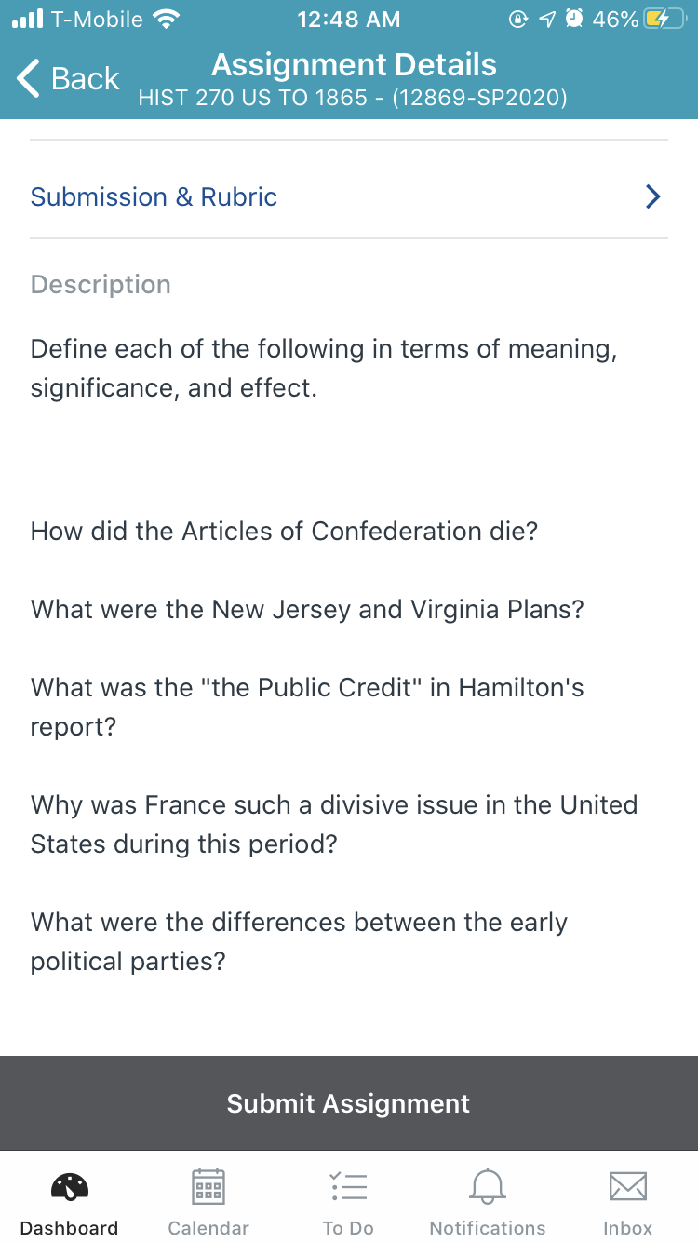

You may text or whatsapp me if there is a clarification a question you need clarified
+1 (872) 703-4237 about the discussions

