Business Discussion Homework

Student’s Name
University
Course
Professor
Date

Business Discussion Homework
Chapter 8: Discussion Questions
Question 1: Define Budgets. How are budgets used in planning?
A budget refers to the estimation of income and expenditure in a certain period, and it reevaluated over a certain period ("Budgeting - Overview and Steps in the Budgeting Process", 2021).
Uses of budgets in planning:
- To encourage self-discipline. This helps a person to stick to his budget without overspending the actual amount that should be spent.
- Limits Overspending. This helps an individual to set priorities on their financial goals.
- It enables an individual to maintain a debt pay off strategy because the budget restricts the spending habits.
- Increase savings. A budget enables planning hence enables a person to set some amount aside that can be used in future
Question 4: What is the master budget? An operating budget? A financial Budget?
A master budget refers to the summation of lower-level budgets produced by companies by analyzing budgeted financial statements, a financial plan and a cash forecast. Operating budget refers to expenditure and revenue generated from the daily operation of the business. A financial budget refers to forecasting expenses and income at a certain period to enable the business to meet its targets. (Carlson, 2020)
Question 15: What are the steps involved in building and activity based budget? How does these steps differentiate the ABB from the master budget?
An activity-Based Budget is used to predict the costs of activities.
The Steps in Activity Based Budget are:
- Identification of Cost Drivers Of activities
- Scheme the number of units required in each cost driver
- Calculation of cost per unit of each project
Cornerstone Assignment: Picture attached (Production Budget) Page 437
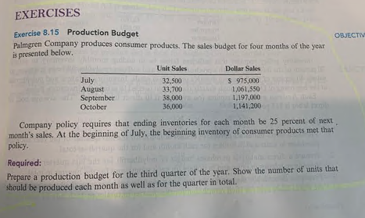

Palmgren Company: Production Budget for Third Quarter
 | July | August | September | Total
Units Sales | 32500 | 33700 | 38000 | 104200
Ending Inventory | 8425 | 9500 | 9000 | 26925
Total | 40925 | 43200 | 47000 | 131125
Beginning Inventory (Less) | 8125 | 8425 | 9500 | 26050
Units Produced | 32800 | 34775 | 37500 | 105075
Ending Inventory: 25% of Next month unit sales
For Example: August =25%*38000=9500 Units
Beginning Inventory: 25% of Current month unit sales
For Example: August =25%*33700=8425 Units

Chapter 9: Discussion Questions
Question 1: Discuss the difference between budget and standard cost
Standard cost refers to a certain cost per unit, whereas a budgeted cost refers to the total cost in a given activity.
Question 4: What are ideal standards? Currently attainable standards? Of the two which is usually adopted? Why? #5 How does standard costing improve the control function?
Ideal standards refer to perfect standards, whereas currently attainable standards are easily attainable and motivate an organization. Standard cost enables an organization to control the Organization: in terms of the organization cost, management of cost, and cost proficiency. The material price variance is often computed at a point of purchase other than issuance because it enables the control of information faster. (Agarwal, 2021)
Question 7: Explain why the direct materials price variance is often computer
The material price variance is often computed at a point of purchase other than issuance because it enables the control of information faster
Cornerstone Assignment: Direct Materials and Direct Labor Variances
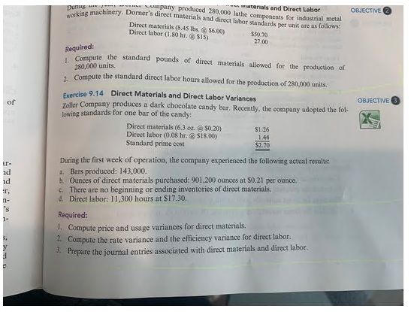
Required:
- The direct materials price and usage variance will be.
$$Material price Variance=(Actual quantity)×(Actual Price-Standard Price)$$
$$MPV=\left(901,200 ounces\right)×\left(0.21-0.20\right)\$ per ounce$$
$$MPV=\$9,012 which is unfavourable$$
$$Material Usage Variance=(Standard Price)×(Actual quantity-Standard Quantity)$$
Where; $Standard Quantity=Per unit standard quantity ×Actual units$
$$MUV=\left(\$0.20\right)×\left(901200-(143000×6.3)\right)$$
$$MUV=\$60 which is unfavourable$$
- The direct labor rate and efficiency variance will be.
$$Labor Rate Variance=Actual hours×(Actual Rate-Standard Rate)$$
$$LRV=11,300 hours×\left(17.3-18.0\right)\$ per hour$$
$$LRV=\$7,910 which is favourable$$
$$Labor Efficiency Variance=Standard rate×(Actual hours-Standard hours)$$
Where; $Standard hours=Per unit standard quantity ×Actual units$
$$LEV=11,300 hours×(11,300 hours-(143,000 units×0.08 hours))$$
$$LRV=\$2,520 which is favourable$$
- Journal entry for direct materials and labor was as below.
Journal Entry for Direct Materials and Labor
Date | Accounts | Debit | Credit
 | Material Purchase Record
 | Direct Mateial ($0.20* 901200 ounces) | $ 180,240.00
 | Material Price Variance | $ 9,012.00
 | Account Payable ($0.21* 901200 ounces) |  | $ 189,252.00
 | Total | $ 189,252.00 | $ 189,252.00
 | Material Usage Record
 | Working-In-Process Inventory ($0.20*6.3 ounces* 143,000 units) | $ 180,180.00
 | Material Usage Variance | $ 60.00
 | Direct Materials ( $0.20*901,200 ounces) |  | $ 180,240.00
 | Total | $ 180,240.00 | $ 180,240.00
 | Labor Variance Record
 | Working-In-Process Inventory ($18.0*0.08 hours* 143,000 units) | $ 205,920.00
 | Labour Efficiency Variance |  | $ 2,520.00
 | Labor Rate Variance |  | $ 7,910.00
 | Wages Payable ($17.30 per hour *11,300 hours) |  | $ 195,490.00
 | Total | $ 205,920.00 | $ 205,920.00

Chapter 10: Discussion Questions
Question 10: What is a transfer price
Transfer pricing refers to the exchange of prices of goods and services between companies ("Transfer Pricing - Learn How Companies Use Transfer Pricing", 2021).
Question 11: What is the transfer pricing problem?
Transfer pricing problem occurs when there are challenges in determining the specific prices of group transactions in an organization set up operating on business units.
Question 14: Identify three cost-based transfer prices. What are the disadvantages of cost-based transfer prices? When might it be appropriate to use cost-based transfer prices?
Identify three cost-based transfer prices
Cost-based transfer prices refer to the cost paid to transfer goods and services within a company. The three cost-based transfer prices are variable cost, actual cost and standard full cost.
What are the disadvantages of cost-based transfer prices?
The advantages of cost-based transfer pricing are;
- Helps to set prices for innovative and new products.
- Incurred cost are recovered using pricing models
Disadvantages of pricing models are:
- Inflexibility when it faces changes in the market demand levels.
- The method ignores the price elasticity of demand.
When might it be appropriate to use cost-based transfer prices?
It is appropriate in inducing optimal decision making in an organization for an organization to maximize profits. It enables the allocation of organizations resources

References
Agarwal, R. (2021). Standards in Accounting (4 Types). Your Article Library. Retrieved 21 March 2021, from https://www.yourarticlelibrary.com/accounting/standard-costing/standards-in-accounting-4-types/52827.
Budgeting - Overview and Steps in the Budgeting Process. Corporate Finance Institute. (2021). Retrieved 21 March 2021, from https://corporatefinanceinstitute.com/resources/knowledge/finance/budgeting/.
Carlson, R. (2020). What Is a Master Budget?. The Balance Small Business. Retrieved 21 March 2021, from https://www.thebalancesmb.com/budgeting-what-is-a-master-budget-393049#:~:text=The%20master%20budget%20is%20a,is%20a%20budgeted%20income%20statement.
Transfer Pricing - Learn How Companies Use Transfer Pricing. Corporate Finance Institute. (2021). Retrieved 21 March 2021, from https://corporatefinanceinstitute.com/resources/knowledge/economics/transfer-pricing/.

