Automotive Industry
Name
Institution Affiliation
Date

Table of Contents
Executive Summary 3
Analyzing firms past performance and issues 5
Firm and Industry performance 5
External analysis 7
PESTEL analysis 7
Internal analysis 11
Al Futtaim automotive organization structure 13
Critical assessment of strategy 15
Marketing strategy 15
Key lesson learned from the past 17
Generating alternatives 23
Recommended strategies, Evaluation and Control 24
KPL 25
Balanced Scoreboard 26
Conclusion 27
References 28

Automotive Industry

Executive Summary
Al Futtaim automobile company is one of the largest automotive industry in the world.it was formulated in the early 1985s and has progressively developed over time. Al Futtaim motors are one of the primary distributors of different brands of vehicles. Since the year 1955, the company is considered and holds the first position in being the largest distributor of cars and other automotive products across the UAE. Moreover, the company is also recognized in being one of the largest privately owned company across the whole of the Gulf region. It mainly consists of a wide range of different types of vehicles (Gouda, 2016). The company does not manufacture not only small vehicles but also large tracks both heavy and light. The company mainly manufactures these brands to sell them in both the state and the global market. The company doesn’t discriminate the less developed country rather it also markets its products in these countries to make the company’s name to grow and be known worldwide. Al detail automotive company offers a variety of makes and models such as Toyota, Lexus, Honda, Jeep, Dodger and Volvo including others. Therefore this means that the company does not focus on one brand or model of the vehicle rather it goes a step ahead and display a variety of cars. The company mainly markets its products in more than one geographical region.
Al Futtaim automobile company is mainly subjected to a vast demand that is experienced worldwide. The economic condition of a given country affects the industrial sales. This means that in case a country has lugged down regarding economic development then automatically the infrastructural development will also be affected. More developed countries mostly regarding infrastructural development have a high demand in the automotive products this is mainly because the transport networks are good and one can have easy access in different parts of the country therefore there arises a need to purchase a vehicle.
The company was mainly formulated to help provide high-quality transport vessels. The company primarily deals with high brand vehicles which have a good visual appearance. The company helps ease the transportation of both people and goods from one geographical position to the other, and this helps in time-saving. One can do a lot of activities through the use of the vehicle as a mode of transport (Pasha & Ismail, 2012). The company mainly uses high-quality material during manufacture and assembling of these brands of vehicles. Unlike other companies, Al Futtaim maintains the quality of its vehicles ensuring that they meet the demands of the consumer. The company goes a step forward to launch different showroom which is used to display the latest brand of vehicle that the company manufacture. This will help in increasing awareness of the different types of vehicles being branded day in day out. The company formulates a couple of strategies to improve its sales and make its products known all over the country.
The automobile industry is both a labor and capital intensive company since it requires a lot of manual workers to perform the various activities in the organization, e.g., assembling of different parts of the vehicle and welding of steel. The company, therefore, need to have a management that manages the costs and various expenses incurred during the purchasing of equipment and parts. Al Futtaim automotive company is ranked as an essential segment of the global economy.

Analyzing firms past performance and issues

Firm and Industry performance
Al Futtaim automotive industry has a couple of factors that have led to the improvement of the general industrial performance, and they include
- Development of new technology
- Quality of human resource
- Government policies
- Proper management
- Availability of Finance
Al Futtaim automotive industry has incorporated the use of new technologies in branding and manufacturing of its vehicles. From the brands and models that the company is offering one can tell that the technology being used in the manufacture of these vehicles is high. Taking an example of Lexus and dodge this car brands are automatic in that some of the function they perform by just a voice command or a press of a button. The use of this digital technology has made Al Futtaim automotive industry to be outstanding from other automotive industries thus posing a stiff competition in the market segment (Välikangas, 2018).
The industry considers the quality of human resource during employee enrollment. The company ensures that the human resource persons have high-quality skills and the know-how of assembling and the manufacture of vehicles. High-quality human resource reflects high both quality and quantity of the final product. This helps in improving the company’s performance by maintaining its image and reputation in the market.
The UAE government does not pose harsh legislative laws in the companies that are in the state. The industrial policies of the government have an essential effect on the general productivity of a firm. The government is therefore expected to formulate and make an implementation of policies that favor the industrial productivity, e.g., creating favorable conditions for investments and flow of capital from one industry to the other. The government should also opt to grant protection of the automotive industry to enhance the general development of the state.
The management system is a vital sector of the industry, and if not well managed it can lead to the industry being closed down. A professional manager is required to facilitate the management process. This means that it is the work of the manager to oversee all the activities and ensure that everything is done in a well-coordinated and organized manner. The industry should ensure that the manager heading the company should be devoted to their professions and have a good understanding of the responsibilities allocated to them. A good manager who thinks and makes critical changes in the organization will automatically improve both the productivity and the performance of the organization.
Al Futtaim automotive industry increases its general performance by having adequate funds. These funds are used in purchasing of different materials needed in production and also paying the workers their wages and salaries. Availability of enough funds helps in reducing cases such as striking of the employees or loans from other organizations. In availability of funds can reduce the general industrial performance and in the long run, might lead closure of the industry. Therefore the industry should ensure that it has enough funds to meet all the requirements of the different sectors found in the automotive industry (Kamath & Jadhwani, 2015).

External analysis

PESTEL analysis
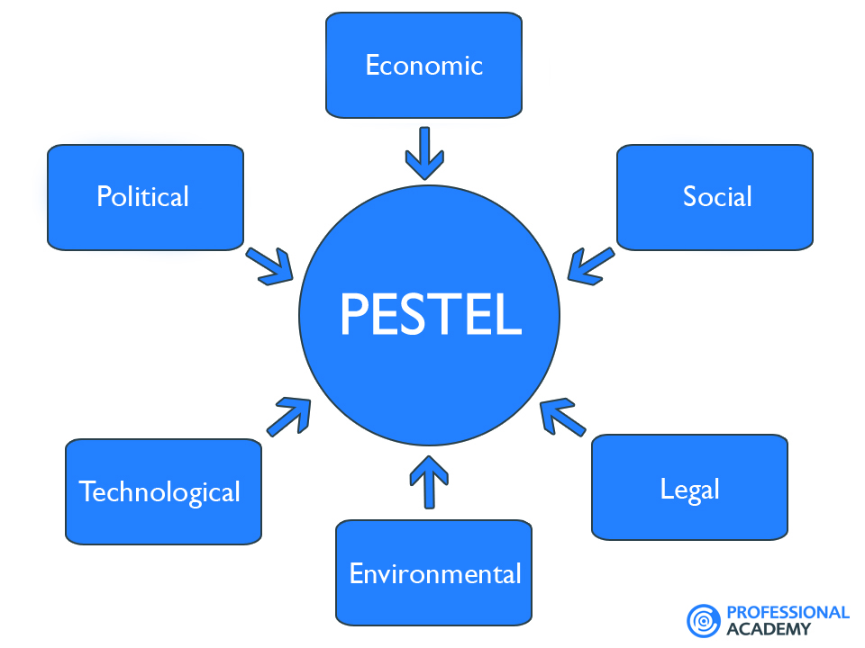
PESTEL analysis includes various external factors that affect the automotive industry in the UAE, and they include political, economic, social, technological, legal and environmental.
- Political factors- These are factors which influence the industry externally and are mainly facilitated by intervenes of the government. Al Futtaim in the automotive industry is established around an area that lacks political conflicts and rivalry. Therefore, the government of the state tends to support all the decisions and amendments made by the industry. This will intern facilitate the progress of the company. The performance of the industry is also improved because the law of the state favors the growth and manufacture of products in the industry (Bayram 2018). The government has a tax policy that protects the industry from being overtaxed. The government also goes a step forward and help in eradicating corruption and improve on the foreign trade policy. This act creates a favorable environment for the Al Futtaim automotive industry to sell its products both across the country and in other states without any restriction. The buying and selling of the vehicles are done following the rights procedures since the government has already created a corruption-free state.
- Economic factors- these factors include economic growth, exchange rates, inflation, disposable income for both the consumer and the industry and inflation. The exchange rates in UAE are not high thus favoring the automotive industry. The company is not limited to selling its products to one geographical region instead it sells its products across different countries. During the selling and purchasing of these automotive parts, different currencies are used. The industry thus needs to check the exchange rate to determine the pricing of the automotive products. In case the exchange rate is high then it will reduce the purchasing power of both the consumers and the industry. Exchange rates might adversely affect the company because if the exchange rates increase the consumers will not be in a position to make purchases of the products thus the demand might become less and the company will start to experience losses.
- Social factors- this dimension mainly represent the general demographic and its characteristics, the beliefs, customs and values which have been cultivated in the peoples mid. The society has a significant impact on the Al Futtaim automotive company. The society around UAE believes that the industry is the leading producer of quality automotive products not only in the United Arab Emirates but also across the entire world. The society has cultivated a strong belief in the company's products, and these make the society to be satisfied. The positive image depicted by the industry has positively impacted the industry by increasing the market size and encourages the buyers to stick to Al Futtaim automotive so that they can receive a high quality and quantity products.
- Technological factors-the technology in the UAE is digital meaning that the state uses the modernized system of technology in most of its production sector (Bayram, 2018). The transport and communication networks have also been improved from the adoption of the current technology system. In some countries, the transport system is not modernized hence people find it difficult to travel from one place to another due to poor infrastructural development. The industry, therefore, uses a high system of technology in the manufacture of its automotive products. The people of UAE are willing to purchase the products because the infrastructural development of the country is well established. The use of a new technology system has also aided in the industry marketing program. The industry can now use various modes of advertisement of its products, e.g., the social media, internet, etc. Technology, therefore, has significantly posed an impact in the development of Al Futtaim automotive industry in the UAE.
- Environmental Factors- these factors have of late come to the forefront. These factors are considered essential and vital because they tend to have a direct impact on the organization. The Al Futtaim automotive industry requires raw materials and this raw material are extracted from the environment. The vehicles are mainly made of steel and steel is a mineral that is mined from underground. Therefore the environment acts as a basic factor in the provision of raw materials to the industry. UAE is located in a geographical region which is rich in different minerals thus it is easy for the industries to obtain steel from the mines.
- Legal Factors. This is the factors which tend to overlap the political factors. They have a major impact on the automotive industries when compared to political elements. These factors include everything that is concerned with the formulation and the amendment of the law. The law made by the UAE is aimed at protecting the consumers from being exploited be it in the pricing of products or any other factor. Therefore the industry cannot put high pricing of the product even if the demand arises this is because the law governing the state prohibits such an action. By any chance, if the Al Futtaim automotive industry is caught performing such an act, then it will automatically be brought to a closure.

Internal analysis

Value System

Mission and objectives
Organization structure

Internal analysis

Labor unions
Culture and style of functioning of top management

Quality of Human resource.

Internal analysis entails factor that usually happens within the organization and has a direct effect on the performance of the industry. These factors may appear to be small, but if not highlighted they can cause a great impact on the general industry performance. They include
- Value system. - This entails the ethical beliefs which an organization use to ensure all the set mission, vision, and objectives of the industry are achieved. Al Futtaim has developed a value system to ensure that their set goals during the industry establishment are achieved. The industry can adapt to policies that are made by the government of UAE. This factor helps them to know what to do and what not to do when it comes to production. In case the company is planning on manufacturing a car model that is not safe for the consumers then after a careful evaluation of the risks the industry will automatically restrain manufacturing of such vehicles.
- Mission and objectives- Al Futtaim focus on the missions and the objectives of the automotive industry. The company aims at providing high-quality vehicles and branding of new models using a high system of technology. Therefore the organizations have set objectives which govern the production process and ensure that all the products being produced are of high quality and quantity. The products should also meet the consumer demands as per the mission and objective statement. The company should not go below the set standards. The mission and objectives should be well known to the workers and managers of the industry, and this will facilitate more work output from minimum input.
- Organization structure- Al Futtaim has a good organization structure that runs from the head of the department to the subordinate and junior staff. The organization structure ensures that the industry has enough workers in the organization. Moreover, the organization structure facilitates the decision-making process. Decisions conserving different crucial matters are made easily since then there is an already formulated system facilitate this process and make it easy. Organization structure also helps in the allocation of duties and responsibilities to the workers and directors. Every person will be in a position of knowing which duty to perform and how to perform it. This reduced the conflicts that may arise due to disagreements and lack of respect to the senior directors.

Al Futtaim automotive organization structure
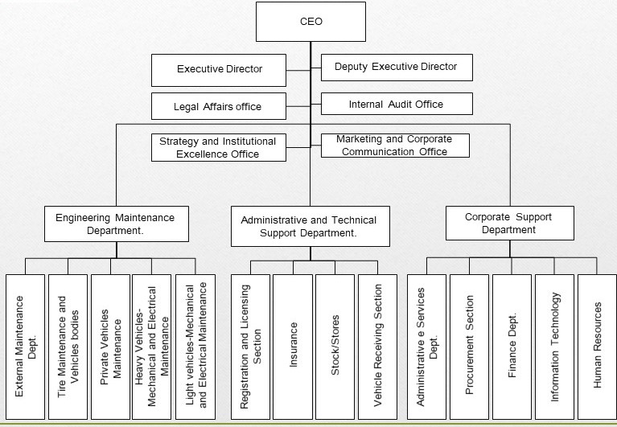

- Culture and style of functioning of Top management- the person in charge of the topmost management position of the organization, has a great impact on the industrial performance. The manager is put in charge of overlooking all activities in the organization are done in a systematic and organized way. He or she is responsible for giving orders to the junior staff and formulate the organization policy. Therefore for the industry to thrive there is need of incorporating a manager who knows and understands his duties. The manager of Al Futtaim automotive industry is expected to increase the production of the company and take appropriate measures in ensuring that the name of the organization grows to become popularly known across the world. The manager of Al Futtaim automotive industry is seen to have proper management strategies since the company produces high quality and quantity goods and the company is in a position to survive the stiff completion in the market segment without undergoing an extra cost.
- Quality of human resources – the success of any industry is primarily dependent on the skills and competence of workers working in the organization. It is difficult for a highly skilled manager to work with workers that have a low-quality output. Therefore both of these aspects should go hand in hand. A high-quality manager should relatively work with highly skilled employees. Al Futtaim automotive industry ensures that the human resource persons have high-quality skills and the know-how of assembling and the manufacture of vehicles. High-quality human resource reflects high both quality and quantity of the final product. This helps in improving the company's performance by maintaining its image and reputation in the market.
- Labor unions-this unions are mainly established to bargain with the managers of the organization on the wages of the workers. In case the workers need a change in the working conditions then automatically the labor union will ensure that the workers’ demands are met. Al Futtaim automotive industry ensures that all the worker's petitions are adhered to and the working environment for the employees is also improved.

Critical assessment of strategy

Marketing strategy
Al Futtaim automotive industry has employed a couple of approaches to assist in the marketing of the company's products. The products being produced by the company are intended to be sold not only locally but also international. The strategies used include.
Making sure that the industry products show up in the local search results- this means that the company has made it possible for everyone to have access to the industry products while accessing the internet. The industry has coordinated with some marketing sites thus it is now easy to have a look at the company’s brands and models of vehicles. One can even make a purchase of the item from the website because the company has gone a step forward and created a system where a customer can make her purchase.
Giving out gift cards for service discounts- The Company has gone a step forward in giving out large gift cards after a customer has a purchased any of the automotive products. This is a good marketing strategy since the company shows an appreciation of its customers thus bringing about customer satisfaction. The industry goes ahead and gives out discounts to its customers once they make a purchase. The more the value of the product purchased the more the discount one will receive. This marketing strategy helps in maintain the customers and also it attracts other customers who previously bought products from other automotive companies (Bloomfield, 2017).
By posting "How to" videos on YouTube- this will help in creating awareness on how to make a purchase of an item from the company for those who do not know the procedure. The video on YouTube is accessible to everyone therefor this increases awareness, interest and the purchasing power of different customers.
Celebrating dealerships or industrial anniversary- Al Futtaim automotive company should adopt this system of marketing by ensuring that they celebrate every anniversary. The Company should invite all the customers who have previously made purchases of the company products and those with the intention of making purchases to come and celebrate the achievements of the company. By so doing it will attract a lot of customers from different geographical region. Everyone would like to become a part of the Al Futtaim Automotive industry.
Encouraging clients to share reviews- reviews from different clients will help the company by identifying both their strong and weak holds regarding customer satisfaction. This will help the company to make necessary adjustments to the loopholes of the company which are making the customers complain. After a careful adjustment and correction of the prior made errors, the company will be in a position of producing high-quality automotive products thus posing competition threat to other automotive industries.
Pair up with online auto repair service- Al Futtaim has paired up with several auto repair service companies to provide or recommend the customers on where to obtain service from. In case the customers happen to damage the purchased vehicle he or she is advised by the industry where he can get assistance from. This aspect is a good marketing strategy because a lot of customers will not worry about where to repair their vehicles once they are damaged because the industry has already provided a solution.

Key lesson learned from the past
Al Futtaim automotive industry has learned a couple of lessons from the past. One of the main lessons that the company has learned is the need for employing a proper marketing strategy in the organization. The company has come to realize that for it to go global, then the market strategies should be implemented. The company has learned to use more advanced marketing strategies leaving alone the outdated ones which other small automotive industries use. For the company to be known across the world, it has identified the internet or the use of the social network as the best and most effective way of marketing their produce. A lot of people have access to the social media hence it will be easy for the organization to post its products immediately they launch one in the market. Social media and internet avail the product to a lot of people across the world. The method of advertisement is costly but can market products across the world thus increasing the market.
The industry has learned that good management practice accompanied by high-quality human resource will automatically make the organization to thrive. The management segments the cornerstone of all the development of the industry. Therefore the company has identified the need for always having a highly qualified manager who is in charge or running the organization to ensure all work is done accurately and all activities are well coordinated. The company has also learned that the employees on the other end should be highly trained and conversant with the activities that take place in the company. The company also realized that poor human resource would have a direct impact on the final product because the employees are the ones who are responsible in the manufacture and assembling process.
The industry has also come to realize that more developed countries have more market strongholds when compared to the other less developed countries. The main reasons for this factor are because the less developed country tends to have less developed transport networks thus most of them feel if they purchase a vehicle the vehicle will not provide service for a long time without breaking down — the main reason being poor transport networks. Countries which use a modernized system of technology do not suffer from this problem because both the transport and communication networks are well established (Mustangs-ur-Rahman., 2017) thus people will see the need of purchasing the vehicles and not only conventional vehicles but vehicles with a good design. Therefore the company has learned not to generalize its marketing program rather do more sales advertisement in the developed countries. This will increase the sales of the industry and facilitate the growth and development of other branches of the industry.
The company has come to learn that the discounts they offer to the customers after making purchases attract more and more buyers to the industry. Therefore there is a need for maintaining this discounts even when the sales are less or when the company is spending a lot of money purchasing the raw materials for the manufacturing process. The company has learned that the more the discount they offer, the more the number of customers they get.
Finally, the company has been able to learn that different people have different choice and preferences thus there is a need for providing a wide range of different models of vehicles for people to choose from. Some people will prefer Toyota while others prefer Lexus. This creates an urgency where the company is expected to develop more brands with different shapes and sizes to increase the variety of vehicles they sell. An increase in the number of vehicles will lead to an increase in the number of customers because there is a variety of cars to choose from.

Defining the current issues and problem statement
The company is facing a couple of issues and challenges which hinder the development and expansion of the company. These challenges and issues tend to pose a negative impact on the general company performance by holding it behind or make it stagnate. One of the main challenges is the Chinese market. The Chinese pose a stiff competition to this industry because they tend to offer the same products at a relatively lower price. The population of China is enormous thus providing a market to the Chinese automotive industry. This reduces the number of Chinese and other people in another state who have an interest in purchasing the companies vehicles.
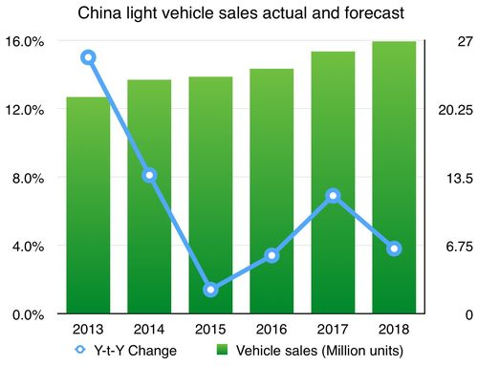
From the above statistics, we can tell that China is progressively making more and more sales as each year progresses. Therefore, this is a threat to Al Futtaim automotive (Natsuda & Thoburn, 2015).
The other primary challenge is increased competition from other developed countries such as Japan. Japan is well known in the manufacture and assembling of automotive products. Despite Al Futtaim being known of producing high-quality vehicles and also different types of models japan come in picture and provides a stiff competition coming up with more advanced vehicles. People from Japan are known to be good at mechanical work, and they use a high level of technology to manufacture its products. Therefore, Japan tends to make slightly more sales as compared to the automotive industry in the UAE.
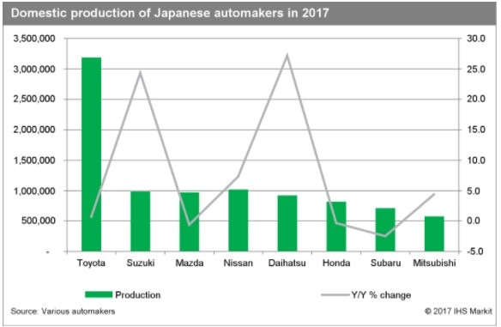
From the above statistics, one can tell that Japan manufactures a lot of Toyota brand cars and also make a lot of sales of the car brand when compared to Al Futtaim automotive industry. The company should, therefore, formulate appropriate strategies to curb this competition rate.
Introduction of new powertrains and new regulations has also brought up a challenge to the industry because people can now travel faster within a short period. The speed of the new powertrains is higher compared to the speed of some vehicles thus people opt to travel by train. The number of accident expected by train is also less as compared to the number of accidents that one is prone to experience when using a vehicle as a means of transport. Therefore the company is expected to lose its market once the technology of powertrains is developed.
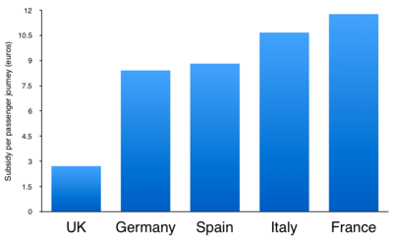
The above graphs show how train has become a popular mode of transport in different countries across the world the trend is expected to increase as time goes by. The automotive company in UAE is at the fear of losing potential market due to development of this new train technology.
The last challenge is the manufacture of connected cars brought about by industrial revolution and transformation. These cars mainly serve as a communication hub whereby there is a transition of data and information from one person to another in different geographical positions across the world. These cars easy the connectivity of drivers with other people since they can relay information right from the car while driving. Al Futtaim automotive do not have such technology. Therefore, this new industrial development acts as a threat to the brand of vehicles their manufacturing.

The above graph shows the number of connected cars being shipped. From the graph, it is true to say that the number of connected cars being shipped and sold to other countries is relatively increased as each year goes by.
Connected cars market size
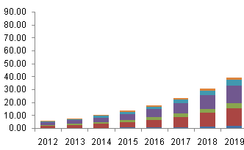
The graph illustrates the trend of the market demand for connected cars in the world. The trend is increasing from the year to year and its forecast in the current year 2019 is also projected to be high. The company is at the risk of losing the market of its products if the trend of connected cars is maintained.

Generating alternatives
The organization can develop other alternatives in that it expands its automotive industry manufacturing of new products which happen to pose a challenge to the industry. The company can start with manufacturing of spare train part this will increase the potential market. The company should not only specialize in the manufacture of vehicles alone rather it should go an extra mile in the manufacturing of automotive products that are trending in the market to curb the stiff competition from other states across the world.

Recommended strategies, Evaluation and Control
To become the best automotive industry the company should try and adapt to the following recommended strategies. The first strategy is to create an internal training and development academy. By so doing it will help in the training of workers from an early period and prepare them to work for the company in the future. The academy will, therefore, provide high-quality human resource thus ensuring the company manufacture high-quality brands and models of vehicle.
The company should have a review of the individual development plan which will act in place of the annual performance review. This means that let not one be driven with the yearly performance review rather allow the manager to be inspired by the individual development plan that he or she has in mind.
Keep all the worker's compensation current. This means that the company should not carry forward the employee’s salaries and wages. If an organization delays to make payment to its employees the automatically the organization will be formulating bad debts which can bring an effect in the long run. Paying employees in time will boost their motivation and supplement their working ability because they will perform their duty knowing that at the end of the month they will be receiving some good sum of money (Karanouh & Kerber, 2015). This will generally boost the company’s general performance and enable it to survive the stiff competition in the automotive market segment.

KPL
Perspective | Goal | Weight (* of 10) | Description | Performance  (%) | Measure Unit
Quality maintenance prospect. |  | 5 |  | 8 2.00%
 | First pass Quality Rate | 5 | This KPIs value gives a hint as to what extent the total production is being accepted. That is in the first sight. In other words this is the total fraction of all the products which have a tendency of resting well in the preset standards. | 1 1 .2%
 | The total number of quality management concept used | 4 | This the cumulative effort taken by the producer of a specific product in making the process a quality intensive task. Some of these are TOM manufacturing. | 6
 | Defect Rate | 3 | This KPI is for knowing how well the attempts of producing a good quality product are being rewarded. The value can be had for every sale of 1 0 0 0 cars. | 4
 | Total number of quality checks and inspections | 2 | It refers to the total number of quality checks and inspections implemented in the production line to make sure a consistent level of high quality cars are being produced.
Total Performance in groups |  |  | Quality Maintenance Perspective | 7 2 .0 0%

Balanced Scoreboard

Profit
Financial

Contribution per car

Number of cars sold
Customer

Customer satisfaction with options

Internal business process
Time to install option
Number of options available

Learning and growth
Employee skills in installing options

The balanced scoreboard comprises of various levels of production units and the flow of finance right from the finance department to the outcome. The flow also include the internal business processes. Under the financial department it indicates the total profit made, the contribution of each car and the total number of the cars sold. Under internal business process includes number of the available options and the total time taken to install these available options. The last segment is the learning and growth it mainly consist of employee skills in installing options.

Conclusion
The paper provides an analysis of the Al Futtaim automotive. The paper indicates all the strongholds and the weak point of the company. There is a careful review of why the company is not coping with the stiff competition being posed by other related companies and provides the measures and appropriate strategies to be put in place for the company to survive the competition. The company has the potential of being the leading automotive industry not only in the United Arabs Emirates but also across the entire globe. The company is generally expanding its boundaries, and the number of car models and brands are relatively increasing as time goes by therefore the company is expected to have extended to other states in the world in the new future. With the current trend of development automatically the company is growing and it is continuing to meet its customers need thus enhancing its customer satisfaction.

References

Bayram, A. K. A. Y. (2018). The Use of Information Technologies (IT) in Car Rental Businesses. Social Sciences Researches in the Globalizing World, 411.
Bloomfield, G. T. (2017). The world automotive industry in transition. In restructuring the global automobile industry (pp. 19-60). Routledge.
Gouda, I. (2016). To centralize or decentralize your marketing. LinkedIn. {Online}.
Joseph, G., Renjith, T. A., & Cheeran, M. T. (2015). Evaluation of PLM Domain Using Product Attribute Rating. The International Journal of Science and Technoledge, 3(8), 57.
Kamath, S., & Jadhwani, A. C. (2015). Demand Forecasting in Apparel Industry in UAE.
Karanouh, A., & Kerber, E. (2015). Innovations in dynamic architecture. Journal of Facade Design and Engineering, 3(2), 185-221.
Mustaghis-ur-Rahman. (2017). Living in Line with the UNGC Principles: A Hinopak Way of Doing Business. South Asian Journal of Business and Management Cases, 6(2), 113-126.
Natsuda, K., Otsuka, K., & Thoburn, J. (2015). Dawn of industrialization? The Indonesian automotive industry. Bulletin of Indonesian Economic Studies, 51(1), 47-68.
Pasha, H., & Ismail, Z. (2012). Automotive Sector in Pakistan Phase I Report.
Välikangas, L. (2018). Forum on Tesla and the Global Automotive Industry. Management and Organization Review, 14(3), 467-470.

