I have a project which how feeding fuzee “pic1” (fuzee seems a toothbrush and is a small piece. It put both side from a window but they give us long strip.) I have a team. each one takes a part of writing. My part is Societal Analysis (criteria considered for global, social, environmental, economic aspects of the design). To be clear to you, our design is there staple gun. They want a project to staple fuzee easy. We decide our project will feed staple from front “pic 2”. Pic 2 is the new project. I want to write 2 paper about societ analysis. There some point gives you a hunt:
-Old design, problems
-new design
- Differences
-Reasons, conviction

do not use pics in paper ( I give to explain to you)
Pic 1 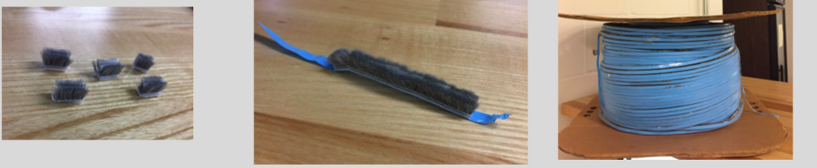

Pic 2
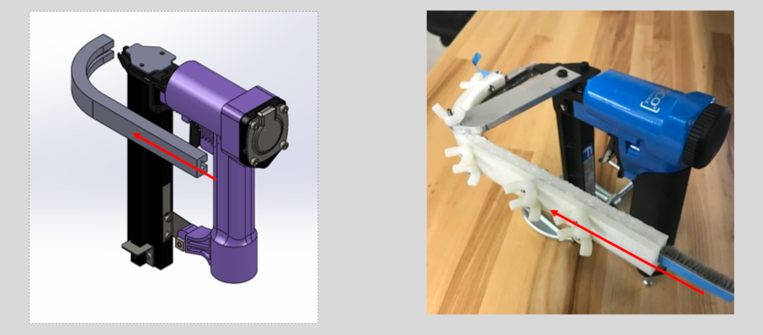

These are some descriptions
Interface ( how be our project set)
we were thinking about using feeding staple from side staple. Operator can change our project easy like our project can set of both side of sable because there is pin (pic 3) in both side. Pin gives problem to feeding fuzze. We decided to be our project in both side of the stalpe. But it is difficult to worker because it changes hand. For example of problem, the right hand of worker handles staple and other had holds our device but when they go to other side of window( pic 4) worker will change side of hands. Also, if we decide our project that will be on interface. It will be problem to worker feeding fuzze on the hole and shooting staple gun. So it is difficult. Our new project will be one side but noes will be thin” to be clear to there is pic down in “Out of fuzze”.

pic 3
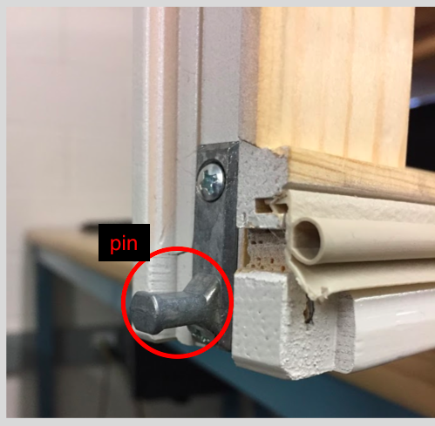

pic 4
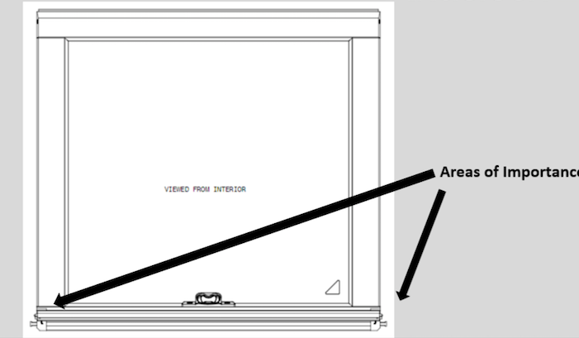
Indexing mechanis

There are 4 type to move fuzze that are roller, clamp and drag, press and push and thumb (pic 5). Frist, clamp and drag seems V. It is tired to worker because worker will use thumb every time to press and push. Alos, if it is broken, it will difficult to maintenance to make one. Press and puch is pressing part and push to front to move fuzze. But this one seems also exhust to worker. Third, thumb that there is an opening in our device that can see fuzze. To move fuzze . worker touches fuzze and bushs it front. Problem is disturb the operator because he or she will do it many times and it could not move fuzze many times. New our design is roller . it seems easy to worker and fuzze move smoothly.
Pic 5
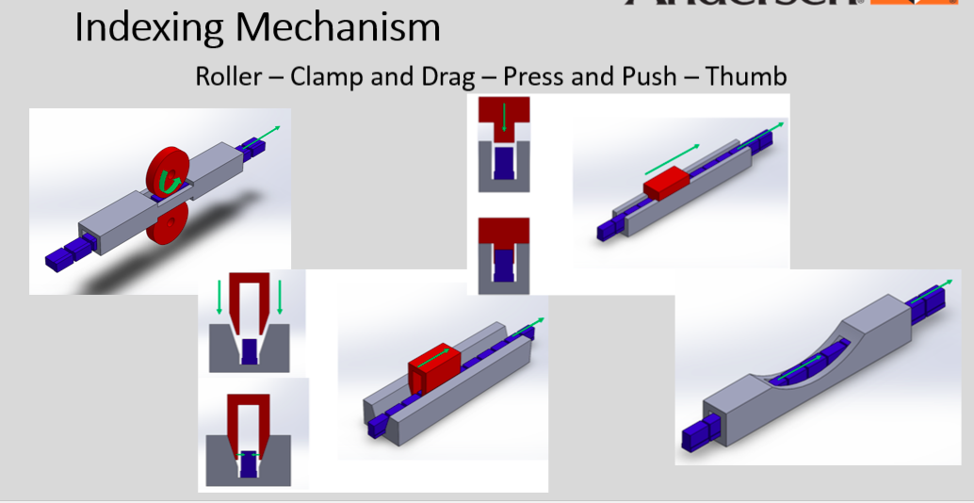
Type driver

How using power of moving fuzze, there are type that are pneumatic, eclectic and manual. Pneumatic use pressure air to move fuzze. It seems difficult to maintenance. Also, eclectic is difficult to maintenance. But our project uses manual by operator that it is easy to operator to control fuzze and it does not take a time to maintain it.

Out of fuzze
This how fuzze is out from our device. Old design sets 90 degree of stale gun. But it will be difficult to operator to use it. Because there are many windows on cart. Our device touch other window. We decide to long noes and quarter of circle (pic 6). It cannot touch other window when operator staples fuzze. Long nose is goal to do not touch pin.
Pic 6

