The Impacts of Art and Advertisements

Image 1: Witches in the Air- oil painting by the Spanish painter Francisco Goya, 1798.

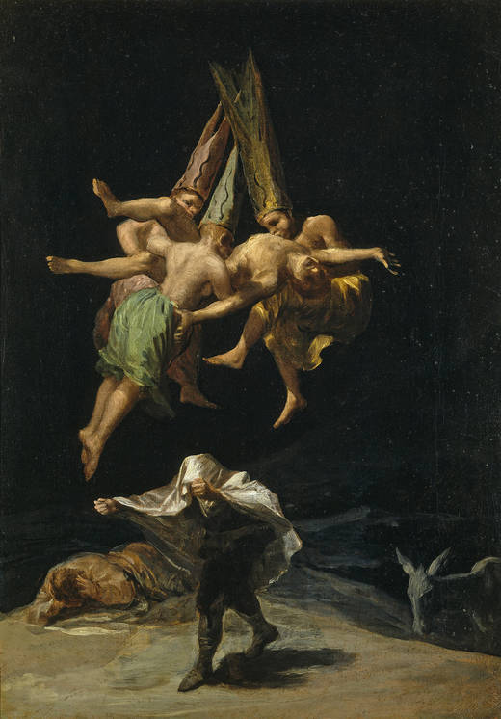
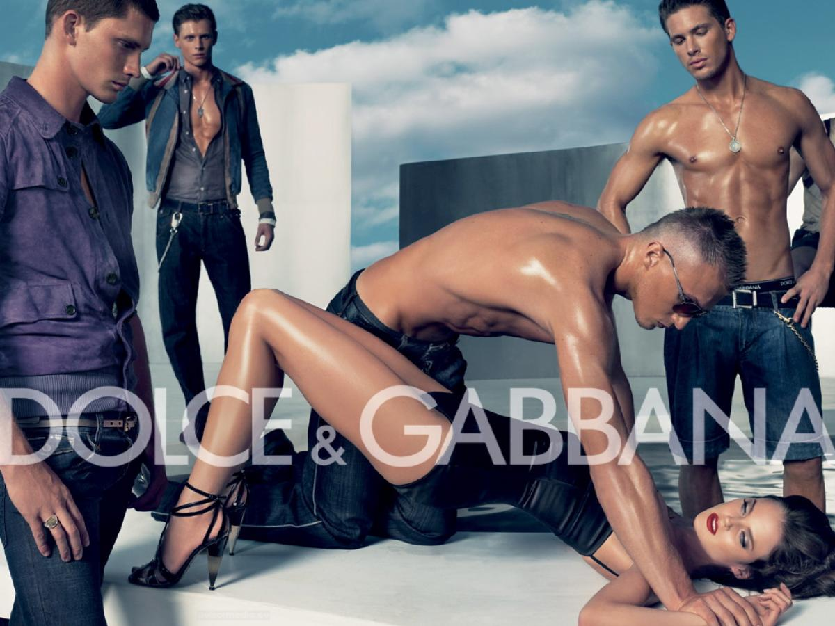
Image 2: Ad by Dolce & Gabbana, 2007. The fashion house received backlash for this ad that featured a woman being restrained by a shirtless man while surrounded by other half-dressed men. The ad was banned in both Italy and Spain, then based on several critical reviews that rejected the “rape scene” in the ad, it was back to media.

Consider each of these images separately and a) explain the title and b) identify 5 details and their connotative meanings:
Image 1: Witches in the Air

a. Explain the title of this artwork providing YOUR own interpretation (use the space below):

b. Details Meaning

- 1.
- 2
- 3
- 4
- 5

Image 2: Dolce & Gabbana Ad
a. Think of a Title for this ad (use your creative ideas), then explain the title of this artwork providing YOUR own interpretation:

Title: _________________________________________
Explain:

b. Details Meaning
1. 1.
2. 2.
3. 3.
4. 4.
5. 5.

Compare and Express YOUR Opinion
Why and how are these two works similar? Explain in 2-4 sentences providing YOUR interpretation/opinion:

