ECONOMICS
Student’s name
Institution
Date of submission

Discuss the process of profit maximization for a competitive firm.
For a firm to make profits in a competitive market, it needs to adjust to achieve it. The firms can either make profits in the long run or short run. A competitive market has many producers and consumers, and none of the companies can influence pricing strategies in the market. To make profits in the short run, it must ensure that the marginal cost equals the marginal revenue. When the price of the commodities is above the total cost, the firm will be making profits (Kwak, 2017).

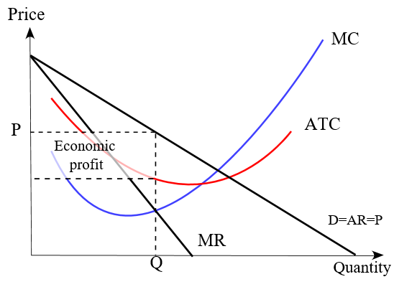
When the price moves below the total cost, the firm will be making losses.
In the long run, the firms will profit when the demand curve intersects the marginal cost and average cost curve.
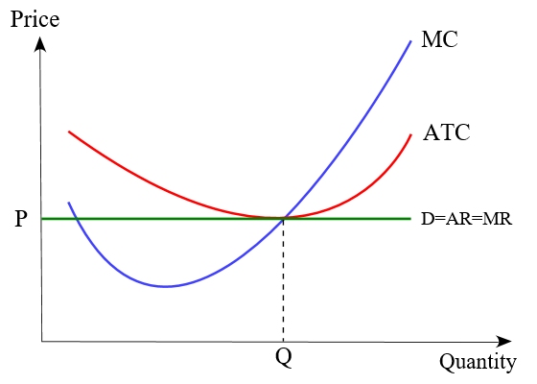
Discuss the source of market power in a monopolistically competitive firm.
In monopolistic markets, the demand curve of the firm is slopping in monopolistic competition. The strong market power causes the phenomenon; this is achieved through the ability to raise prices and still retain the customers (Gonçalves, et al 2018). . The source of energy is that the firms have fewer competitors than those experiencing competition from other firms. The monopolistic firms focus on product differentiation and other issues that are not related to prices. Product differentiation in monopolistic markets leads to imperfect substitutes of the products; thus, the firm will increase branding strategies and not risk the customer base.
Discuss oligopoly and source market power
Oligopoly occurs when a market has a small number of interdependent on pricing and output issues. Factors that increase the power of oligopoly markets is the control of indispensable resources that allow some firms to have more advantages in the cost than others; the firms operate at a profit-making rate. A legal restriction monitors the entry of new markets where rivals are excluded in case there are diseconomies of scale. Economies of scale are another factor where large organizations can enjoy economies of scale because some firms cannot meet the demand. Small firms will not be able to access economies of scale due to large production scales. Difficulties of new firms to enter the markets due to large capital requirements (Chen, et al 2020).
Discuss a model of a typical market.
In a typical market, the forces of demand and supply interact, leading to determining the number of goods sold and their prices. When there are surpluses in the stock market, this affects when the supply becomes higher than the demand, the prices of the commodities will decrease. When there is a shortage, the supply is lower than the demand; thus, the costs of the goods will increase. The firm's equilibrium in a stock market occurs when the demand and supply are equal. If the market price rises above the equilibrium price, the suppliers will reduce the amount of goods produced and decrease the cost so that customers can buy more to increase demand that will take back the demand to equal the supply (Ji, et al 2021).
Discuss how price ceilings affect market outcomes
The price ceiling is an initiative by the government to avoid consumer exploitation by the sellers. The price ceiling has a negative outcome in the firms. When the government sets an effective price ceiling, there is increased demand for the goods, leading to a shortage in the supply. The producers are unwilling to sell the goods at lower prices, but consumers are only willing to purchase cheap goods (Fan, & Zhang, 2021). The demand curve will result in consumer surplus, and producer surplus will be negative.
America introduced a price ceiling on houses for the military personnel; this resulted in increased affordable housing that led to many people having rent to pay for the homes; this hurts the producers who were the owners of the houses.
Discuss the concepts of externalities and advantages and disadvantages of trade permit solutions in resolving problems posed to them.
Cost externality is based on benefit or cost prevalent to the third party who had no choice of receiving use or cost. They are divided into positive externalities where there is the involuntary gain of the party that is undertaking a task for another person. The party causing benefit has no compensation. A negative externality is prevalent where there is an involuntary loss of one party caused by the actions of another individual (Borger, et al 2021).

Advantages of tradeable pollution permits
Firms invest more in technological advancement.
The government will raise more revenues from the sale of the permits.

Disadvantages
Price fluctuation causes problems for the firms to make plans.
Firms can opt to pass the cost incurred in purchasing the permit to consumers.
Discuss the use of the Coase theorem in resolving externalities
A theorem is based on assigned property rights used to allocate the correct economic values of various business investments. When the property rights are not determined, there is inefficiency in the allocation of resources. Some of the negative externalities include air pollution and noise pollution (Holcombe, 2018). Coase theorem suggests that to control this externality, they should be assigned property rights that allow both parties to have bargaining power. The involved parties are involved will negotiate the prices that they are willing to pay to reduce.
Discus the free-rider problem in the case of public goods and provide examples.
The free-rider problem occurs when the beneficiaries of some products and services don't make payments for them. The utility good may be overused; despite the statement that the consumers are cooperative, it's detrimental in that the products deteriorate. Free-rider mainly occurs when property rights are not clearly defined. Non-excludable consequences the consumers can't be prevented from using them. Nor-rival when the good is consumed more does not affect product availability (Bogoviz, et al 2019).
Examples.
Use of Wikipedia by many people in research while only a few of them are willing to pay for the goods.
When a lighthouse is built, sailors will benefit from it despite not paying for the house's upkeep.
Discuss the tragedy of the commons as it applies to the problem of resource allocation.
This occurs when some of the individuals in the society aim at consuming resources at the expense of other individuals. The result of this problem can either be under-investment of the firms and also depletion of the resources. When the demand for resources increases and moves above the supply level, individuals who use additional units to get satisfaction to harm others. The resources are available to people who have minimal barriers to accessing the funds. To solve the tragedy of common goods, there is a need to impose property rights and government regulations (Mildenberger, 2019).

Reference
Kwak, M., & Kim, H. (2017). Green profit maximization through integrated pricing and production planning for a line of new and remanufactured products. Journal of cleaner production, 142, 3454-3470.
Gonçalves, A. B., Schiozer, R. F., & Sheng, H. H. (2018). Trade credit and product market power during a financial crisis. Journal of Corporate Finance, 49, 308-323.
Chen, J., Xie, X., & Liu, J. (2020). Capacity sharing with different oligopolistic competition and government regulation in a supply chain. Managerial and Decision Economics, 41(1), 79-92.
Ji, S., Zhang, S., Dong, Y., Liu, D., Liang, J., & Runfu, Z. (2021, February). Identification of Typical Behaviors of Market Subjects in Competitive Power Market Environment. In IOP Conference Series: Earth and Environmental Science (Vol. 657, No. 1, p. 012082). IOP Publishing.
Fan, Y., & Zhang, G. (2021). The Welfare Effect of a Consumer Subsidy with Price Ceilings: The Case of Chinese Cell Phones (No. w28659). National Bureau of Economic Research.
Borger, B. D., Glazer, A., & Proost, S. (2021). Rational Drivers and the Choice Between Congestion Tolls and Tradeable Permits: A Political Economy Model.
Holcombe, R. G. (2018). The Coase theorem, applied to markets and government. The Independent Review, 23(2), 249-266.
Bogoviz, A. V., Rycova, I. N., Kletskova, E. V., Rudakova, T. I., & Karp, M. V. (2019). Tax Awareness and “Free Rider” Problem in Taxes. In Optimization of the Taxation System: Preconditions, Tendencies and Perspectives (pp. 117-123). Springer, Cham.
Mildenberger, M. (2019). The Tragedy of the Tragedy of the Commons. Sci Am Blogs. Accessed, 12.

