Question 1a) An external cost, such as the cost of pollution from carbon-based fuels, makes the marginal social cost (MSC) curve higher than the private marginal cost (MPC). The socially efficient output is where MSC = MSB at Q1, which is a lower output than the market equilibrium output.
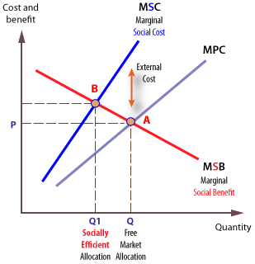
Question 1b)
A detrimental externality is the cost of a commercial exchange that a third party suffers. The producer and buyer are first and second parties to a transaction, and third parties are any indirectly affected person, organization, property owner, or resource. Some externalities, like waste, result from consumption, while others, like factory carbon emissions, are generated ("Global Warming, Natural Hazards, and Emergency Management", 2009).
Question c)
- The carbon tax may have a low impact on the market equilibrium of fossil fuels since the introduction of this tax will lead to the rapid growth of alternative energy technologies and limit the demand for energy sources related to minerals.

- Also, the tax can negatively affect the socially optimal fossil fuel since the poorest segments of the population often use fossil fuels; that is, the imposed tax should be introduced, taking into account the needs of various components of the people.
Question 2a)
- Elastic
- Demand will be elastic because, With ever more stringent climate policy targets from national governments, the green steel sector has been searching for alternatives to metallurgical coal and coke to improve general energy efficiency and lower fossil fuel emissions.
Question 2b)
One of the main arguments of the project's proponents is that there is no alternative to coking coal for steel production. It is not valid. For instance, the European steel industry has long turned its strategic eye away from coking coal and increased recycling and hydrogen. Thus the demand for coal-fired steel in the next decade will drastically increase, especially when the pandemic is over and later reduce because of the European steel industry ("Energy economics", 1990).
Question 3a)
The graph below shows the market for high grade cooking coal necessary for the traditional production of steel, including all the externalities associated with fossil fuels

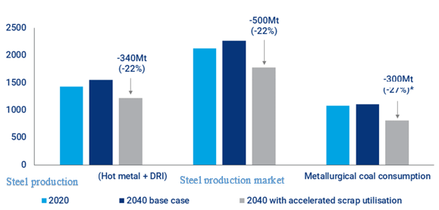
Question 3b)
With green steel technology, coking coal will no longer be a critical raw material in steel production. Thus the primary production of coking coal will reduce, thus affecting the market demand for coking coal (reduction).

Question 3c)
At close to 10% of global emissions, the steel industry is under pressure to clean up. Increasing carbon costs and stringent environmental investment criteria have spurred a race to develop a zero-carbon steelmaking process. New technologies are advancing slowly, but with enormous implications for costs and raw materials, depicting that steel market demand will reduce in the future.
Question 3d)
Change shown in the market for coal will move away from the socially optimal quantity of coal because of the developing green steel technology.
Question 4a)
BWL Power Company plans to use its land resources by installing solar panels for mass production of electricity.

Question 4b)

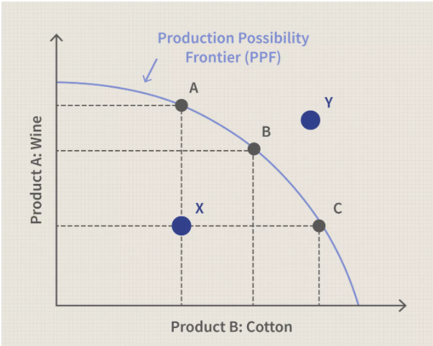
In business analysis, the production possibility model above shows a curve illustrating the varying amounts of two products. For instance, power production can be produced when both depend on the same finite resources, such as the land. The model demonstrates that solar production may increase only if the production of the other means of electricity decreases.
Question 5a)
The graph below shows a market share for BEV and ICE vehicles (Van Mierlo & Maggetto, 2007).
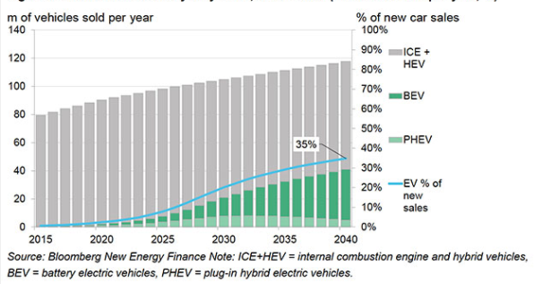 Question 5b)
From the graph of BEV and ICE markets, ICE vehicles contribute more to the climatic change since the chart above shown they have more than an 80% purchase rate.
Question 5c)

In economics, elasticity refers to the degree to which customers change their demand in response to price. It is mainly used to evaluate the change in consumer demand due to a change in goods, in this case, vehicles. ICE vehicles elasticity in 2021 is elastic because customers will prompt to buy ICE vehicles. After all, BEV vehicles are much more expensive (Van Mierlo & Maggetto, 2007).
Question 5d)
- With the technology change, there will be positive changes in socially optimal quantity in each market because technology makes things more efficient and cheaper.
- ICE vehicles will become more expensive because of the rise in tax from carbon policies.
- No, because the changes will move closer to social optimal since all the market activities are favoring social optimizing in a market model

References
Energy economics. (1990), 12(4), 309. https://doi.org/10.1016/0140-9883 (90)90025-b
Global Warming, Natural Hazards, and Emergency Management. (2009), 18(3). https://doi.org/10.1108/dpm.2009.07318cae.015
Van Mierlo, J., & Maggetto, G. (2007). Fuel Cell or Battery: Electric Cars are the Future. Fuel Cells, 7(2), 165-173. https://doi.org/10.1002/fuce.200600052

