Contents
- Interotction 2
- Theroy 2
- Equipment 3
- Procedure 3
- Results 5
- Discussion 8
- Conclusion 10
- References 11

Introduction
Some of Network theorems can allow us to analysis complex circuit. For Thevenin's Theorem, ,making the circuit from complicated one to simple one with considering the Thevenin equivalent Voltage Source, a Thevenin Equivalent Resistance, and the load. In superposition we take voltage at current time and we calculate the equivalent voltage and current for specific time. The purpose of this experiment is to verify these network theorems.
Theory
The superposition theorem of electrical circuits said for example the voltages or currents at any branch of circuit can have more than one independent source which equals the algebraic sum of the voltages or currents that caused by each independent source will acting alone. To ascertain the contribution of each individual source, all of the other sources first must be "turned off" by:
- Frist, make all other independent voltage sources to short circuit
- Second, make all other independent current sources to open circuitThis procedure is followed for each source in turn, and then all Voltages or Currents are added to determine the total voltages or currents. 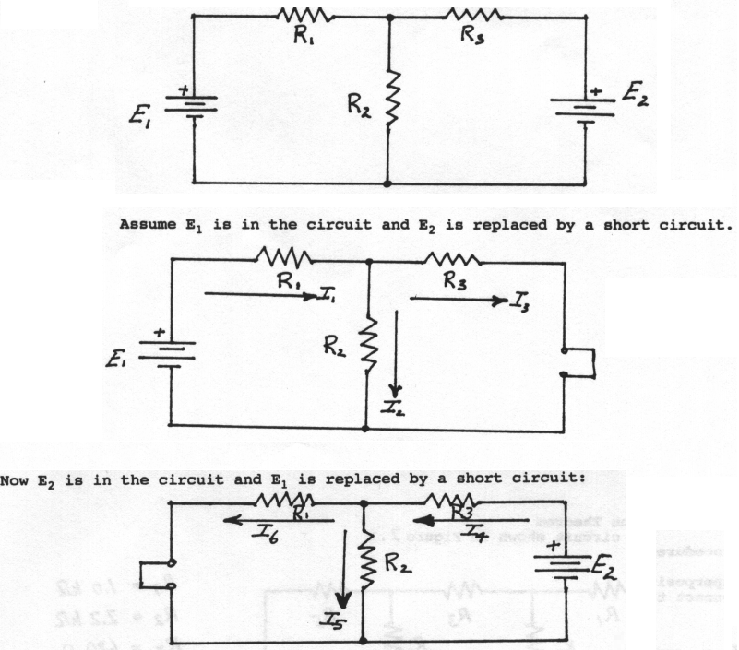
Figure 1 - Superposition
Thevenin’s theorem said that any mixing of current, voltage sources with resistor that having two terminals is electrically equivalent to the single voltage source and single series resistor V_{th}, R_{th}.The thevenin voltage V_{th} can be used as an ideal voltage source that can equal to the voltage open circuit at that terminals where R_{th} can be used as the resistance that been measured at terminals AB with all voltage sources are replaced by short circuits and all current sources are replaced by open circuits.

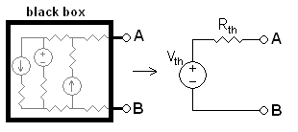
Figure 2 - Thevenin
Equipment
- DC power supplies
- DC voltmeter
- DC millimetre
- Resistors as required
- 1kohm pot
Procedure
To use superposition, we replace all the other independent voltage sources with a short circuit
- Start with the left 12 V and calculate the current and voltage across all resistors.
- Repeat for 5V and 12V
- Add the current and voltages to get total current and voltage.
To use Thevenin's Theorem:
- Identify the load and remove it. (R_{L}=R₄)
- Calculate V_{th}, which the voltage present at the load terminals with the load that been removed. (V_{AB} in Figure 3)
- Remove all sources, replacing the voltage sources with a short circuit, and all the current sources with an open but retain all internal source resistances. Calculate R_{TH}, the resistance seen at the load terminals. (R_{AB} in Figure 3)
- Construct a series circuit consisting of V_{TH}, R_{TH}, and R_{L}.

V_{A}

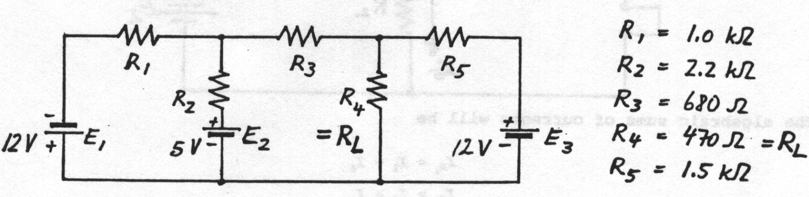
Figure 3 - Circuit used in lab

V_{B}

Also in this lab we measured voltages and currents across the five resistors while all the power supplies are on.
Results
Table 1 - Resistor Values
Resistors | Resistances(kΩ)
R1 | 1
R2 | 2.2
R3 | 0.68
R4 | 0.47
R5 | 1.5

Table 2 - Theoretical Results across left 12V only
Left 12V source only
Resistors | Voltage(V) | Current(mA) | Direction
R1 | -7.4 | -7.4 | right to left
R2 | -4.96 | -2.25 | bottom to top
R3 | -3.25 | -4.78 | right to left
R4 | -1.71 | -3.64 | bottom to top
R5 | -1.71 | -1.14 | right to left

Table 3 - Theoretical Results across 5V only
5V source only
Resistors | Voltage(V) | Current(mA) | Direction
R1 | -0.94 | -0.94 | right to left
R2 | -4.06 | -1.85 | bottom to top
R3 | 0.62 | 0.91 | left to right
R4 | 0.32 | 0.69 | top to bottom
R5 | 0.32 | 0.22 | left to right

Table 4 - Theoretical Results across Right 12V only
Right 12V source only
Resistors | Voltage(V) | Current(mA) | Direction
R1 | -1.14 | -1.14 | right to left
R2 | +1.14 | +0.52 | top to bottom
R3 | -1.13 | -1.66 | right to left
R4 | 2.27 | 4.83 | top to bottom
R5 | -9.73 | -6.49 | right to left
Table 5 - Total Theoretical Results by adding all 3 sources
Theoretical total current and voltages using superposition
Resistors | Voltage(V) | Current(mA) | Direction
R1 | -9.12 | -9.12 | right to left
R2 | -7.88 | -3.59 | bottom to top
R3 | -3.76 | -5.51 | right to left
R4 | 0.88 | 1.88 | top to bottom
R5 | -11.12 | -7.41 | right to left

Table 6 - Theoretical Results using mesh
Theoretical total current and voltages using mesh
Resistors | Voltage(V) | Current(mA) | Direction
R1 | -9.12 | -9.12 | right to left
R2 | -7.88 | 3.58 | bottom to top
R3 | -3.76 | -5.54 | right to left
R4 | 0.88 | 1.88 | top to bottom
R5 | -11.12 | -7.41 | right to left

Table 7 - Experimental Results using superposition
Experimental Results with one source only
Resistors | Voltage(left 12 V) | Current-mA | Voltage-5 V | Current-mA | Voltage(right 12 V) | Current-mA
R1 | -7. | -7 | -0.9 | -0.9 | -1.13 | -1.13
R2 | 4.98 | -2.26 | 4.06 | -1.85 | -1.13 | -0.51
R3 | -3.24 | -4.76 | 0.62 | 0.91 | -1.12 | -1.65
R4 | 1.74 | 3.70 | -0.32 | -0.68 | -2.25 | -4.78
R5 | 1.74 | 1.16 | -0.32 | -0.21 | 9.75 | 6.5

Table 8 - Experimental Results with all 3 sources together
Experimental Results with all power sources
Resistors | Total voltage(V) | Total current(mA)
R1 | -9.09 | -9.09
R2 | 7.9 | 3.59
R3 | -3.75 | -5.51
R4 | -0.85 | -1.81
R5 | 11.15 | 7.43

Table 9 - Experimental and Theoretical Thevenin equivalence values
 | V_{th}(V) | R_{th}(kΩ)
Theoretical Results | 2.56 | 0.715
Experimental Results | -2.15 | 0.711

The negative signs in the currents and voltages in the experimental results doesn’t state anything about the direction of flow as we need to calculate our theoretical values to determine the current direction.
Discussion
Table 10 - Theoretical vs Experimental all sources
Theoretical vs Experimental with all 3 sources together
 | Theoretical results |  | Experimental results |  | Difference in Voltage (%) | Difference in Current (%)
 | Voltage(V) | Current(mA) | Voltage(V) | Current(mA) | Difference in Voltage (%) | Difference in Current (%)
R1 | -9.12 | -9.12 | -9.09 | -9.09 | 0.99 | 0.99
R2 | -7.88 | 3.58 | 7.9 | 3.59 | 0.51 | 0.27
R3 | -3.76 | -5.54 | -3.75 | -5.51 | 0.28 | 0.26
R4 | 0.88 | 1.88 | -0.85 | -1.81 | 0.00 | 1.08
R5 | -11.12 | -7.41 | 11.15 | 7.43 | 0.00 | 2.20
Table 11 - Theoretical vs Experimental superposition
Theoretical vs Experimental with superposition
 | Theoretical results |  | Experimental results |  | Difference in Voltage (%) | Difference in Current (%)
 | Voltage(V) | Current(mA) | Voltage(V) | Current(mA) | Difference in Voltage (%) | Difference in Current (%)
R1 | 9.09 | 9.09 | 9.18 | 9.18 | 0.99 | 0.99
R2 | 7.9 | 3.61 | 7.94 | 3.61 | 0.51 | 0.27
R3 | 3.79 | 5.57 | 3.78 | 5.56 | 0.28 | 0.26
R4 | 0.88 | 1.85 | 0.88 | 1.87 | 0.00 | 1.08
R5 | 11.36 | 7.75 | 11.36 | 7.57 | 0.00 | 2.20

Table 12 - Theoretical vs Experimental Thevenin equivalence circuit
Theoretical vs Experimental for Thevenin equivalence circuit
 | Vth(V) | Rth(kΩ) | Difference in Voltage (%) | Difference in Current (%)
Theoretical Results | 2.56 | 0.715 | 0.19 | 1.34
Experimental Results | -2.15 | 0.711 | 0.19 | 1.34
In all these results difference in voltage=% error calculated by
$$\% error=\left|\frac{Experimental-Theoretical }{Theoretical }\right|*100$$

By using the result in table 12 we find out the the voltage across R4 is was measured and the theoretical value was 0.872V where the experimental value is 0.878V which we can say from their values that they are almost the same. As shown in tables above all the differences are less than 2.5% which means that our values are fairly accurate. In the experiment the resistance of wires may have altered the actual current. Thevenin's is used where the load can be varied. By reducing a complex circuit to a simple circuit with 1 source (V_{Th}) series with 1 resistor (R_{TH}) we can measure any by putting any kind of load & measure the variations of current & voltages across the load. The load can be a Fan, bulb, etc thus you can determine which component will be suitable to use. Also, where maximum power is required from source, thevenin is used where R_{TH}=R_{L} on the other hand, Thevenin's theorem is only valid for linear and bilateral networks. Practically, linearity of any circuit is over a certain range hence it is only valid for certain range. On the other hand, Superposition advantage is that the circuit can be found with at least one power source at a time. This will simplify the circuit making the analysis easier which means lesser equations to solve.
Conclusion
The experimental values were checked with the theoretical results that having a maximum Error % or Difference % = 2.30 %.All the results were very close indicating that both the human and the apparatus error were kept to the minimum. Thevenin's Theorem is great in term of finding power systems and other circuits where one particular resistor in the circuit called the “load” resistor is where is subject to change, and re-calculation of the circuit is important for each trial, to determine voltage across it and current through it. Thevenin’s theorem is also greatly applied in resistance measurement using the Wheatstone bridge. Kirchhoff's current and voltage laws, the superposition theorem have been verified. Also the current flowing through a load resistance under thevenin’s theorem is the same as the current that flowing through it under normal condition. For that all the results above show that there is no difference using any methods cause it will give you the same answer in the end. However if there was difference for example will be due torero reading or thing else.

