- What is a resource? Distinguish between an inexhaustible resource and a renewable resource and give an example of each. What is the sustainable yield of a renewable resource? Define and give two examples of a nonrenewable or exhaustible resource. Distinguish between more-developed countries and less-developed countries and give an example of a high-income, a middle-income and a low-income country.

- Why is biomimicry so important? Find an example of something in nature that you think could be mimicked for some beneficial purpose. Explain that purpose and how biomimicry could apply.

- What are the three most environmentally unsustainable components of your lifestyle? List two ways in which you could apply each of the six principles of sustainability (Figure 1.2 and 1.6) to make your lifestyle more environmentally sustainable.

Ecological Footprint Analysis
If the ecological footprint per person of a country or of the world (Figure 1.9) is larger than its biological capacity per person to replenish its renewable resources and absorb the resulting waste products and pollution, the country or the world is said to have an ecological deficit. If the reverse is true, the country or the world has an ecological credit or reserve. Use the data below to calculate the ecological deficit or credit for the countries listed and for the world. (For a map of ecological creditors and debtors see Figure 1.10.)

Place | Per Capita  Ecological Footprint (Hectares per person) | Per Capita  Biocapacity  (Hectares per person) | Ecological  Credit (+)or Debit (–) (Hectares per person)
World | 2.6 | 1.8 | 0.4
United States | 6.8 | 4.7
Canada | 7.0 | 13.0
Mexico | 2.4 | 1.3
Brazil | 2.5 | 9.0
South Africa | 2.5 | 1.2
United Arab Emirates | 8.0 | 0.7
Israel | 4.6 | 0.3
Germany | 4.3 | 1.9
Russian Federation | 4.4 | 6.6
India | 0.9 | 0.4
China | 0.5 | 0.8
Australia | 7.5 | 15.0
Bangladesh | 0.65 | 0.35
Denmark | 4.0 | 4.0
Japan | 3.7 | 0.7
United Kingdom | 4.0 | 11
Data from WWF Living Planet Report 2014

- Which three countries have the largest ecological deficits? Why do you think they have such large deficits?
- Which three countries have the largest ecological credit? Why do you think each of these countries has an ecological credit?
- Rank the countries in order from the largest to the smallest per capita ecological footprint.

- Respond to the following statements: a. Scientists have not absolutely proven that anyone has ever died from smoking cigarettes. b. The natural greenhouse effect theory—that certain gases (such as water vapor and carbon dioxide) warm the atmosphere—is not a reliable idea because it is just a scientific theory.

Data Analysis
Consider the graph (below) that compares the losses of calcium from the experimental and control sites in the Hubbard Brook Experimental Forest (Core Case Study). Note that this figure is very similar to Figure 2.5, which compares loss of nitrates from the two sites.

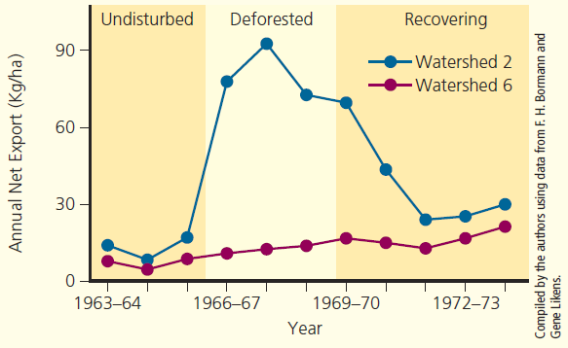

After studying this graph, answer these questions:

- In what year did the calcium loss from the experimental site begin a sharp increase? In what year did it peak? In what year did it level off?

- In what year were the calcium losses from the two sites closest together? In the span of time between 1963 and 1972, did they ever get that close again?

- Does this graph support the hypothesis that cutting the trees from a forested area causes the area to lose nutrients more quickly than leaving the trees in place? Explain.

- How would you explain the importance of tropical rainforests (Core Case Study) to people who think that such forests have no connection to their lives?

- How might a reduction in species diversity affect the other three components of biodiversity?

- Is the human species a keystone species? Explain. If humans were to become extinct, what are three species that might also become extinct and three species whose population would probably grow?

- What difference would it make if the southern sea otter (Core Case Study) became extinct primarily because of human activities? What are three things we could do to help prevent the premature extinction of this species?

- Do you think that projected increases in the earth’s population size and economic growth are sustainable? Explain. If not, how is this likely to affect your life?

- A journalist has asked to interview you about the importance of environmental sustainability. Based on what you have learned currently in the course, write a draft of what you would say to the journalist. Please reference at least 2 pieces of evidence to support your thoughts that you will share with the journalist. This should be roughly 7-10 sentences.

