Websites Comparison and Contrast
Name
Date

Websites comparison and contrast
The New York Times and the Wall Street Journal are media companies in the United States. The two companies broadcast news from all the sectors, and they do so mainly on their websites, and the frequency of the broadcasts is daily. By comparing the two media houses' websites, it is possible to get the proximity, alignment, contrast, and repetition as applied in the individual company websites. The media disseminates information in many forms, and the use of graphics is a common feature relevant to the media companies in their online platforms. The use of alignment indicates how an organization has managed to polish its work hence displaying its strength when it comes to news coverage. The text display should be clear and properly aligned to the margin for the alignment to be deemed excellent. In contrast, there is a focus on highlighting the important points required to be disseminated to the audience. Contrast involves using colors, font sizes, distinguishing parts of an image, or a text. The news sites use contrast to show emphasis on specific news in a large compilation of news. In repetition, the graphic elements such as images and bolded texts are repeated to ensure that the content at hand is disseminated and gets the audience's attention. Proximity involves the creation of relationships within aspects of an image. In the news, the related objects are placed together, which displays the connection between them. For instance, the use of words to explain an image is an example used in news coverage. Comparing the two media websites aims to bring out the similarities in the application of the graphic elements in their pursuit of news anchorage.
Alignment
New York Times
The New York Times has managed to apply alignment in the division of the different news articles. The site has managed to divide news sections in different alignments, as shown in Figure 1.1. The news sections are divided with a bold line that cuts across the page. In each category of news, several sections are properly aligned and divided with a thin line that cuts down the section. When navigating through the page, it is easy to see the different news sections and identify the different news articles in a specific news section without any confusion.
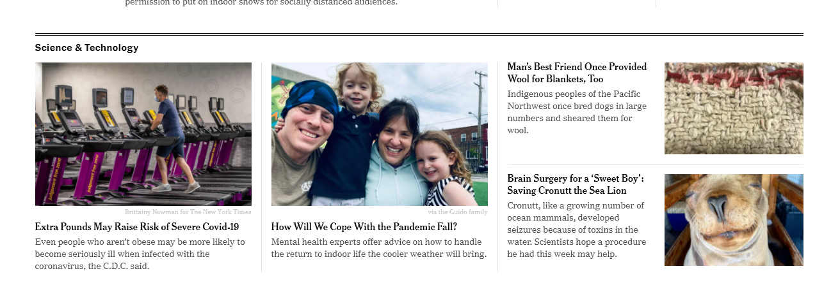
Figure 1.1 Home page of New York Times
The Wallstreet Journal
The Wallstreet Journal has managed to use a bold black line to align the different news sections. The articles in each section are divided into thin lines but not consistent. In some articles, the divisions are divided through blank space, as observed in Figure 1.2.

Fig 1.2 The Wallstreet Journal home page
Proximity
New York Times
In Figure 2.1, the images shown have captions that explain more of the image content. The site has ensured that every image has a caption that acts as a highlight of the image's news. Similarly, some captions have a brief explanation of the news contained in the article.
The Wallstreet Journal
In Figure 2.2, the captions have an explanation of the news article. Like the news in the News York Times, every image has a caption explaining each of the content in the news article in which the images have been placed.

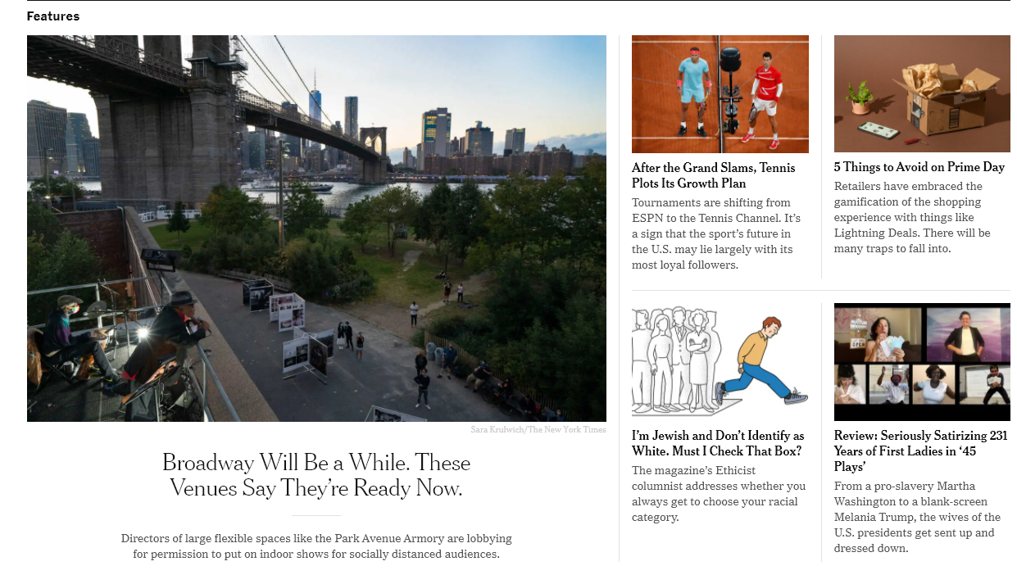
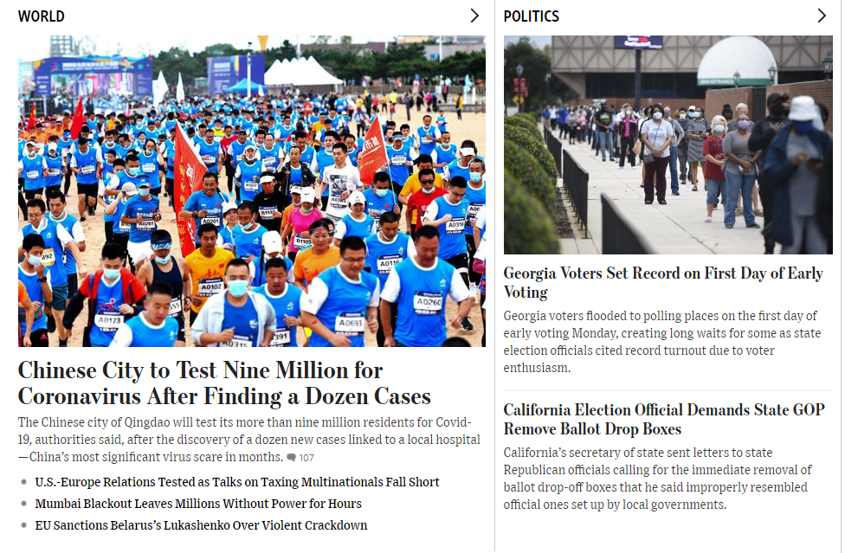
Fig 2.2 Wallstreet Home Page

Contrast
New York Times
The site has consistently used contrast in various sections. In the menu section, the different news sections show the different news articles in different subtitles. In the highlights of different news articles, the topics are bolded to ensure that the news comes out distinctively to be easily noted. There are different colors, for example, black in the news title, while other different classes make different news outstanding.
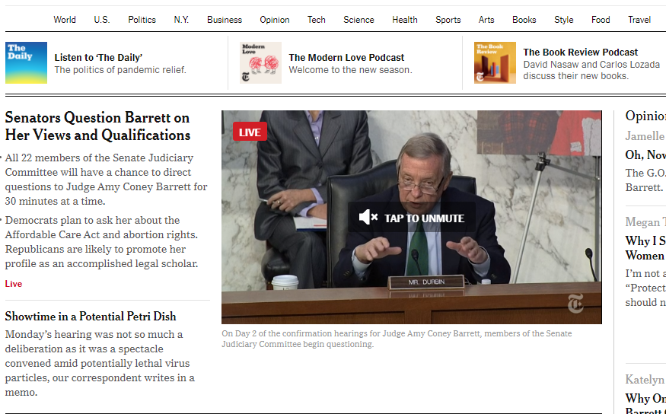
Fig 3.1 New York Times home page
The Wallstreet Journal
In Fig 3.2, it is evident that contrast has not been applied consistently as that of the New York Times. The contrast is only evident through the captions' black color in the various news sections and the articles. The divisions of different news sections have been captured through the use of capital letters. The contrast is not clear in The Wall Street Journal and not consistent in the whole site.

Fig 3.2 The Wallstreet Journal News Page
Repetition
Repetition is not dominant in the two sites except the repetitive use of bold news articles titles. However, the repetition is not that effective since the contrast in color is the only effective aspect.
New York Times
In Figure 4.1, repetition is only observed through photos in the display of news articles that may seem not to be easily notable. Therefore, the site has not fully adopted the use of repetition in the news articles and the different graphics applied.
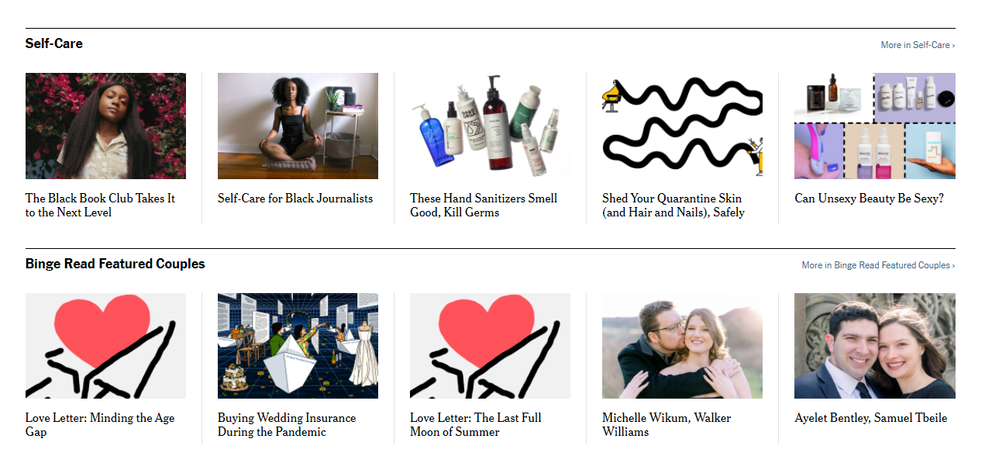
Fig 4.1 New York Times Lifestyle page
The Wallstreet Journal
In figure 4.2, the only aspect of repetition evident is the use of bold and black color for the news article's caption. Therefore, the effectiveness of the aspect of repletion in the two media sites is not evident.


Fig 4.2 The Wallstreet Journal Sports Section page
Conclusion
In conclusion, therefore, the use of different aspects of graphics in the news websites is well outlined, and the significance of the aspects is well noted. The use of alignment, proximity, contrast, and repetition is very relevant and effective in media sites.

References
New York Times. (2020). Breaking News, World News & Multimedia. Retrieved October 13, 2020, from https://www.nytimes.com/
The Wall Street Journal. (2020). WSJ life, style & arts: Weekend news and reads. WSJ. Retrieved October 13, 2020, from https://www.wsj.com/news/life-arts?mod=nav_top_section

