Real Estate Business Simulation
Subject
Course
Name

Real Estate Business Simulation
3 Property analyses
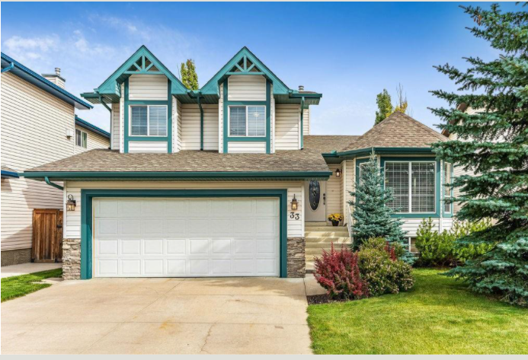

The Property goes for $419,000.
The property is a solitary family house on a 510-meter squared; 4051 by 7251 sqft. Built-in 1998 with a somewhat outfitted cellar and a parking spot of four vehicles. The main level offers a large living room with a BAY window, a formal dining room and kitchen with eating nook overlooking the third level family room with a cozy Fireplace. There is a door off the nook that leads to your large DECK and fenced back yard. The top floor has 3 bedrooms and 3 bathrooms including a master retreat with a full EN-SUITE. The lowest level is a wide-open space ready for your creation. The house accompanies pre-introduced machines; Refrigerator, Dishwasher, Stove, Microwave and Window Coverings. The floor type in the entire house; cover, ceramic tile and hardwood. Moreover, the property isn't animal/smoking amicable Heating sort: Forced air and Natural Gas
Conveniences Nearby: School, Daycare, Shopping Center, Restaurant
Schools-map within Jurisdiction
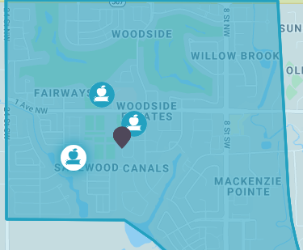
- Ralph McCall School; elementary school located in 1505 - 1 Avenue N.W. which is 4 minutes-walk from the Property
- Our Lady Queen of Peace Elementary School; a Roman Catholic Separate School District No. 1 on the 1820 - 1 Avenue N. The school is 10 minutes’ walk.
- C.W. Perry School Elementary school; View School Division No. 41 on the 186 Sagewood Boulevard SW. The school is 14-minutes’ walk from the property.
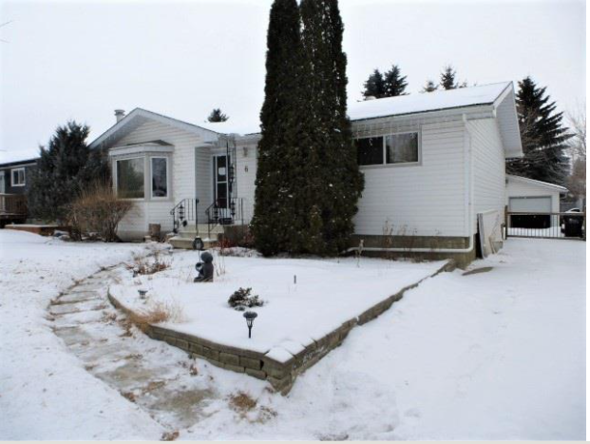
The Property goes for $379,900.
The property is on a 1300sq.ft. in Maplewood. Highlights 3 rooms, 2 washrooms, huge radiant lounge with light inlet window, formal lounge area, and kitchen with eating Island, simply off the kitchen sitting above a private perfectly finished yard. Fully finished basement features a spacious family room with corner stone-faced wood-burning fireplace, huge pantry with a lot of extra room. Family home in an incredible area near schools, shopping, public transportation. The hearting sort is by wood on the fireplace while the heating type is forced air.
Schools-map within Jurisdiction

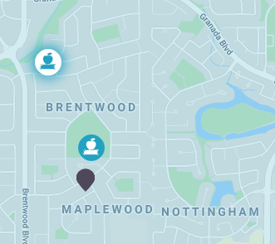
- École Pere Kenneth Kearns Catholic School, 15 minutes’ walk from resident.
- Brentwood School; Public Schools Regional Division No. 14 28 Heron Road. 4minutes walk from resident
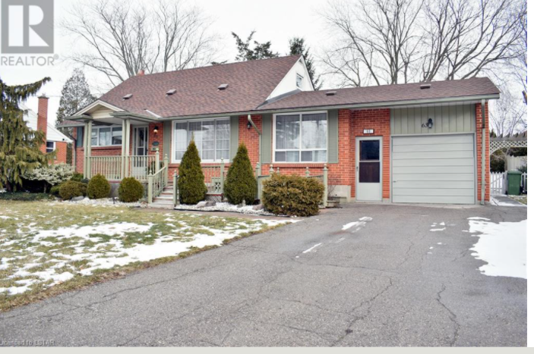
The Property goes for $ 409,900
Home is found south of Chestnut St and Park Ave crossing point. The property accompanies 3 rooms and three restrooms. Highlights incorporate; a vast lounge with two windows and electric fireplace, the main floor is the family stay with gas fireplace and lawn access. Sunroom Overlooking mature treed lot, large dining room with built-in cabinets, and centrally located kitchen with easy access to the sunroom. Storm cellar has a pantry. The house is attached to a carport that has extra stockpiling and admittance to the sunroom. The Cooling sort is a central cooling while the Heating Type is the Forced air, (Natural gas)
Schools-map within Jurisdiction
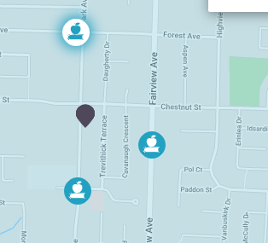
- St. Anne's Separate School; District Catholic School Board located in the 84 Park Ave 3-minutes’ walk.
- St. Thomas Community Christian School; Private Elementary School located 77 Fairview Ave. 6- minutes’ walk.
- Forest Park Public School; Public Elementary School, Valley District School Board located in the 295 Forest Ave, Approximately 7-minutes’ walk.

Amortization | Selling Price | Down Payment | Principal | CMHC Premium | Mortgage Interest Rate | Percentage Down Payment | Monthly Payment Amount | Annual Property Taxes | Total Interest Cost of Amortization
25 | $ 419,000.00 | $ 80,000.00 | $ 348,492.00 | $ 9,492.00 | 1.33% | 19.09% | $ 1,366.00 | $ 2,664.00 | $ 61,154.84
25 | $ 419,000.00 | $ 80,000.00 | $ 348,492.00 | $ 9,492.00 | 1.64% | 19.09% | $ 1,416.00 | $ 2,664.00 | $ 76,267.20
25 | $ 419,000.00 | $ 80,000.00 | $ 348,492.00 | $ 9,492.00 | 1.68% | 19.09% | $ 1,422.00 | $ 2,664.00 | $ 78,240.44
Amortization of the property that cost $ 419,000.00

Amortization of the property that cost $ 379,900.00

Amortization | Selling Price | Down Payment | Principal | CMHC Premium | Mortgage Interest Rate | Percentage Down Payment | Monthly Payment Amount | Annual Property Taxes | Total Interest Cost of Amortization
20 | $ 379,900.00 | $ 80,000.00 | $ 299,893.00 | $ - | 1.33% | 21.06% | $ 1,423.00 | $ 1,216.00 | $ 41,697.87
25 | $ 379,900.00 | $ 80,000.00 | $ 299,893.00 | $ - | 1.33% | 21.06% | $ 1,175.00 | $ 1,216.00 | $ 52,627.72
20 | $ 379,900.00 | $ 80,000.00 | $ 299,893.00 | $ - | 1.64% | 21.06% | $ 1,466.00 | $ 1,216.00 | $ 51,884.48
25 | $ 379,900.00 | $ 80,000.00 | $ 299,893.00 | $ - | 1.64% | 21.06% | $ 1,218.00 | $ 1,216.00 | $ 65,632.88
20 | $ 379,900.00 | $ 80,000.00 | $ 299,893.00 | $ - | 1.68% | 21.06% | $ 1,471.00 | $ 1,216.00 | $ 53,211.59
25 | $ 379,900.00 | $ 80,000.00 | $ 299,893.00 | $ - | 1.68% | 21.06% | $ 1,224.00 | $ 1,216.00 | $ 67,330.98

Amortization of the property that cost $ 409,900.00
Amortization | Selling Price | Down Payment | Principal | CMHC Premium | Mortgage Interest Rate | Percentage Down Payment | Monthly Payment Amount | Annual Property Taxes | Total Interest Cost of Amortization
25 | $ 409,900.00 | $ 80,000.00 | $ 339,125.00 | $ 9,237.00 | 1.33% | 19.52% | $ 1,329.00 | $ 3,320.00 | $ 59,513.22
25 | $ 409,900.00 | $ 80,000.00 | $ 339,125.00 | $ 9,237.00 | 1.64% | 19.52% | $ 1,378.00 | $ 3,320.00 | $ 74,219.91
25 | $ 409,900.00 | $ 80,000.00 | $ 339,125.00 | $ 9,237.00 | 1.68% | 19.52% | $ 1,378.00 | $ 3,320.00 | $ 76,140.18

