Question 1
a). Suppose that there is free trade, the firm can not charge a price that is higher than Pw. The production will be at point where MC= Pw, and therefore quantity of goods produced will be Q1.The quantity demanded by domestic market will be Q7 and the quantity imported will be Q7-Q1.
b). With tarrif t, the firm will charge Pw+t. It will produce at point where MC=Pw+t, hence the production will be Q4, and the quantity demanded will be Q6. Therefore imports are Q6- Q4.
Question 2.
i. With the decline in the price of the food, the wage rate for the food industry declines. Because the price of the cloth is constant, some labor force will move to the clth industry where the prices are high and this will cause increase in production of cloths hence increased exports.
ii. With the decline in the real wage of labor, the nominal wage rate for the food industry increases hence increase in food production. The nominal wage of clths remains unchaged but exports decline.
iii. the real return on capital will increase for cloths with the decline in the real rental price of capital in the C industry. The production of C will increase.
Iv. As the quantity of C exported declines, the price of C will decline but the price of food and its production will increase.

Question 3
a)
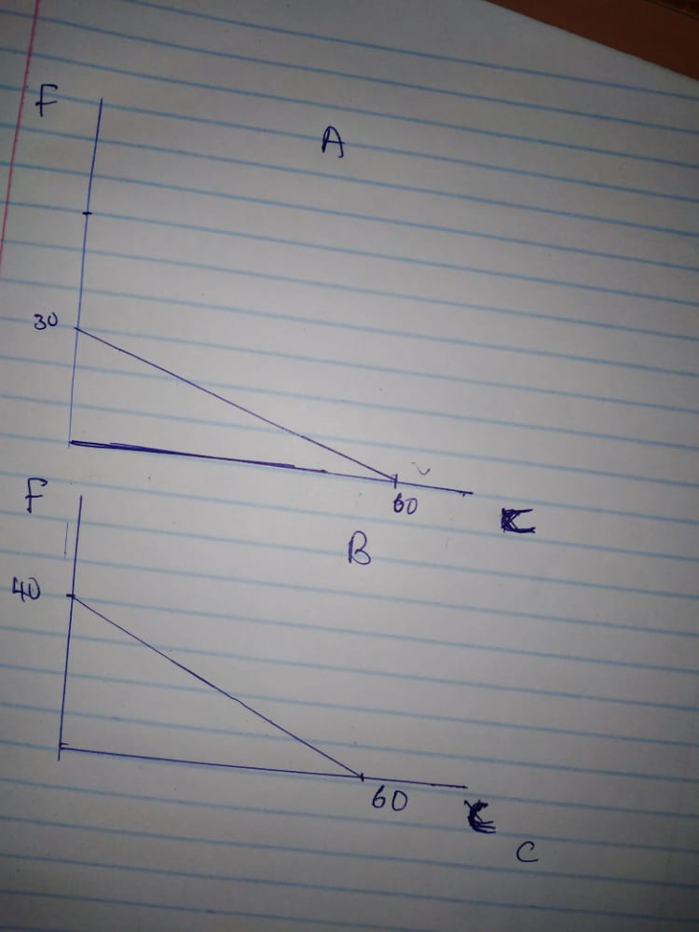
b). A. autarky px/py = 30/60 = 0.50
B: autarky px/py = 40/60 = 0.67
c). . Absolute advantage in X: A
Absolute advantage in Y: A
Comparative advantage in X: A
Comparative advantage in Y: B
d). The Autarky wages are just recipricakls of the respective unit labor requirements. Therefore, For Autarky Price of C in country A=1/1 C=1 C
Autarky Price of F in country A=1/2 F=0.5 F
Also, the Autarky Price of C in country B=1/2 C=0.5 C
Autarky Price of F in country B=1/3 F=0.33 F
The above shows that the A’s workers are better off because they can consume more of both goods.
e). the countries will soecialise in the goods for which they have comparative advantage in. In units of the goods that they produce, the wages will be same to autarky.
Therefore for A, wA /pX = 1/aLX= 1/1 = 1.0
For B, wB /pY = 1/aLY*=1/3 or 0.33
The wages will depend on the price ratio, for
A : wA /pY = (wA /pX )(pX/pY) = (1.0)(0.60) = 0.60
For B: B /pX = (wB /pY )/(pX/pY) = (0.33)/(0.60) = 0.55
From the above, the A’s workers are better off because they can buy same amounts of X and more of Y. B can buy same amounts of Y and more of X hence they are also better off.

