(I took the first text) On zoom they only want to see the area your testing in. I was thinking next time you will have to log in and take it while im sitting at the computer screen , Looks like they only want to make sure you don’t have paper or text books in the area. I have enclosed the information needed. On zoom they give you the passcode I will have to send it to you once the give it to me. You will have to be available next time please.

Instructions: You will type this in your web browser:
Examsoft.com
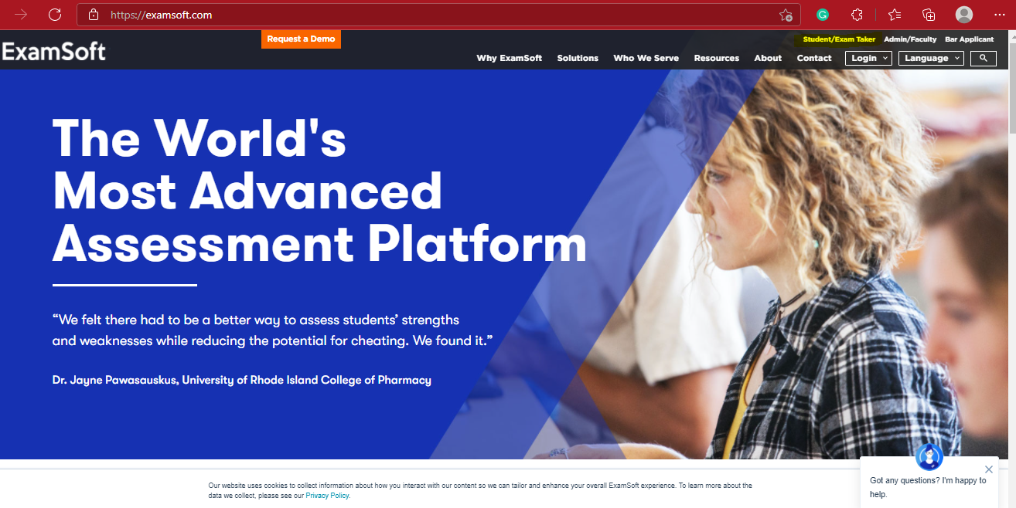
Click on student exam taker
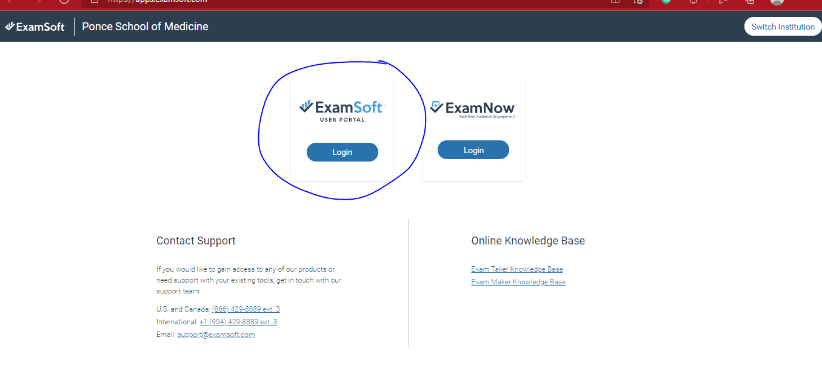
If it ask for a school you will type in ponce health science university
Click on Examsoft
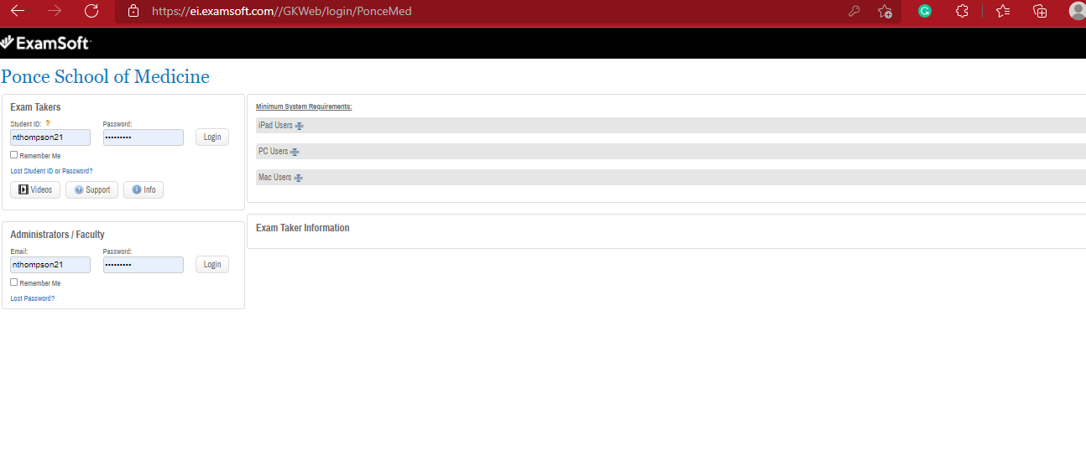
My log in is
Nthompson21
Password
MSMSOL123 (all upper letters)
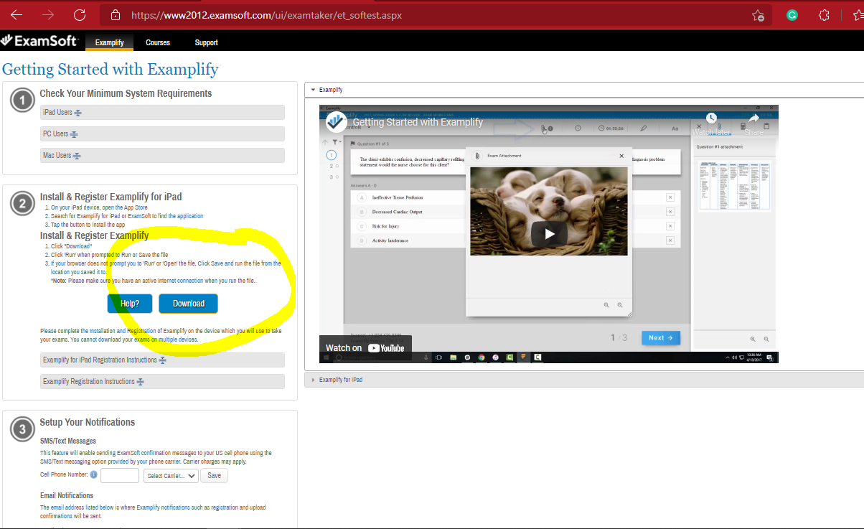
You will then click on enter and go to the download button to down load on your computer. Once download. You will click on it and see the screen below.
