Directions: Be sure to make an electronic copy of your answer before submitting it to Ashworth College for grading. Unless otherwise stated, answer in complete sentences, and be sure to use correct English spelling and grammar. Sources must be cited in APA format. Your response should be four (4) pages in length; refer to the "Assignment Format" page for specific format requirements.
Business Consulting
Remember Bill? He was the gentleman that you helped to start up his business in Lesson 4. Well his business is doing well, but he has come to you with some questions and concerns. You discuss each of these with Bill and promise to send him a written report with your suggestions and recommendations. Bill’s questions and concerns are as follows:
Bill has set up a spreadsheet in Excel that will help him keep track of expenses. So far, he has this:

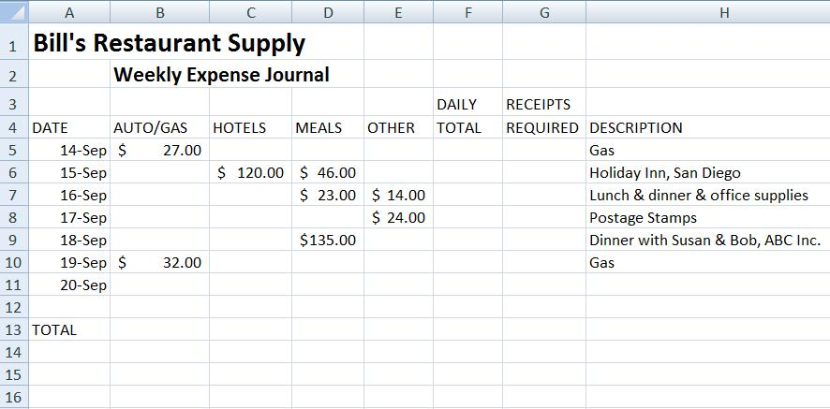
1. Tell Bill how to do the following tasks:
- What formula or function does he put in Column F that will show the total expenses for each day? The formula Is sum (B5:E5)
- What formula or function does he put in columns B through F in Row 13 that will give him the total expenses for the week in each category? The formula is sum (E5:B11) and this must be repeated in all column.
- Bill wants the entry in Column G to remind him of expenses that require receipts for the accountant. Tell Bill what to put in Column G to do this: The entry that Bill will put in Column G to remind him of expenses that require receipts for the accountant would be the following lunch and dinner and office supplies.
  - Print the word “Yes” in any row where the total daily expenses are greater than or equal to $100.00. The function or the formula is =IF (F6>=100,”Yes,””No”) and =IF(F9>=100,”Yes,””No”
  - If the daily expenses total is less than $100.00, leave the Column G entry for that row blank. To leave column G bill need to delete a column, select the column, select Home > Insert > Delete Sheet Columns.

2. Bill’s business is already expanding. He thinks that in a few weeks he will need to hire one or two employees to help him. He knows that each new employee will need their own computer. He is also making the necessary changes so that the new employees will be working in a spare room in Bill’s house. Explain to Bill what networking options he has. Go through each type or configuration of network possible for him, making sure that you explain the pros and cons of each configuration. Finish with your suggestion for the network that he should set up and explain what new hardware will be required to do this.

3. With the possibility of three business computers in his home, and all of his business records possibly vulnerable, this would be a good time to advise Bill on how to set up a routine plan to protect and defend his new network. Provide a list of the five most important concerns for safety and security of the network and the computers in the network. For each concern, specify the action to be taken, and if applicable, what software you recommend be added to the system. Justify each of your recommendations.

