Favorite Hobbies for Students in the Emirates of Abu Dhabi

Name:
Institution:
Professor:
Course:
Date:

Table of Contents
TABLE OF CONTENTS..................................................................................................... 2
INTRODUCTION............................................................................................................. 3
LITERATURE REVIEW..................................................................................................... 3
Research Question................................................................................................. 3
METHOD........................................................................................................................ 4
Participants.............................................................................................................. 4
RESULTS........................................................................................................................ 5
Data Analysis........................................................................................................... 8
CONCLUSION................................................................................................................ 8
REFERENCES................................................................................................................ 10

INTRODUCTION
Hobbies play an essential role in our lives because they are a source of joy and enrichment. They offer people the opportunity to learn new skills. Having hobbies provides a chance to spend time consciously and productively. Trying something new every time is essential because it helps in personal exploration. When individuals have a particular hobby, they are motivated to act in a certain way, which portrays their personality (Halen, 2017). Several benefits are associated with pursuits, including relieving stress, cultivating patience, improving social life, boosting self-esteem, offering new perspectives, preventing terrible habits, and developing new skills and knowledge. Examples of hobbies can include reading, watching movies, cooking, gardening, and cycling. For college students, hobbies are vital because they enhance their ability to become better performers in class. This paper aims at identifying the favorite hobby among students in the Emirates of Abu Dhabi. The report will also explore the differences between males and females using the PISA student questionnaire data.
Research question
Is reading considered the favorite hobby for students in the Emirates of Abu Dhabi?
LITERATURE REVIEW
Hobbies play an essential part in the improvement of a person's life. Having hobbies is necessary because it acts as an opening for an individual to know himself/ herself better. According to Becket and Taylor (2016), hobbies can help an individual grow into a more productive and self-conscious person. Hobbies are activities that a person does out of their own free will and are expected to bring joy and amusement. Other researchers consider hobbies as alternative activities. In this context, these activities are those that a person engages in when they do not do their routine work. Alternative activities are aimed at helping a person become better in different areas. For example, a person may desire to be competent in sports. This alternative activity would be achieved through experimentation. Alternative activities, therefore, are aimed at adding value or increasing an individual's competitiveness in a particular area.
Engaging in a particular hobby is considered beneficial. One of the benefits is that hobbies are used to relieve stress. Engaging in an activity that you love and doing it at will results in joy and fulfillment. Hobbies help a person shift their attention from the challenges of a day, instilling them with happiness. Another benefit is that they allow a person to become patient in life. An individual's time to learn a new hobby portrays their patience because it takes time to learn a new skill. Hobbies are used to boost confidence. When a person does something they love, they can do it excellently and with confidence. Working with confidence can enhance the achievement of goals. Hobbies are associated with learning new skills and increasing knowledge. Engaging in a hobby prompts an individual to learn and develop new skills. Learning these skills allow them to become proficient and competent. Besides, hobbies are used to help in the development of more unique perspectives.
METHOD
Quantitative research methods will be used to gather results for this study. Quantitative research methods focus on quantifying a problem by providing quantified data that can be translated into meaningful statistics. Quantitative research methods are structured and can include surveys, systematic observations, interviews, online polls, and questionnaires (Oh, 2014).
Different factors will be put into consideration in the process of conducting this research. The rights of the participants will be protected by ensuring that the investigation is ethical. Participants will be required to sign an informed consent, provide the right to withdraw from the study, and avoid unethical behaviors.
Closed-ended questionnaires were used in this research to collect data on students’ favorite hobbies. The questionnaire had four items: strongly disagree, disagree, agree, and strongly agree.
Participants
The population used in the research will be carefully selected to ensure that the research objectives are met. A randomized sampling technique will be employed to ensure that the investigation has an equal representation of the study population. Additionally, a random sampling technique will ensure that all study groups are included, thus promoting reliable results. Adequate sample size will be used in the research to ensure that the results obtained are conclusive. Besides, a sufficient number of participants is significant because it will ensure that the results are generalized. The sample size used is 7115 students in Abu Dhabi.
RESULTS
The results of the research are shown below.
Table 1
How much do you agree or disagree? Reading is one of my favorite hobbies.
Statistics
How much do you agree or disagree? Reading is one of my favorite hobbies.
N | Valid | 2558
N | Missing | 363
Mean |  | 2.78
Std. Error of Mean |  | 0.019
Median |  | 3.00
Mode |  | 3
Std. Deviation |  | 0.939
Variance |  | 0.881
Range |  | 3
Minimum |  | 1
Maximum |  | 4
Sum |  | 7115
Percentiles | 25 | 2.00
Percentiles | 50 | 3.00
Percentiles | 75 | 3.00
Table 1 shows the statistics of 7115 students in Abu Dhabi showing mean, median, mode, and standard deviation.
Table 2
Valid | Strongly disagree | 298 | 10.2 | 11.6 | 11.6
Valid | Disagree | 573 | 19.6 | 22.4 | 34.1
Valid | Agree | 1077 | 36.9 | 42.1 | 76.2
Valid | Strongly agree | 610 | 20.9 | 23.8 | 100.0
Valid | Total | 2558 | 87.6 | 100.0
Missing | No Response | 317 | 10.9
Missing | System | 46 | 1.6
Missing | Total | 363 | 12.4
Total |  | 2921 | 100.0
Table 2 shows valid questionnaire responses for students in Abu Dhabi.
Chart 1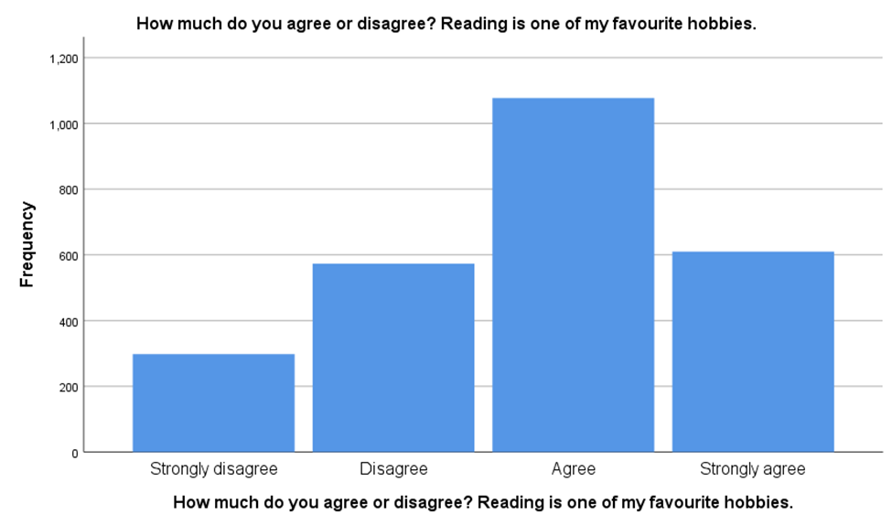
Chart 1 shows the number of students who strongly disagreed, disagreed, agreed, and strongly agreed that reading is one of their favorite hobbies.
Chart 2.
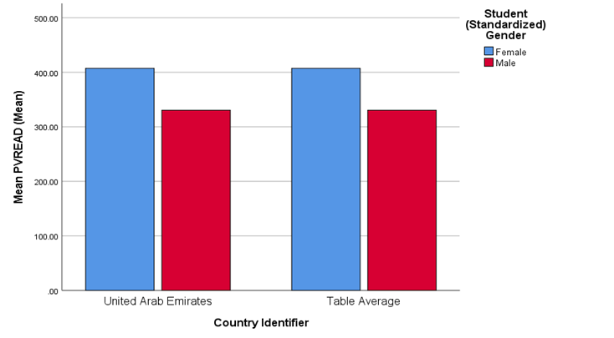
Chart 2 shows the mean number of female and male students who agree to reading as one of their favorite hobbies.
Chart 3.
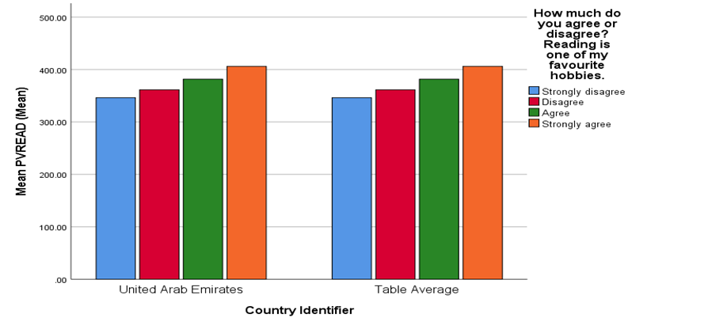
Chart 3 show the mean number of students in the four response categories regarding reading as their favorite hobby.

Data Analysis
Table 1 shows the statistics of all students who took part in the study. The research included 7115 students in Abu Dhabi. The table shows that the valid results used to decide on favorite hobbies were 2558, with 363 missings. The mean response rate was 2.78, with a standard deviation of 0.939.
Data in Table 2 shows how the valid results were distributed. The responses were distributed in four items. Two hundred ninety-eight accurate participants strongly disagreed that reading was one of their favorite hobbies. This was 11.6% of the right participants and 10.2% of the total participants. Five hundred seventy-three students disagreed that task was one of their favorite hobbies: 22.4% of the valid participants and 19.6% of the total participants. One thousand seventy-seven students agreed that reading was one of their favorite hobbies: 42.1% of the accurate participants and 36.9% of the total participants. Six hundred ten strongly agreed that reading was one of their favorite hobbies. This value was 23.8% of the valid participants and 20.9% of the total participants. Three hundred seventeen participants did not respond to the question, while 46 were not included in the system. From the table, it can be identified that the majority of the participants (36.9%) agreed that reading was one of their favorite hobbies. The least percentage, 10.2%, strongly disagreed that learning was one of their favorite hobbies.
Chart 1 shows that most students in Abu Dhabi consider reading one of their favorite hobbies. The highest frequency is for students who agreed, while the lowest frequency is for students who strongly disagreed.
Chart 2 shows data about gender. More females agreed that reading was one of their favorite hobbies compared to male students from the data. Female students have a higher mean of PVREAD compared to male students.
Chart 3 shows the average number of students who strongly disagree, disagree, agree, and strongly agree that reading is among their favorite hobbies. This chart shows that most students, both males and females in Abu Dhabi, consider reading a favorite hobby.
CONCLUSION
Students have different hobbies, with reading being one of their best. The research identified that most of the students from Abu Dhabi prefer to read as one of their hobbies. Also, the study shows that female students prefer reading to be a hobby than male students.
References
Becket, C., & Taylor, H. (2016). Human growth and development. 3rd ed. London: SAGE.
Halen, M. (2017). Experiences of Hobbies among the Youth: Bachelor Thesis.
Oh, J. H. (2014). Research methods. https://gsis.korea.ac.kr

