College of nurses
Nutrition management for high blood pressure

[hypertension]

Introduction
Nutrition management for hypertension in;
Centers for disease control and prevention, The National Heart, Lung, and Blood Institute, Western Cape government

Definition: (2).
Blood pressure is the force of blood pushing against the walls of your arteries, which carry blood from your heart to other parts of your body

Type of High Blood Pressure (3)
There are two main types of high blood pressure: primary and secondary high blood pressure.
- Primary High Blood Pressure
Primary, or essential, high blood pressure is the most common type of high blood pressure. This type of high blood pressure tends to develop over years as a person ages.
- Secondary High Blood Pressure
Secondary high blood pressure is caused by another medical condition or use of certain medicines. This type usually resolves after the cause is treated or removed

Symptoms of hypertension (1)

Hypertension is known as the silent killer since most people don’t have any symptoms. In some cases hypertension causes symptoms such as:
• Headache,
• Shortness of breath,
• Dizziness, chest pain,
• Palpitations of the heart, and
• Nose bleeds.
Uncontrolled hypertension can lead to
• A heart attack,
• Stroke,
• Kidney failure, and
• Damage to eyesight.
Risk factors for hypertension (1)
Hypertension is mainly related to environmental and lifestyle factors, including:
- unhealthy diet,
- consumption of food containing too much salt and fat,
- not eating enough fruit and vegetables,
- physical inactivity and lack of exercise,
- harmful alcohol use,
- smoking and use of other tobacco products, or
- High levels of stress and poor stress management.
- Genetic factors can also play a role in high blood pressure, heart disease, and other related conditions.

Nutritional management guidelines of Centers for disease control and prevention (2)
Lifestyle, you can help keep your blood pressure in a healthy range and lower your risk for heart disease and stroke. A healthy lifestyle includes:
• Eating a healthy diet.
• Maintaining a healthy weight.
• Getting enough physical activity.
• Not smoking.
• Limiting alcohol use.

- Healthy Diet
- Choosing healthful meal and snack options can help you avoid high blood pressure and its complications.
- Be sure to eat plenty of fresh fruits and vegetables.
- Eating foods low in salt (sodium) and high in potassium
- The DASH (Dietary Approaches to Stop Hypertension) eating plan is one healthy diet that is proven to help people lower their blood pressure.
- Healthy Weight
- Being overweight or obese increases your risk for high blood pressure.
- To determine if your weight is in a healthy range, know your weight and height,
- Doctors sometimes also use waist and hip measurements to measure excess body fat.

- Physical Activity
Physical activity can help you maintain a healthy weight and lower your blood pressure.
- Adults, the Surgeon General recommends 2 hours and 30 minutes of moderate-intensity exercise, like brisk walking or bicycling, every week.
- Children and adolescents should get 1 hour of physical activity every day.

- No Smoking
- Cigarette smoking raises your blood pressure and puts you at higher risk for heart attack and stroke.
- If you do not smoke, do not start. If you do smoke, quitting will lower your risk for heart disease.
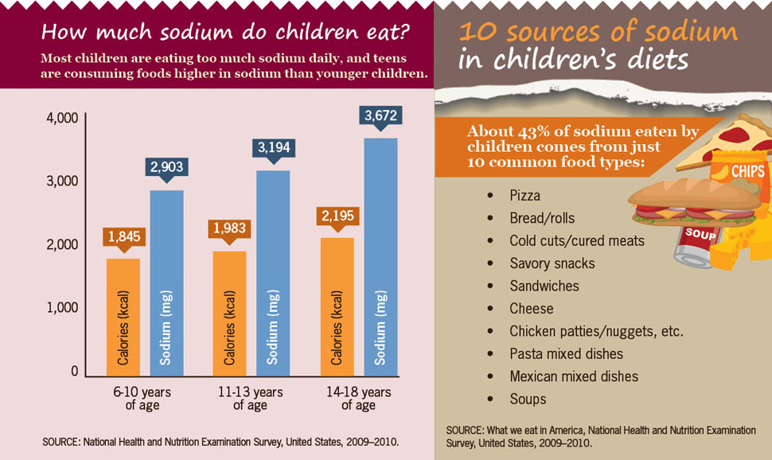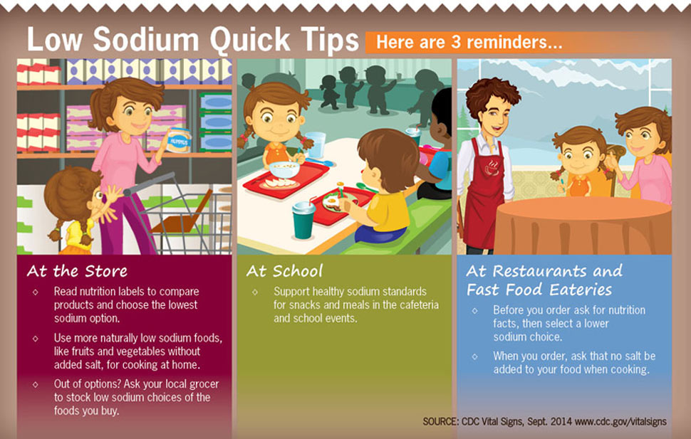

Nutritional management guidelines of centers for disease control and prevention (3)

- Healthy Lifestyle Changes
Healthy lifestyle habits can help you control high blood pressure. These habits include:
• Healthy eating
• Being physically active
• Maintaining a healthy weight
• Limiting alcohol intake
• Managing and coping with stress

- Healthy Eating
- To help treat high blood pressure, Limiting Sodium and Salt
- A low-sodium diet can help you manage your blood pressure.
- Try to use low-sodium and “no added salt” foods and seasonings at the table or while cooking.
- Try to eat no more than 2,300 mg sodium a day.
- Your health care provider may recommend the Dietary Approaches to Stop Hypertension (DASH) eating plan if you have high blood pressure.
- The DASH eating plan focuses on fruits, vegetables, whole grains, and other foods that are heart healthy and low in fat, cholesterol, and salt.

- Your health care provider also may recommend heart-healthy eating, which should include:
• Whole grains
• Fruits, such as apples, bananas, oranges, pears, and prunes
• Vegetables, such as broccoli, cabbage, and carrots
• Legumes, such as kidney beans, lentils, chick peas, black-eyed
Peas and lima beans
• Fat-free or low-fat dairy products, such as skim milk
• Fish high in omega-3 fatty acids, such as salmon, tuna, and trout,
About twice a week
- When following a heart-healthy diet, you should avoid eating:
• A lot of red meat
• Palm and coconut oils
• Sugary foods and beverages

- Being Physically Active
- Routine physical activity can lower high blood pressure and reduce your risk for other health problems.
- Talk with your health care provider before you start a new exercise plan.
- Ask him or her how much and what kinds of physical activity are safe for you.
- Everyone should try to participate in moderate-intensity aerobic exercise
- Participate in aerobic exercise for at least 10 minutes at a time, spread throughout the week.
- Maintaining a Healthy Weight
- Maintaining a healthy weight can help you control high blood pressure
- If you’re overweight or obese, try to lose weight
- Greater amounts of weight loss can improve blood pressure readings, lower LDL cholesterol, and increase HDL cholesterol
- A useful measure of overweight and obesity is body mass index (BMI).

  - Below 18.5 is a sign that you are underweight.
  - Between 18.5 and 24.9 is in the healthy range.
  - Between 25 and 29.9 is considered overweight.
  - Of 30 or more is considered obese.
A general goal to aim for is a BMI below 25. Your health care provider can help you set an appropriate BMI goal.
- Losing weight or maintaining your weight, go to Aim for a Healthy Weight.

- Limiting Alcohol Intake
- Too much alcohol will raise your blood pressure and triglyceride levels,
- A type of fat found in the blood.
- Alcohol have extra calories
- weight gain
- Men should have no more than two drinks containing alcohol a day.
- Women should have no more than one drink containing alcohol a day.

- Managing and Coping With Stress
Stress management techniques include:
• Being physically active
• Listening to music or focusing on something calm or peaceful
• Performing yoga or tai chi
• Meditating,

Nutritional management guidelines of Western Cape government (1)
Making small changes for big health benefits: Here are some healthy living tips that you can use to improve your health.
- Eating a healthy balanced diet
- Reduce your salt intake to no more than 1 teaspoon (5g) of salt a day.
  - Reduce the salt added to your food during cooking and at the table.
  - Make use of fresh and dried herbs, spices, garlic or lemon juice to add flavor to your food, without adding extra salt or salty seasoning.
  - Foods like packet soups, stock cubes, gravies, cheese, many breakfast cereals, breads, salty snacks, processed meats and fast foods are very high in salt, and should be used sparingly.
- Enjoy a variety of fruits and vegetables, and aim to have at least 5 servings a day.
- Choose whole grain and high fiber foods.
- Limit unhealthy saturated and trans fats, found in fatty and processed meats, chicken skin, full-cream dairy products, butter, ghee, cream and hard cheeses, commercially baked goods such as pies, pastries, biscuits and crackers, fast foods and deep-fried potato/slap chips.
- Eat healthier unsaturated fats such as sunflower /canola /olive oil, soft tub margarines, peanut butter, nuts and seeds, avocado or fish. Try to include fatty fish (sardines, pilchards, salmon, and mackerel) at least twice a week.
- Eat small, regular meals.

- Doing more physical activity

- Increasing your level of physical activity doesn’t mean having to join a gym or a sports group!
- There are lots of physical activities that are free, healthy and could be fun, for example, walking with your family or dog, dancing at home, avoiding lifts and taking the stairs instead, swimming, and gardening.
- 150 minutes (2 and 30 minutes) per week in order
- To reduce your risk of a number of chronic diseases, such as high blood pressure, high cholesterol and type 2 diabetes.
- Avoiding harmful alcohol use, or if you drink alcohol, limit it to no more than 1 drink a day for women and 2 drinks a day for men.
- Stopping tobacco use and exposure to tobacco products.
- Managing stress and striving for a good night’s sleep.
- Have your blood pressure and glucose levels checked at least once a year, and more often if you have a family history of chronic diseases such as hypertension and diabetes.

Conclusion
If hypertension is detected early it’s possible to minimize the risk of heart attack, heart failure, and stroke and kidney failure. Individuals who already have hypertension can manage their condition by: adopting the healthy behaviors listed above, monitoring blood pressure at home if feasible, going for regular check-ups at a health facility, and regularly taking any prescribed medications for lowering blood pressure. And to Checking your blood pressure The only way to find out what your blood pressure is to measure it using acceptable measuring devices, such as: upper-arm or wrist blood pressure monitors that can be bought at local pharmacies, wireless blood pressure monitors, pocket-sized blood pressure monitor that offers connectivity via NFC (near field communication), battery-powered devices that connects via Bluetooth to an app on your smart phone or tablet, public blood pressure machines at certain pharmacies, or Alternatively, you can have a test done on a regular basis at a health facility in your area.

Discussion
Preventing Worsening High Blood Pressure or Complications
If you have been diagnosed with high blood pressure, it is important to obtain regular medical care and to follow your prescribed treatment plan, which will include healthy lifestyle habit recommendations and possibly medicines. Not only can healthy lifestyle habits prevent high blood pressure from occurring, but they can reverse prehypertension and help control existing high blood pressure or prevent complications and long-term problems associated with this condition, such as coronary heart disease, stroke, or kidney disease. Make the Lifestyle changes can help you control your blood pressure. Eat a healthy diet that is: Low in salt (sodium), total fat, saturated fat, and cholesterol. High in fresh fruits and vegetables. Be active. Try taking a brisk 10-minute walk 3 times a day 5 days a week. Do not smoke. These lifestyle changes for blood pressure control are similar to those for preventing high blood pressure.

Reference
- Western Cape government. (2017, july11).Understanding hypertension. Retrieved from
https://www.westerncape.gov.za/general-publication/understanding-hypertension

- Centers for disease control and prevention. (2017, November13). high blood pressure’s, GOV. Retrieved from
https://www.cdc.gov/bloodpressure/index.htm
- The national heart, lung, and blood institute. (2015, September 10). Explore High Blood Pressure, USA,GOV. Retrieved from
https://www.nhlbi.nih.gov/health/health-topics/topics/hbp/treatment

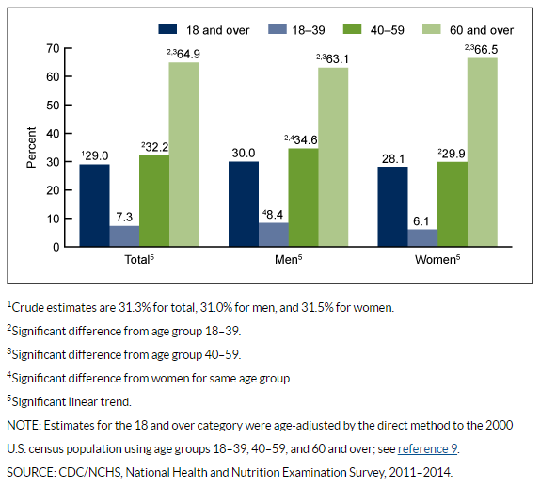
Prevalence of hypertension among adults aged 18 and over by sex and age: United States, 2011-2014

https://permanent.access.gpo.gov/gpo80199/db278.pdf

