1.Compute the price of a 3.8% coupon bond with 18 years left to maturity and a market interest rate of 7%. Compute the price again if interest payments are paid semi-annually (solve using semi-annual compounding). Par value is $1000
Solution for the first case (annually)
PVF = (1 + (r/m))-mn
(1 + (7%/1))-(1)(18)
(1.07)-18
PVF = 0.295863916
PVP = $1,000 * 0.295863916
PVP = $295.86
Present Value of Interest
Interest = $1,000 * 3.8% = $38
PVFOA = (1 - PVF) / (r/m)
PVFOA = (1 - 0.295863916) / (7%/1)
PVFOA = 0.704136083 / 7%
PVFOA = 10.05908691
PVi = Interest * PVFOA
PVi = $38 * 10.05908691
PVi = $382.25

Price of Bonds

PVP + PVi

$295.86 + $382.25

PV = $678.11
solution for semi-annual

Present Value of Principal

PVF = (1 + (r/m))-mn

P(1 + (7%/2))-(2)(18)

(1.035)-36

PVF= 0.289832716

PVP = Principal Amount * PVF

$1,000 * 0.289832716

PVP = $289.83

Present Value of Interest
$1,000 * 3.8% * 6/12 =
$19

PVFOA = (1 - PVF) / (r/m)
(1 - 0.289832716) ÷(7%/2)

0.710167283 ÷ 3.5%

PVFOA = 20.29049381

PVi = Interest * PVFOA

$19 × 20.29049381
PVi = $385.52

Price of Bonds

PVP + PVi

$289.83 + $385.52

PV = $675.35

2. A 6.50% coupon bond with 18 years left to maturity is offered for sale at $1,035.25. What yield to maturity [6.19] is the bond offering? Assume interest payments are paid semi-annually and solve using semi-annual compounding. Par value is $1000
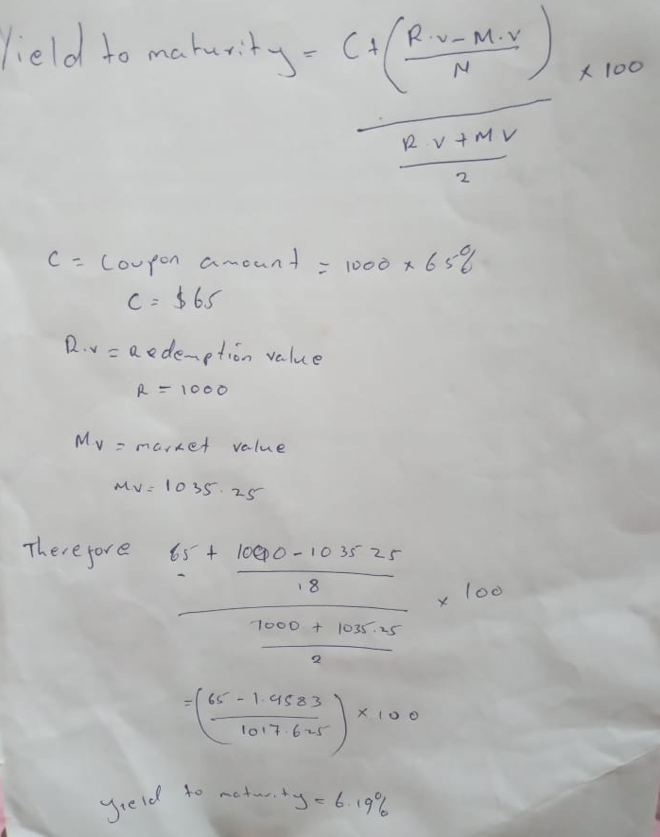

4.A company XYZ issued 30-year bonds with 10% annual coupon rate at their par value of $1000 in 2010. The Bonds had a 7% call premium, with 5 years of call protection. Today XYZ called the bonds. Compute the realized rate of return for an investor who purchased the bonds when they were issued in 2010.Briefly explain why the investor should or should not be happy?
Y = (I + (C - P)/n)/((C+P)/2)
I = interest
10% × 1000 = $100

C = value called at
1000× 1.07 = 1070

n = holding period till call
= 10 years
P = purchase price = 1000
therefore
(10 +(1070-1000)/10)/((2070/2) = 0.0164
=0.0164
The investor should be happy since he can manage their liabilities and obligation because they are secured and will receive fixed income up to the agreed period. He should also be pleased since he will receive a higher interest rate on callable bonds.
5. Your discount brokerage firm charges $9.50 per stock trade. How much money do you need to buy 300 shares of Time Warner, Inc. (TWX), which trades at 22.62?
Cost per stock trade=$9.50
Per share=$22.62
Number of shares=300
Therefore, the amount you need to buy 300 shares
($22.62×300) +$9.50=$6795.5

