Finish the following problem, which has been started for you. Note that there may be items missing at any point in this partial problem solution. All missing parts should be added for full credit of 8 points.
- What is the kinetic energy of a particle with a charge of 55microCoulombs moving with a radius of 3.7 mm in a constant magnetic field with strength 1.9 x 10⁻⁴ T, if it is moving at constant speed 75 m/s?
Qualitative Representation
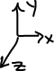

Variables (Known and Unknown) and Equations
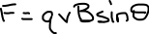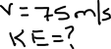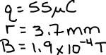
Solution
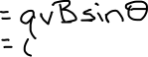
Since the angle between magnetic field B and the velocity v of the particle is 90º , then the particle will be moving in a circular path. So, the force F=640.076N must be equal to the centripetal force required for the particle to move in a circular path.
Now, centripetal force = $\frac{mv^{2}}{r}$
Then, F= $\frac{mv^{2}}{r}$
Or, $\frac{mv^{2}}{r}$ = 640.076 N

Or, mv² = (640.076 N) $×$ r = (640.076 N)$×$ (3.7mm) = (640.076 N) $×$ ($\frac{3.7}{1000}$ m) =2.3683 J
Then, kinetic energy of the particle = $\frac{1}{2}$mv² = $\frac{2.3683}{2}$ J = 1.1841 J

For this problem you must BOTH identify the errors (circle them) and correctly solve the problem. Identifying all errors and correctly solving this -with all steps shown – is worth 8 points.
- An MRI technician moves her hand from a region of very low magnetic field strength (approximately zero) into the MRI scanner’s 1.5 T field in a quick motion, taking 3.1milliseconds.The MRI is essentially a solenoid, with 1500 loops of wire. If she is wearing a wedding ring of diameter 1.75 cm and it has a measured resistance of 119 Ohms, what is the current induced in the ring?
Qualitative Representation
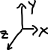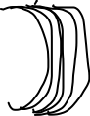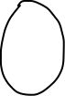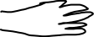
Variables (Known and Unknown) and Equations
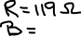

Solution
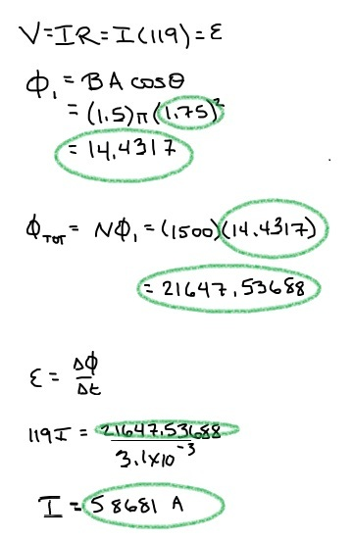

Correct Solution:
V = ΙR = Ι(119)= ϵ
Area, A = πr² where r is the radius of the ring.
Since the diameter, d = 1.75 cm
Then, r = $\frac{d}{2}$ = $\frac{1.75}{2}$ cm = 0.875 cm =$\frac{0.875}{100}$ m = 0.00875 m
Then, Φ₁ = BAcosθ
=1.5π($0.00875)$² weber
=0.00036 weber
Φ_{TOT} = N Φ₁ = (1500)( 0.00036) weber
=0.54 weber

ϵ$=\frac{ΔΦ}{Δt}$
119Ι = $\frac{0.54 weber}{3.1 milliseconds}$ = $\frac{0.54 }{3.1×{10}^{-3}}$ =174.19
Ι = $\frac{174.19}{119} A$ = 1.464 Α

So, the induced current in the ring is 1.464 ampere .

